**CS342: Computer Networks Assignment 5**

**Group 52**

**Group Members Roll Number**

**Sahil Kumar Gupta 200123081**

**Tiyasa Majumder 200123083**

**Gaurang Thakur 200123082**

**Part A**

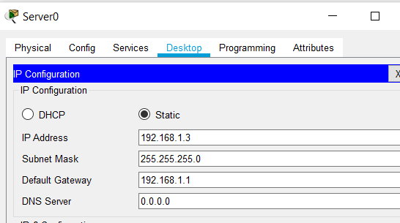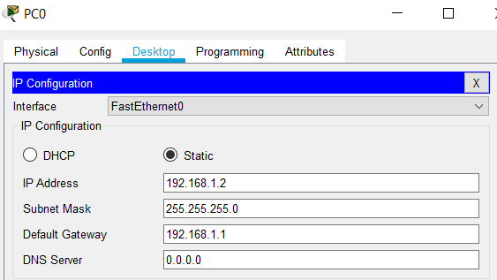Ip address, default gateway and subnet mask to both the PCs and Servers were assigned as:

Screenshots for PC0 and Server0 is shown above. Similar thing was done for PC1 and Server1 with the required values

**Part B**

Below are the respective commands for Switch0 for all the sub-parts. Same thing is done for Switch1 as well.

1. Switch(config)#hostname Sahil_Switch
2. Sahil_Switch(config)#enable password cisco

Sahil_Switch(config)#enable secret cisco123

Sahil_Switch(config) #line console 0

Sahil_Switch(config-line) #password cisco123

1. Sahil_Switch(config) #int vlan 1

Sahil_Switch(config-if) #ip address 192.168.1.5 255.255.255.0

Sahil_Switch(config-if) #ip default-gateway 192.168.1.1

no shutdown command is then used to up the connection

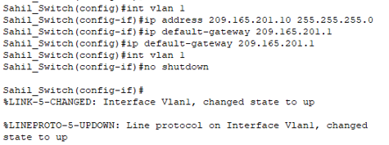

For switch1 instead of the VLAN1 interface VLAN2 interface was used and the IP addresses and gateway were changed accordingly

Verification for Switch0

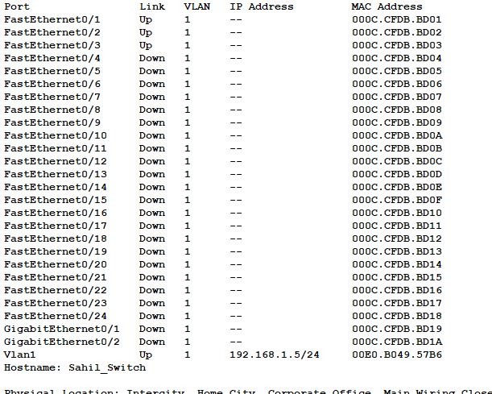

1. Now the devices were connected as shown in the figure

**Topology**

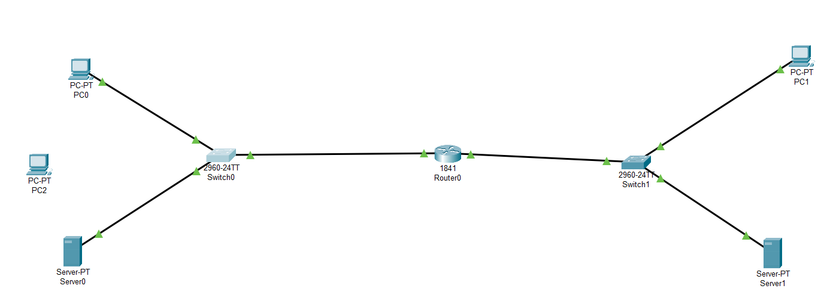

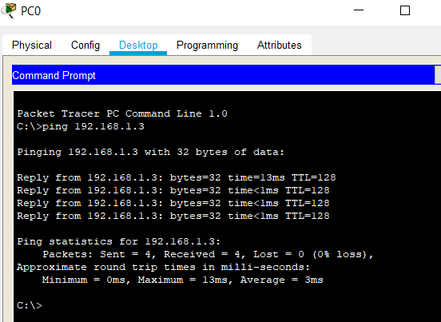As expected the intra VLAN communication was working but the inter VLAN communication was not.

**Here the ping is sent from PC0 to Server0 and since it was intra VLAN communication it is verified that it was working and obviously inter VLAN communication was not working as the router is still not configured.**

**Part C**

The first 2 sub-parts are same as was done in the Part B first 2 sub-parts and hence only the screenshots are pasted below for them.

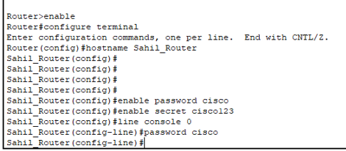

IP address, subnet mask to interface fa0/0 and fa0/1 are assigned using the commands:

Sahil_Router(config)#int fa0/1

Sahil_Router(config-if)#ip address 192.168.1.1 255.255.255.0

Sahil_Router(config-if)#exit

Sahil_Router(config)#int fa0/2

Sahil_Router(config-if)#ip address 209.165.201.1 255.255.255.0

Sahil_Router(config-if)#exit

Verification for Router



Now the inter VLAN communication was also working as shown in the screenshot below

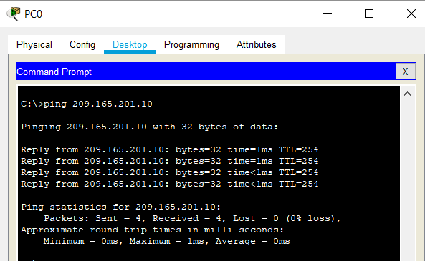

This ping was sent from PC0 to PC1 and all the packets were received as visible in the above screenshot. And also, from PC1 to PC0 ping was working.

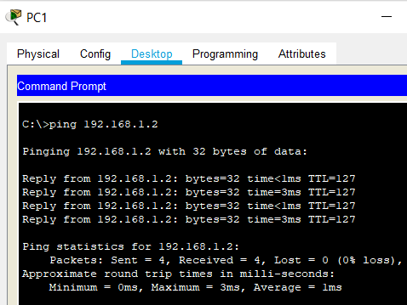

**Part D**

We first enable the port security for the port used by PC0, using the commands shown in the screenshot

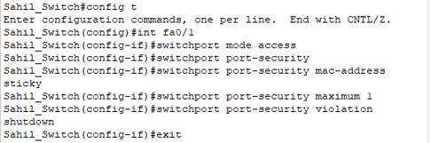

Now, the verification of port security. Security violation count 0 as shown below verifies the port security.

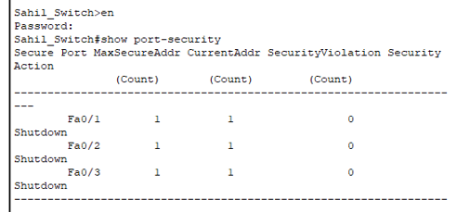

Ping sent from PC0 to Switch0 is working properly as shown below:

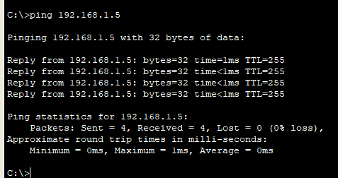

Verification of the MAC address

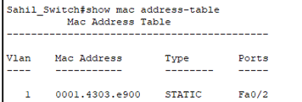



Now removing the connection fa0/1 b/w Switch0 and PC0 and connecting to PC2, cause the port to shut down and causes the violation as shown below:

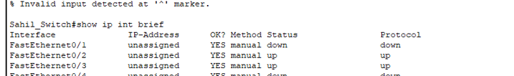

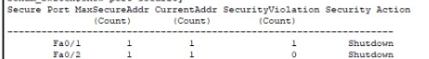

For the last part connections were again established and it started working properly.

**Part E**

1. For both Switch0 and Router0, the following command was run to save the configuration to NVRAM

*copy run startup*

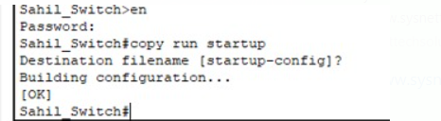

1. Back up of the configuration file was done to Server0 using the following commands:

**For router**

copy startup-config tftp

192.168.1.3 (address of remote host, here address of Server0)

Router0_config (this command was to give the required name)

**For server**

copy startup-config tftp

192.168.1.3 (address of remote host, here address of Server0)

Swtich0_config (this command was to give the required name)

Below is the screenshot for Switch0 commands

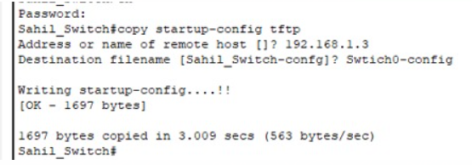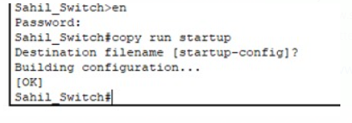

1. 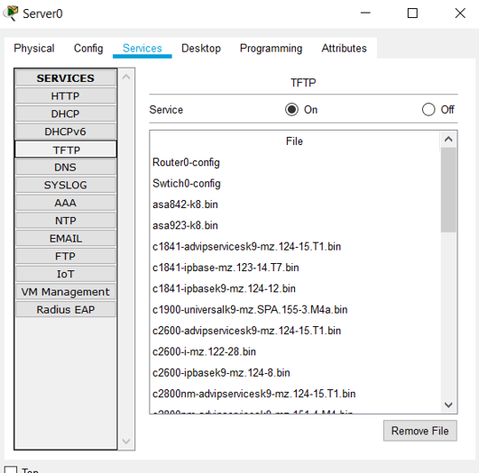Verification that the server has the required files