**MA374: Financial Engineering Lab**

**Lab03**

**Sahil Kumar Gupta**

**200123081**

**Question 1**

Given expression for u and d are:

$$u=e^{σ\sqrt{∆t}+\left(r-\frac{1}{2}σ^{2}\right)∆t } and d=e^{-σ\sqrt{∆t}+\left(r-\frac{1}{2}σ^{2}\right)∆t }, where ∆t= T/M, M here is the number of subintervals in \left[0,T\right].$$

Initial price of the American Call option price = 12.123047074012304 and Put option price = 5.27983714598915.

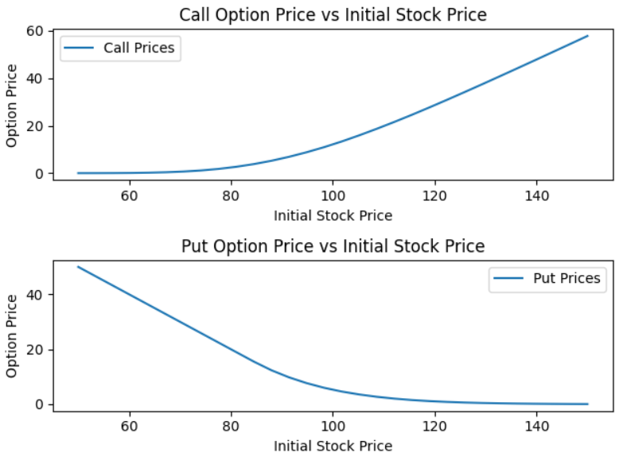

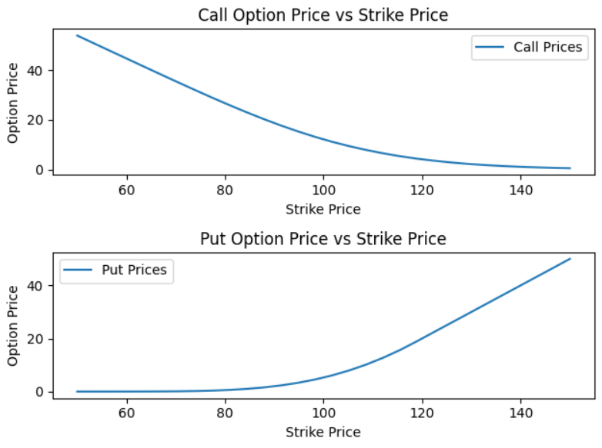 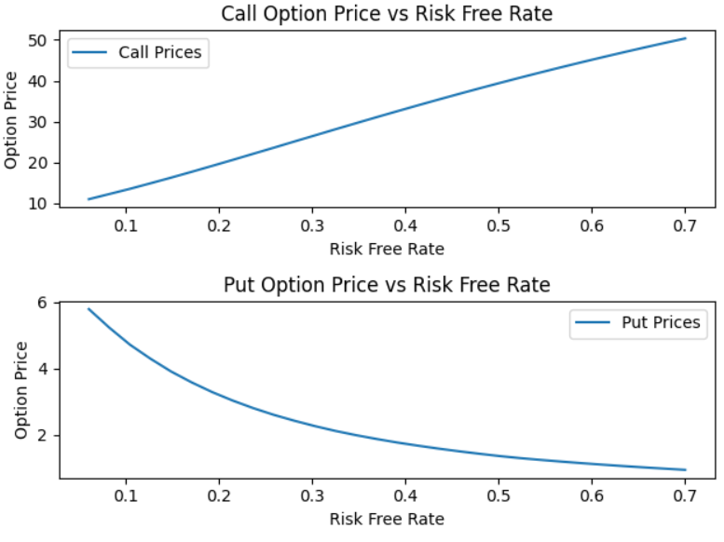 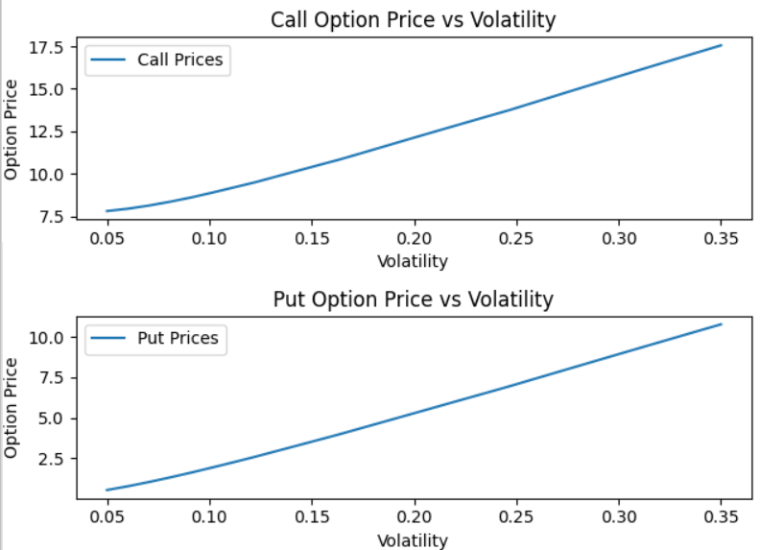 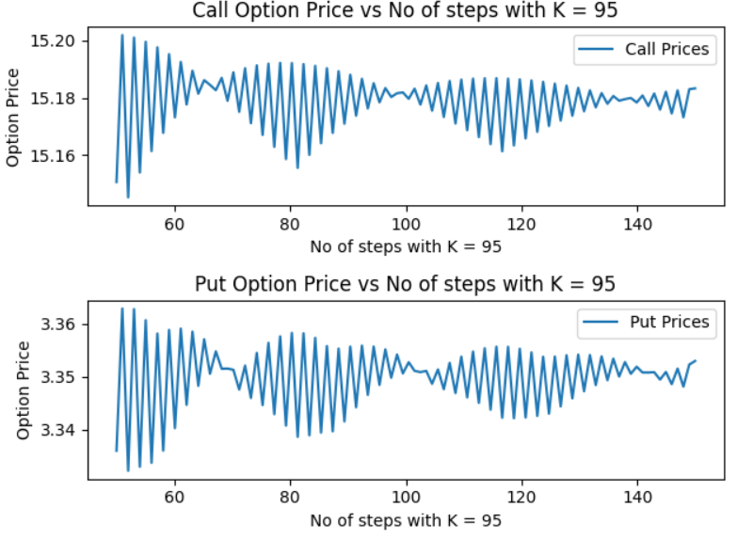 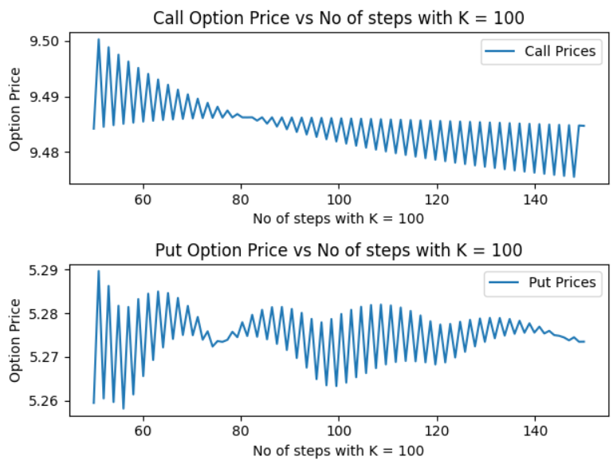 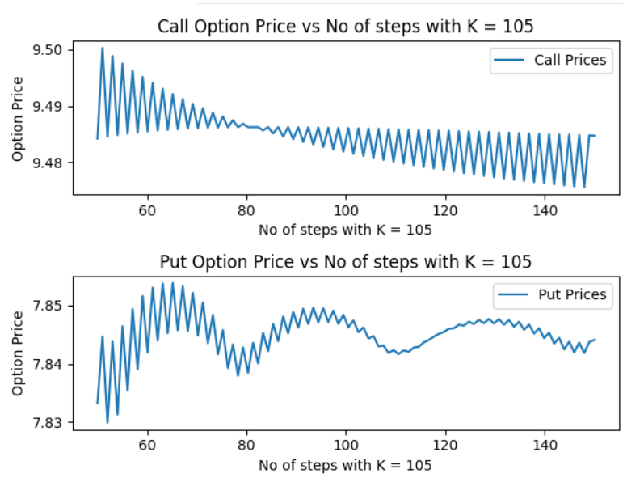

**Question 2**

For the European Option, we use the following data,

$$S\left(0\right)=100, T=1, r=8\%, σ=20\%$$

The payoff of the lookback option is given as,

$$V=\max_{0≤i≤M}{S\left(i\right)-S(M)}$$

$S\left(i\right)=S(i∆t)$ and $u=e^{σ\sqrt{∆t}+\left(r-\frac{1}{2}σ^{2}\right)∆t } and d=e^{-σ\sqrt{∆t}+\left(r-\frac{1}{2}σ^{2}\right)∆t }, where ∆t= T/M, M here is the number of subintervals in \left[0,T\right].$

1. The initial value of Option Prices for different M are as:

|  |  |
| --- | --- |
| M | Option Price |
| 5 | 9.11929898586469 |
| 10 | 10.08058290683101 |
| 25 | Computationally Infeasible |
| 50 | Computationally Infeasible |

1. 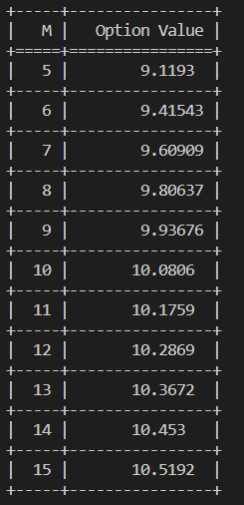

From the table it is evident that the Option Value increase with M.

1. 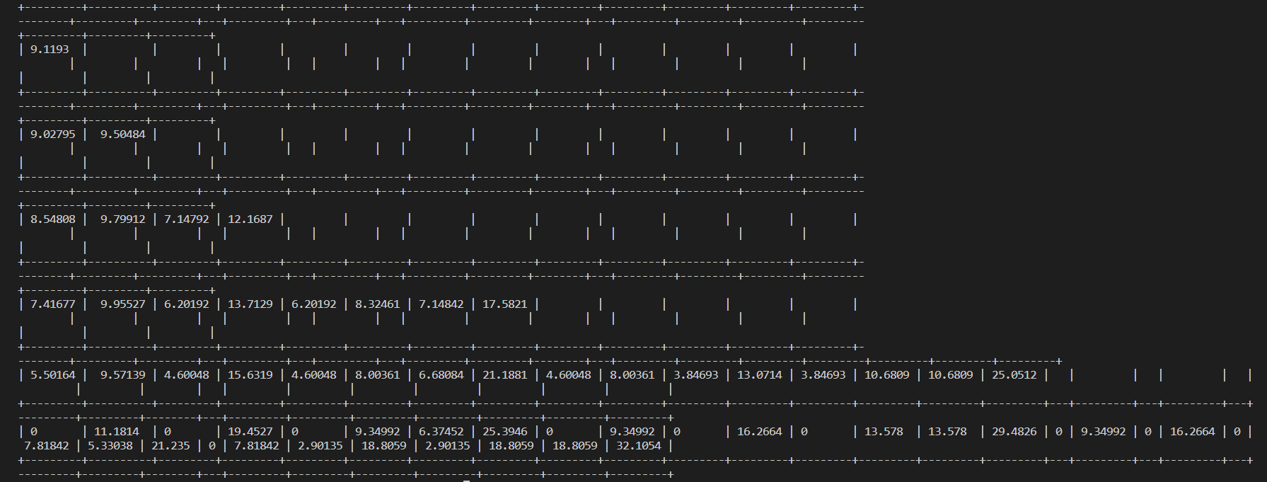Below image shows the table for all intermediate values for M = 5. Here each row denotes the option price at each intermediate level. Last level has 32 values, coming in 2 lines in image.

**Question 3**

Initial payoff the Lookback Option using Markov based algorithm are as:

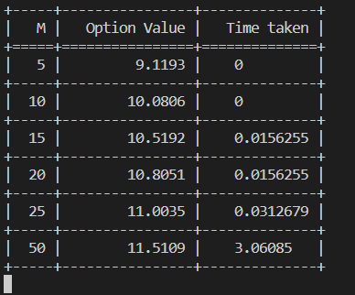**Note:** 0-time value does not mean that the time taken is 0 but it is coming because of the precision of the system.

**Comparison**

We can see that for binomial model time taken is high and also it is not feasible for high values of M which is not the case with Markov Algorithm.

Also, the initial Option Value increases with M as evident from the graph shown below.

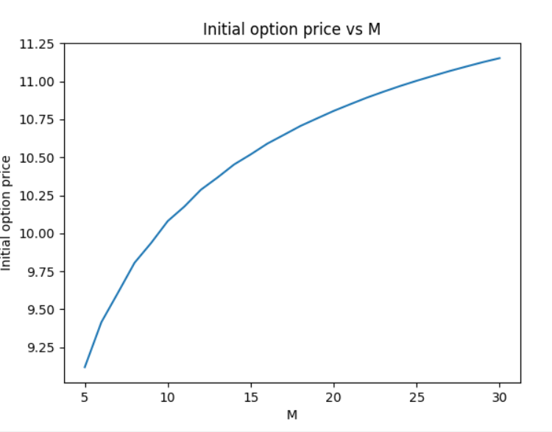

Maximum value of M for the algorithm to run in reasonable in time:

* For binomial: 15
* For Markov: 50

**Time Complexity**

* Time complexity for binomial algorithm is O(2^M) because we are exploring every path of the binomial tree.
* Markov algorithm depends on 2 states, the current stock price and maximum stock price encountered along the path till now. Time complexity of this algorithm is O(M^4), because number of unique paths is bounded by O(M^2) and hence, maximum stock prices is also bounded by O(M^2).

**Question 4**

Output on running the code, following is the output:

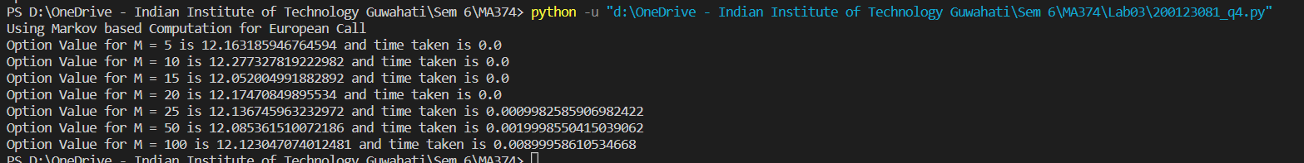

In a reasonable amount of time, we found that

* $M_{max}=20$ for Binomial
* $M_{max}=1000 approx.$ for Markov

Below is the table showing the comparison time and initial Option Value.

|  |  |  |  |
| --- | --- | --- | --- |
| M | Time for Binomial | Time for Markov | Option Value |
| 5 | $$0.0$$ | $$0.0$$ | $$12.163185946764594$$ |
| 10 | $$0.0010020732879638672$$ | $$0.0$$ | $$12.277327819222982$$ |
| 20 | $$0.0010013580322265625$$ | $$0.0$$ | $$12.052004991882892$$ |
| 25 | $$Infeasible$$ | $$0.0009982585906982422$$ | $$12.136745963232972$$ |
| 50 | $$Infeasible$$ | $$0.0019998550415039062$$ | $$12.085361510072186$$ |
| 100 | $$Infeasible$$ | 0.00899958610534668 | $$12.123047074012481$$ |

**Time Complexity**

* Time complexity for binomial algorithm is O(2^M) because we are exploring every path of the binomial tree.
* Markov algorithm depends on 2 states, the step number and count of up steps encountered along the path till now. Time complexity of this algorithm is O(M^3), because number of unique states is bounded by O(M^2) and hence, number of up states is also bounded by O(M).