**MA 374 - Financial Engineering Lab05**

**Sahil Kumar Gupta**

**200123081**

**Calculations for BSE (Sensex)**

Daily data of BSE (Sensex) from January 1, 2018 to December 31, 2022 are taken for this lab and also in the same duration data of 10 indexed companies and 10 non-indexed companies are taken.

**Indexed Companies:**

'ADANIPORTS.BO','RELIANCE.BO', 'BAJFINANCE.BO','HDFCBANK.BO', 'TATAMOTORS.BO', 'TCS.BO', 'ITC.BO', 'ICICIBANK.BO', 'SBIN.BO', 'TECHM.BO'

**Non-Indexed Companies:**

'FEDERALBNK.BO', 'DLF.BO', 'BHARATFORG.BO', 'VOLTAS.BO', 'GAIL.BO', 'ACC.BO', 'NAUKRI.BO', 'TATAPOWER.BO', 'BANKBARODA.BO', 'AMBUJACEM.BO'

The minimum variance line is constructed using the following steps:

i) Obtain the required weights $w$ using the following relation -

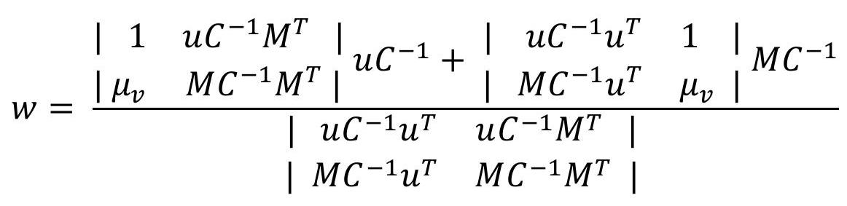

where, return,

(with same dimension as that of number of assets)

Minimum variance portfolio has weights:

using which the corresponding point was calculated.

The efficient frontier is a concept in finance that refers to the portfolio with the highest expected return for a given level of risk, as measured by standard deviation. The efficient frontier is represented on a graph as a curve with points that have a higher return than the minimum variance portfolio, indicating a trade-off between risk and reward.

Here M, C and σ are the mean return, Covariance Matrix and risk (volatility) of each of the 20 stocks and is calculate from the data obtained.

The Markowitz efficient frontier is as follows :

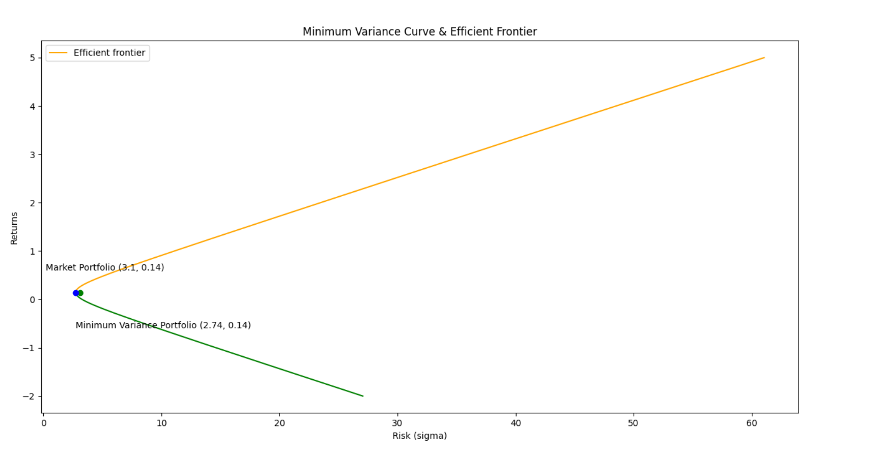

b) Market Portfolio:

Return = 0.13730084360173597

Risk = 3.104875027916485

c) Equation of Capital Market Line comes out as: *y = 0.03 x + 0.05*

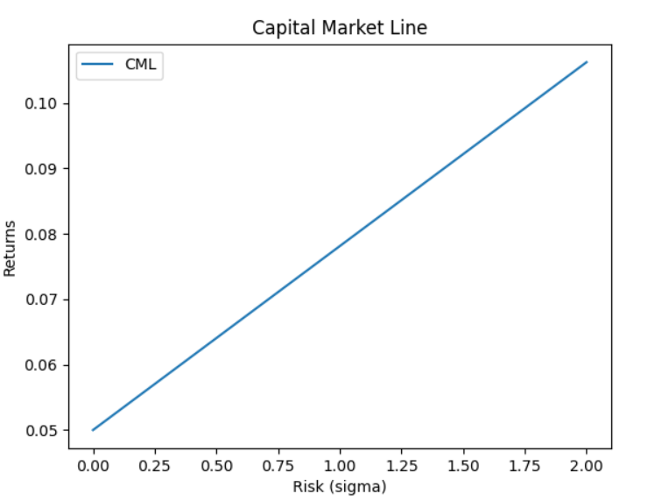

d) Equation of Security Market Line comes out as: μ (mu) = 0.09β + 0.05 The Security market line is obtained using the following formula:

$$μ=\left(μ_{M}-μ_{rf}\right)β+μ_{rf}$$

where, $$\begin{matrix}μ_{M} & =\text{ return corresponding to market portfolio } \\ μ_{rf} & =\text{ risk free }\text{return }\text{= 0.05}\end{matrix}$$

In the plot below SML equation is plotted. Also, there are 2 types of markers plotted. Blue one represents the stocks included in the BSE index and the red ones are those which are not included. For each point we have plotted ($β, E[R]$), where $β$ is the calculated beta value for that stock and E[R] is the expected return calculated.

We can see that most of the indexed stocks have higher return than average and opposite is the case for stocks not included in the BSE index. SML thus divides stocks into over and undervalued stocks.

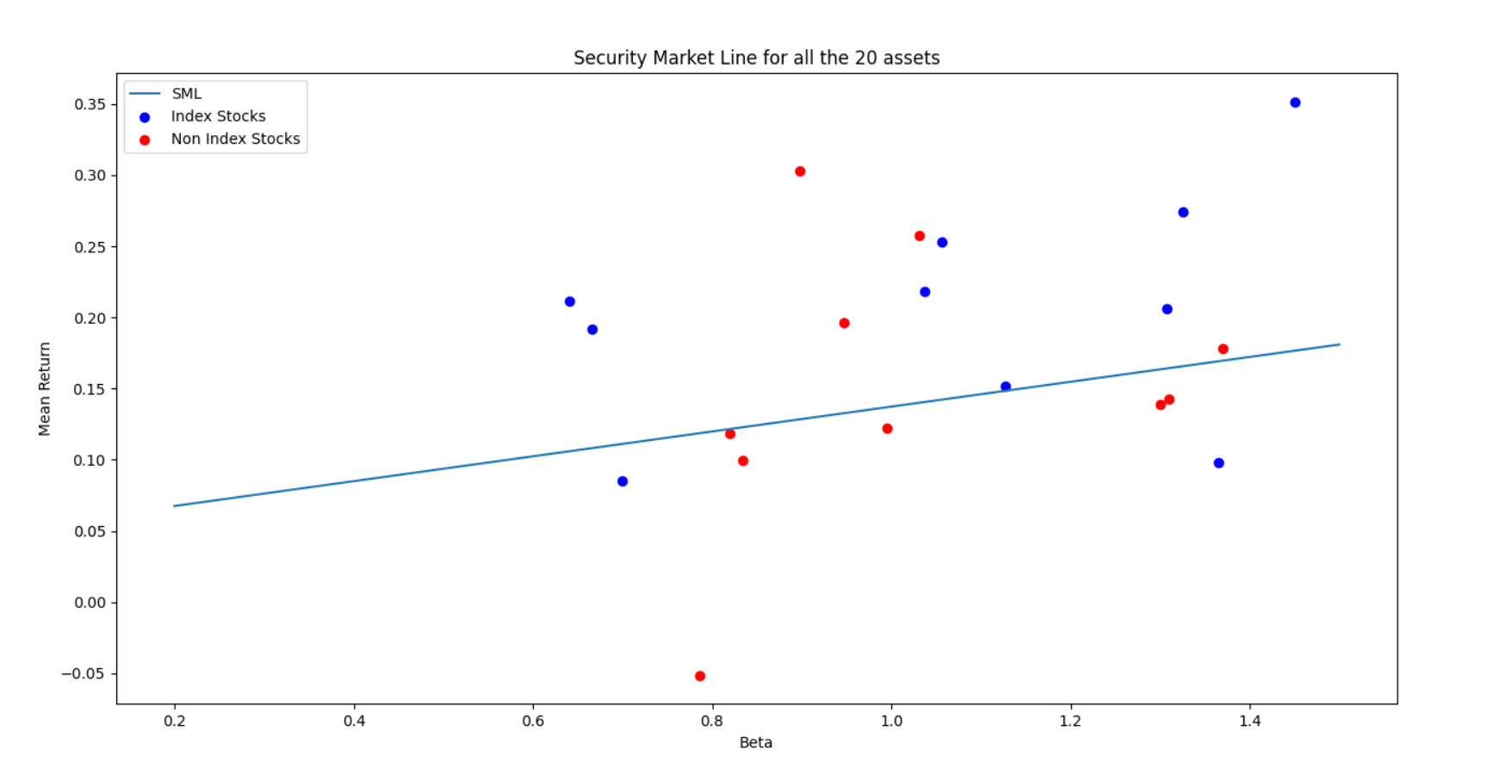

Below screenshot shows the expected return value, actual return value and expected beta value for all the stocks taken, and we can see that the expected return value is quite close to the actual return value.

We can observer that the beta values for the stocks indexed is mostly greater than 1 which is not the case with the stocks not in BSE index.

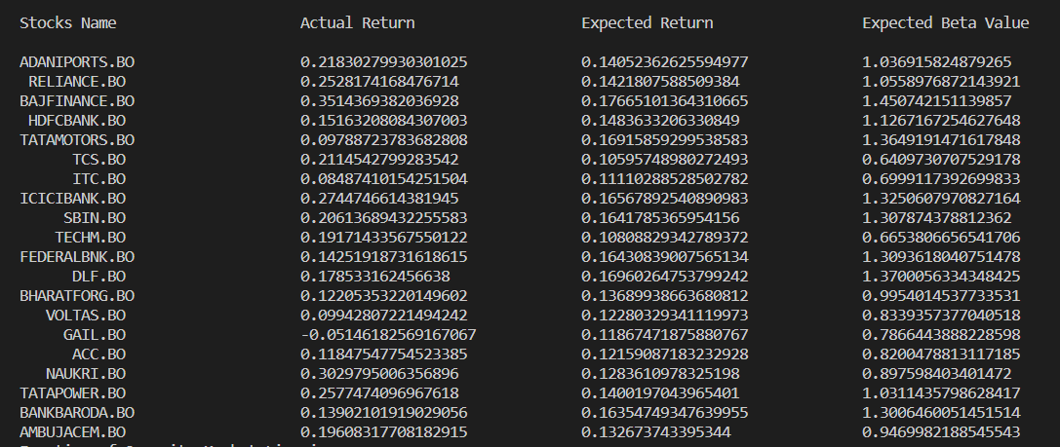

|  |  |  |
| --- | --- | --- |
| Stock Name | Expected Beta Value | Actual Beta Value (Long Term Beta) |
| ADANIPORTS.BO | 1.036915824879265 | 1.30 |
| RELIANCE.BO | 1.0558976872143921 | 1.08 |
| BAJFINANCE.BO | 1.450742151139857 | 1.76 |
| HDFCBANK.BO | 1.1267167254627648 | 1.06 |
| TATAMOTORS.BO | 1.3649191471617848 | 2.36 |
| TCS.BO | 0.6409730707529178 | 0.824 |
| ITC.BO | 0.6999117392699833 | 0.868 |
| ICICIBANK.BO | 1.3250607970827164 | 1.25 |
| SBIN.BO | 1.307874378812362 | 1.43 |
| TECHM.BO | 0.6653806656541706 | 1.03 |
| FEDERALBNK.BO | 1.3093618040751478 | 1.23 |
| DLF.BO | 1.3700056334348425 | 1.65 |
| BHARATFORG.BO | 0.9954014537733531 | 1.20 |
| VOLTAS.BO | 0.8339357377040518 | 1.05 |
| GAIL.BO | 0.7866443888228598 | 1.08 |
| ACC.BO | 0.8200478813117185 | 0.791 |
| NAUKRI.BO | 0.897598403401472 | 0.97 |
| TATAPOWER.BO | 1.0311435798628417 | 1.30 |
| BANKBARODA.BO | 1.3006460051451514 | 1.29 |
| AMBUJACEM.BO | 0.9469982188545543 | 0.777 |

**Calculations for NSE (Nifty)**

Daily data of NSE (Nifty) from January 1, 2018 to December 31, 2022 are taken for this lab and also in the same duration data of 10 indexed companies and 10 non-indexed companies are taken.

**Indexed Companies:**

'ICICIBANK.NS', 'INFY.NS', 'AXISBANK.NS', 'WIPRO.NS', 'HDFCBANK.NS', 'BHARTIARTL.NS', 'CIPLA.NS', 'TCS.NS', 'BRITANNIA.NS', 'NESTLEIND.NS'

**Non-Indexed Companies:**

'INDUSTOWER.NS', 'BANKBARODA.NS', 'NAUKRI.NS', 'HAVELLS.NS', 'GODREJCP.NS', 'ACC.NS', 'DMART.NS', 'GAIL.NS', 'INDIGO.NS', 'DLF.NS'

The minimum variance line is constructed using the following steps:

i) Obtain the required weights $w$ using the following relation -



where, return,

(with same dimension as that of number of assets)

Minimum variance portfolio has weights:

using which the corresponding point was calculated.

The efficient frontier is a concept in finance that refers to the portfolio with the highest expected return for a given level of risk, as measured by standard deviation. The efficient frontier is represented on a graph as a curve with points that have a higher return than the minimum variance portfolio, indicating a trade-off between risk and reward.

Here M, C and σ are the mean return, Covariance Matrix and risk (volatility) of each of the 20 stocks and is calculate from the data obtained.

The Markowitz efficient frontier is as follows:

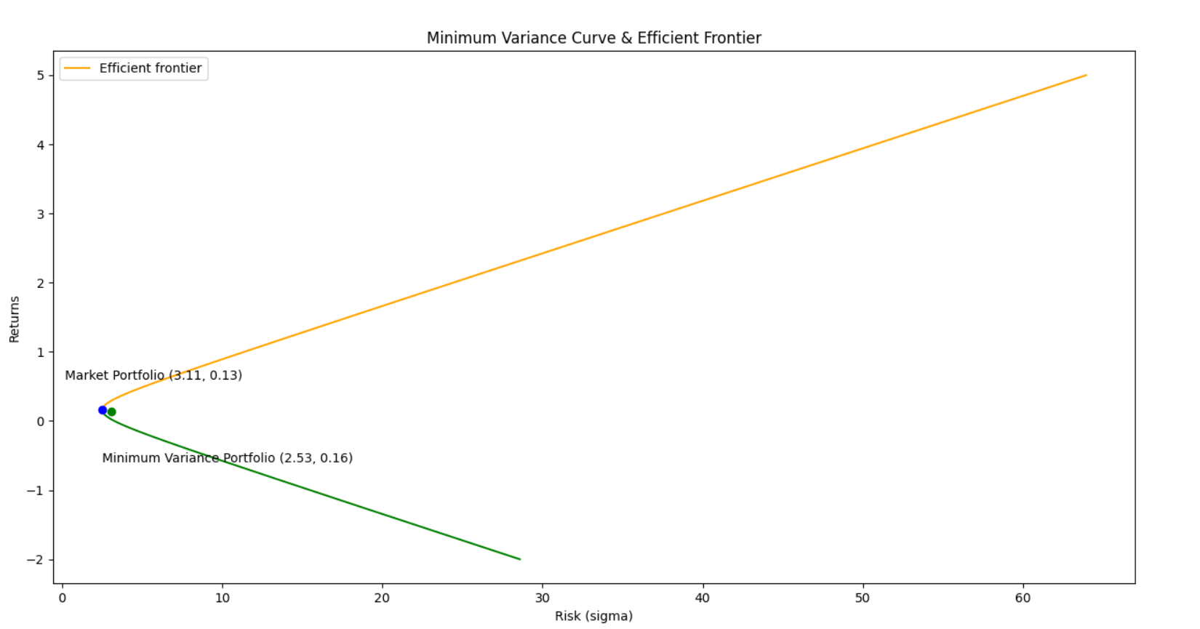

b) Market Portfolio:

Return = 0.1312238417183743

Risk = 3.106646443812293

c) Equation of Capital Market Line comes out as: *y = 0.03 x + 0.05*

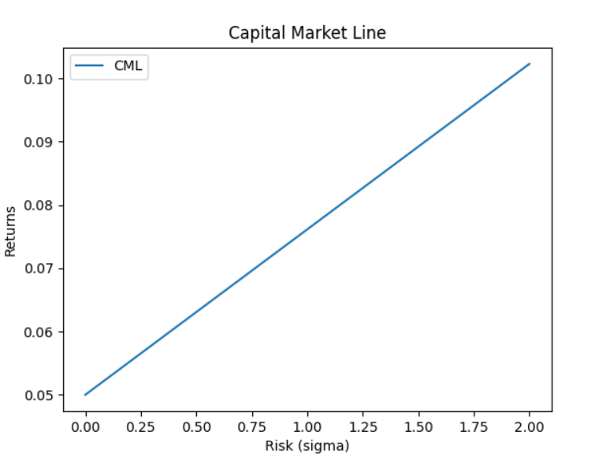

d) Equation of Security Market Line comes out as: μ (mu) = 0.08β + 0.05 The Security market line is obtained using the following formula:

$$μ=\left(μ_{M}-μ_{rf}\right)β+μ_{rf}$$

where, $$\begin{matrix}μ_{M} & =\text{ return corresponding to market portfolio } \\ μ_{rf} & =\text{ risk free return }\text{= 0.05}\end{matrix}$$

In the plot below SML equation is plotted. Also, there are 2 types of markers plotted. Blue one represents the stocks included in the NSE index and the red ones are those which are not included. For each point we have plotted ($β, E[R]$), where $β$ is the calculated beta value for that stock and E[R] is the expected return calculated.

We can see that most of the indexed stocks have higher return than average and opposite is the case for stocks not included in the NSE index. SML thus divides stocks into over and undervalued stocks.

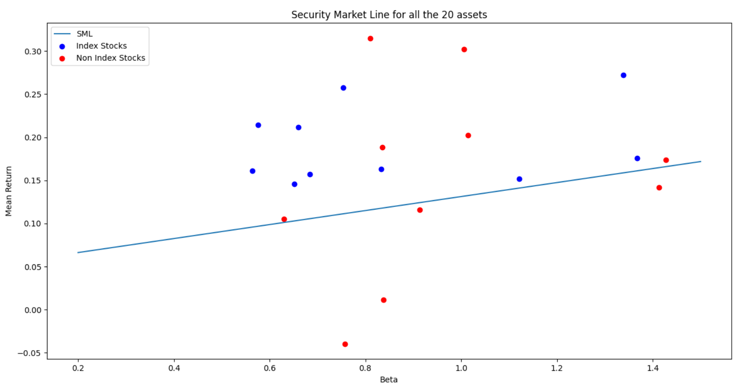

Below screenshot shows the expected return value, actual return value and expected beta value for all the stocks taken, and we can see that the expected return value is quite close to the actual return value.

We can observer that the beta values for the stocks indexed is mostly greater than 1 which is not the case with the stocks not in NSE index.

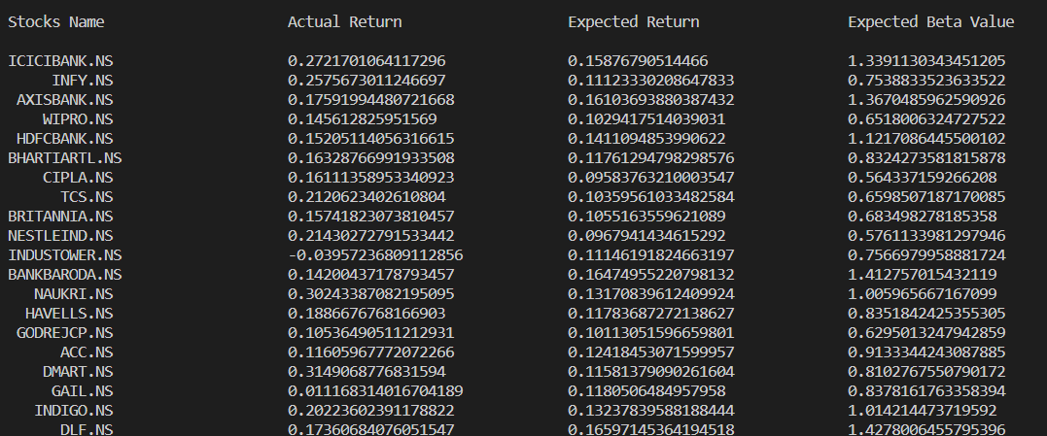

|  |  |  |
| --- | --- | --- |
| Stock Name | Expected Beta Value | Actual Beta Value (Long Term Beta) |
| ICICIBANK.NS | 1.3391130343451205 | 1.25 |
| INFY.NS | 0.7538833523633522 | 0.884 |
| AXISBANK.NS | 1.3670485962590926 | 1.37 |
| WIPRO.NS | 0.6518006324727522 | 1.17 |
| HDFCBANK.NS | 1.1217086445500102 | 0.954 |
| BHARTIARTL.NS | 0.8324273581815878 | 0.728 |
| CIPLA.NS | 0.564337159266208 | 0.264 |
| TCS.NS | 0.6598507187170085 | 0.824 |
| BRITANNIA.NS | 0.683498278185358 | 0.495 |
| NESTLEIND.NS | 0.5761133981297946 | 0.489 |
| INDUSTOWER.NS | 0.7566979958881724 | 0.70 |
| BANKBARODA.NS | 1.412757015432119 | 1.29 |
| NAUKRI.NS | 1.005965667167099 | 1.02 |
| HAVELLS.NS | 0.8351842425355305 | 0.872 |
| GODREJCP.NS | 0.6295013247942859 | 0.755 |
| ACC.NS | 0.9133344243087885 | 0.891 |
| DMART.NS | 0.8102767550790172 | 0.793 |
| GAIL.NS | 0.8378161763358394 | 1.08 |
| INDIGO.NS | 1.014214473719592 | 1.06 |
| DLF.NS | 1.4278006455795396 | 1.65 |