**MA374: Financial Engineering Lab11**

**Sahil Kumar Gupta**

**200123081**

**Q1**

The Vasicek Model is given by:

The risk neutral process for given by the model is:

$$dr=β\left(μ-r\right)dtσ{dW}^{Q}$$

Zero-coupon bond prices in Vasicek's model are given by:

$P\left(t,T\right)=A\left(t,T\right)e^{-B\left(t,T\right)r\left(t\right)}$ where, $B\left(t,T\right)=\frac{1-e^{-β\left(T-t\right)}}{β}A\left(t,T\right)=exp\left(\frac{\left(B\left(t,T\right)-T+t\right)\left(β^{2}μ-\frac{σ^{2}}{2}\right)}{β^{2}}-\frac{σ^{2}B{\left(t,T\right)}^{2}}{4β}\right)$

and the Continuously compounded zero coupon yield is given by:

y(t,T) = - (log (P(t , T)))/(T - t)

where, P(t ,T) is zero coupon bond price,

T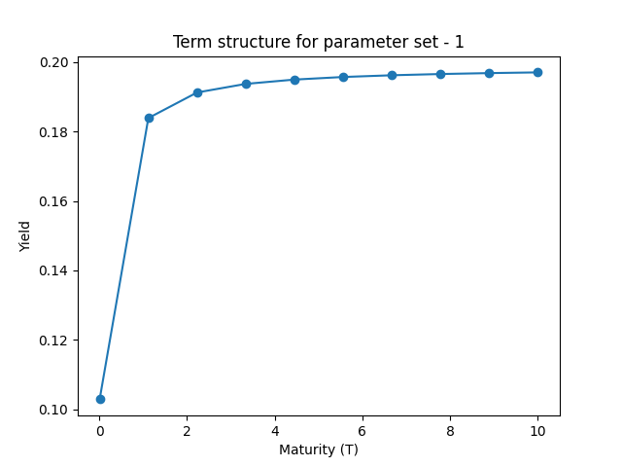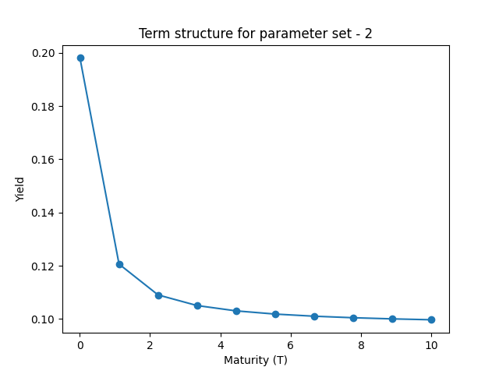he outputs are-

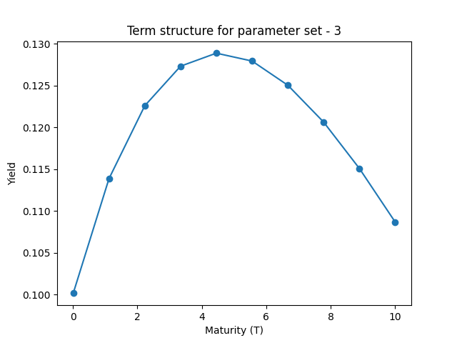

Term structure for 10 different values of r(0) and 500 time units

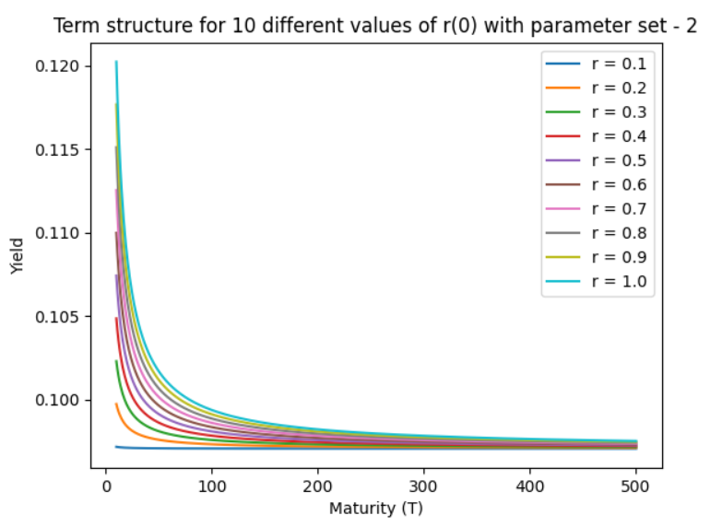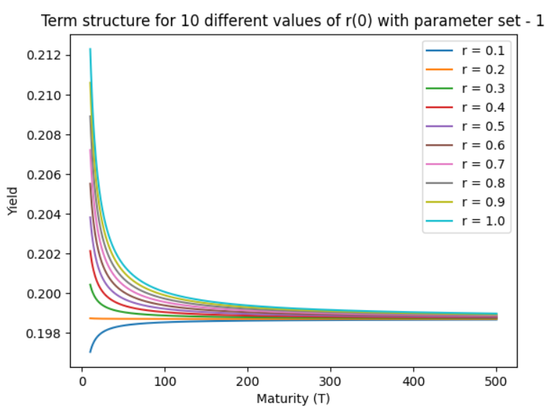

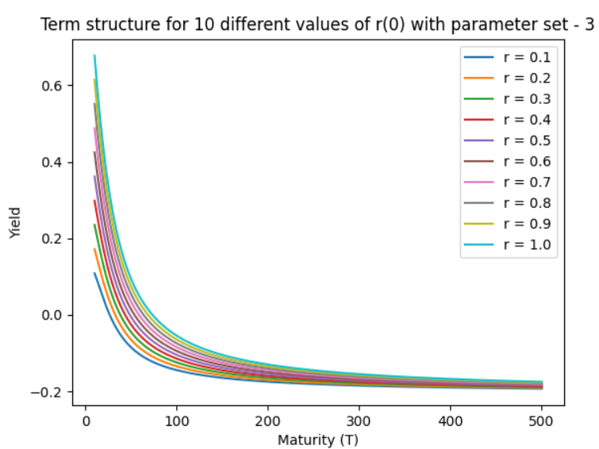

**Observations:**

* The bond price yield converges to a certain value once the maturity term is raised to a sufficiently large value, regardless of the value of r(0) used.
* The behaviour of the term structure of parameters set for 10 time units is noticeably different. The yield grows and eventually converges for the initial parameter set. The yield curve for the second one declines and eventually converges, but the yield curve for the last one has a "hump" in it.
* Mean reversion is noticed because high interest rates have a negative trend whereas low interest rates have a positive tendency to the reversion level. This is because the Vasicek Model involves mean reversion.

**Q2**

The CIR Model is given by:

The risk neutral process for given by the model is:

$$dr=β\left(μ-r\right)dt+σ\sqrt{r}{dW}^{Q}$$

Zero-coupon bond prices in CIR model are given by:

$$P\left(t,T\right)=A\left(t,T\right)e^{-B\left(t,T\right)r\left(t\right)}$$

where,

$$B\left(t,T\right)=\frac{2\left(e^{γ\left(T-t\right)}-1\right)}{\left(γ+β\right)\left(e^{γ\left(T-t\right)}-1\right)+2γ}$$

$$A\left(t,T\right)=\left[\frac{2γe^{\left(β+γ\right)\frac{T-t}{2}}}{\left(γ+β\right)\left(e^{γ\left(T-t\right)}-1\right)+2γ}\right]\frac{2βμ}{σ^{2}}$$

$$γ=\sqrt{β^{2}+2σ^{2}}$$

and the Continuously compounded zero coupon yield is given by:

y(t,T) = - (log (P(t , T)))/(T - t)

where, P(t ,T) is zero coupon bond price,

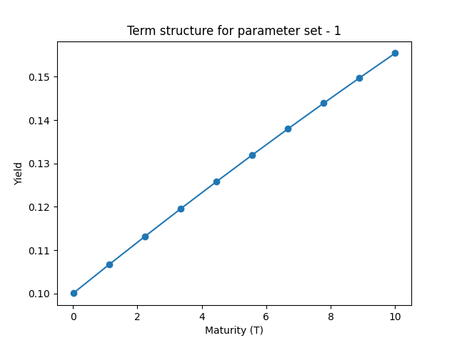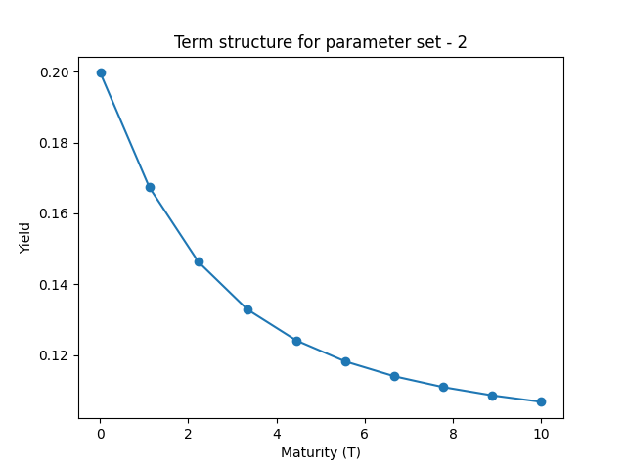The outputs are-

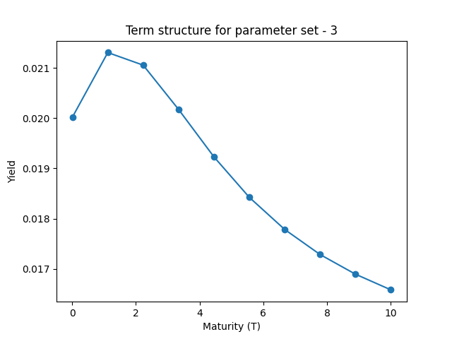

**Term structure for 10 different values of r(0) and 600 time units**

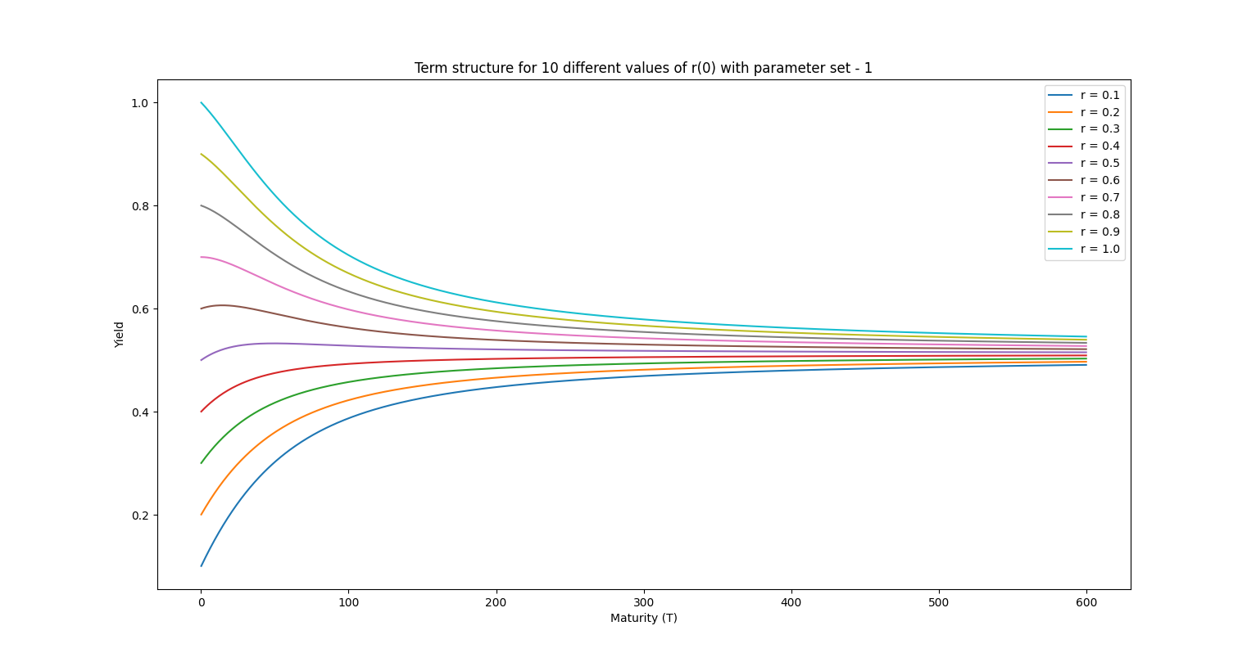

**Observations:**

* Regardless of the value of r(0) chosen, the yield of the bond price converges to a certain value as the maturity term is extended to a high enough number.
* A startling difference in behaviour may be seen in the term structure of parameters set for 10 time units. The yield rises for the first parameter set before convergeing. The yield declines and then converges for the second, but there is a "hump" in the yield curve for the last one.
* The mean reversion from the plots phenomena is seen. This is because the model counts on mean reversion to a level of long-term normal interest rates.