MA374: Financial Engineering Lab10
Sahil Kumar Gupta
200123081

Q1
10 differnet paths of the asset prices generated using GBM model in real world using the differential equation:

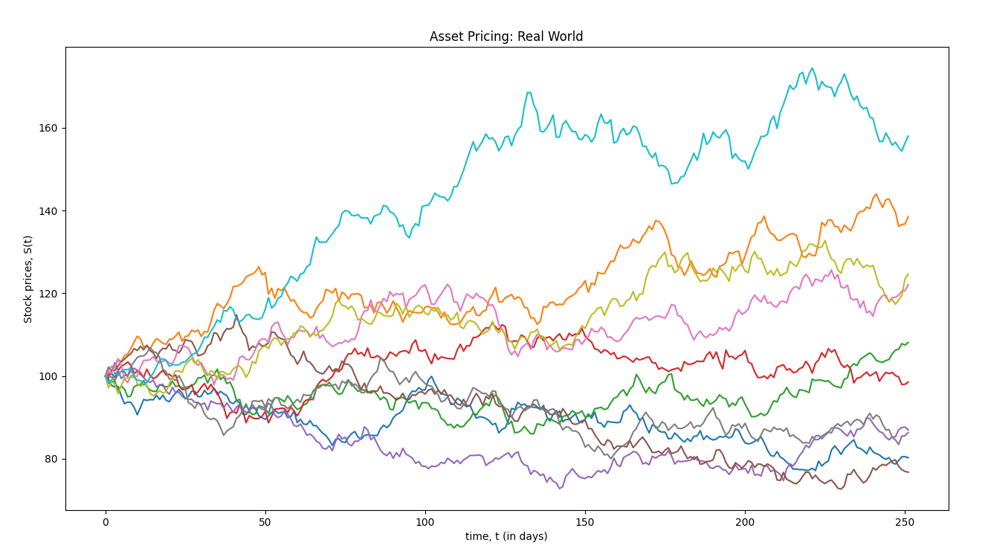

10 differnet paths of the asset prices generated using GBM model in risk-neutral world using the differential equation:

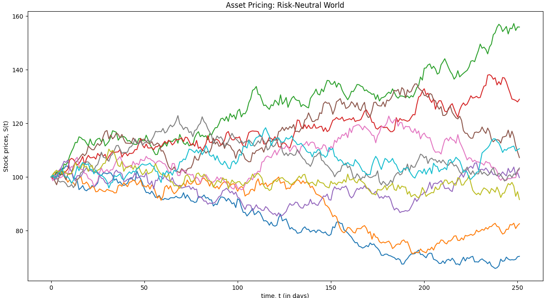
where denotes Brownian Motion in Risk-Neutral Probability measure:
Prices of six month fixed-strike Asian option with different strike prices are as:

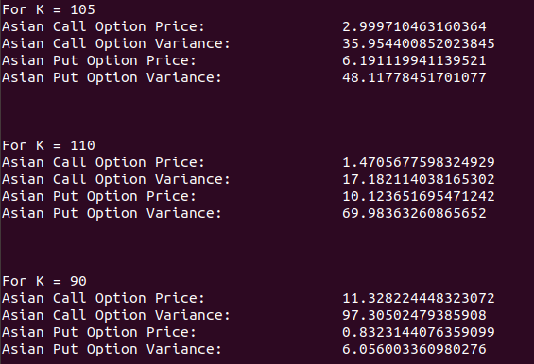

Sensitivity Analysis
- Variation of Asian Option Prices with Stock Price:
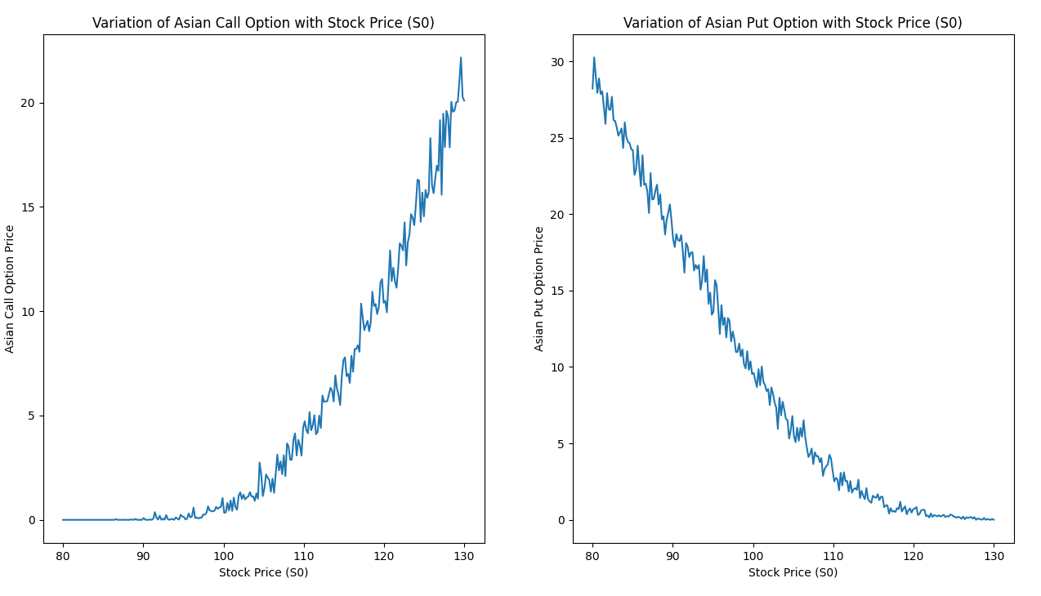
- Variation of Asian Option Prices with Strke Price
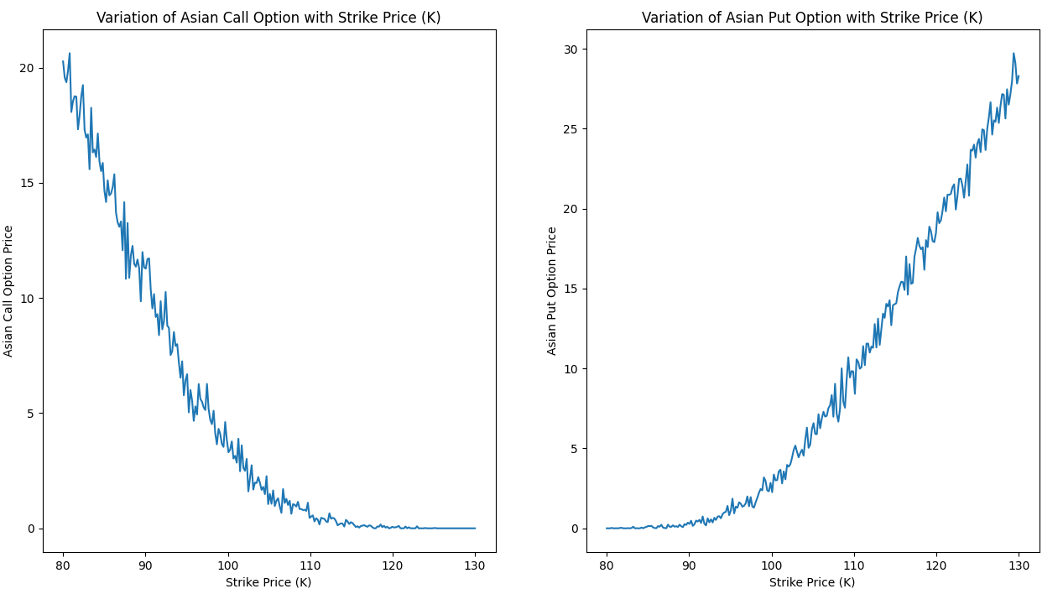
- Variation of Asian Option Prices with Volatility
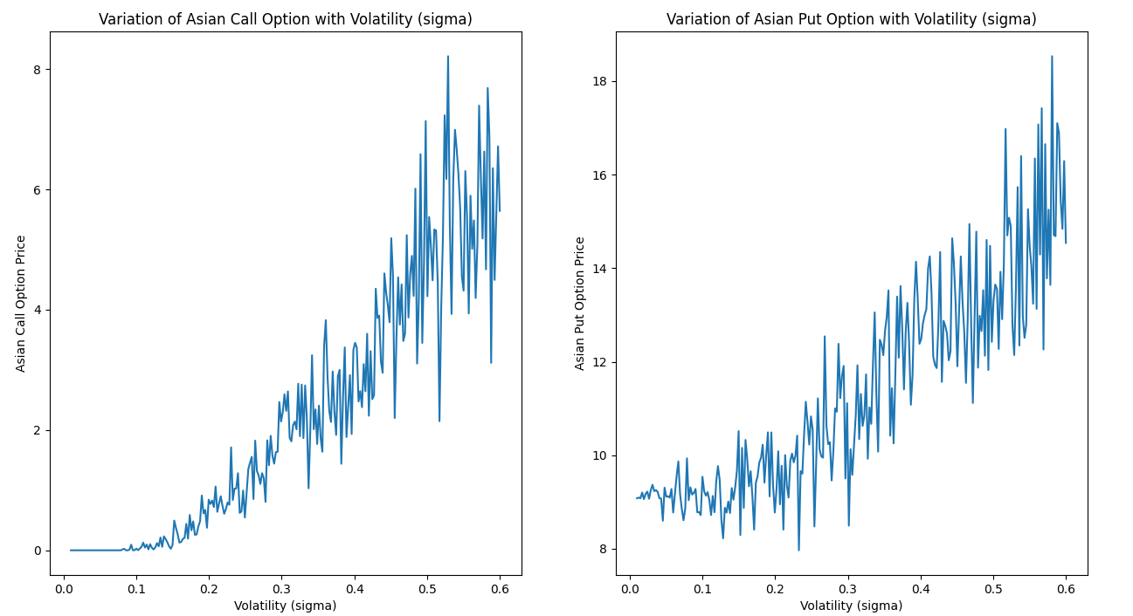
- Variation of Asian Option Prices with r
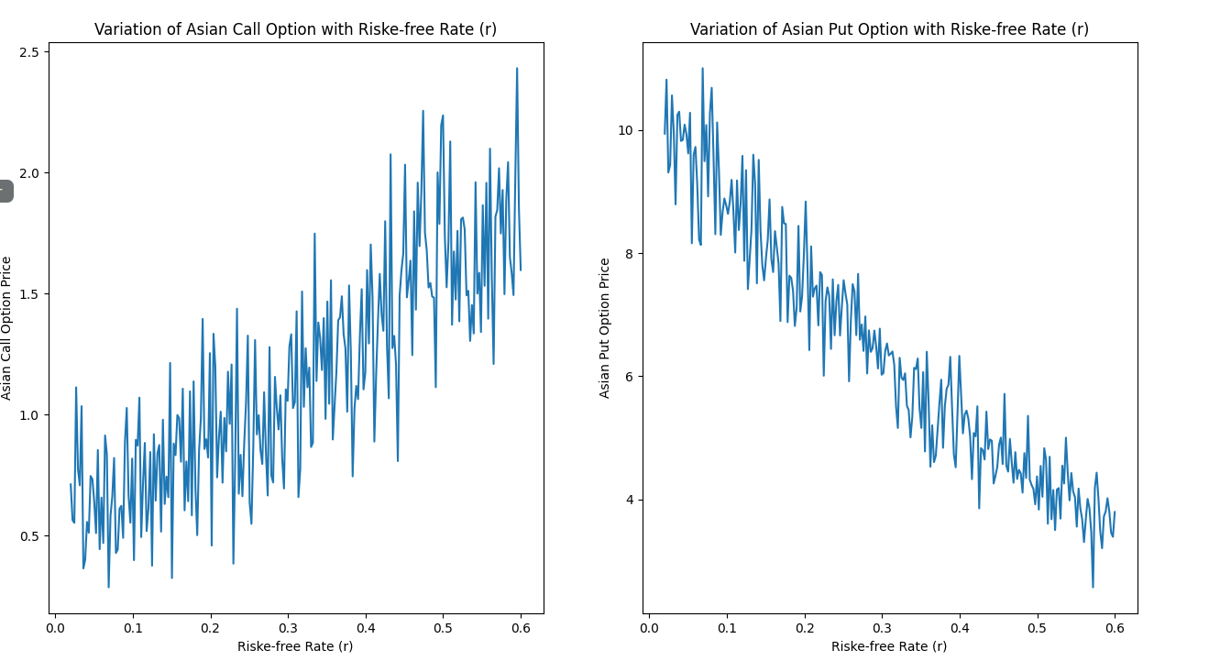
Observations:
- As the original asset price, S0, rises, the price of the call option rises while the price of the put option falls.
- As Strike Price, the price of the call option falls while the price of the put option rises.
- With an increase in the risk-free interest, the price of the call option rises while the price of the put option falls. r
- As volatility rises, the price of both call and put options rises.
- There appear to be some variations in the graphs, which we attempt to reduce in the next question using variance reduction methods
.
Q2

Variance Reduction Technique:

The method of Control Variate is used as a variance reduction tool. This technique uses knowledge about estimation errors in known quantities to minimise estimation errors in unknown quantities.
The prices of European Option Prices are taken as the control variaate here, i.e., for Call Option Prices the payoff max(S(t) – K, 0) and for Put Option Prices the payoff max(K – S(t), 0) is taken as the control variate.

The optimal value of b calculated which minimises the variance of our estimator is:
b_{n} = (∑(X_{i} –)(Y - ))/((Y_{i} –)^2)
Here Yi are outputs from n replications of the simulations and Xi are corresponding output using the control variate.
Using SLLN, we coculde that b* is the required optimal value with bn -> b* with probability 1 and hence using this value we calculate the Control Value Estimator to achieve variance reduction.

The variance reduction value depends on the Correlation of X and Y.

Prices of six month fixed-strike Asian option with different strike prices after performing variance reduction:

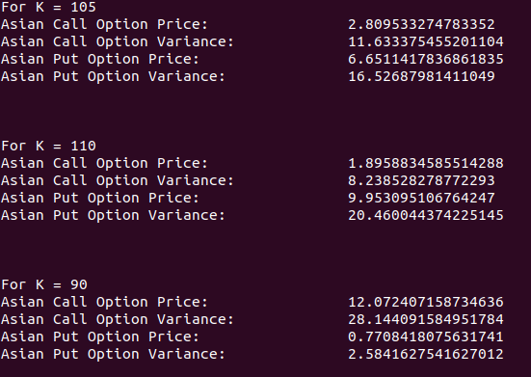

Table to compare the variance:

Strike Price | Asian Call Variance | Asian Call Variance after Variance Reduction | Asian Put Variance | Asian Put Variance after Variance Reduction
105 | 11.633375455201104 | 11.633375455201104 | 16.52687981411049 | 16.52687981411049
110 | 17.182114038165302 | 8.238528278772293 | 69.98363260865652 | 20.460044374225145
90 | 97.30502479385908 | 28.144091584951784 | 6.056003360980276 | 2.5841627541627012

Clearly, we can see that the variance has reduced after applying the variance reduction technique.

Sensitivity Analysis After Variance Reduction:

- Variation of Asian Option Prices with Stock Price:
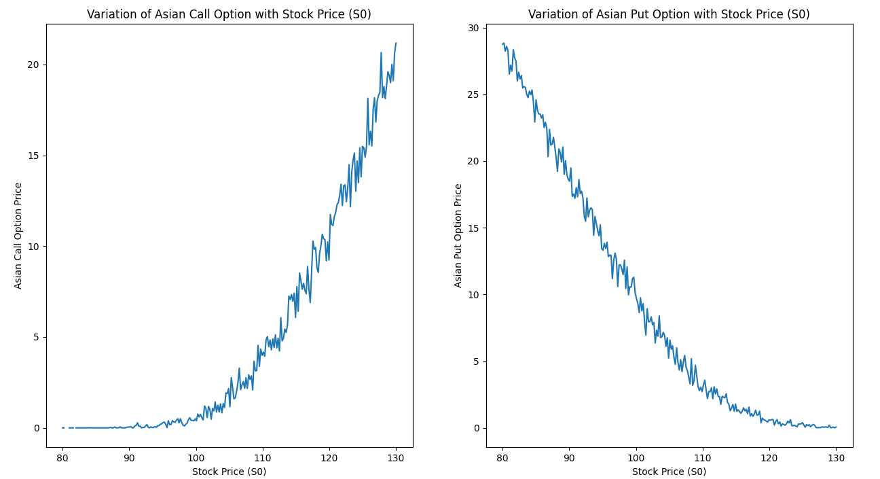
- Variation of Asian Option Prices with Strike Price:
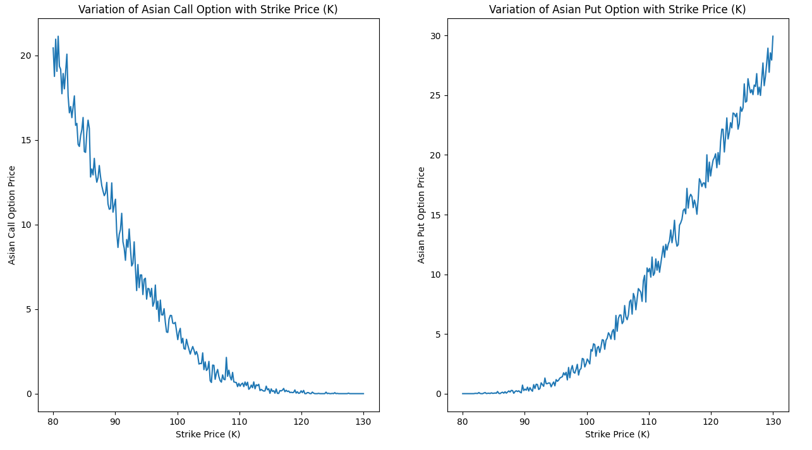

- Variation of Asian Option Prices with Volatility:
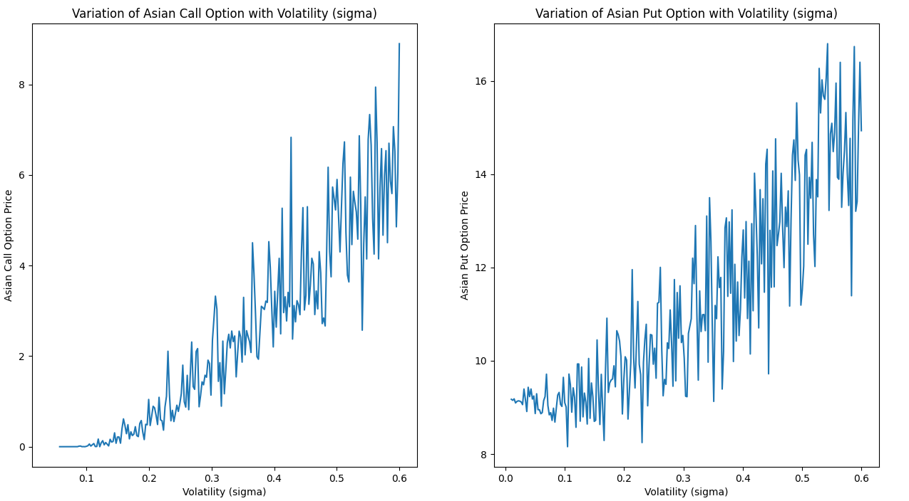
- Variation of Asian Option Prices with Riske-free Rate:
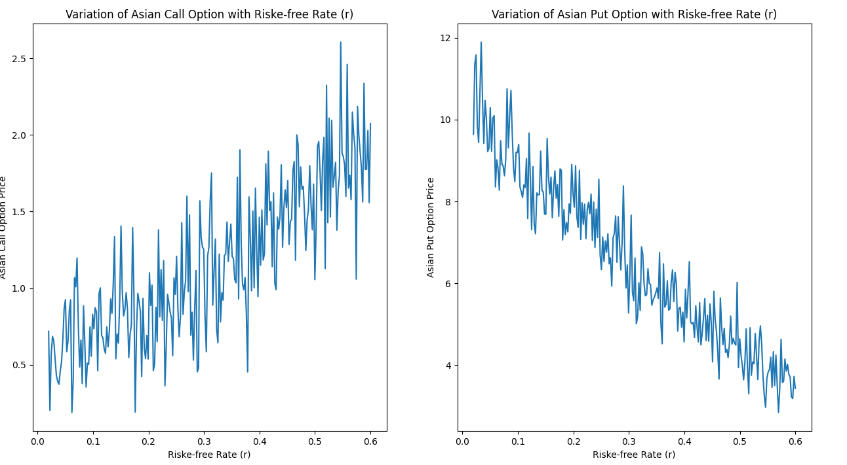
Observations:

Behavior of all the graphs is same as that of the previous question. Other observations made due to the variance reduction technique are as:
- We have previously proven numerically that the variance decrease is accomplished. The plots created further corroborate this assertion.
- After thorough examination, the fluctuations in the graphs appear to be less than when variance reduction was not used. As a result, the plan succeeds.

