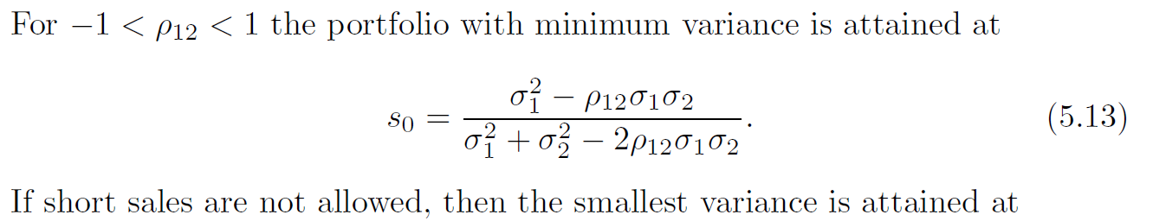

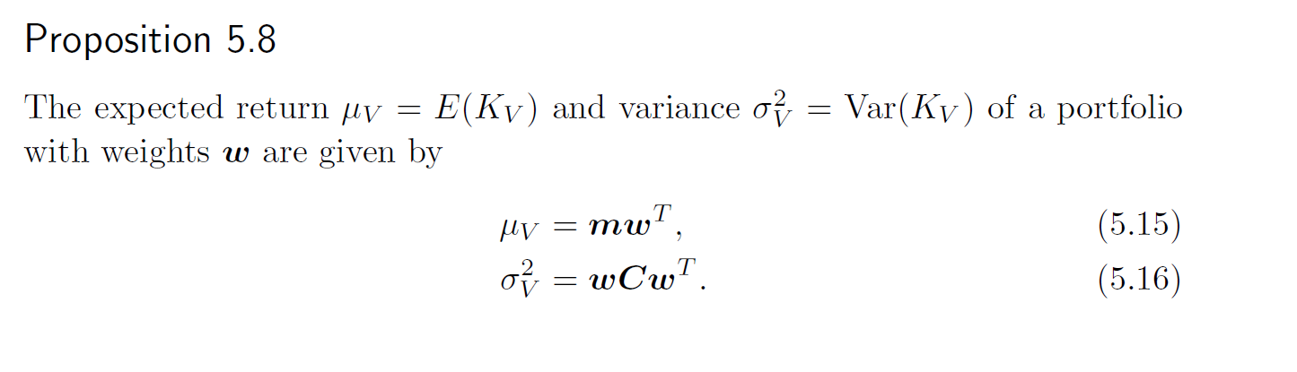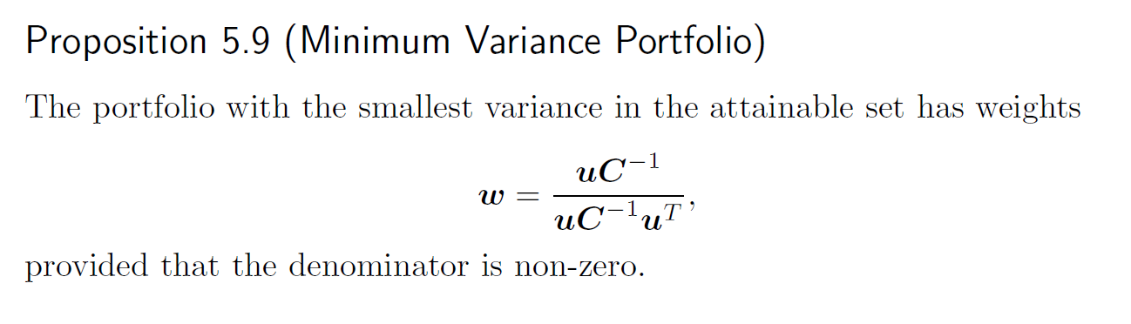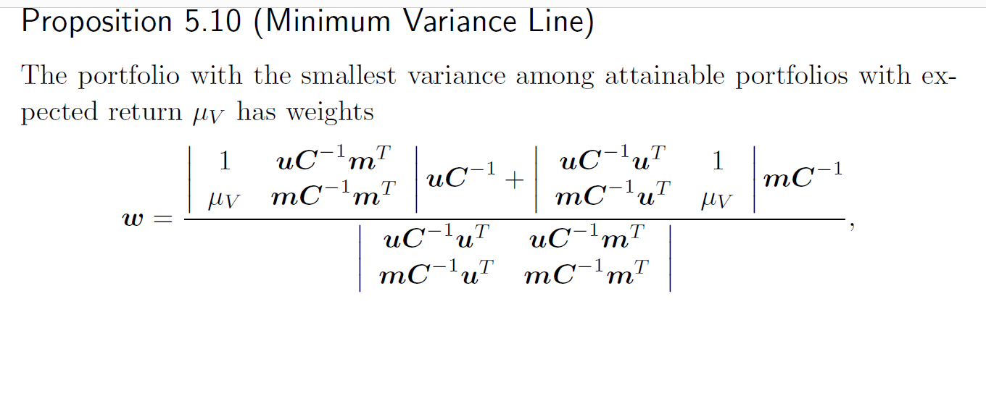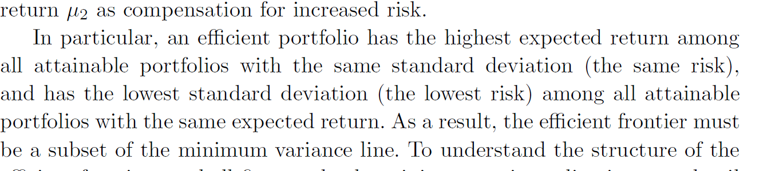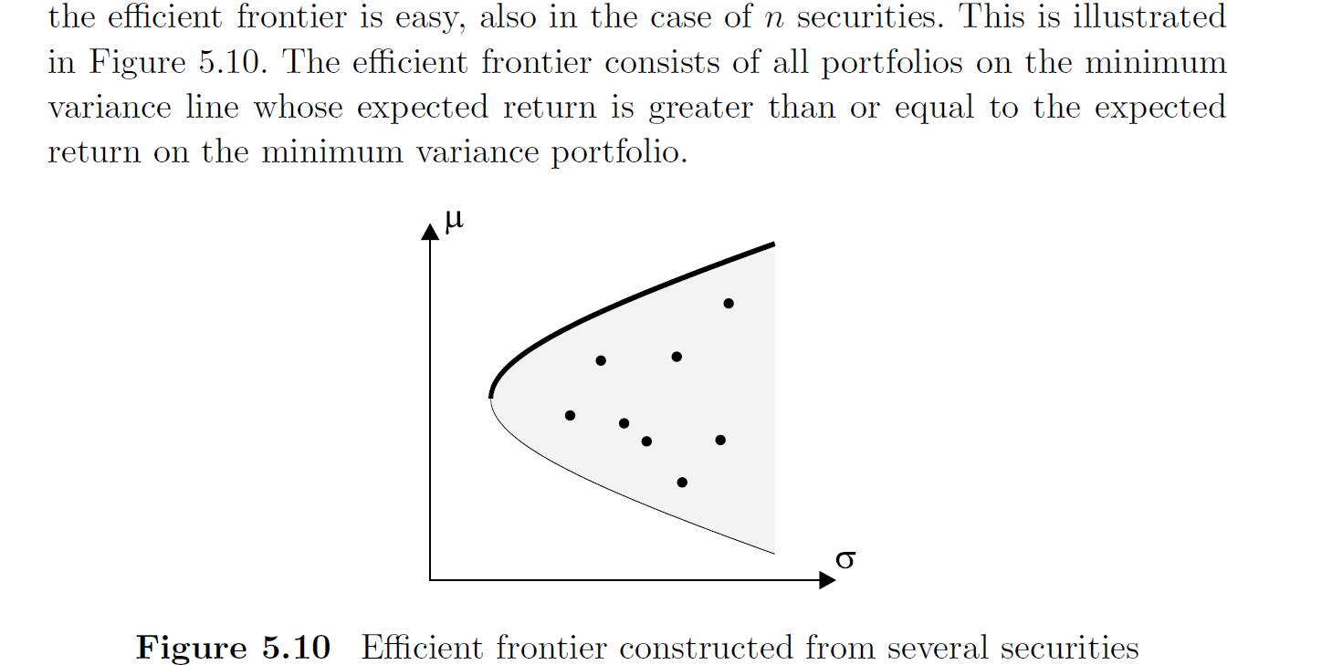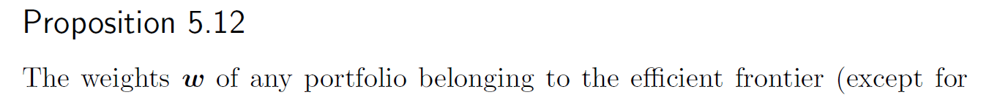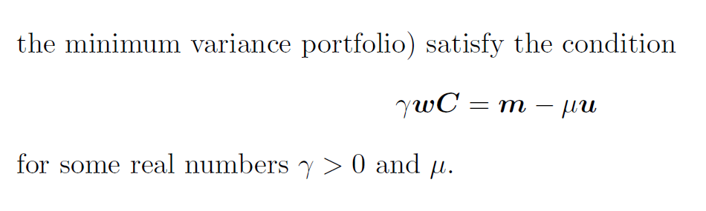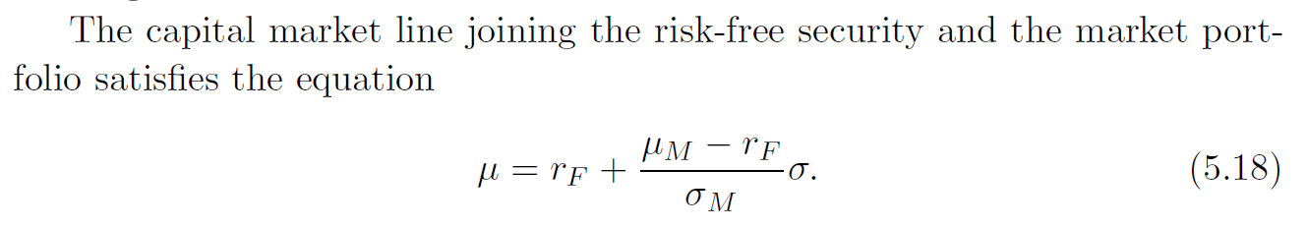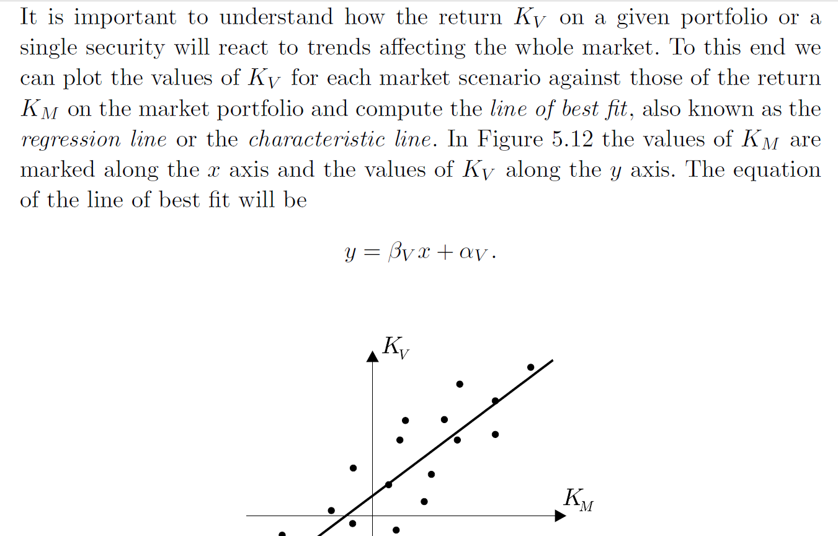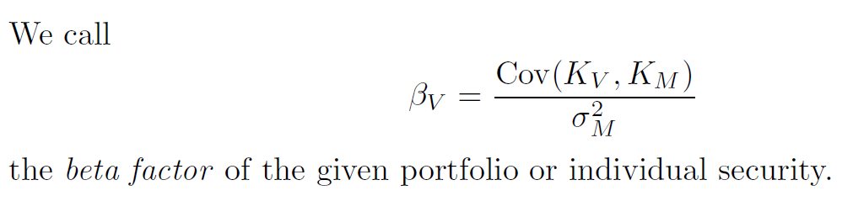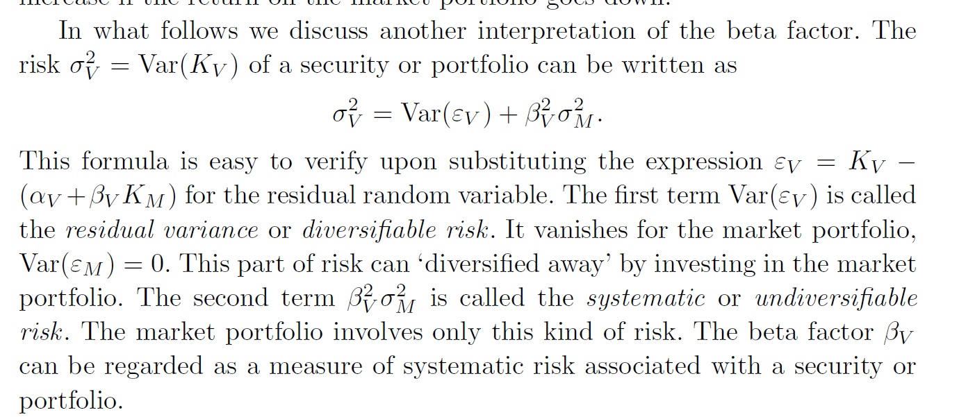



path = format(i, 'b').zfill(M)

  # print(len(path))

  path = path[::-1]

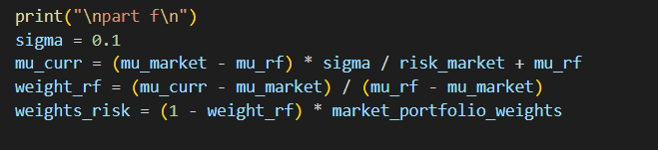

df1.fillna(method='ffill',inplace=True)

    df1.fillna(method='bfill',inplace=True)