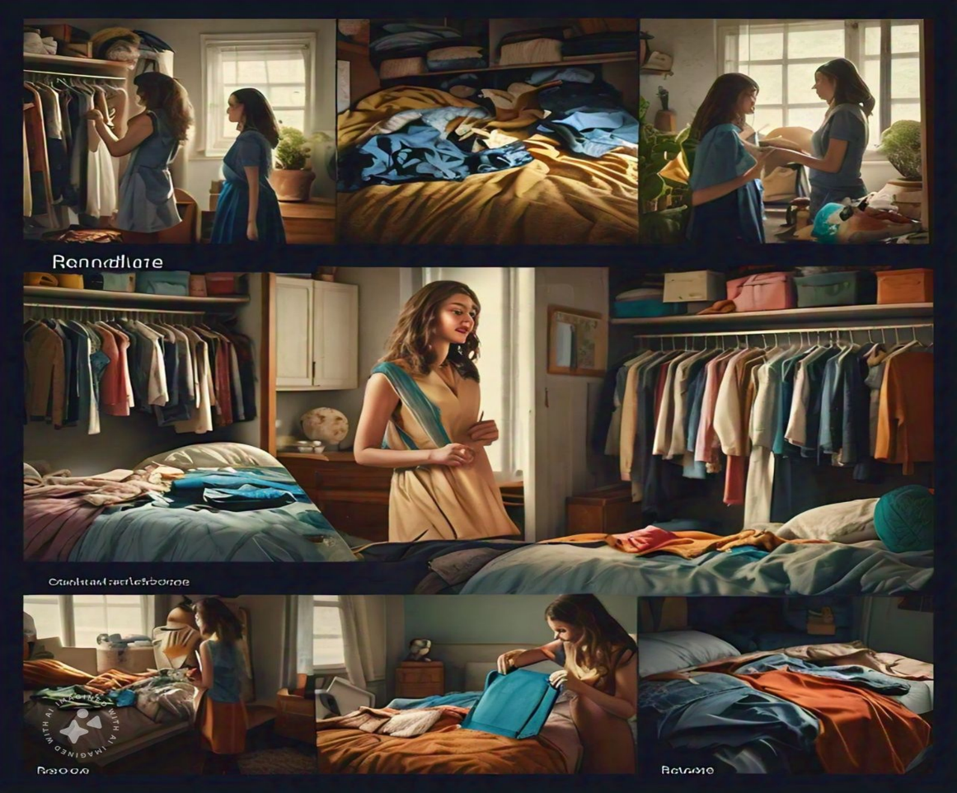 **Fashion that Tells Your Story, Renovare Makes it Possible**

**1. Nostalgic Memories in Old Clothes**  
The scene opens with a customer, Rachel, standing in front of her closet, browsing through old clothes. Her hand lingers on a soft, faded blue dress, her face showing a mix of nostalgia and warmth. A flashback scene shows Rachel wearing the dress at her graduation, laughing with friends. The camera zooms in on Rachel's smile as she remembers this moment. It’s clear this dress is more than just fabric—it's a cherished memory, but it's too old to wear again.

**2. The Realization of Waste**  
As Rachel pulls out more items, the camera pans to show her bed piled with clothes she no longer uses. She sighs, conflicted. These clothes hold stories, yet they’re wasting space. The focus shifts to her expression of helplessness, realizing she doesn't want to throw them away. A close-up of her hands as she places each item back into the drawer reflects her attachment to them, but she knows she needs a solution.

**3. Discovering Renovare**  
Rachel scrolls through her phone one evening and comes across a post about Renovare, a brand that converts old clothes into customizable, personalized accessories like handbags and backpacks. A close-up shot of the Renovare logo and the text “Preserve Your Memories” catches her attention. Curious, she clicks on the website. Her eyes light up with intrigue as she explores the possibilities of turning her old clothes into something new.

**4. Creating a Custom Handbag**  
In her living room, Rachel carefully wraps her blue graduation dress and sends it to Renovare. The camera follows the package as it’s delivered to Renovare’s workshop, showing skilled artisans delicately working on it. Scenes of cutting, stitching, and assembling a handbag from the old fabric are shown in quick succession, highlighting the craftsmanship. A mid-shot of Rachel receiving a message that her custom handbag is ready brings anticipation.

**5. The Reveal of the Reborn Accessory**  
Rachel receives the package from Renovare. As she opens it, her eyes widen with joy. A beautifully crafted handbag, made from her beloved graduation dress, emerges from the packaging. The camera zooms in to capture the familiar fabric reimagined in a new form. She touches it, and we see flashbacks of her wearing the dress at graduation, followed by her admiring her new handbag. The memory is preserved, but now, it’s part of her present.

**6. A Sustainable and Sentimental Future**  
The final scene shows Rachel proudly using her new handbag as she meets up with friends. A voiceover narrates the idea of preserving memories while reducing waste, explaining how Renovare helps customers like Rachel hold onto sentimental moments in sustainable ways. The camera focuses on the Renovare logo with the tagline, “More than Reuse, It’s Memory Reborn,” inviting viewers to join the movement of sustainable and meaningful fashion.

**TEAM MEMBERS:**

1. **Neha Pednekar 22102A0019**
2. **Parth Satvekar 22102A0007**
3. **Sahil Patil 22102A0065**
4. **Jaskirat Singh Banga 22102A0026**
5. **Sarthak Jagtap 22102A0077**
6. **Sanika Dudhal 22102A0008**
7. **Sayali Chavan 22102A0059**
8. **Govind Shukla 22102A0031**