





SUNGKUR&KESSOONATH
Assignment 1 programming Techniques 2
DD
DD

GymPro Manager: Advanced Gym Management System Using Java OOP

Module Name: PROGRAMMING TECHNIQUES 2 Module Code: BCNS2101C,
Student Names: Sungkur Lagnesh,
kessoonath Surakshit
Student ID: 2504_01292, 2504_28537
Course Name: BSC (Hons) Computer Science with Network security Cohort: BCNS/25A/FT,
Lecturer: Mr. Ajit Kumar Gopee
Date Of Submission: 5TH JUNE 2026

Certificate of Originality

This is to confirm that I, Sungkur Lagnesh (Student ID: 2504_01292) and Kessoonath Surakshit (Student ID: 2504_28537) are the authors of this assignment, "Assignment 1," submitted for BCNS2101C Programming Techniques 2. we have not reproduced any part of this work from other sources, unless clearly attributed and referenced.
- All third-party ideas, data, or text used have been cited correctly in line with academic standards.
- I assert that this submission meets all University requirements regarding plagiarism and academic integrity.

© 2025 Sungkur Lagnesh and Kessoonath Surakshit
All rights reserved worldwide.
This document constitutes a partial fulfillment of the academic requirements for the course, BCNS2101C Programming Techniques 2, undertaken with the guidance of Mr. GOPEE Ajit Kumar.
Reproduction, storage in a retrieval system, or transmission of this material in any form or by any means—be it electronic, mechanical, photocopying, recording, or otherwise—is strictly prohibited without the express prior written consent of the author.

TABLE OF CONTENTS

- Introduction ............................................. 5
- Object-Oriented Programming .............................. 6
- Problem Statement ........................................ 7
- Aims and Objectives ...................................... 7
- Scope of the System ...................................... 8
- OOP Concepts Used ........................................ 8
6.1 Encapsulation ........................................ 9
6.2 Inheritance .......................................... 9
6.3 Polymorphism ......................................... 10
- System Features .......................................... 10
- Development Procedure .................................... 11
- UML Diagrams ............................................. 13
9.1 Use Case Diagram ..................................... 13
9.2 Class Diagram ........................................ 23
9.3 Sequence Diagram ..................................... 24
9.4 Collaboration Diagram ................................ 31
9.5 Inheritance Design ................................... 32
- Algorithms and Flowcharts ............................... 37
10.1 Member Registration Algorithm ...................... 37
10.2 Trainer Management Algorithm ....................... 39
10.3 Attendance Recording Algorithm ..................... 41
10.4 Payment Processing Algorithm ....................... 43
10.5 Monthly Income Report Algorithm .................... 45
- Payment Transaction Calculations ........................ 47
- Java Source Code ........................................ 53
- System Testing and Outputs .............................. 54
- Errors Encountered ...................................... 65
- Conclusion .............................................. 68
- References .............................................. 69

GYMPRO MANAGER

Object-Oriented Gym Membership, Trainer, Attendance and Payment Management System.

INTRODUCTION
GymPro Manager is a java console-based application developed using Object-Oriented Programming (OOP) Principles. I have designed the system in a way to automate the gym operations such as the member registration, the trainer management, attendance tracking, payment processing and monthly income reporting. The application uses java collections and java file Handling to permanently store records in text files.

To simplify things, the projects demonstrate important OOP concepts including Encapsulation, Inheritance and Polymorphism. The system also performs calculations such as BMI calculation, discount calculation and monthly income calculation.

1. object-Oriented Programming

What is exactly a Project Oriented Programming?
We learnt before in previous session that an OOP is a programming paradigm which is based on objects and classes. It simply helps us developers to create reusable, secure and organized programs.

The project demonstrates important Object-Oriented Programming concepts such as:
- Encapsulation
- Inheritance
- Polymorphism

So, in this project, Encapsulation is used by making variables private and accessing them using methods.
In addition, Inheritance is used because Member and Trainer inherit from the Person class.
In addition, Polymorphism is used because different classes override the displayInfo() method differently. Abstraction as well demonstrated using the abstract person class.

I have made the application completely in a console-based and does not use databases or GUI components which suit the criteria of the assignment.

2. PROBLEM STATEMENT
What problem we can face in a gym as admin?
Many small gyms still manage their members, trainers, attendance, and payments manually using notebooks or spreadsheets. So.this often creates several problems such as data loss, wrong calculations, poor attendance tracking, difficulty updating records, slow searching, and poor organization of information.
Therefore, I came across this project thinking about the main objective is to design and develop a Java-based Gym Management System that automates gym operations and permanently stores records using text files. Eventually, the system aims to improve efficiency, accuracy, and organization as well within gym management processes.

3.AIMS AND OBJECTIVES
Aim
Our aim is to design and develop an advanced Object-Oriented Gym Management System using Java.

OBJECTIVES
- creating a Java console-based application.
- We will demonstrate Object-Oriented Programming concepts.
- demonstrating encapsulation, inheritance and polymorphism.
- We will use Java Collections such as ArrayList.
- storing data permanently using text files.
- reading data back from files.
- Performing CRUD operations: Create, Read, Update and Delete.
- We will process membership payments.
- Also, calculating BMI.
- Calculating discounts.
- Generating monthly income reports.
- Validating user inputs.
- We will test and debug the system professionally.

4. SCOPE OF THE SYSTEM
The system includes:
- Member management
- Trainer management
- Attendance recording
- Payment processing
- BMI calculation
- Discount calculation
- Monthly income reporting
- File saving
- File loading
- File rewriting
- Validation and error handling
5. OOP CONCEPT USED
Now, I will explain some concepts below which will include in our coding phases.

5.1 Encapsulation
Encapsulation; in a brief explanation, we used that to declare class variables as private and accessing them through getter and setter methods.

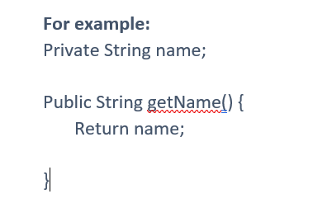

Benefits:
- It protects the data
- It prevents direct across
- It improves security

5.2 Inheritance
In our project, we will use inheritance because Member and Trainer inherit from the person class.

For example:
public class Member extends Person

Benefits we receive:
- It reduces duplication
- It improves code reuse
- It makes the system organized

5.3 Polymorphism
Again here, it is demonstrated through method overriding.



For example:
- It allows different behaviors.
- It improves flexibility.
- Supports reusable code.

6. SYSTEM FEATURES

The following features has been included in our projects which can be shown below:

- Add Member
- View Members
- Update Member
- Delete Member
- Search Member by ID
- Add Trainer
- View Trainers
- Process Payment
- Record Attendance
- Process Payment
- View Payments
- Monthly Income Report
- Automatic ID Generation
- BMI Calculation
- BMI Status
- Discount Calculation
- File Saving
- File Loading
- File Rewriting
- Input Validation (Rules)
- Error Handling
- Console Menu System

7.DEVELOPMENT PROCEDURE

We have carried out the development of the GymPro Manager step by step using the tool V IntelliJ IDEA 2026.1.1.

First, we have created the project folders manually. Then all Java classes and text files were created. Furthermore, we have written the Java source code and compiled using the Java compiler. The application was then executed using the Java console.

We have tested the normal function and error cases. Screenshots were taken during testing. UML diagrams and flowcharts were created using draw.io, and finally the complete report was prepared. Everything will be shown in the upcoming pages of the report.

Development Steps

- Create folders in IntelliJ IDEA 2026.1.1
- Create all .java files
- Create all .txt files
- Paste the source code
- Compile using javac *.java
- Run using java Main
- Test normal functions
- Test error cases
- Take screenshots
- Create UML diagrams
- Create flowcharts
- Prepare report
- Add conclusion
- Prepare viva explanation

8. UML DIAGRAMS
8.1 Use Case Diagram
What is a Use case Diagram?
It simply shows the interaction between the user and the system. It explains what functions the user (who can be us) we will perform in the application. We are called an actor, and the function are called use cases.

Based on our project GymPro Manager, the main actor is the Admin, that is us; we are the admin doing the project and manage members, trainers, payments, attendance and reports.
The diagram below shows all the main services available in the system.

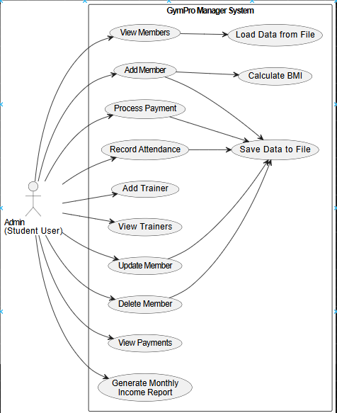
Figure 1 shows the Use Case Diagram of GymPro Manager.
The use case diagram interacts between Admin and the system. The admin which is us student user; we perform operations such as adding members, managing trainers, processing payments and generating reports.

8. Use case Specification
Use case 1 : Add Member
Field | Description
Actor | Admin
Description | Admin enters new member details into the system.
Input | ID, name, age, phone, membership type, weight, height
Process | System creates a Member object and stores it in ArrayList<Member>.
Output | Member added successfully.
Related Classes | Main, GymService, Member, FileManager
Use case 2: View Members
Field | Description
Actor | Admin
Description | Admin views all registered members.
Input | Menu option
Process | System retrieves and displays member records.
Output | Member details displayed.
Related Classes | GymService, Member

Use Case 3: Update Member
Field | Description
Actor | Admin
Description | Admin updates member information.
Input | Member ID and updated details
Process | System searches member by ID and updates the record.
Output | Member updated successfully.
Related Classes | GymService, Member, FileManager

Use Case 4: Delete Member
Field | Description
Actor | Admin
Description | Admin removes a member from the system.
Input | Member ID
Process | System deletes the member record from the list.
Output | Member deleted successfully.
Related Classes | GymService, Member, FileManager

Use Case 5: Add Trainer
Field | Description
Actor | Admin
Description | Admin adds trainer information.
Input | ID, name, age, phone, specialization, salary
Process | System creates a Trainer object and stores it.
Output | Trainer added successfully.
Related Classes | GymService, Trainer, FileManager

Use Case 6: Record Attendance
Field | Description
Actor | Admin
Description | Admin records attendance for members.
Input | Member ID and attendance date
Process | System creates an Attendance object.
Output | Attendance recorded successfully.
Related Classes | GymService, Attendance, FileManager

Use Case 7: Process Payment
Field | Description
Actor | Admin
Description | Admin records member payments.
Input | Member ID, amount, payment method
Process | System creates a Payment object and stores payment information.
Output | Payment processed successfully.
Related Classes | GymService, Payment, MembershipPlan, FileManager

Use Case 8: Generate Monthly Income Report
Field | Description
Actor | Admin
Description | Admin generates the monthly income report.
Input | Month
Process | System calculates total monthly income from payments.
Output | Monthly income report displayed.
Related Classes | GymService, Payment

8.2 Class Diagram
What is a class Diagram?
For the class diagram, it shows the structure of the system. That is; it includes the classes, attributes, methods and relationships between classes. Overall, it shows how the program is organized.

In our project, we implement this concept by dividing the system into different classes such as Member, Trainer, Payment, Attendence, and FileManager. The Member and Trainer classes inherit from the Person class, which therefore show inheritance. Then afterwards, the attributes are private, which shows the encapsulation.
For better understanding, I will provide the class diagram below.

So, below:
Figure 2 shows the Class Diagram of GymPro Manager.
This diagram shows the classes, attributes, methods and relationships used in the system
It also shows the use of inheritance where Member and Trainer inherit from Person.
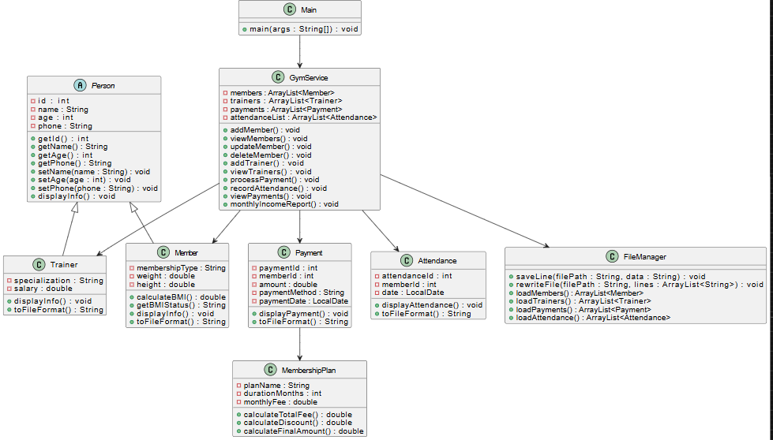
8.3 Sequence Diagram
What is a sequence Diagram?
It simply shows the order of actions between objects. It explains how objects communicate step by step during a process.

According to our project GymPro Manager, the best sequence diagram is Payment Processing because it includes validation, calculation, object creation and file storage.
Note: Person is an Abstract Class

- Main class
main(args : String[]) : void
Here, ill start the system, displays the menu and calls the GymService methods.

- GymService Class
Attributes
members : ArrayList<Member>
trainers : ArrayList<Trainer>
payments : ArrayList<Payment>
attendanceList : ArrayList<Attendance>
The system stores all members, all trainers, all payments, and all attendance records using java collections (ArrayLists).

Methods
- addMember()
- viewMembers()
- updateMember()
- deleteMember()
it manages trainers

Trainer Functions
  - addTrainer()
  - viewTrainers()
It manages trainers

Payment Functions
  - processPayment()
  - viewPayments()
It manages the gym payments.

Attendance Functions
recordAttendance()

Report Function
monthlyIncomeReport()
Calculate gym income

- Person Class (Abstract Parent Class)

Attributes
id : int
name : String
age : int
phone : String
These are common information shared by members and Trainer.

Methods
- getId()
- getName()
- setName()
- displayInfo()
These are getters, setters, and display methods.

- Members Class
This is the class inherits from Person. The arrow pointing upwards means the inheritance.
So:
class Member extends Person

Attributes
- membershipType : String
- weight : double
- height : double

Methods
The BMI Calculation
calculateBMI()
formula: BMI = Weight divide by height^2

BMI Status:
It returns the Underweight, Normal, Overweight

- Trainer class
This class also inherits from Person

Attributes
- specialization : String
- salary : double

- Payment class
It stores payment information
Attributes:
- paymentId : int
- memberId : int
- amount : double
- paymentMethod : String
- paymentDate : LocalDate
This mean:
- Which member has paid
- The amount Paid
- Payment Method
- Date

Methods
- displayPayment()
- toFileFormat()
It is used to show and save payment records.

- Attendance Class
It stores attendance records.
Attributes:
- attendanceId : int
- memberId : int
- date : LocalDate

It tracks which member attended and when.

- MembershipPlan Class
It simply handles gym plans
Attributes
- planName : String
- durationMonths : int
- monthlyFee : double

Example:
Plan Duration Fee
Basic 1 Month Rs 1500
Premium 6 Months Rs 1200

Methods:
- calculateTotalFee()
- calculateDiscount()
- calculateFinalAmount()
Example:
Final Amount = TotalFee -Discount

- FileManager Class

The fileManager is very important for the file handling.
I will use textfile instead of database.

Methods
- saveLine()
- rewriteFile()
- loadMembers()
- loadTrainers()
- loadPayments()
- loadAttendance()

In this class, it saves the records into .txt file and loads records again back into the program.

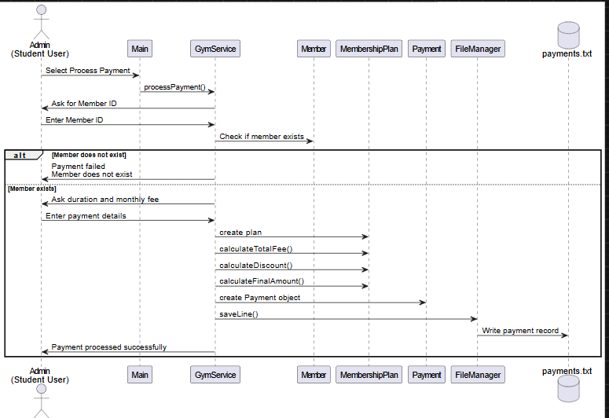
Figure 3 shows the Sequence Diagram for payment processing. This diagram explains the order of messages between objects when a payment is made.
8.4 collaboration Diagram
What is a collaboration Diagram?
It shows how objects work together. It focuses on object communication instead of time order.

So, for the GymPro Manager, different objects work together. The Main class receives the menu choice, GymService controls the logic, and FileManager saves data int text files.

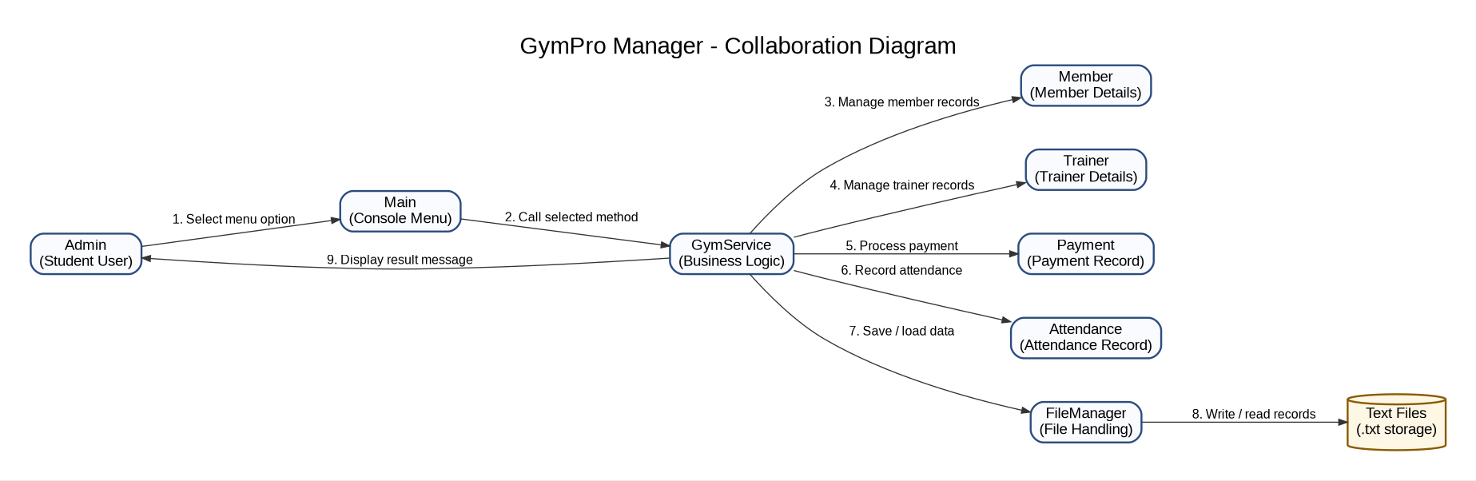
Figure 4 shows the Collaboration Diagram of GymPro Manager. This diagram shows how different objects communicate and work together to complete system operations.
8.5 INHERITANCE DESIGN
So, in diagram below, it shows different types of inheritance.
1 Single Inheritance
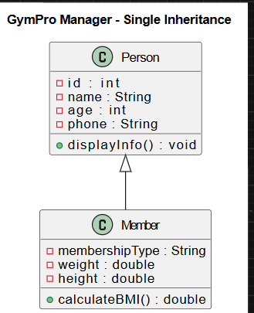
In above screenshot, the single inheritance occurs when one child class inherits from one parent class. So, the Member class inherits common attributes and methods from the Person class.
Eventually, this reduces code duplication and improves reusability because shared features are written once in the parent class and reused by the child class.

2. Multilevel Inheritance
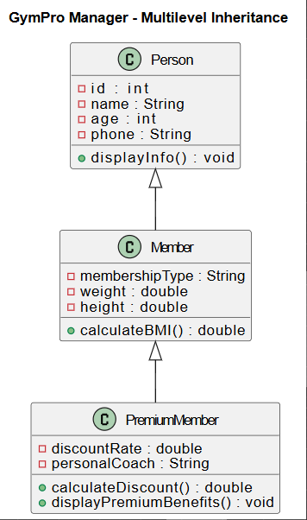
For Multilevel Inheritance, this is when the child class becomes the parent of another class. So, based on the above diagram, PremiumMember inherits form Member, and Member already inherits from Person which therefore creates a three-level inheritance hierarchy.
Example:
Person to Member to PremiumMember
This improves the structure scalability and allows advanced member features such as discounts which I’ve added and personal coaching to be added without modifying the original classes.

3. Hierarchical Inheritance
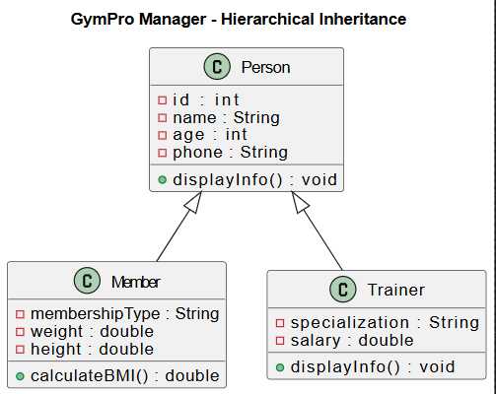
Now, for the hierarchical inheritance, this occurs when multiple child classes inherit form the same parent class. In this diagram, both Member and Trainer inherit from the Person class. The child classes share common information from the parent class while also having their own specific attributes and methods. At the end, it improves the code organization and reusability.

4. Multiple Inheritance
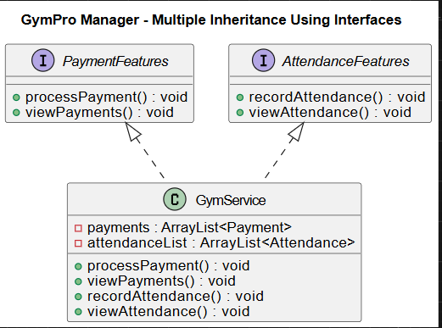

For the above screenshot, we know that Java does not support multiple inheritance classes directly, but it does support it through interfaces. In this diagram, the GymService class implements both PaymentFeatures and AttendanceFeatures interfaces which allows the class to inherit behaviors form multiple sources while avoiding problems found in traditional multiple inheritance

5. Hybrid Inheritance
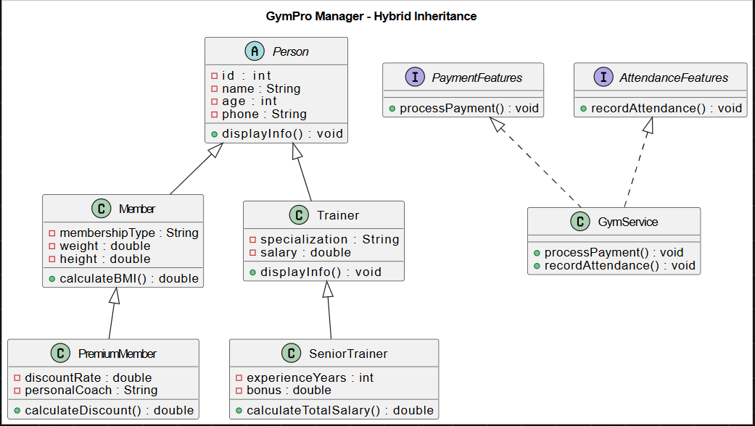

Now, In the above diagram, it combines two or more inheritance types that is; there are a combination of hierarchical inheritance, multilevel inheritance and interface-based multiple inheritance within the same system.
The class Member and Trainer inherit from Person
While, PremiumMember and SeniorTrainer extend the inheritance hierarchy further.
At the same time, Gymservice implements multiple interfaces which creates a flexible and scalable Object-Oriented design for our project GymPro System.

9. ALGORITHM AND FLOWCHARTS
9.1 Member Registration Algorithm
1. Start
2. Generate a unique Member ID
3. Enter member details such as name, age, phone number, membership type, weight and height
4. Validate the entered details
5. If the input is invalid, display an error message and ask the Admin to re-enter the details
6. Create a Member object
7. Add the Member object to the ArrayList<Member>
8. Save the member record permanently into the text file
9. Display a success message
10. End

Flowchart
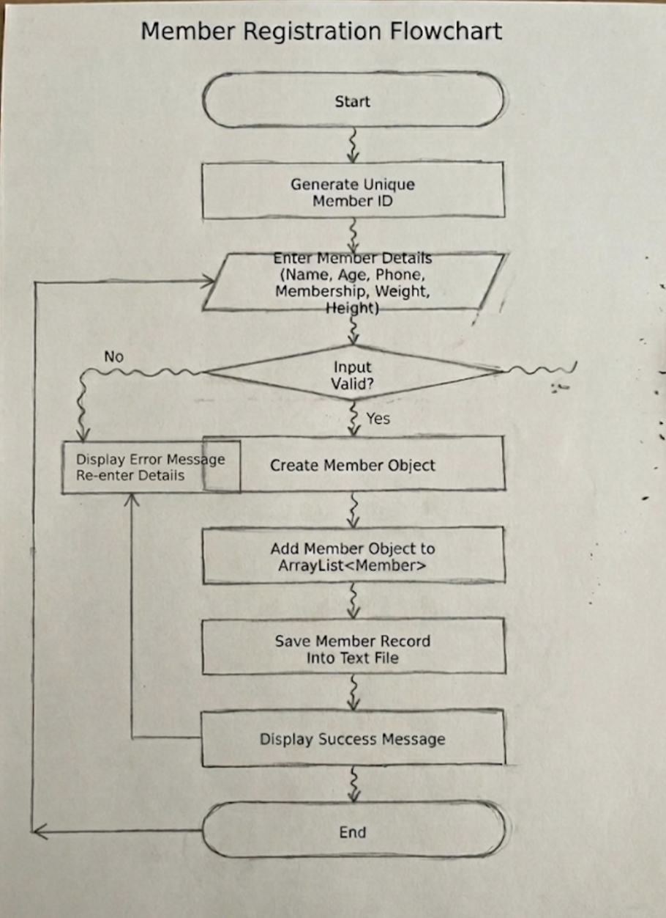

9.2 Trainer Management Algorithm
1.Start
2.Generate a unique Trainer ID
3.Enter trainer details such as name, age, phone number, specialization and salary
4.Validate the trainer details
5.f the input is invalid, display an error message and ask the Admin to re-enter the details
6.Create a Trainer object7.Add the Trainer object to the ArrayList
8.Save the trainer record permanently into the text file9.Display a success message
10. End

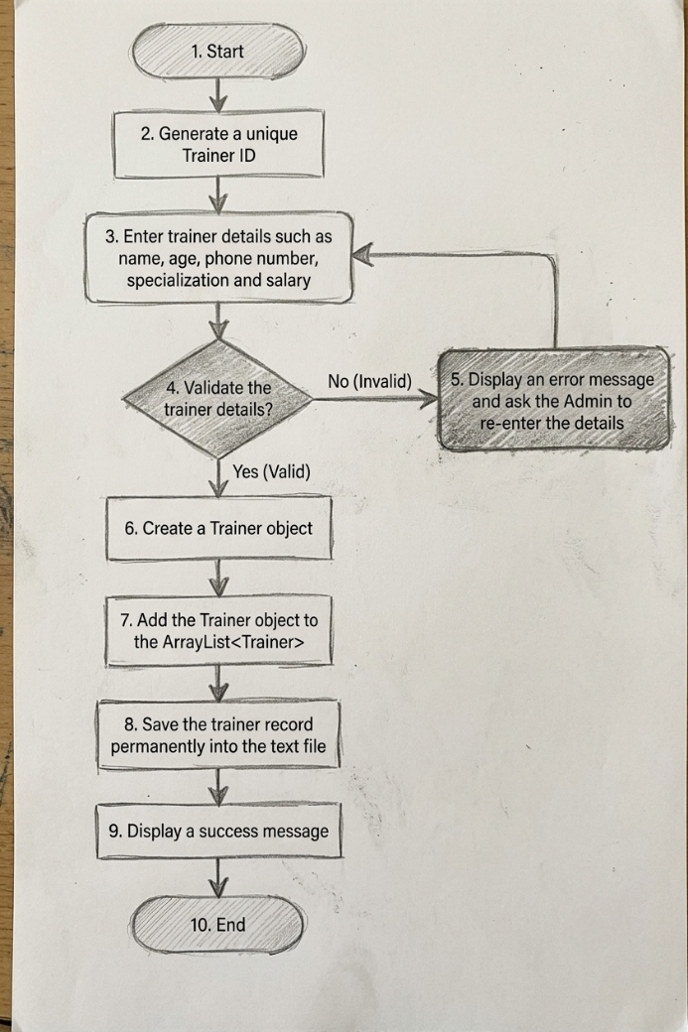
9.3 Attendance Recording Algorithm
- Start
- Enter the Member ID
- Search and validate the Member ID in the member list
- If the Member ID does not exist, display an error message
- Enter or generate the attendance date
- Create an Attendance object
- Add the Attendance object to the ArrayList
- Save the attendance record permanently into the text file
- Display a success message
10. End

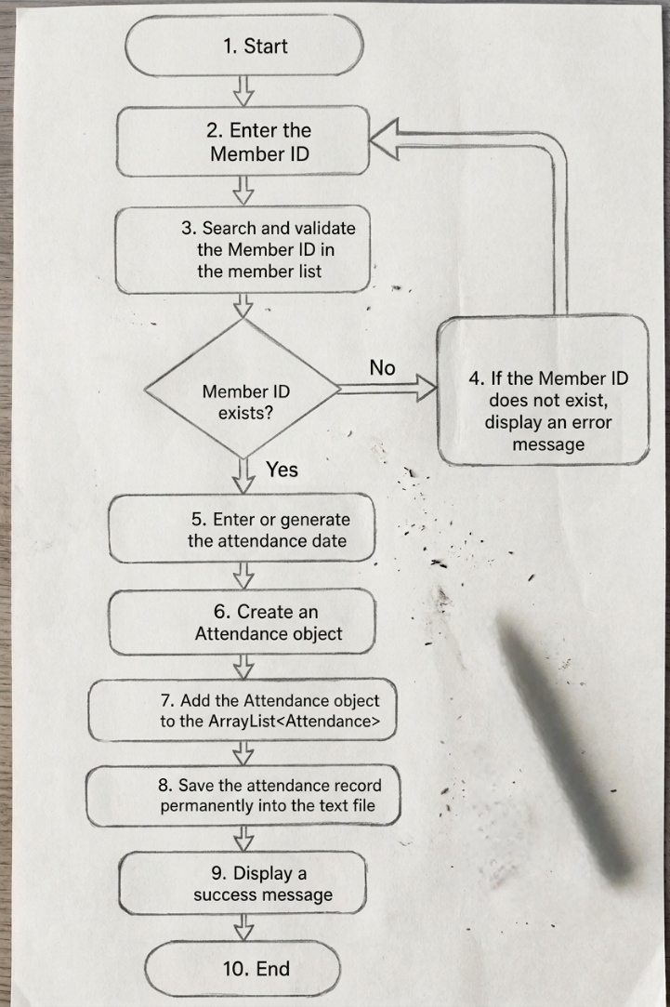
9.4 Payment Processing Algorithm
1. Start
2. Enter the Member ID
3. Validate the Member ID
4. Enter membership duration and monthly fee
5. Calculate the total fee
6. Calculate the discount, if applicable
7. Calculate the final amount
8. Enter the payment method
9. Create a Payment object
10. Add the Payment object to the ArrayList<Payment>
11. Save the payment record permanently into the text file
12. Display a success message
13. End

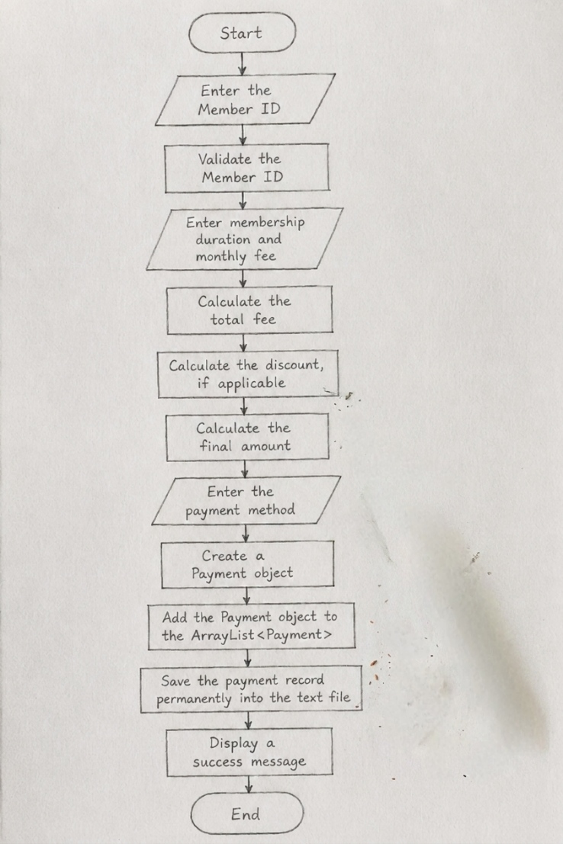
9.5 Monthly Income Report Algorithm
1. Start
2. Enter or select the required month
3. Load all payment records from the payment list or text file
4. Check each payment record one by one
5. If the payment belongs to the selected month, add the amount to the total income
6. Count the number of payments made during the selected month
7. Calculate the final monthly income total
8. Display the number of payments and total income
9. End

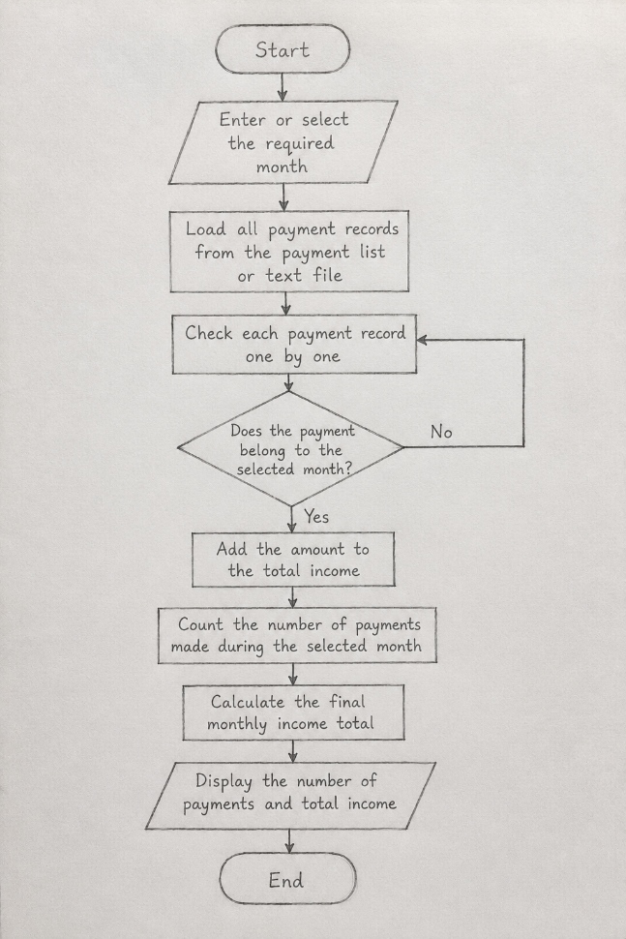
10 PAYMENT TRANSACTION CALCULATION
1. BMI Calculation
What is a BMI calculation?
It means Body Mass Index. It is used to check whether a member has a healthy body weight compared to their height.
Formula:
BMI = Weight/(height x height)
Example:
Weight = 70kg
Height = 1.75 M
Step-by-step:
1.75 × 1.75 = 3.0625
70 / 3.0625 = 22.86
So, the member’s BMI is 22.86.

2. BMI Status
Now, after calculating the BMI, the system will check which category the member belongs to:

There are rules that we have put:
1. Below 18.5 = Underweight
2. 18.5 to 24.9 = Normal
3. 25 to 29.9 = Overweight
4. 30 and above = Obese
In above BMI, we got 22.86. Since 22.86 is in the range of 18.5 to 24.9, the member is classified as Normal.

3. Total Membership Fee
It calculates the full membership price before discount.
Formula used:
Total Fee = Monthly Fee X Number of Months
Example:
Monthly fee = Rs 1000 Months = 12
Calculations:
1000 X 12 = Rs 12000
Therefore, the total membership fee is Rs 12000

4. Discount Calculation
For the discount calculation, the system gives discount depending on the membership duration.
Rules:
12 months or more = 20% discount
6 months or more = 10% discount
Below 6 months = No discount
Example:
Monthly fee = Rs 1000 Months = 12
Since the member chooses 12 months, the discount is 20%
Calculations:
12000 × 20 / 100 = Rs 2400
So, the discount amount is Rs 2400.

5. Final Amount
It is the calculation of the real amount the member must pay after discount.

Formula:
final amount = Total Fee – Discount
Example:
Total Fee = Rs 12000
Discount = Rs 2400

Calculations:
12000-2400 = Rs 9600; so, the amount to pay is Rs 9600

6. Monthly Income Report
It does the calculation about how much money the gym earned in a selected month.

What exactly the system does?
It checks all payments record. If the payment belongs to the selected month and year, the payment amount is added to the monthly income total.

Example:
June 2026 payments:
Rs 9600 + Rs 4500
Step-by-step:
9600 + 4500 = Rs 14100
So, the total income for June 2026 is Rs 14100.

7. Automatic Member ID
For the specific ID, the system automatically generates a new member ID to avoid duplicate IDs.

How it works?
New Member ID = Highest Existing Member ID + 1
Example:
Highest Member ID = 1003

Calculations:
1003 + 1 = 1004
So, the new member ID is 1004.

8. Automatic Payment ID
Here, the system also generates a unique payment ID automatically.

The logic behind:
New Payment ID = Highest Existing Payment ID + 1
Example:
Highest Payment ID = 249

Calculations:
249 + 1 = 250
So, the new payment ID is 3006.

9. Attendance ID
The attendance ID is generated automatically to identify each attendance record clearly.
Example:
Previous attendance count = 4

Logic behind:
The system creates the next attendance ID.

Calculations:
If attendance IDs start from 4001, then:
4001, 4002, 4003, 4004
The next ID will be:
4005
So, the new attendance ID is 4005.

So, overall, in the above calculation, it calculates to demonstrates processing data.

NOTE:
12 months or more = 20% discount
6 months or more = 10% discount
Below 6 months = No discount

11. JAVA SOURCE CODE
Project Structure
Figure 1: Full project structure of GymPro Manager
I have opened IntelliJ and as can be shown below depicting my project folders and sub folders like the data and src.

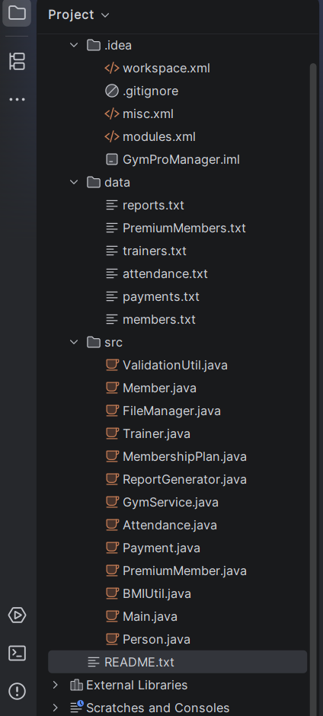

Figure 2 shows the main menu of GymPro Manager.
MAIN MENU
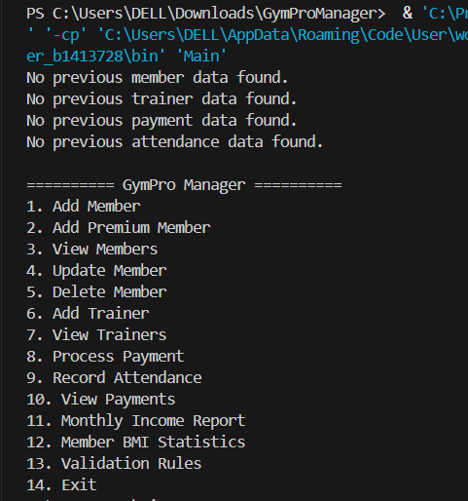

Figure 3: Adding a normal gym member
ADD MEMBER
Below, as can be seen in the terminal, I choose 1 which is add Member, it showed the list of the person information who is my name itself, so that I can be a member in the gym.
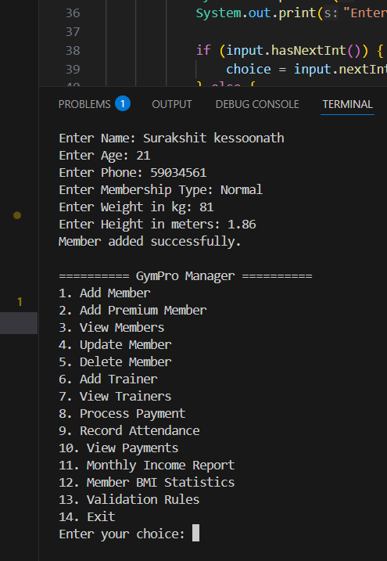

Figure 4: Viewing member details and BMI calculation
VIEW MEMBER + BMI
Now, in the terminal below, I choose 3 which is view Members. It shows the BMI for the new member john which is 22.86 and the BMI status is normal.
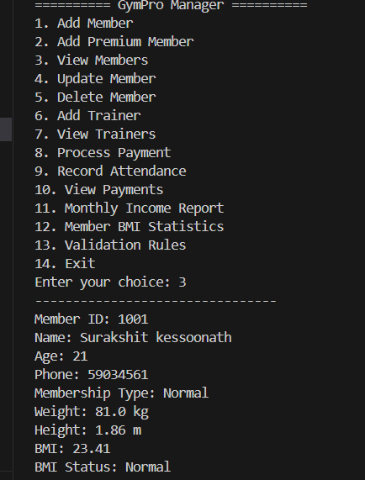

Figure 5: Adding a premium member
ADD PREMIUM MEMBER
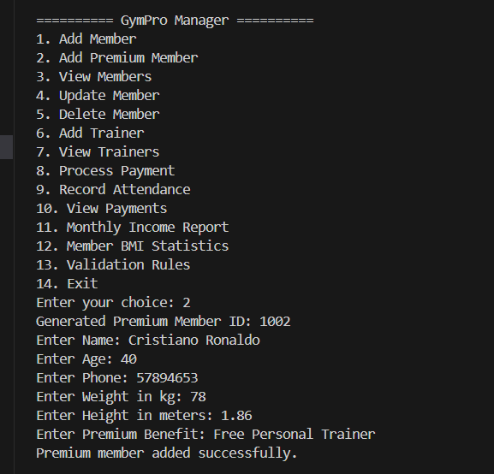

Figure 6: Adding a trainer
ADD TRAINER
Below, show the name of the trainer and I confirmed that the trainer has been added successfully.
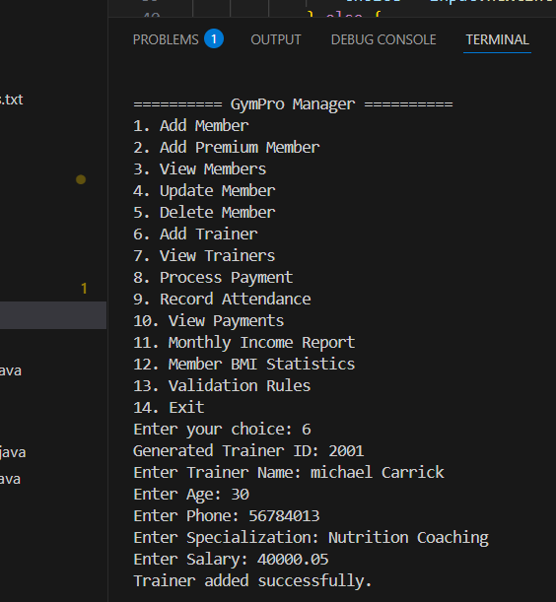

Figure 7: Payment processing and discount calculation
PAYMENT PROCESSING
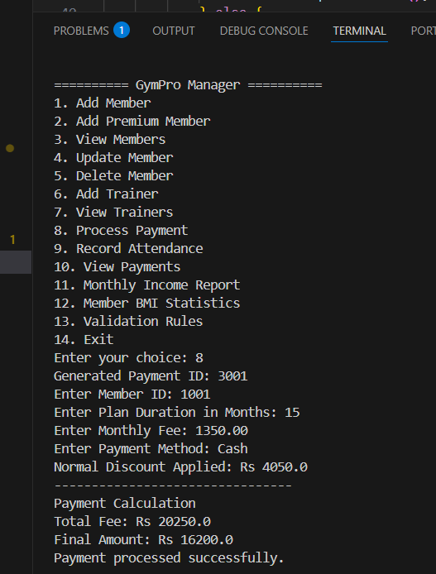
Figure 8: Attendance recording
ATTENDANCE
The attendance is recorded every time, I entered the gym.
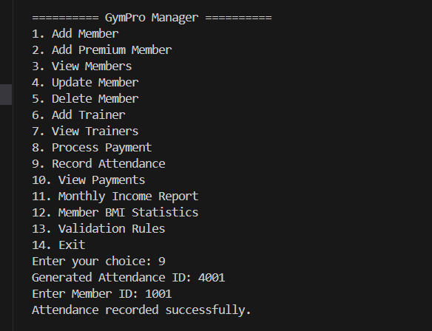
Figure 9: Viewing payment records
VIEW PAYMENTS
This shows all my payment record since day one I joined the gym.
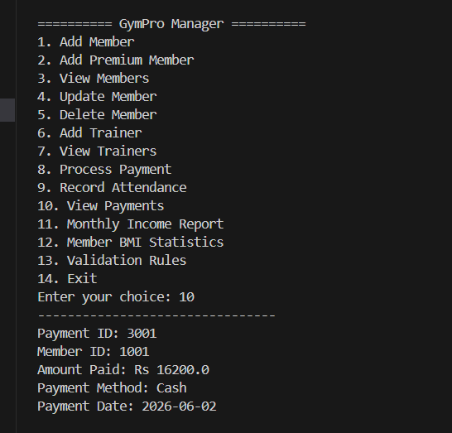

Figure 10: Monthly income report
MONTHLY REPORT
Below, the payment for June 2026 has already been done. To confirm I entered the monthly income report to get the confirmation amount of Rs 16200

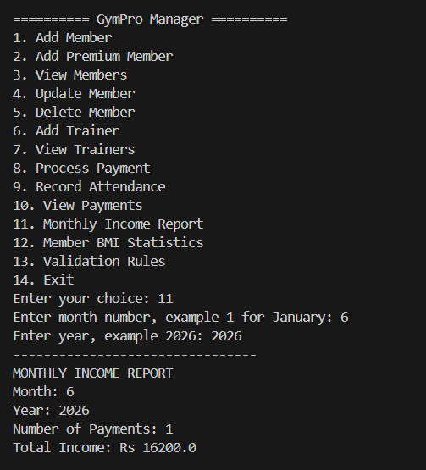
Figure 11: BMI statistics report
BMI STATISTICS
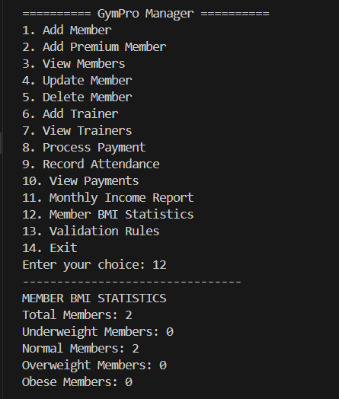

Figure 12: Validation rules display
VALIDATION RULES
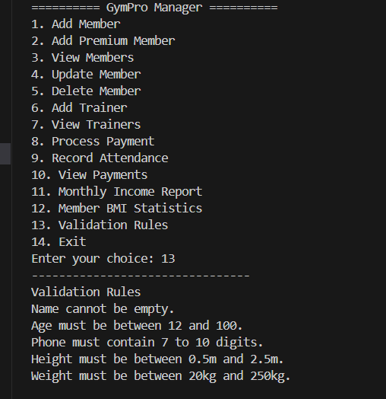

ERROR ENCOUNTERED
When I was doing my coding, I encountered some errors which I have screenshot. I will show one by one below with the mistakes I made in my coding.

ERROR 1: FILE WRITING ERROR
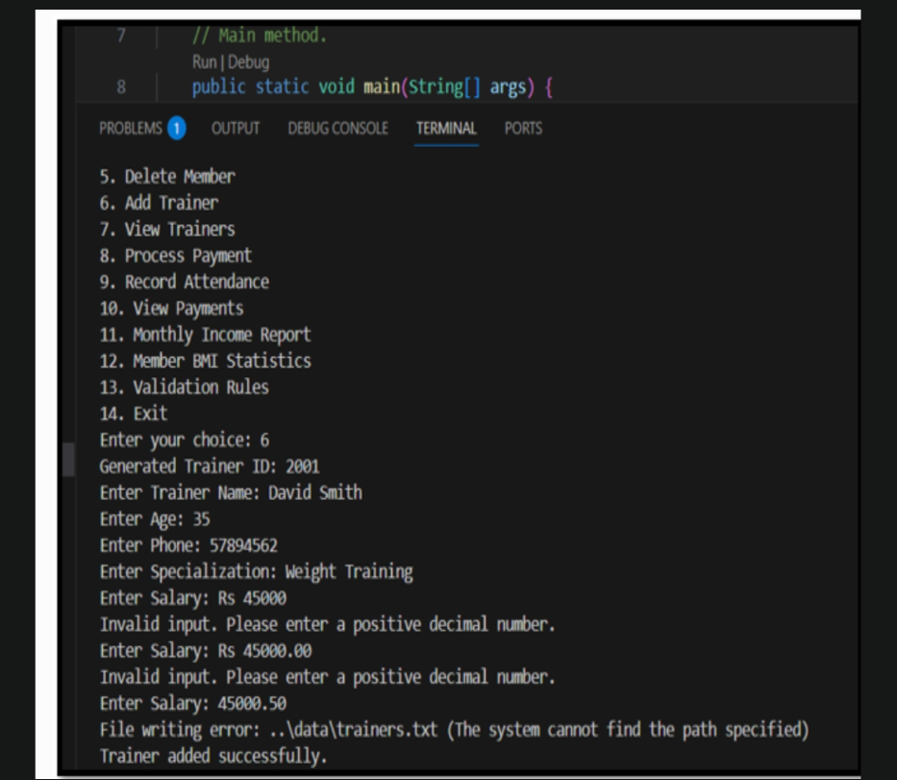

File writing error: ../data/members.txt
The system cannot find the path specified.

During the development, the system could not write member record into the text file because the relative file path was not being located correctly by java
Correction: Then I changed the file path to an absolute path Which allowed the system to save the records permanently.

public static final String MEMBER_FILE =
"C:/Users/DELL/Downloads/GymProManager/data/members.txt";

Error 2: MEMBER ID NOT FOUND DURING PAYMENT

x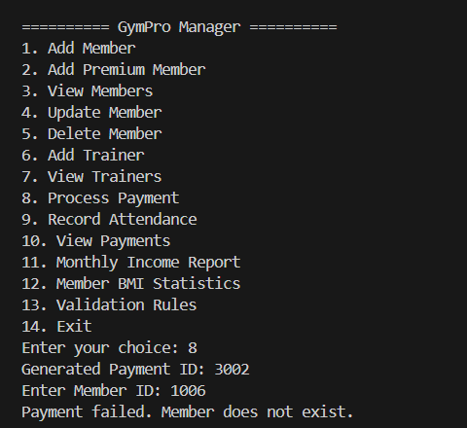
This happened because the member record was not saved correctly into members.txt due to the file path issue. Therefore, when payment was processed using ID 1006, the system could not find the member.

Correction: I corrected the file path, then the member was added again and the record appeared in members.txt

This error showed that payment processing depends on member records. The system correctly prevented payment from being processed for a member that was not found.

ERROR 3: INVALID MENU INPUT
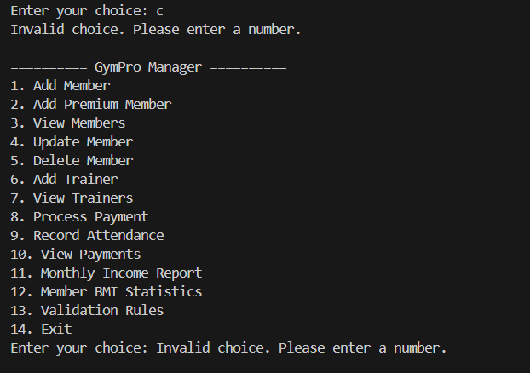
By mistakes, I entered letters instead of a a menu number.
In the system, it uses:
input.hasNextInt(); to check whether the menu input is numeric.
This validation prevents the program from crashing when the user enters text instead of a number.

ERROR 4: Invalid Decimal Input
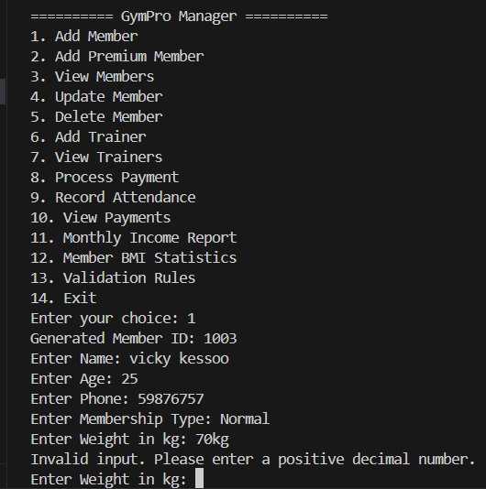

Here, above errors occurs because java expects decimal numbers using a dot, not a comma or text.
Correction: The system hasNextDouble() and repeats the input request until a valid decimal number is entered.

ERRORS 5: Negative Age
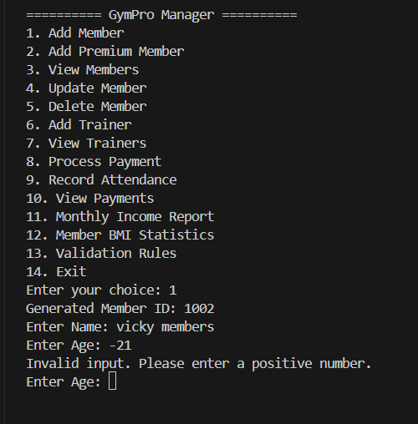

I accidentally pressed negative in my keyboard.
So. Having a negative age is unrealistic and should not be stored.

Correction: age >= 12 && age <= 100
Age validation was added to ensure that only realistic gym member ages are accepted.

TEXT FILE OUTPUT LOCATION
Members.txt
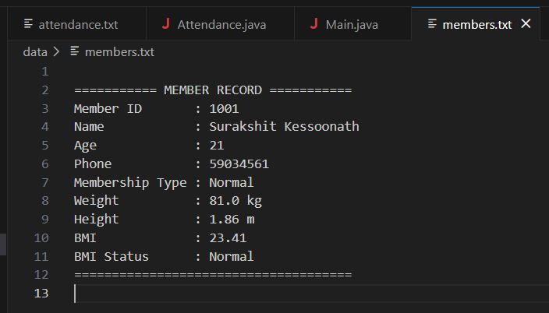

Attendance.txt
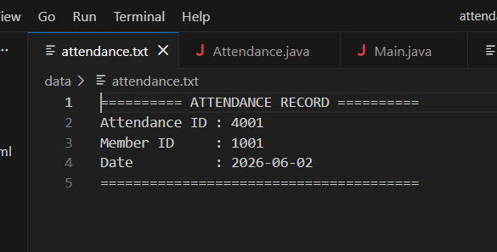
Payments.txt
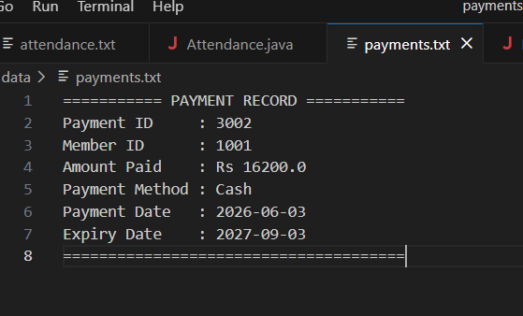

PremiumMembers.txt
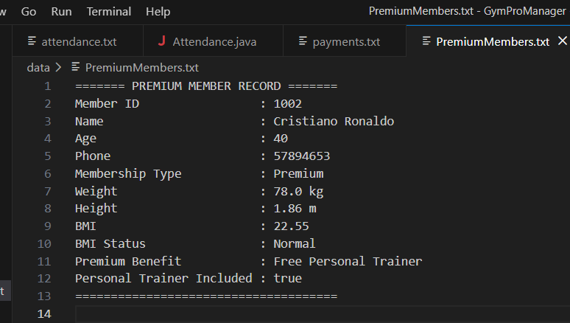
reports.txt

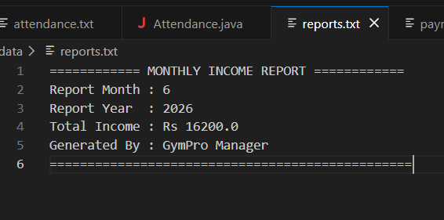

Trainers.txt

