Project Title: G/D Chatbot using Streamlit and Gemini API

Overview

This project is a user-friendly chatbot application built with Streamlit and integrated with

Google's Gemini API (via LangChain). It supports two modes:

General Chatbot: A conversational assistant for everyday questions.

Document Chatbot: Enables users to upload documents (PDF, DOCX, CSV, etc.) and ask context-specific questions based on the content.

Key Features

Dual Modes: General conversation and document-based Q&A.

Multi-File Support: Processes TXT, PDF, DOCX, CSV, and JSON files.

Interactive UI: Clean chat interface with structured message display.

Contextual Memory: Retains recent conversation history for coherent responses.

Natural Language Processing: Powered by Gemini 2.0 via LangChain.

Streamlit-Based GUI: Browser-accessible with no user installation required.

Technologies Used

Tech/Library | Purpose
Python | Core development
Streamlit | UI/web app framework
LangChain | Chat memory & Gemini model integration
Gemini API | AI language model for responses
PyMuPDF (fitz) | PDF text extraction
python-docx | DOCX file handling
Pandas | CSV data processing
YAML | API key configuration management

UI Highlights

Structured chat bubbles for user and bot messages.

Avatar icons for visual distinction.

Sidebar file uploader for document mode.

Clear mode selection for seamless user experience.
How It Works

General Chatbot Mode

User submits a message.

Recent conversation history + new query are sent to Gemini.

Response is displayed in a structured chat format.

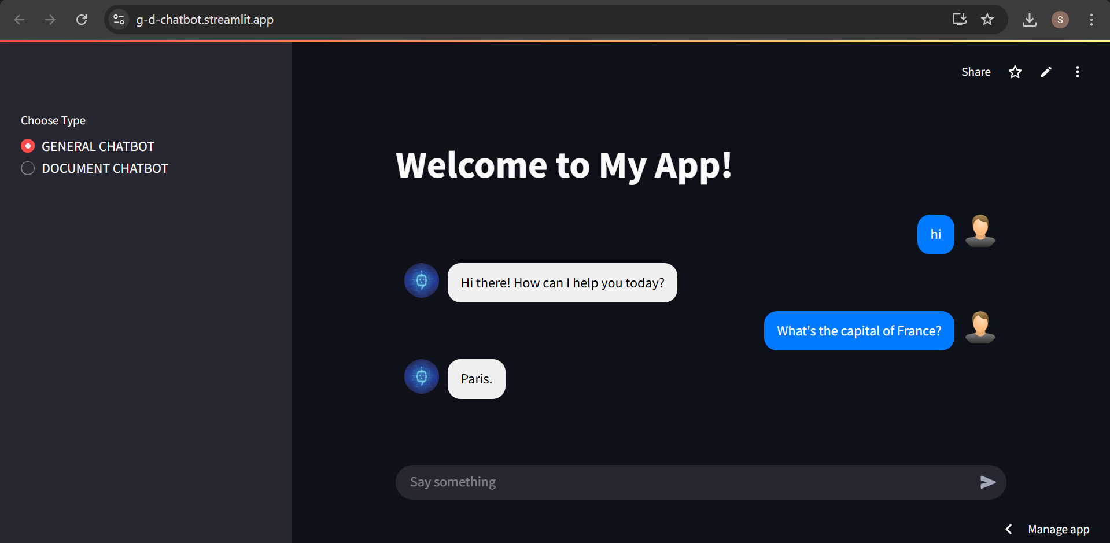

Document Chatbot Mode

User uploads a supported file (PDF, DOCX, etc.).

Content is extracted and processed.

User queries are answered based on the document's content.

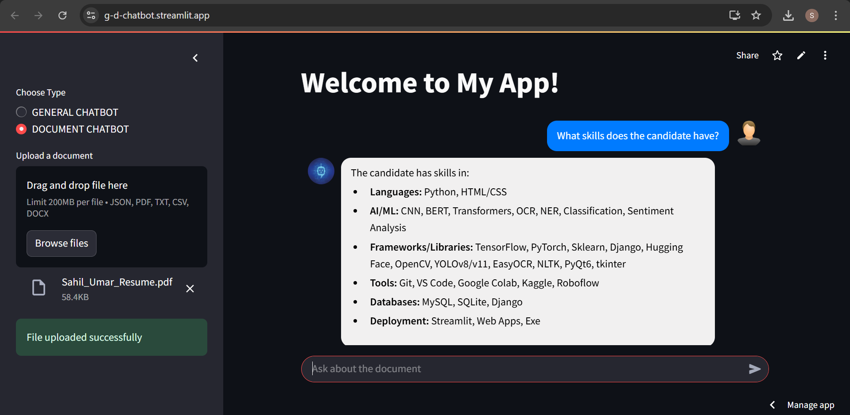

File Support & Processing

File Type | Processing Method
.txt | Direct text reading
.csv | Loaded as DataFrame, displayed as table
.json | Parsed and formatted
.pdf | Text extracted using PyMuPDF
.docx | Paragraphs read via python-docx

Sample Use Cases

General Chatbot:

Input: "What's the capital of France?"

Output: "The capital of France is Paris."

Document Chatbot:

Upload: Resume (PDF)

Input: "What skills does the candidate have?"

Output: "The candidate has Python, ML, and Data Analysis skills."

