LOGO

**Project Proposal**

**Advance Furniture**

ABOUT ADVANCED FURNITURE

In 2017, we started Advanced Furniture with a vision - to make a million homes beautiful. Back then, our catalogue featured just 35 designs. Yet, when our customers shared photographs of their homes, we saw they were remarkably distinct. The same table, the same chair was used differently by different people. This told us something. People want their homes to be unique. We also realized that people are a lot happier creating things than they are buying things. We are a creative, imaginative, expressive species. And our homes are just one of the many canvases we have at our disposal. Today, we understand that we’re here not just to sell well-designed products. We’re here to help you create spaces that mirror who you are. At Advanced Furniture, we want you to discover the joy of creating. Starting with your home. We want you to think of the setting up of a space as an energizing, creative pursuit. To breathe life into empty rooms with your ideas. To take a few square feet of nothing, and transform it into something beautiful.\

# Project Goals

Project is storing details of furniture, sales and stock in the database used for various purposes like that keeping track of stock and many more things

# Project Objectives

To Keep record of all products and show them to customers so that they can have a look of products before coming to store.

# Project Scopes

To turn this site big level adding purchase functionality in the project

# Project Milestone

|  |  |
| --- | --- |
| Made design | 2 days |
| Finalized UI design | 1day |
| Functionality working | 1day |
| Documentation | 4 hours |

# Admin Secure

Admin Login have access to add furniture for the website

# Id : Admin123@gmail.com

# Password: Password12

# Following pages will be added in the site (Admin)

## Clicking On Add Furniture

## Furniture Page

## Admin can delete update these added furniture

# User Side

## Can View Products

## Can view detail view of Products

## Can add contact form

All the new furniture that we have added on site are will shown to page from database

Wireframes

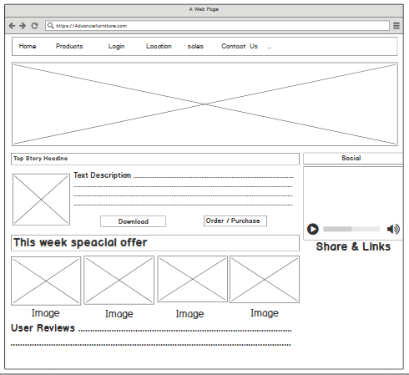

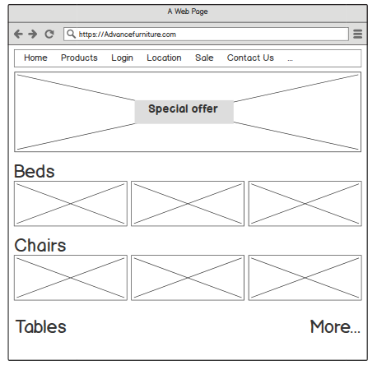

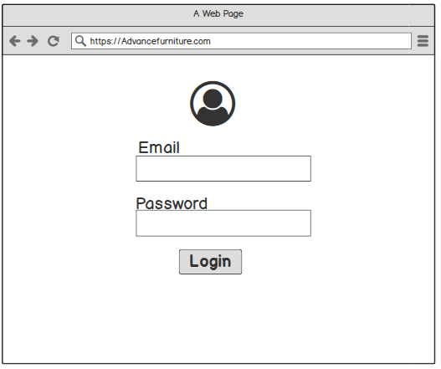

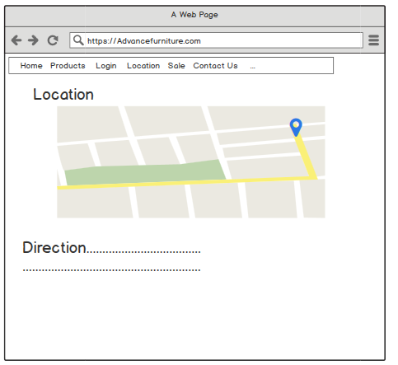

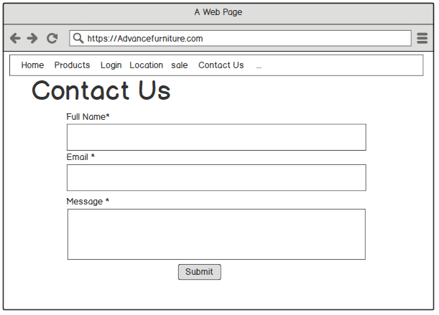

# Final Pages

# 

# 

# Admin Login

# Admin Dashboard

# 