**Lab #3**

**Enterprise Cloud Computing**

Step 1:

Create user account in AWS:

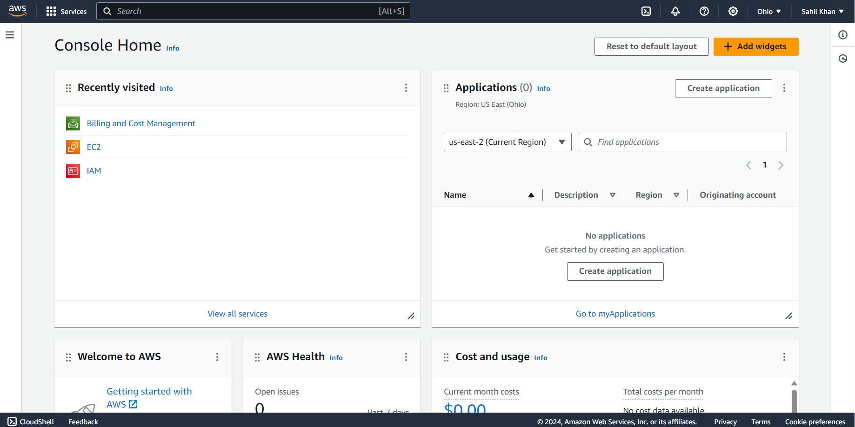

Step 2:

Create an IAM account in AWS:

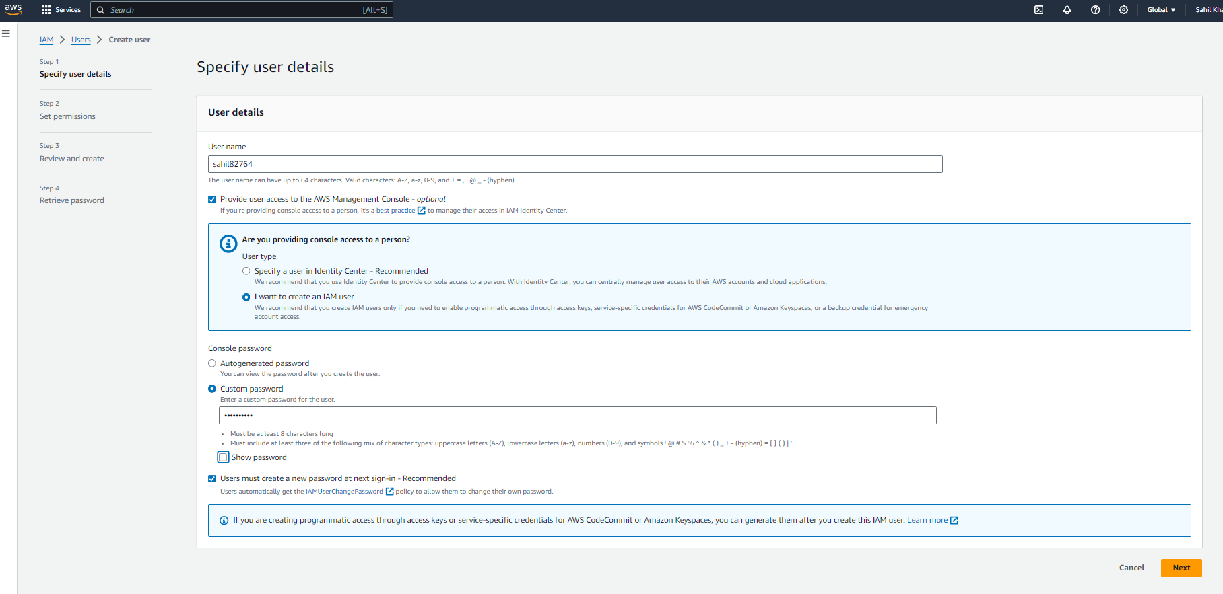

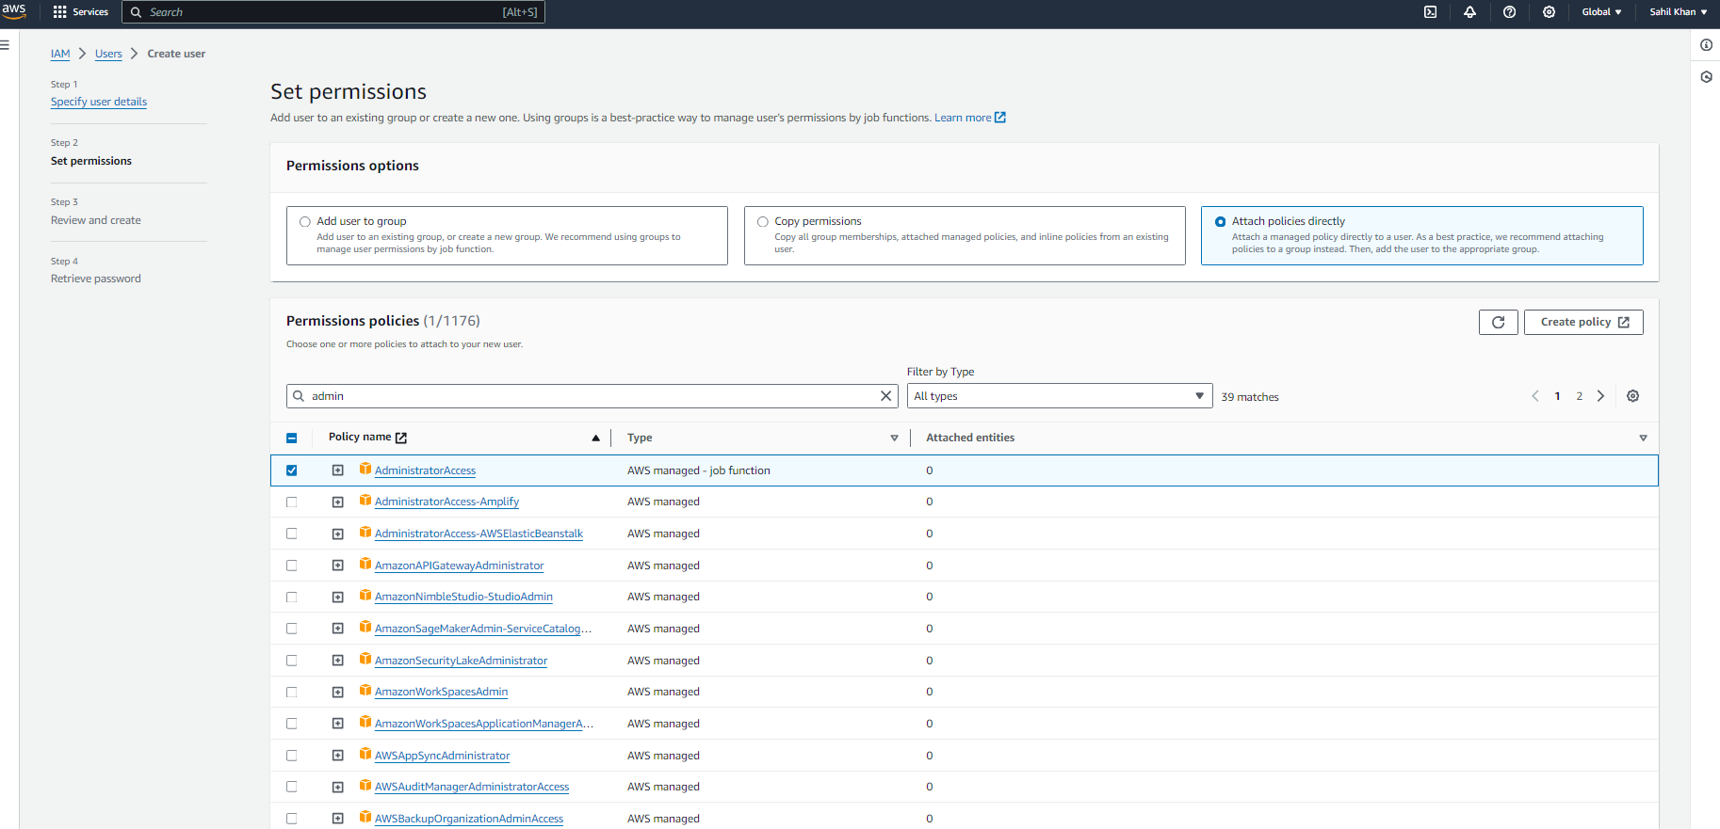

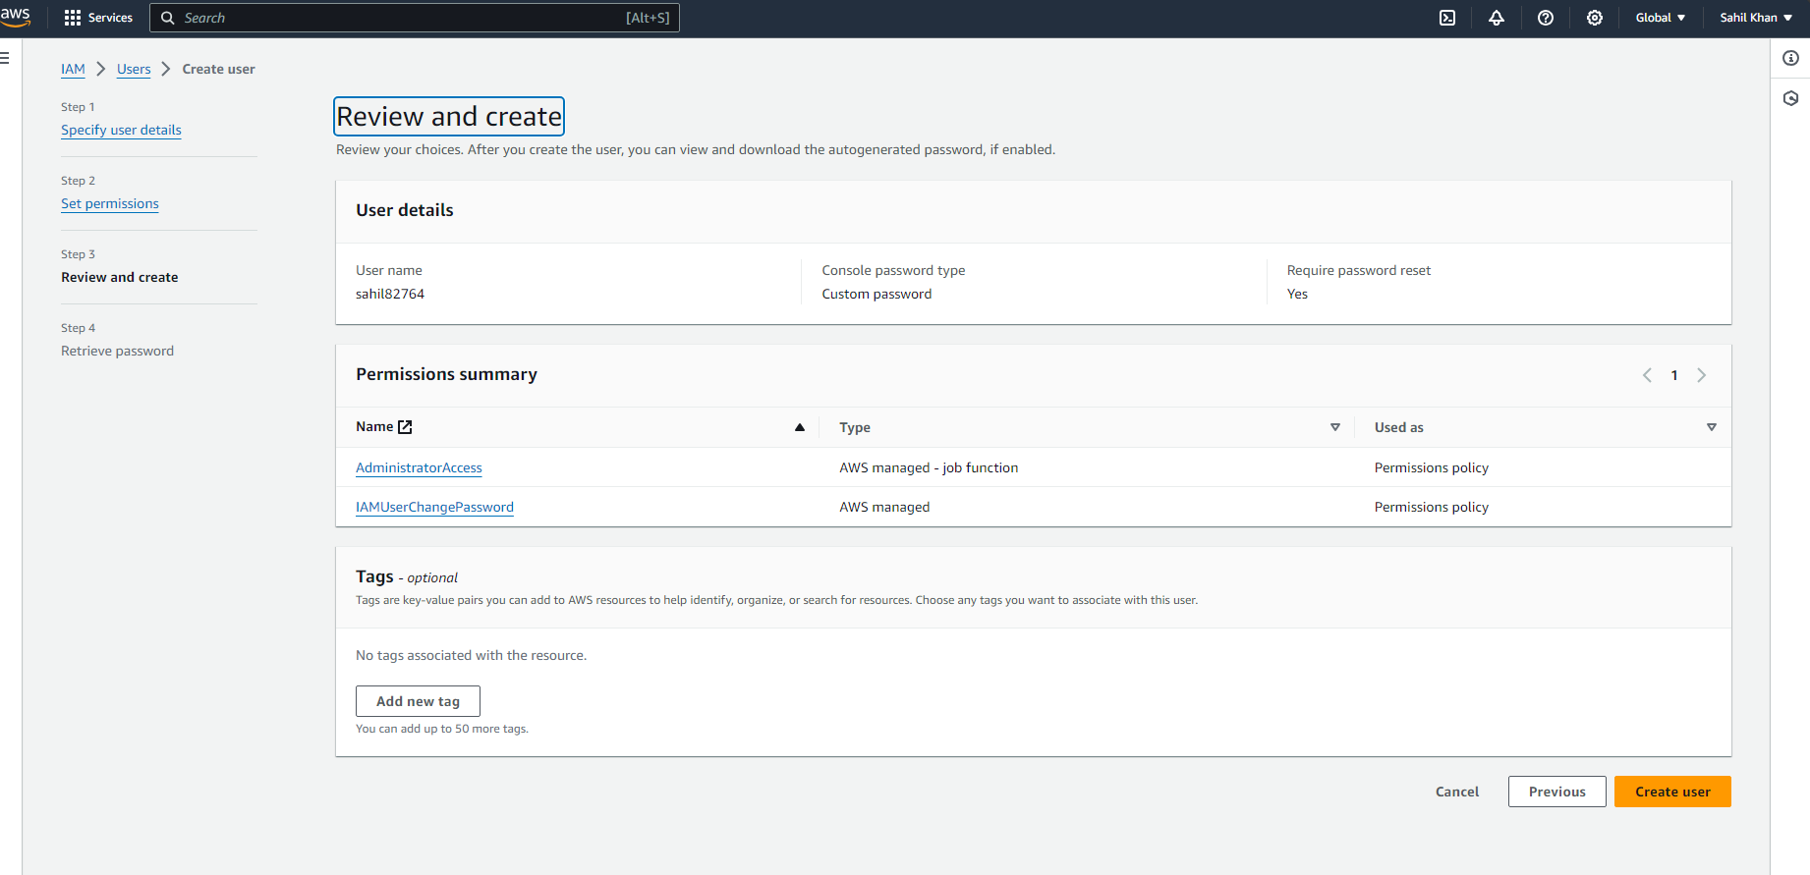

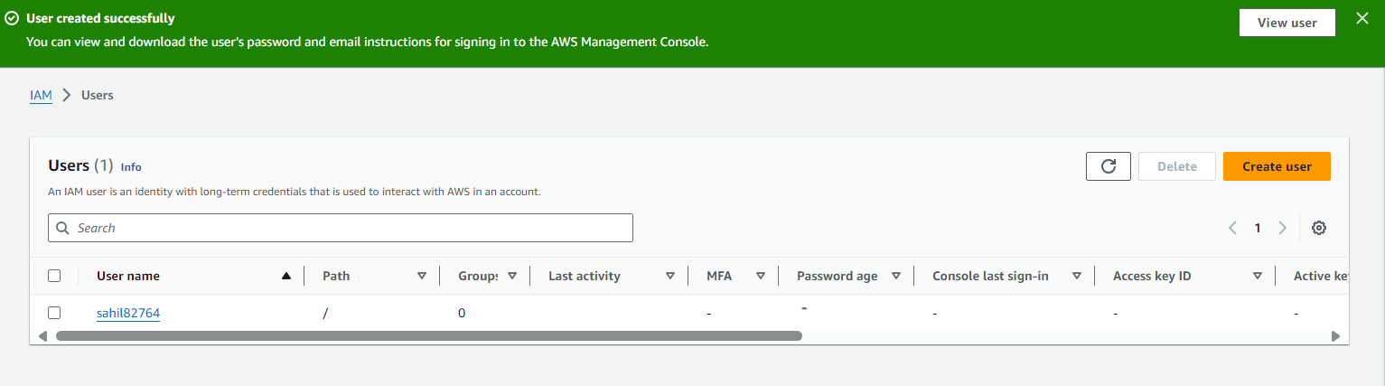

Step 3:

Assign (attach) existing policy “Administrator/Access” to the new user

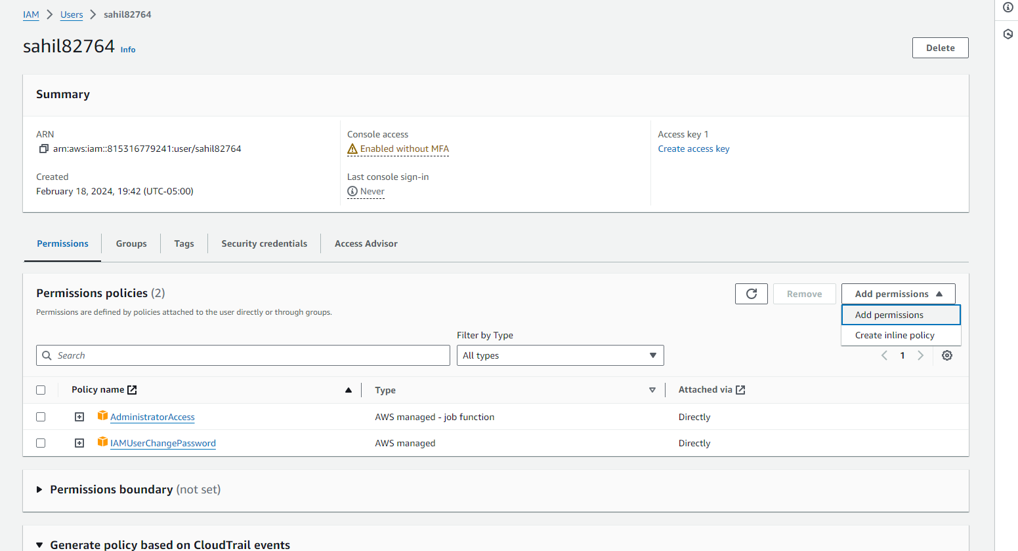

Step 4:

Create a virtual machine (EC2 instance) of your preference (Linux, Windows)

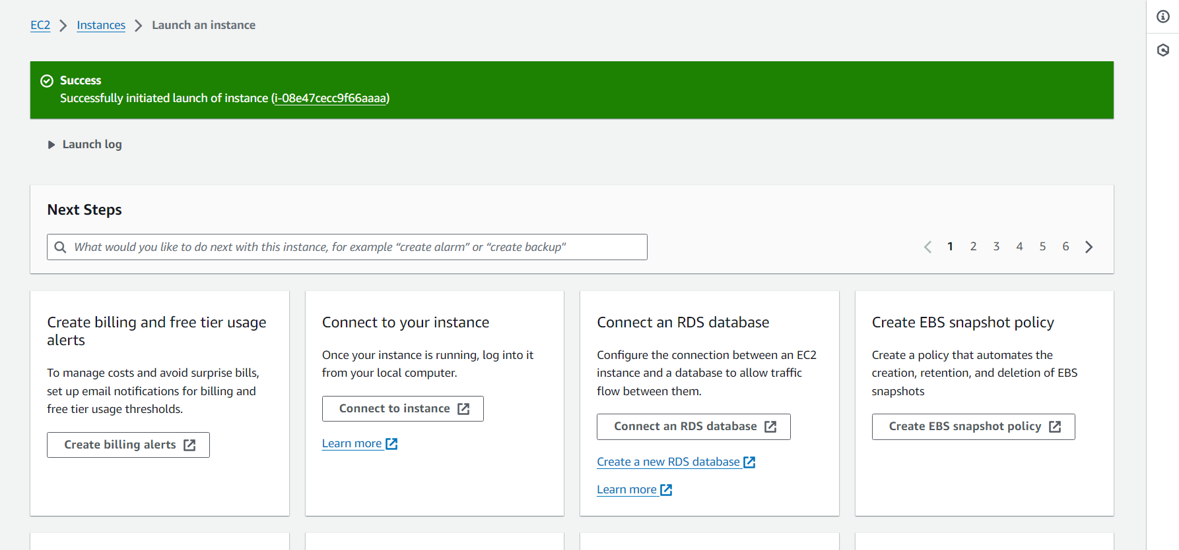

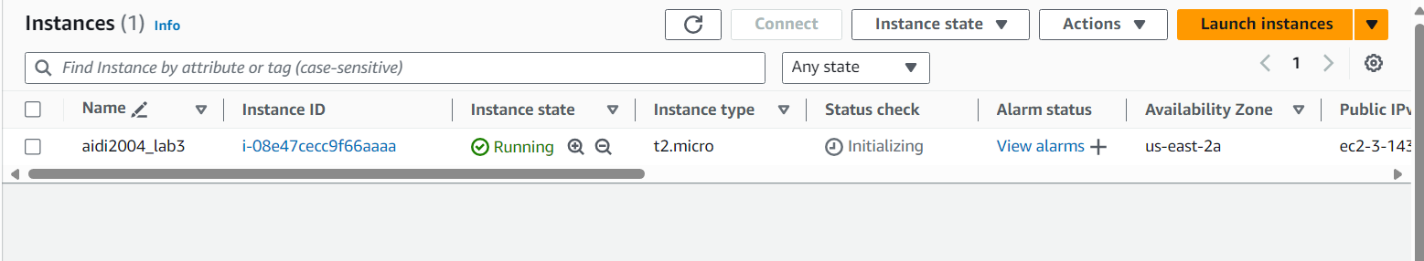

Step 5:

Connect to virtual machine using its public IP (if VM is Linux: please use SSH, if VM is Windows, Remote Desktop Client)

