**LAB#4 HEROKU**

PREDICTION ON: WEIGHT

MODEL USED: RandomForest

SCREENSHOTS

1. The Home page of Heroku that shows name.

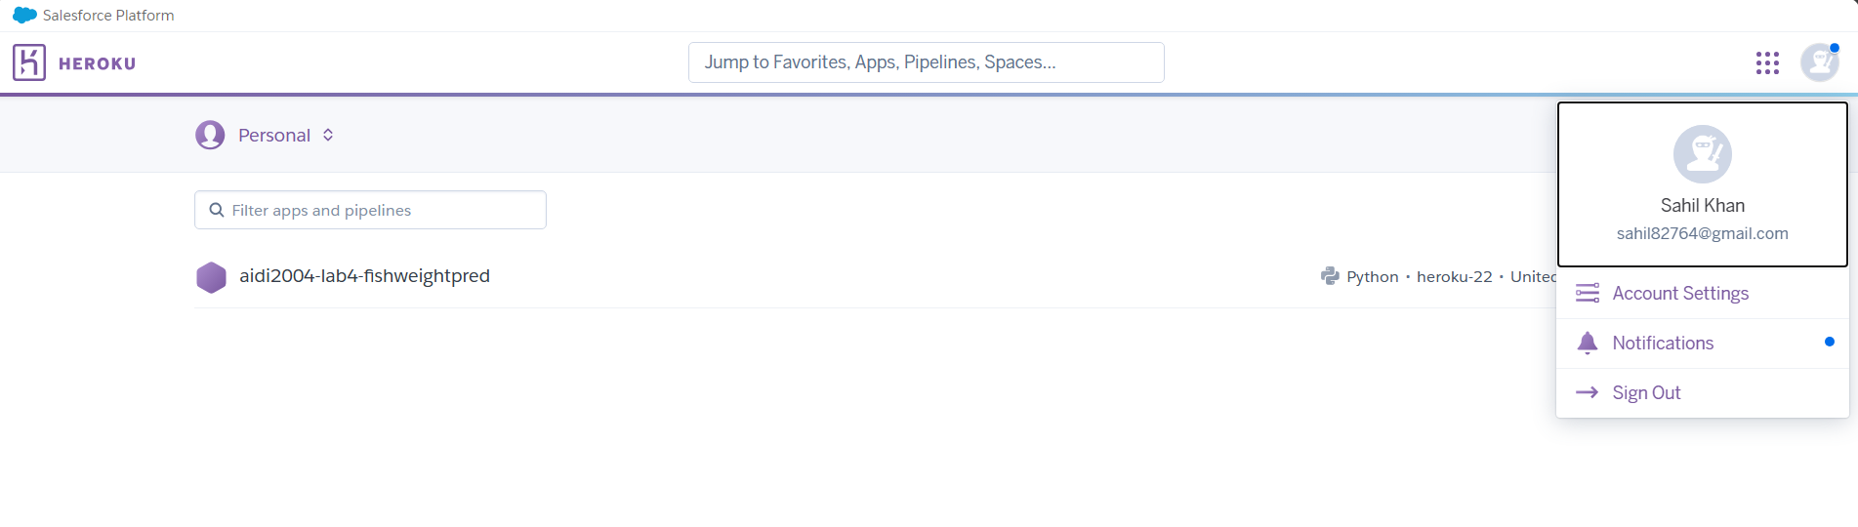

1. App names

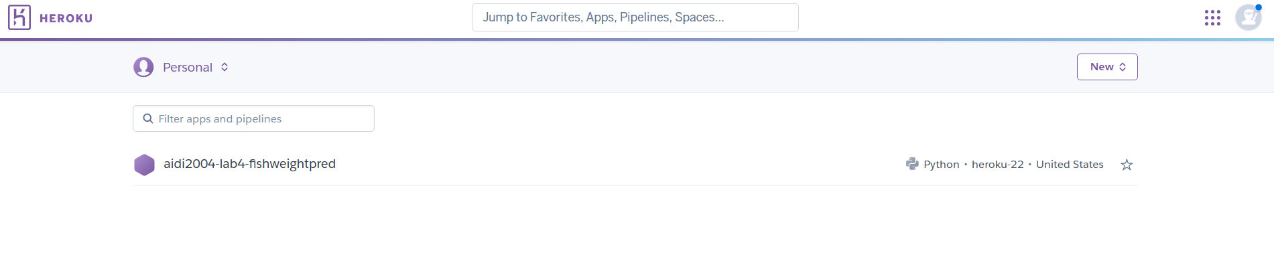

1. Screenshot showing I have established the connection between Heroku and my GitHub Repo.

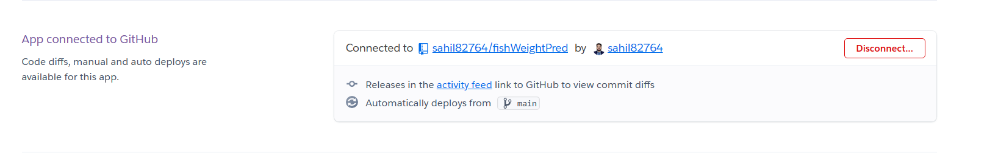

1. Screenshot of Build log

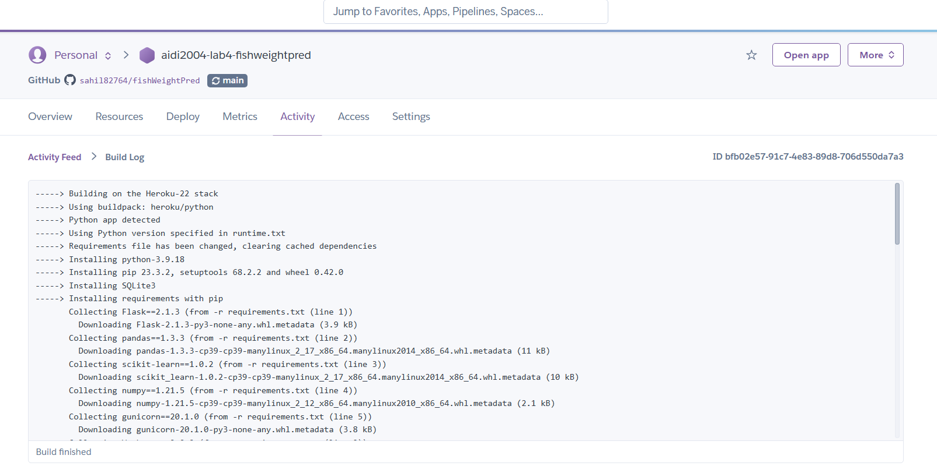

1. The Screenshot indicating my model was successfully launched.

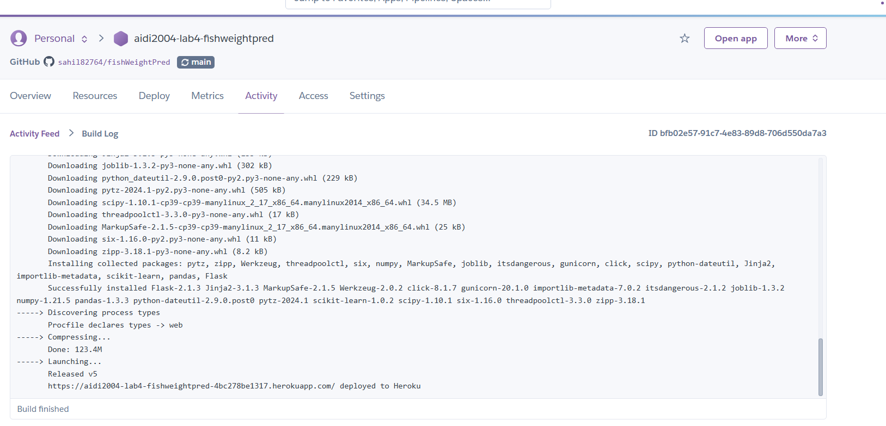

1. My app making predictions.

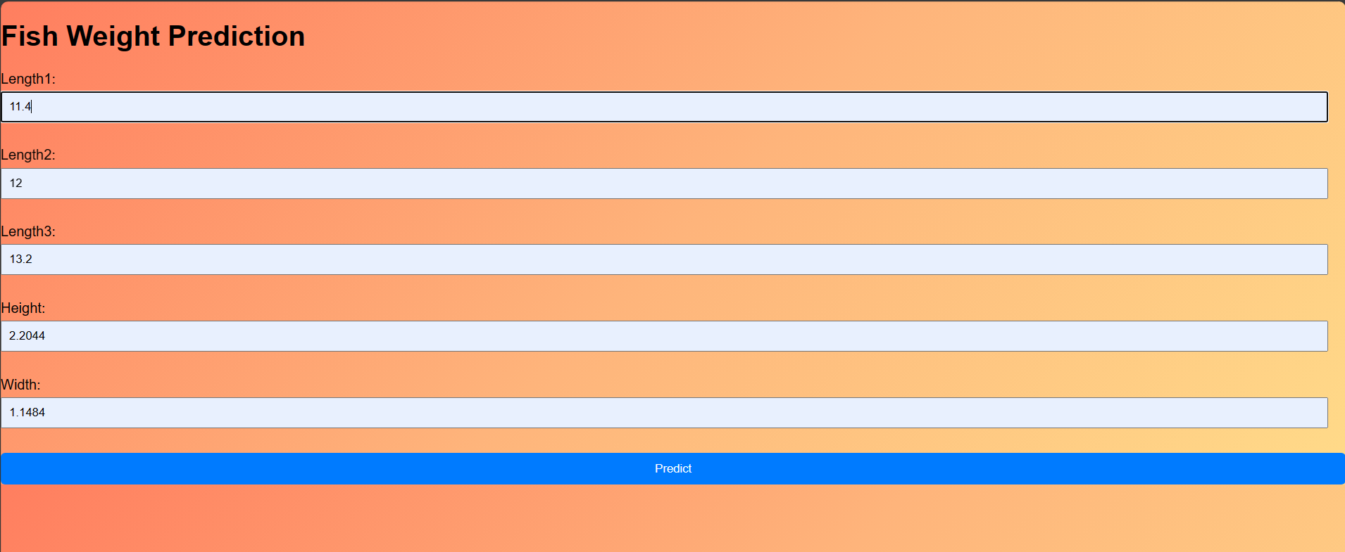

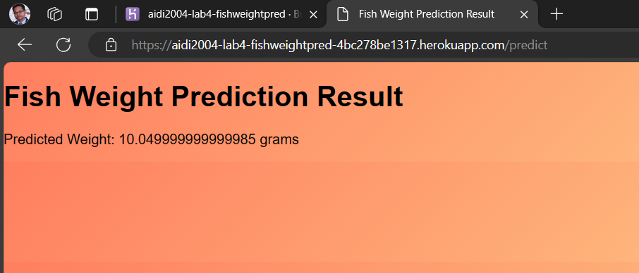

HEROKU LINK: <https://aidi2004-lab4-fishweightpred-4bc278be1317.herokuapp.com/>

Github Link: https://github.com/sahil82764/fishWeightPred