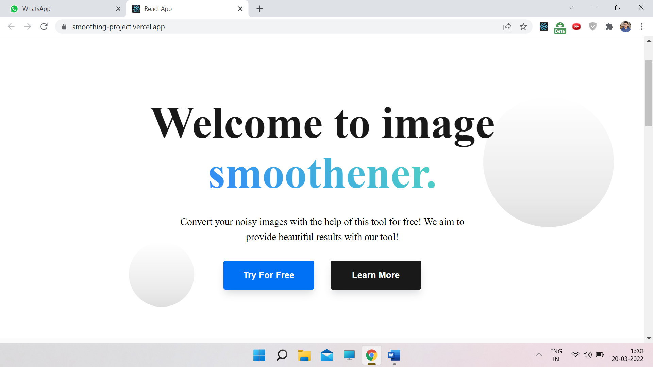

REPLACE (TEXT) => *TEXT*

(Welcome to image smoothener) => *Welcome to Smooth.ai* (smoothen sounds weird)

(Convert your noisy images with the help of this tool for free! We aim to provide beautiful results with our tool!)=> *Your one-stop solution to get noise-free images!*

# Explore the solutions

(Duis aute irure dolor in reprehenderit in voluptate velit esse cillum dolore eu fugiat nulla pariatur excepteur sint occaecat cupidatat.) => *Convert your noisy images with the help of this tool for free!*

**Powerful suite of tools**

Our platform uses state-of-the-art techonology to bring out the best in your pictures!