

**Open pig**

pig



**Load input file**

input_lines = load '/user/arhantjain/pigWord/input/file.txt' as (line:chararray); 

**Dump to check**

dump input_lines



**Tokenize**

words = FOREACH input_lines GENERATE FLATTEN(TOKENIZE(line)) AS word;



**Dump to check**

dump words

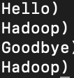

**Desribe to see**

describe words

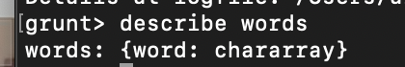

**Group words**

word_groups = GROUP words BY word;



**Dump to see**

dump word_groups



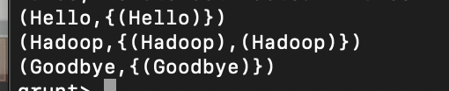

**Desribe to see**

describe word_groups

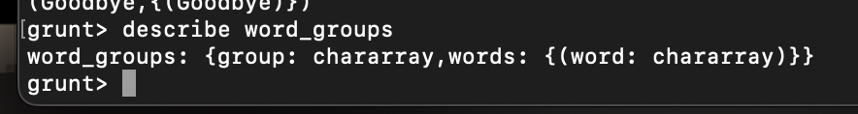

**Generate Word Count**

word_count = foreach word_groups GENERATE group, COUNT(words);



**Dump to see**

dump word_count



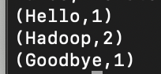

**Store in to file**

STORE word_count INTO '/user/arhantjain/pigWord/output' USING PigStorage(',');

