<https://www.wisdomjobs.com/e-university/hadoop-tutorial-484/an-example-to-write-hadoop-14864.html>

records = LOAD '/user/arhantjain/pigWeather/input/input.txt' USING PigStorage(',') AS (year:chararray, temperature:int, quality:int); 

dump records

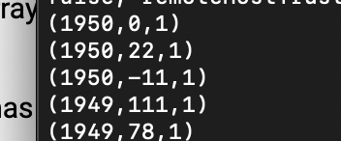

DESCRIBE records;



grouped_records = GROUP records BY year;



DUMP grouped_records;



DESCRIBE grouped_records;



max_temp = FOREACH grouped_records GENERATE group, MAX(records.temperature);



DUMP max_temp;



ILLUSTRATE max_temp;

