Danny’s Diner SQL Challenge

**Tables**

1. **Sales**
   1. Customer_id
   2. Order_date
   3. Product_id
2. **Members**
   1. Member_id
   2. Join_date
3. **Menu**
   1. Product_id
   2. Product_name
   3. Price

# Creating Database And Tables

CREATE SCHEMA dannys_diner;

SET search_path = dannys_diner;

CREATE TABLE sales (

"customer_id" VARCHAR(1),

"order_date" DATE,

"product_id" INTEGER

);

INSERT INTO sales

("customer_id", "order_date", "product_id")

VALUES

('A', '2021-01-01', '1'),

('A', '2021-01-01', '2'),

('A', '2021-01-07', '2'),

('A', '2021-01-10', '3'),

('A', '2021-01-11', '3'),

('A', '2021-01-11', '3'),

('B', '2021-01-01', '2'),

('B', '2021-01-02', '2'),

('B', '2021-01-04', '1'),

('B', '2021-01-11', '1'),

('B', '2021-01-16', '3'),

('B', '2021-02-01', '3'),

('C', '2021-01-01', '3'),

('C', '2021-01-01', '3'),

('C', '2021-01-07', '3');

CREATE TABLE menu (

"product_id" INTEGER,

"product_name" VARCHAR(5),

"price" INTEGER

);

INSERT INTO menu

("product_id", "product_name", "price")

VALUES

('1', 'sushi', '10'),

('2', 'curry', '15'),

('3', 'ramen', '12');

CREATE TABLE members (

"customer_id" VARCHAR(1),

"join_date" DATE

);

INSERT INTO members

("customer_id", "join_date")

VALUES

('A', '2021-01-07'),

('B', '2021-01-09');

# Questions

**1. What is the total amount each customer spent at the restaurant?**

SELECT

sl.customer_id,

sum(pr.price) as totalSpent

FROM dannys_diner.sales sl

JOIN dannys_diner.menu pr

ON

sl.product_id = pr.product_id

GROUP BY 1

ORDER BY 2 DESC;

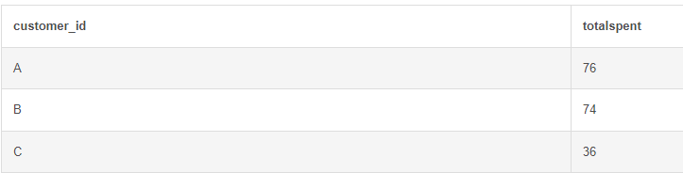

**2. How many days has each customer visited the restaurant?**

SELECT

sl.customer_id,

COUNT(DISTINCT sl.order_date) as daysVisited

FROM dannys_diner.sales sl

GROUP BY 1

ORDER BY 2 DESC;

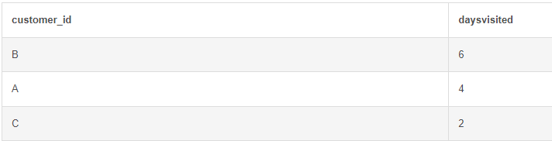

**3. What is the most purchased item on the menu and how many times was it purchased by all customers?**

SELECT

sl.product_id,

pr.product_name,

count(sl.product_id)

FROM dannys_diner.sales sl

JOIN dannys_diner.menu pr

ON

sl.product_id = pr.product_id

GROUP BY 1,2

ORDER BY 3 DESC;

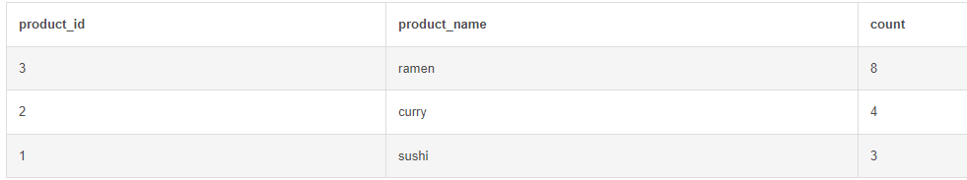

**5. Which item was the most popular for each customer?**

SELECT

sl.product_id,

pr.product_name,

sl.customer_id,

count(sl.product_id)

FROM dannys_diner.sales sl

JOIN dannys_diner.menu pr

ON

sl.product_id = pr.product_id

GROUP BY 3,2,1

ORDER BY 4 DESC;

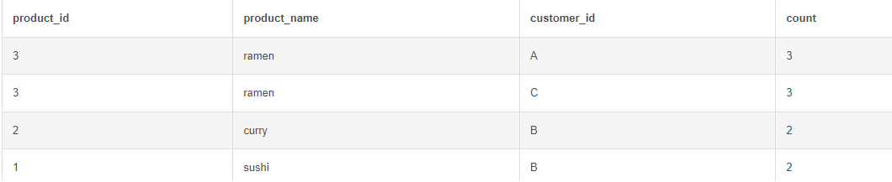

**6. Which item was purchased just before the customer became a member?**

SELECT

sl.product_id,

pr.product_name,

sl.customer_id

FROM dannys_diner.sales sl

JOIN dannys_diner.menu pr

ON

sl.product_id = pr.product_id

LEFT JOIN dannys_diner.members mr

ON

mr.customer_id = sl.customer_id

where mr.join_date > sl.order_date

GROUP BY 1,2,3;

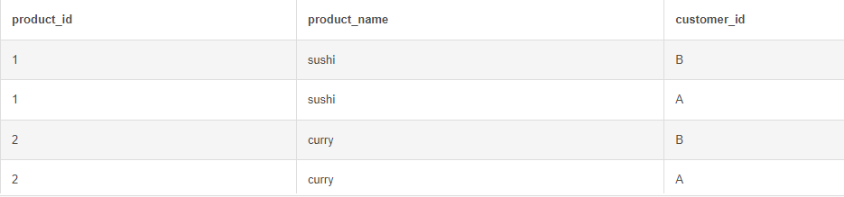

**7. What is the total items and amount spent for each member before they became a member?**

SELECT

sl.customer_id,

COUNT(distinct sl.product_id) as totalItems,

sum(pr.price) as totalSpent

FROM dannys_diner.sales sl

JOIN dannys_diner.menu pr

ON

sl.product_id = pr.product_id

LEFT JOIN dannys_diner.members mr

ON

mr.customer_id = sl.customer_id

where mr.join_date > sl.order_date

GROUP BY 1

ORDER BY 3 DESC;

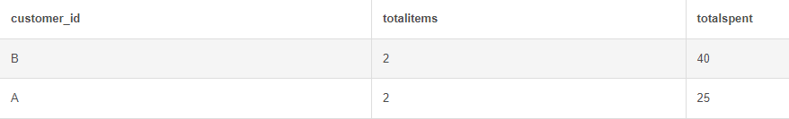

**8. What is the points earned by each customer when $1 spent equals to 10 points?**

SELECT

sl.customer_id,

sum(pr.price) as totalSpent,

sum(pr.price) * 10 as totalPoints

FROM dannys_diner.sales sl

JOIN dannys_diner.menu pr

ON

sl.product_id = pr.product_id

GROUP BY 1

ORDER BY 3 DESC;

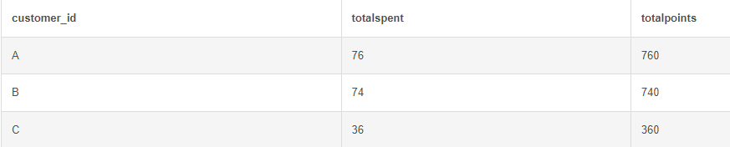

Foodie-Fi SQL Challenge

**Tables**

1. **Plans**
   1. Plan_id
   2. Plan_name
   3. Price
2. **Subscriptions**
   1. Customer_id
   2. Plan_id
   3. Start_date
3. **How many customers has Foodie-Fi ever had?**

SELECT COUNT(DISTINCT customer_id) as totalCustomers FROM foodie_fi.subscriptions;

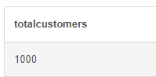

1. **What is the customer count and percentage of customers who have churned rounded to 1 decimal place?**

SELECT COUNT(DISTINCT customer_id) as totalCustomersChurned

FROM foodie_fi.subscriptions sb

LEFT JOIN foodie_fi.plans pl

ON

sb.plan_id = pl.plan_id

WHERE sb.plan_id = 4;

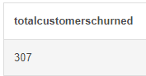

1. **What is the monthly distribution of trial plan start_date values for our dataset - use the start of the month as the group by value**

SELECT EXTRACT('month' FROM start_date) as months,

COUNT(plan_id) as trialPlans

FROM foodie_fi.subscriptions sb

WHERE plan_id = 0

GROUP BY 1

ORDER BY 2 DESC;

