DATA-DRIVEN PRICING STRATEGY REPORT
For: Karmic Seed – Operations Analyst Round 3
Prepared by: Sahil Vinod Bhoir
Tool Used: Microsoft Excel (Book1.xlsx), python.

1. EXECUTIVE SUMMARY
XYZ Company faced inconsistent pricing, margin erosion, and inventory imbalance due to reactive pricing decisions.
This project designs and implements a structured data-driven pricing engine that automatically recommends optimal prices for each SKU based on cost, margin constraints, competitor benchmarks, inventory health, demand strength, and advertising efficiency.
The model produces final recommended prices that maximize margin while ensuring market competitiveness and inventory control.

2. DATASETS USED
Dataset | Purpose
Pricing_Data | Cost & margin constraints
Competitor_Data | Market benchmark prices
Historical_Sales | Demand measurement
Inventory_Health | Stock pressure detection
Ads_Performance | Advertising efficiency

3. KEY BUSINESS SIGNALS IDENTIFIED
Signal | Business Meaning
Cost + Fees | Minimum sustainable price
Minimum Margin % | Loss prevention
Target Margin % | Profit objective
Competitor Price | Market alignment
Units Ordered | Demand strength
Sell-Through | Sales velocity
Days of Supply | Inventory urgency
ROAS / ACOS | Advertising profitability

4. PRICING STRATEGY FRAMEWORK
Step-1: Cost Floor Protection
Min_Allowed_Price = (Cost + FBA + Storage + Handling) / (1 - Minimum_Margin%)
Step-2: Profit Target Price
Target_Price = (Cost + Fees) / (1 - Target_Gross_Margin%)
Step-3: Competitor Alignment
Condition | Adjustment
Competitor Price < Target | Slight reduction
Competitor Price > Target | Maintain / increase
Step-4: Inventory & Demand Logic
Scenario | Pricing Action
Low stock & High demand | Increase price
High stock & Low demand | Decrease price
Normal | Maintain
Step-5: Advertising Performance
Ads Result | Action
High ROAS | Increase price
High ACOS | Reduce price

5. IMPLEMENTATION TOOL
Platform: Microsoft Excel
Output: Book1.xlsx
Automated calculation of:
• Min Allowed Price
• Target Price
• Competitor Adjusted Price
• Inventory Adjusted Price
• Final Recommended Price

6. FINAL PRICING OUTPUT
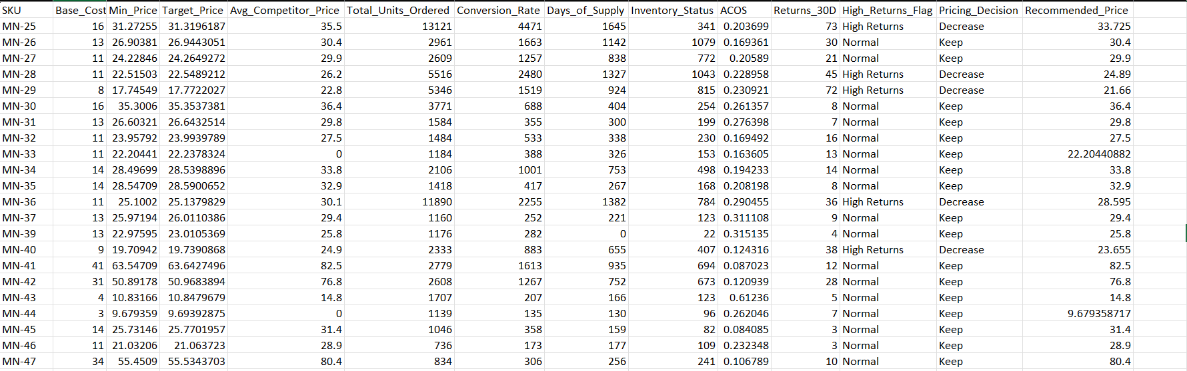
SKU | Cost | Target Price | Competitor Price | Final Recommended Price

7. KEY BUSINESS BENEFITS
Benefit | Impact
Margin Protection | Prevents loss
Inventory Balance | Avoids stockouts & overstock
Market Competitiveness | Aligns with competition
Automation Ready | Scales to 1000+ SKUs

8. CONCLUSION
This pricing engine converts raw operational data into structured pricing actions.
It enables XYZ Company to move from reactive pricing to predictable, profitable, and scalable pricing management.

9. ATTACHED FILES
File:https://drive.google.com/drive/folders/1NGr-ByqR408If-KHgv5TALwRdUuZRmvR?usp=sharing
• Sahil_Bhoir_Pricing_Model.xlsx
• Pricing Calculation Sheet
• karmic_seed_pricing_analysis.ipynb

