**Batch: A1 Experiment Number: 2 Roll Number: 16010422013 Name: Sahil Biswas**

**Aim of the Experiment:**

**Program/ Steps:**

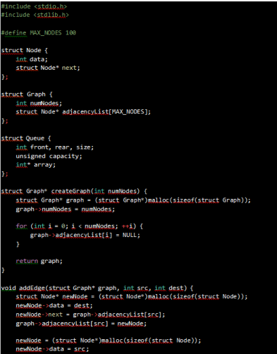

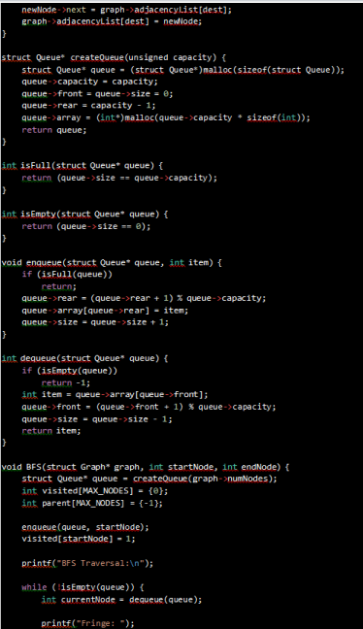

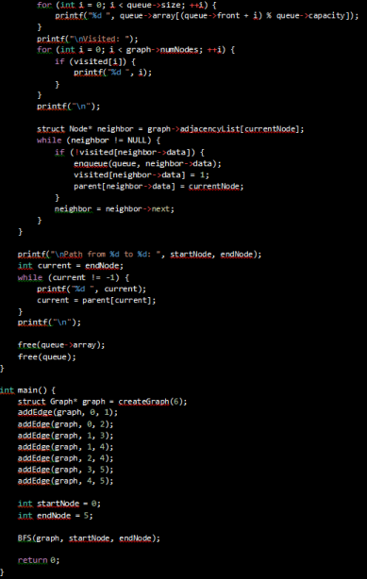

**Output/Result:**

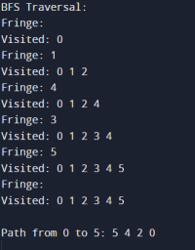

**Outcomes: Analyse and formalize the problem and select the best suited algorithm.**

**Conclusion:**

**The provided C code implements Breadth-First Search (BFS) for graph traversal, displaying the contents of the Fringeand Visited nodes at each iteration and finally printing the traversed path. It utilizes a simple graph representation through adjacency lists and employs a queue data structure for BFS traversal** 

1. **References:** Stuart Russell and Peter Norvig, Artificial Intelligence: A

Modern Approach,Second Edition, Pearson Publication

KJSCE/IT/SY/SEM IV/HO-IAI/2023-24

2. Luger, George F. Artificial Intelligence : Structures and strategies for complex problemsolving , 2009 ,6th Edition, Pearson Education

(A Constituent College of Somaiya Vidyavihar University)