VISVESVARAYA TECHNOLOGICAL UNIVERSITY
“JnanaSangama”, Belgaum -590014, Karnataka.

LAB REPORT
on
Object Oriented Java Programming (23CS3PCOOJ)
Submitted by
Sahil Biswas (1BF24CS262)
in partial fulfillment for the award of the degree of
BACHELOR OF ENGINEERING
in

B.M.S. COLLEGE OF ENGINEERING
(Autonomous Institution under VTU)
BENGALURU-560019
Aug-2025 to Jan-2026

B.M.S. College of Engineering,
Bull Temple Road, Bangalore 560019
(Affiliated To Visvesvaraya Technological University, Belgaum)
Department of Computer Science and Engineering

CERTIFICATE
This is to certify that the Lab work entitled “Object Oriented Java Programming (23CS3PCOOJ)” carried out by Sahil Biswas(1BF24CS262), who is bonafide student of B.M.S. College of Engineering. It is in partial fulfilment for the award of Bachelor of Engineering in Computer Science and Engineering of the Visvesvaraya Technological University, Belgaum. The Lab report has been approved as it satisfies the academic requirements in respect of an Object-Oriented Java Programming (23CS3PCOOJ) work prescribed for the said degree.

Dr. Seema Patil  Associate Professor  Department of CSE, BMSCE | Dr. Kavitha Sooda  Professor & HOD  Department of CSE, BMSCE

Index
Sl.  No. | Date | Experiment Title | Page No.
1 | 23/9/25 | Quadratic Equations | 4-5
2 | 13/10/25 | SGPA Calculator | 6-10
3 | 14/10/25 | Bookstore Program | 11-13
4 | 4/11/25 | Shapes Program | 14-16
5 | 4/11/25 | Bank Program | 17-23
6 | 18/11/25 | Packages | 24-26
7 | 26/11/25 | Errors | 27-28
8 | 9/12/25 | Multi Threading | 29-30
9 | 9/12/25 | Open Ended Question 1 | 30-32
10 | 9/12/25 | Open Ended Question 2 | 32-35

Github Link:https://github.com/sahilbiswascs24-byte/Java-lab
Program 1
Implement Quadratic Equation
Code:

import java.util.Scanner;

class quadratic
{
public static void main(String[] args)
{
Scanner s = new Scanner(System.in);
float a,b,c,d;
double r1,r2;
System.out.println("Enter coefficient of a:");
a= s.nextFloat();
System.out.println("Enter coefficient of b: ");
b= s.nextFloat();
System.out.println("Enter coefficient of c:");
c= s.nextFloat();
d= b*b - 4*a*c;
if (a==0)
{
System.out.println("Not a quadratic equation");

}
else {

if (d==0) {
r1= (-b)/(2*a);
r2=r1;
System.out.println("Roots are real and equal:"+r1);
}
else if (d>0) {
r1 = ((-b) + (Math.sqrt(d)))/(double)(2*a);
r2 = ((-b) - (Math.sqrt(d)))/(double)(2*a);
System.out.println("Roots are real and distinct R1:"+r1+ "and R2:"+r2);
}
else {
System.out.println("Roots are imaginary");
r1 = (-b)/(2*a);
r2 = Math.sqrt(-d)/(2*a);
System.out.println("Root 1:"+r1+"+"+r2+"i");
System.out.println("Root 2:"+r1+"-"+r2+"i");
}
}
System.out.println("USN:1BF24CS262 Name:Sahil Biswas");
s.close();

}
}

Output:

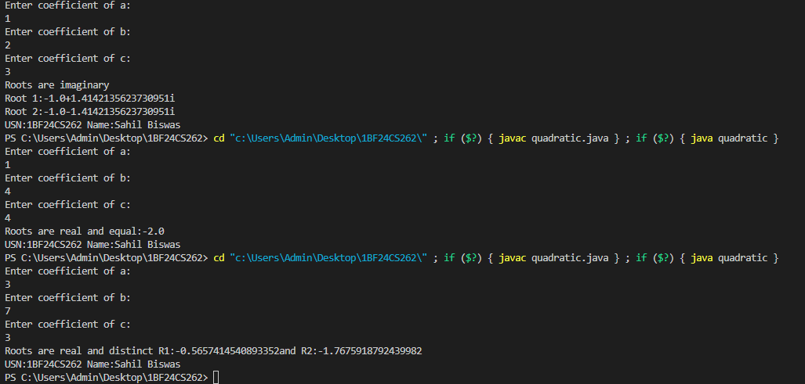

Program 2: SGPA Calculator
Code:

import java.util.Scanner;

class Subject {
int subjectMarks;
int credits;
int grade;

public Subject() {
this.subjectMarks = 0;
this.credits = 0;
this.grade = 0;
}
}

class Student {
String name;
String usn;
double SGPA;
Scanner s;
Subject[] subject;

public Student() {
s = new Scanner(System.in);
subject = new Subject[8];
for (int i = 0; i < 8; i++) {
subject[i] = new Subject();
}
}

public void getStudentDetails() {
System.out.print("Enter student name: ");
name = s.nextLine();
System.out.print("Enter student USN: ");
usn = s.nextLine();
}

public void getMarks() {
for (int i = 0; i < 8; i++) {
System.out.print("Enter marks for subject " + (i + 1) + ": ");
subject[i].subjectMarks = s.nextInt();
System.out.print("Enter credits for subject " + (i + 1) + ": ");
subject[i].credits = s.nextInt();

subject[i].grade = (subject[i].subjectMarks / 10) + 1;

if (subject[i].grade == 11) {
subject[i].grade = 10;
}
if (subject[i].grade <= 4) {
subject[i].grade = 0;
}
}
}
public void computeSGPA() {
int effectiveScore = 0;
int totalCredits = 0;

for (int i = 0; i < 8; i++) {
effectiveScore += (subject[i].grade * subject[i].credits);
totalCredits += subject[i].credits;
}

SGPA = (double) effectiveScore / totalCredits;
}

public void display() {
System.out.println("\nStudent Details:");
System.out.println("Name: " + name);
System.out.println("USN: " + usn);
System.out.println("SGPA: " + SGPA);
}
}

public class SGPACalculator {
public static void main(String[] args)
{
Scanner scanner = new Scanner(System.in);
System.out.print("Enter number of students: ");
int n = scanner.nextInt();
scanner.nextLine();

Student[] students = new Student[n];

for (int i = 0; i < n; i++) {
System.out.println("\nEnter details for student " + (i + 1) + ":");
students[i] = new Student();
students[i].getStudentDetails();
students[i].getMarks();
students[i].computeSGPA();
}
System.out.println("\n--- Student Results ---");
for (int i = 0; i < n; i++) {
students[i].display();
}

scanner.close();
}
}

Output:
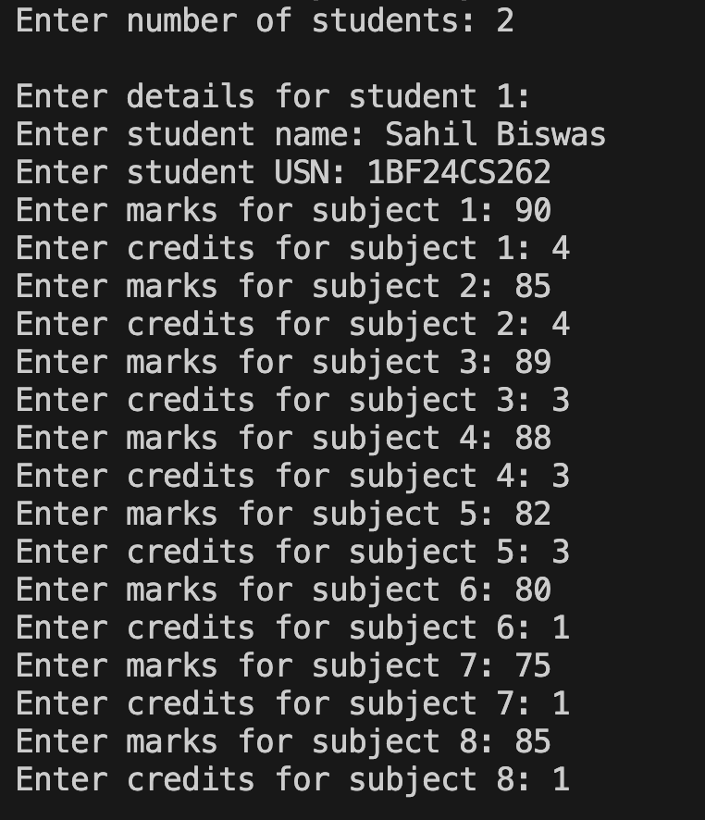
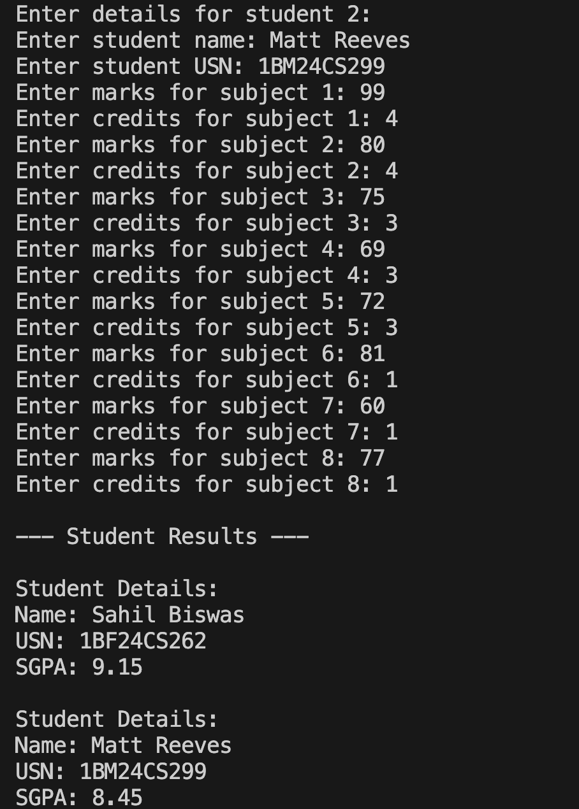
Program 3: Bookstore Program
Code:

import java.util.Scanner;

class Books {
String name;
String author;
int price;
int num_pages;

Books(String name, String author, int price, int num_pages)
{
this.name = name;
this.author = author;
this.price = price;
this.num_pages = num_pages;
}
public String toString()
{
String name = "Book name: " + this.name + "\n";
String author = "Author name: " + this.author + "\n";
String price = "Price: " + this.price + "\n";
String num_pages = "Number of pages: " + this.num_pages + "\n";
return name + author + price + num_pages;
}
}

public class BookStore
{
public static void main(String args[])
{
Scanner in = new Scanner(System.in);
String name,author;
int price, num_pages;

System.out.print("Enter number of books: ");
int n = in.nextInt();

Books[] b = new Books[n];

for (int i = 0; i < n; i++)
{
System.out.println("\n\nEnter details for book " + (i + 1) + ":");

System.out.print("Name: ");
name = in.next();

System.out.print("Author: ");
author = in.next();

System.out.print("Price: ");
price = in.nextInt();

System.out.print("Number of pages: ");
num_pages
= in.nextInt();

b[i] = new Books(name, author, price, num_pages
);
}

System.out.println("\n\nBook details:\n");

for (int i = 0; i < n; i++)
{
System.out.println(b[i].toString());
}

in.close();
}
}

Output:
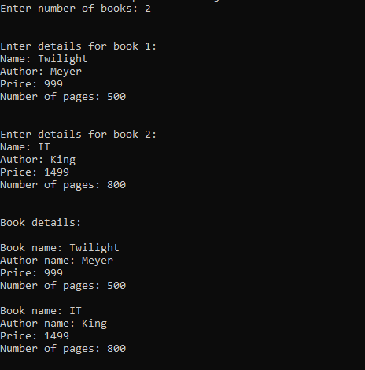

Program 4: Shapes Program
Code:

import java.util.Scanner;

class InputScanner {
Scanner sc = new Scanner(System.in);

int getInt(String msg) {
System.out.print(msg);
return sc.nextInt();
}

double getDouble(String msg) {
System.out.print(msg);
return sc.nextDouble();
}
}

abstract class Shape extends InputScanner {
int a, b;
abstract void printArea();
}

class Rectangle extends Shape {
void input() {
a = getInt("Enter length: ");
b = getInt("Enter breadth: ");
}

void printArea() {
System.out.println("Area of Rectangle = " + (a * b));
}
}

class Triangle extends Shape {
void input() {
a = getInt("Enter base: ");
b = getInt("Enter height: ");
}

void printArea() {
System.out.println("Area of Triangle = " + (0.5 * a * b));
}
}

class Circle extends Shape {
void input() {
a = getInt("Enter radius: ");
}

void printArea() {
System.out.println("Area of Circle = " + (3.1416 * a * a));
}
}

public class MainShape {
public static void main(String[] args) {
System.out.println("Enter the dimensions of rectangle:");
Rectangle r = new Rectangle();
r.input();
r.printArea();

System.out.println("\nEnter the dimensions of triangle:");
Triangle t = new Triangle();
t.input();
t.printArea();

System.out.println("\nEnter the dimension of circle:");
Circle c = new Circle();
c.input();
c.printArea();
}
}

Output:
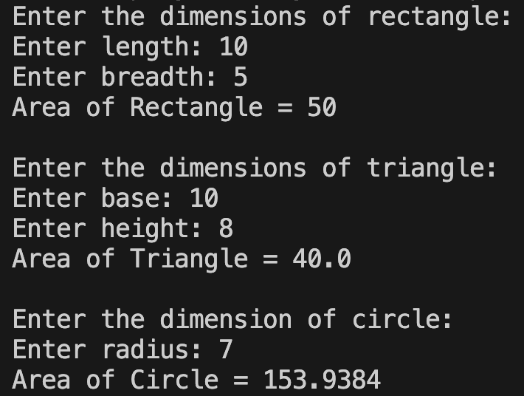

Program 5: Bank Program
Code:

import java.util.Scanner;

class Account {
String customerName;
int accountNumber;
String accountType;
double balance;

Account(String name, int accNo, String type) {
customerName = name;
accountNumber = accNo;
accountType = type;
balance = 0.0;
}

void deposit(double amount) {
balance += amount;
System.out.println("Deposited: " + amount + ". Updated balance: " + balance);
}

void display() {
System.out.println("Customer name: " + customerName);
System.out.println("Account number: " + accountNumber);
System.out.println("Type of Account: " + accountType);
System.out.println("Account Balance: " + balance);
}
}

class SavAcct extends Account {
SavAcct(String name, int accNo, String type) {
super(name, accNo, type);
}

void computeInterest() {
double rate = 0.04;
double interest = balance * rate;
balance += interest;
System.out.println("Interest added: " + interest + ". Updated balance: " + balance);
}

void withdraw(double amount) {
if (amount > balance) {
System.out.println("Insufficient balance!");
} else {
balance -= amount;
System.out.println("Withdrawn: " + amount + ". Updated balance: " + balance);
}
}
}

class CurAcct extends Account {
final double MIN_BAL = 500.0;
final double SERVICE_CHARGE = 100.0;

CurAcct(String name, int accNo, String type) {
super(name, accNo, type);
}

void checkBalance() {
if (balance < MIN_BAL) {
balance -= SERVICE_CHARGE;
System.out.println("Balance below minimum. Service charge imposed: " + SERVICE_CHARGE);
System.out.println("Updated balance: " + balance);
}
}

void withdraw(double amount) {
if (amount > balance) {
System.out.println("Insufficient balance!");
} else {
balance -= amount;
checkBalance();
System.out.println("Withdrawn: " + amount + ". Updated balance: " + balance);
}
}
}

public class BankSystem {
public static void main(String[] args) {
Scanner sc = new Scanner(System.in);
Account[] accounts = new Account[2];

for (int i = 0; i < 2; i++) {
System.out.print("Enter customer name: ");
String name = sc.nextLine();
System.out.print("Enter account number: ");
int accNo = Integer.parseInt(sc.nextLine());
System.out.print("Enter type of account (saving/current): ");
String type = sc.nextLine().toLowerCase();

if (type.equals("saving"))
accounts[i] = new SavAcct(name, accNo, type);
else
accounts[i] = new CurAcct(name, accNo, type);
}

int choice;
do {
System.out.println("\n-------MENU-------");
System.out.println("1. Deposit");
System.out.println("2. Withdraw");
System.out.println("3. Compute Interest for Savings Account");
System.out.println("4. Display Account Details");
System.out.println("5. Exit");
System.out.print("Enter your choice: ");
choice = sc.nextInt();

switch (choice) {
case 1:
System.out.print("Enter the type of account (saving/current): ");
String type = sc.next().toLowerCase();
System.out.print("Enter the deposit amount: ");
double depAmt = sc.nextDouble();
for (Account acc : accounts) {
if (acc.accountType.equals(type)) {
acc.deposit(depAmt);

break;
}
}
break;

case 2:
System.out.print("Enter the type of account (saving/current): ");
type = sc.next().toLowerCase();
System.out.print("Enter the withdrawal amount: ");
double wAmt = sc.nextDouble();
for (Account acc : accounts) {
if (acc.accountType.equals(type)) {
if (type.equals("saving"))
((SavAcct) acc).withdraw(wAmt);
else
((CurAcct) acc).withdraw(wAmt);

break;
}
}
break;

case 3:
System.out.print("Enter the type of account (saving/current): ");
type = sc.next().toLowerCase();
for (Account acc : accounts) {
if (acc.accountType.equals("saving") && type.equals("saving")) {
((SavAcct) acc).computeInterest();

break;
}
}
break;

case 4:
System.out.print("Enter the type of account (saving/current): ");
type = sc.next().toLowerCase();
for (Account acc : accounts) {
if (acc.accountType.equals(type)) {
acc.display();
break;
}
}
break;

case 5:
System.out.println("Exiting...");
break;

default:
System.out.println("Invalid choice!");
}
} while (choice != 5);

sc.close();
}
}

Output:
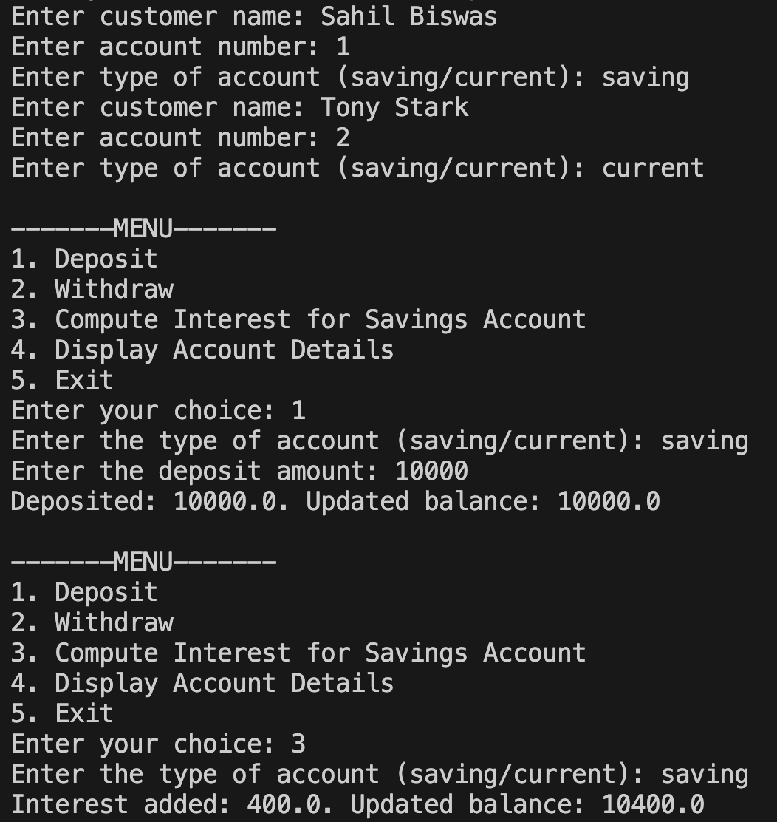

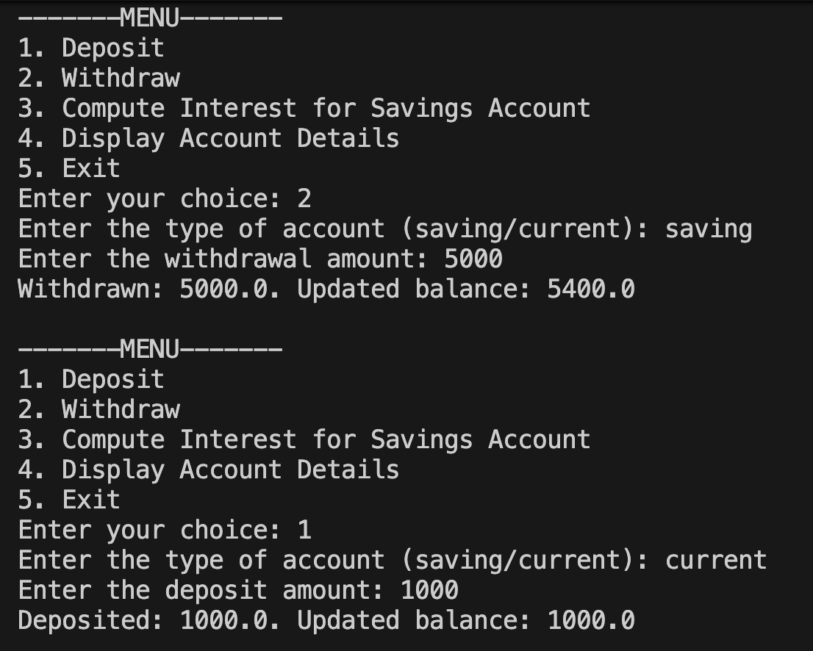

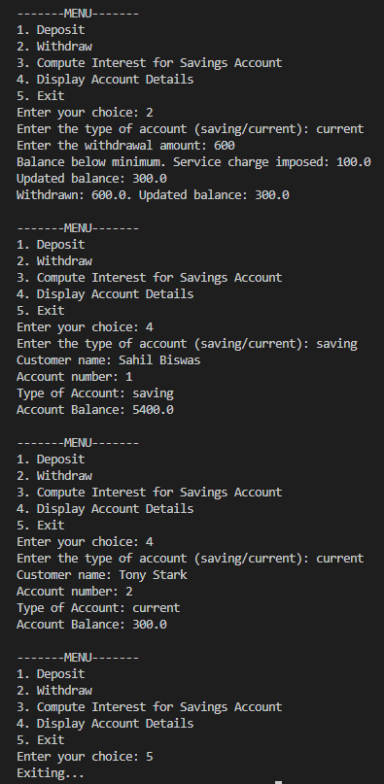

Program 6: Packages
Code:

package CIE;
import java.util.Scanner;

public class Student {
protected String usn;
protected String name;
protected int sem;

public void inputStudentDetails() {
Scanner s = new Scanner(System.in);
System.out.print("Enter USN: ");
usn = s.nextLine();

System.out.print("Enter Name: ");
name = s.nextLine();

System.out.print("Enter Semester: ");
sem = s.nextInt();
}

public void displayStudentDetails() {
System.out.println("USN: " + usn);
System.out.println("Name: " + name);
System.out.println("Semester: " + sem);
}
}

package CIE;
import java.util.Scanner;

public class Internals extends Student {

protected int marks[] = new int[5];

public void inputCIEmarks() {
Scanner s = new Scanner(System.in);
System.out.println("Enter 5 CIE marks: ");

for (int i = 0; i < 5; i++) {
System.out.print("CIE Mark in Subject " + (i + 1) + ": ");
marks[i] = s.nextInt();
}
}
}
package SEE;

import CIE.Internals;
import java.util.Scanner;

public class Externals extends Internals {

protected int marks[];
protected int finalMarks[];

public Externals() {
marks = new int[5];
finalMarks = new int[5];
}

public void inputSEEmarks() {
Scanner s = new Scanner(System.in);
System.out.println("Enter 5 SEE marks: ");

for (int i = 0; i < 5; i++) {
System.out.print("SEE Mark in Subject " + (i + 1) + ": ");
marks[i] = s.nextInt();
}
}

public void calculateFinalMarks() {
for (int i = 0; i < 5; i++) {
finalMarks[i] = super.marks[i] + marks[i]/2; // CIE + SEE
}
}

public void displayFinalMarks() {
System.out.println("\n--- Final Marks ---");
displayStudentDetails();

for (int i = 0; i < 5; i++) {
System.out.println("Final Marks in Subject " + (i + 1) + ": " + finalMarks[i]);
}
}
}

import SEE.Externals;

class Main {
public static void main(String args[]) {

Externals obj = new Externals();

obj.inputStudentDetails();
obj.inputCIEmarks();
obj.inputSEEmarks();
obj.calculateFinalMarks();
obj.displayFinalMarks();
}
}

Output:

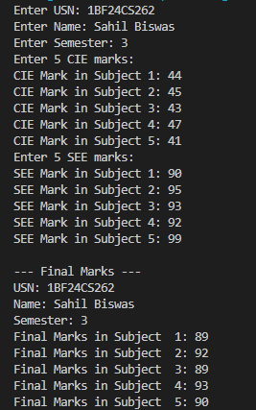

Program 7: Errors
Code:

import java.util.*;

class WrongAge extends Exception {
WrongAge(String message) {
super(message);
}
}

class InputScanner {
Scanner sc;

InputScanner() {
sc = new Scanner(System.in);
}

int getInt() {
return sc.nextInt();
}
}

class Father extends InputScanner {
int fatherAge;

Father() throws WrongAge {
System.out.print("Enter Father's Age: ");
fatherAge = getInt();

if (fatherAge < 0) {
throw new WrongAge("Age cannot be negative");
}
}

void display() {
System.out.println("Father's Age: " + fatherAge);
}
}

class Son extends Father {
int sonAge;

Son() throws WrongAge {
super();

System.out.print("Enter Son's Age: ");
sonAge = getInt();

if (sonAge < 0) {
throw new WrongAge("Age cannot be negative");
}

if (sonAge >= fatherAge) {
throw new WrongAge("Son's age cannot be greater than or equal to father's age");
}
}

void display() {
super.display();
System.out.println("Son's Age: " + sonAge);
}
}

public class Main {
public static void main(String[] args) {
try {
Son s = new Son();
s.display();

} catch (WrongAge e) {
System.out.println("Exception: " + e.getMessage());
}
}
}

Output:
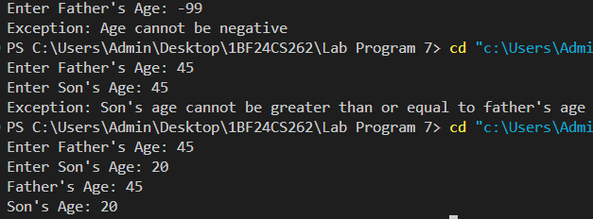

Program 8: Multi Threading
Code:

class MessageThread extends Thread {
String message;
int interval;
int count;

MessageThread(String msg, int time, int count) {
this.message = msg;
this.interval = time;
this.count = count;
}

public void run() {
try {
for (int i = 1; i <= count; i++) {
System.out.println(message);
Thread.sleep(interval);
}
} catch (InterruptedException e) {
System.out.println("Thread Interrupted");
}
}
}

public class Main {
public static void main(String[] args) {

MessageThread t1 = new MessageThread("BMS College of Engineering", 10000, 5);

MessageThread t2 = new MessageThread("CSE", 2000, 10);

t1.start();
t2.start();
}
}

Output:
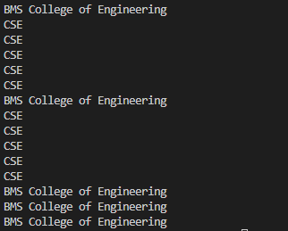

Program 9: Open Ended Question 1
Code:

import javax.swing.*;
import java.awt.*;
import java.awt.event.*;

public class DivisionUI extends JFrame implements ActionListener {

JTextField num1Field, num2Field, resultField;
JButton divideButton;

DivisionUI() {
setTitle("Integer Division");
setSize(350, 200);
setDefaultCloseOperation(JFrame.EXIT_ON_CLOSE);
setLayout(new GridLayout(4, 2, 5, 5));

add(new JLabel("Num 1:"));
num1Field = new JTextField();
add(num1Field);

add(new JLabel("Num 2:"));
num2Field = new JTextField();
add(num2Field);

divideButton = new JButton("Divide");
add(divideButton);

divideButton.addActionListener(this);

add(new JLabel("Result:"));
resultField = new JTextField();
resultField.setEditable(false);
add(resultField);

setVisible(true);
}

public void actionPerformed(ActionEvent e) {
try {
int num1 = Integer.parseInt(num1Field.getText());
int num2 = Integer.parseInt(num2Field.getText());

if (num2 == 0) {
throw new ArithmeticException("Cannot divide by zero");
}

int result = num1 / num2;
resultField.setText(Integer.toString(result));

} catch (NumberFormatException ex) {
JOptionPane.showMessageDialog(this,
"Please enter valid integers!",
"Number Format Error",
JOptionPane.ERROR_MESSAGE);

} catch (ArithmeticException ex) {
JOptionPane.showMessageDialog(this,
ex.getMessage(),
"Arithmetic Error",
JOptionPane.ERROR_MESSAGE);
}
}

public static void main(String[] args) {
new DivisionUI();
}
}

Output:
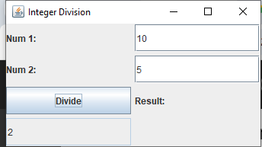

Program 10: Open Ended Question 2
Code:

class Q {

int n;
boolean valueSet = false;

synchronized int get() {
while (!valueSet) {
try {
System.out.println("\nConsumer waiting\n");
wait();
} catch (InterruptedException e) {
System.out.println("InterruptedException caught");
}
}

System.out.println("Got: " + n);
valueSet = false;

System.out.println("\nIntimate Producer\n");
notify();

return n;
}

synchronized void put(int n) {
while (valueSet) {
try {
System.out.println("\nProducer waiting\n");
wait();
} catch (InterruptedException e) {
System.out.println("InterruptedException caught");
}
}

this.n = n;
valueSet = true;
System.out.println("Put: " + n);

System.out.println("\nIntimate Consumer\n");
notify();
}
}

class Producer implements Runnable {

Q q;

Producer(Q q) {
this.q = q;
new Thread(this, "Producer").start();
}

public void run() {
int i = 0;
while (i < 5) {
q.put(i++);
}
}
}

class Consumer implements Runnable {

Q q;

Consumer(Q q) {
this.q = q;
new Thread(this, "Consumer").start();
}

public void run() {
int i = 0;
while (i < 5) {
int r = q.get();
System.out.println("Consumed: " + r);
i++;
}
}
}

public class main {
public static void main(String args[]) {
Q q = new Q();
new Producer(q);
new Consumer(q);
System.out.println("Press Control-C to stop.");
}
}

Output:
