**PIZZA SALES SQL QUERIES**

**. KPI’s**

**1. Total Revenue:**

**-- total revenue**

SELECT SUM(total_price) AS total_revenue FROM pizza_sales;

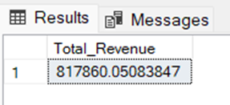

**2. Average Order Value**

SELECT SUM(total_price) / COUNT(DISTINCT order_id))AS Avg_order_Value FROM pizza_sales

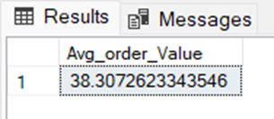

**3. Total Pizzas Sold**

SELECT SUM(quantity) AS Total_pizza_sold FROM pizza_sales

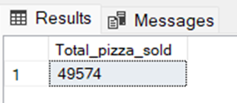

**4. Total Orders**

SELECT COUNT(DISTINCT order_id) AS Total_Orders FROM pizza_sales

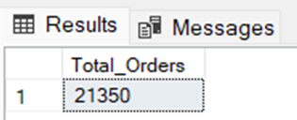

**5. Average Pizzas Per Order**

SELECT CAST(CAST(SUM(quantity) AS DECIMAL(10,2)) /

CAST(COUNT(DISTINCT order_id) AS DECIMAL(10,2)) AS DECIMAL(10,2))

AS Avg_Pizzas_per_order FROM pizza_sales

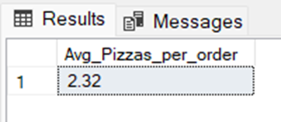

**B. Hourly Trend for Total Pizzas Sold**

SELECT HOUR(order_time) as order_hour , SUM(quantity) as total_pizza_sold

FROM pizza_sales

GROUP BY HOUR(order_time)

ORDER BY HOUR(order_time);

***Output***

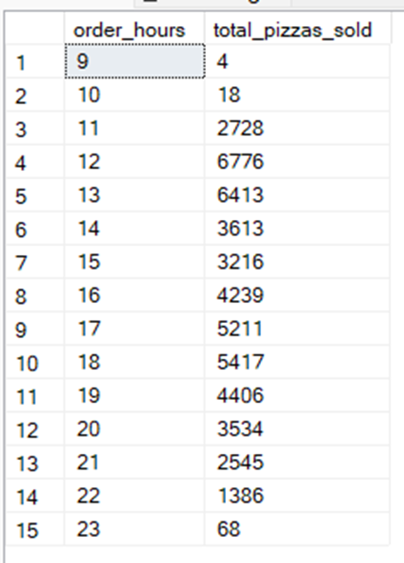

**C. Weekly Trend for Orders**

SELECT WEEK(order_date, 3) AS WeekNumber,

YEAR(order_date) AS Year,

COUNT(DISTINCT order_id) AS Total_orders

FROM pizza_sales

GROUP BY WEEK(order_date, 3),YEAR(order_date)

ORDER BY Year, WeekNumber;

**Output**

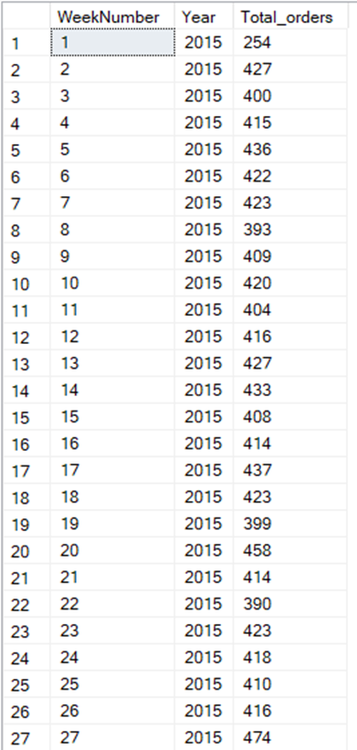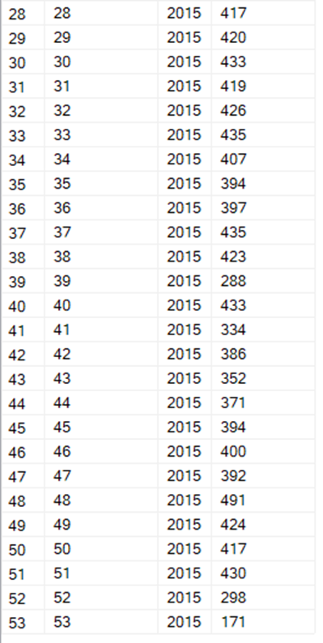

**D. % of Sales by Pizza Category**

SELECT pizza_category, CAST(SUM(total_price) AS DECIMAL(10,2)) as total_revenue,

CAST(SUM(total_price) * 100 / (SELECT SUM(total_price) from pizza_sales) AS DECIMAL(10,2)) AS PCT

FROM pizza_sales

GROUP BY pizza_category

***Output***

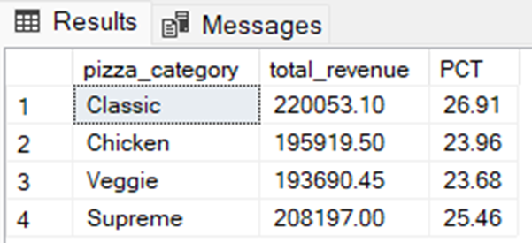

**E. % of Sales by Pizza Size**

SELECT pizza_size, CAST(SUM(total_price) AS DECIMAL(10,2)) as total_revenue,

CAST(SUM(total_price) * 100 / (SELECT SUM(total_price) from pizza_sales) AS DECIMAL(10,2)) AS PCT

FROM pizza_sales

GROUP BY pizza_size

ORDER BY pizza_size

***Output***

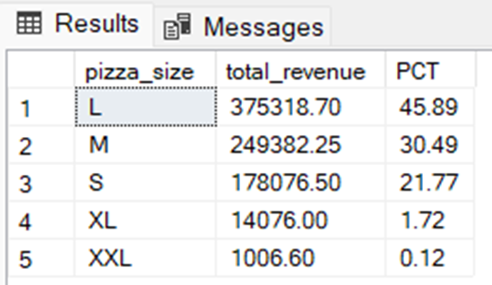

**F. Total Pizzas Sold by Pizza Category**

SELECT pizza_category, SUM(quantity) as Total_Quantity_Sold

FROM pizza_sales

GROUP BY pizza_category

ORDER BY Total_Quantity_Sold DESC

***Output***

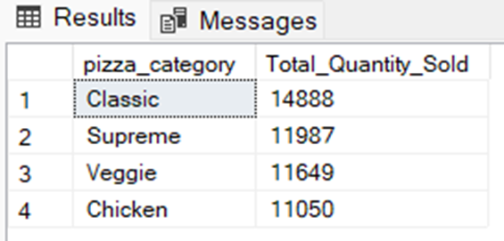

**G. Top 5 Pizzas by Revenue**

SELECT pizza_name , SUM(total_price) as total_revenue FROM pizza_sales

GROUP BY pizza_name

ORDER BY total_revenue desc

limit 5;

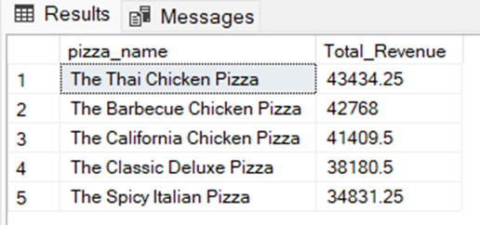

**H. Bottom 5 Pizzas by Revenue**

SELECT pizza_name , SUM(total_price) as total_revenue FROM pizza_sales

GROUP BY pizza_name

ORDER BY total_revenue asc

limit 5;

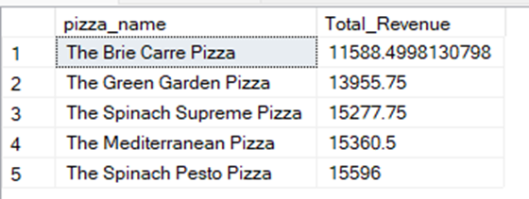

**I. Top 5 Pizzas by Quantity**

SELECT pizza_name , sum(quantity) as total_quantity FROM pizza_sales

GROUP BY pizza_name

ORDER BY total_quantity desc

limit 5;

***Output***

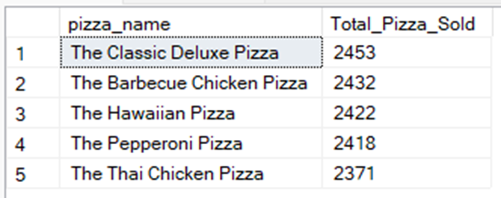

**J. Bottom 5 Pizzas by Quantity**

SELECT pizza_name , sum(quantity) as total_quantity FROM pizza_sales

GROUP BY pizza_name

ORDER BY total_quantity desc

limit 5;

***Output***

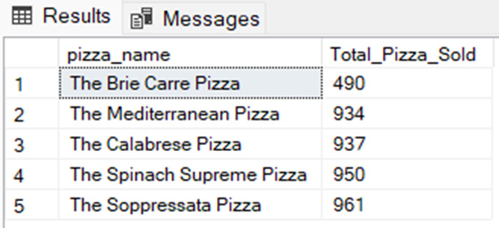

**K. Top 5 Pizzas by Total Orders**

SELECT pizza_name , COUNT(distinct order_id) as total_order FROM pizza_sales

GROUP BY pizza_name

ORDER BY total_order desc

limit 5;

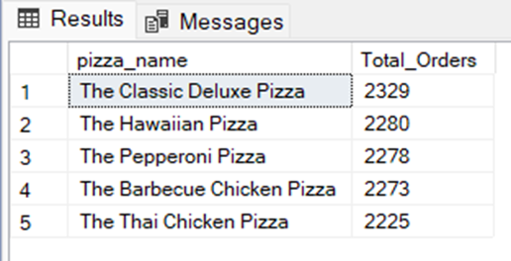

**L. Bottom 5 Pizzas by Total Orders**

SELECT pizza_name , COUNT(DISTINCT order_id) as total_order FROM pizza_sales

GROUP BY pizza_name

ORDER BY total_order asc

limit 5;

