INSTAGRAM

Project Documentation
A full-stack Instagram-inspired social photo application
Project | instagram-clone
Technology | Next.js 16, React 18, TypeScript, Tailwind CSS
Backend services | NextAuth.js, MongoDB/Mongoose, Amazon S3, CloudFront
Document date | 17 October 2026

Prepared from the application source and supplied UI screenshots

Contents
- 1. Project overview
- 2. Technology and architecture
- 3. Main features and user workflows
- 4. Project structure
- 5. API and data model reference
- 6. Local setup and configuration
- 7. Screenshots
- 8. Maintenance and extension notes

1. Project overview
This project is a full-stack social photo application inspired by Instagram. It provides an authenticated user experience for sharing image and video posts, browsing a personalized feed, discovering content, managing a profile, following other users, receiving notifications, bookmarking posts, and exchanging direct messages.
The current application is implemented as a Next.js App Router project. The client interface is built with React components and Tailwind CSS utility classes, while server-side route handlers provide authentication-aware APIs for MongoDB-backed data and signed media uploads.

Project goals
- Provide a familiar social-media interface with persistent navigation and responsive content views.
- Support secure sign-in through Google OAuth using NextAuth.js.
- Persist users, posts, relationships, comments, notifications, bookmarks, and messages in MongoDB.
- Store uploaded media in object storage and serve it through a CDN-friendly public URL.
- Demonstrate modern full-stack web programming patterns using TypeScript and the Next.js App Router.

2. Technology and architecture
Layer | Technology | Responsibility
Presentation | React 18 + Next.js App Router | Renders the application shell, feed, profile, explore, messages, notifications, and upload modal.
Styling | Tailwind CSS + CSS variables | Provides responsive layout, light/dark theme tokens, spacing, typography, states, and component styling.
Authentication | NextAuth.js + Google provider | Creates and maintains authenticated sessions and provisions a local User document on first sign-in.
API | Next.js route handlers | Validates requests, checks sessions, connects to MongoDB, and returns JSON responses.
Database | MongoDB + Mongoose | Stores users, posts, comments, notifications, conversations, and messages.
Media | Amazon S3 + presigned URLs + CloudFront | Supports direct browser uploads and public media delivery without routing file bytes through the app server.

High-level request flow
- The browser loads the Next.js application and the session provider checks the current NextAuth session.
- Authenticated client components call route handlers such as /api/posts, /api/users, /api/notifications, and /api/dms.
- Route handlers validate the session, connect through the cached Mongoose connection, query or update documents, and return JSON.
- For media, the browser requests a signed S3 upload URL, uploads directly to S3, then creates a post containing the resulting public media URL.
- The interface updates optimistically where appropriate and refreshes feed or notification data after successful mutations.

Authentication flow
Google OAuth is configured in [lib/auth.ts]. On first successful sign-in, the application looks up the email address in the User collection. If no record exists, it creates a username derived from the email prefix and adds a numeric suffix if necessary. The user ID and username are then carried through the JWT and session callbacks for API authorization and client rendering.

3. Main features and user workflows
Feature | Description
Home feed | Loads the signed-in user's posts and posts from followed users, sorted newest first. Uses cursor pagination with a default page size of 20.
Explore | Displays a visual grid of content for discovery. The supplied Explore screenshot shows the three-column image grid and persistent sidebar.
Create post | Accepts supported images or videos, generates a preview, collects an optional caption and location, uploads to S3, and creates a MongoDB post record.
Profiles | Shows profile image, name, username, biography, post/follower/following counts, follow controls, tabs, and a post grid. Owners can delete their posts.
Search and follow | Searches users through /api/users/search and allows follow/unfollow actions with optimistic UI updates.
Likes, comments, bookmarks | Post interactions are represented by dedicated API routes and update the post or the current user's bookmarks.
Notifications | Lists recent like, follow, and comment events, supports marking one or all notifications as read, and shows an unread indicator.
Direct messages | Lists conversations and provides a conversation view backed by DMConversation and DMMessage documents.
Theme switch | Toggles the dark class on the document root and uses CSS variable-based color tokens for light and dark themes.

Typical post publishing workflow
- Choose Create from the sidebar.
- Select an image or video. The client accepts common image formats and MP4, WebM, and QuickTime video formats.
- Review the preview and enter an optional caption and location.
- The client requests a presigned upload URL from /api/upload and uploads the file directly to object storage.
- The client sends the public media URL and post metadata to /api/posts.
- The feed refreshes and displays a confirmation message after the post is created.

4. Project structure
Path | Purpose
app/page.tsx | Root page that renders the main InstagramApp component.
app/layout.tsx | Root layout, metadata, server session lookup, and SessionProvider wrapper.
app/globals.css | Tailwind directives, theme variables, and base styles.
components/instagram-app.tsx | Primary client shell: navigation, tabs, feed state, search, notifications, messages, theme, and profile editing.
components/post.tsx | Post card rendering and post-level actions.
components/profile.tsx | Profile data loading, follow state, profile header, tabs, and post grid.
components/create-post.tsx | Upload modal, local preview, metadata entry, S3 upload flow, and post creation.
app/api/** | Authenticated route handlers for posts, users, follows, notifications, DMs, authentication, and uploads.
models/** | Mongoose schemas for User, Post, Comment, Notification, DMConversation, and DMMessage.
lib/auth.ts | NextAuth configuration and session/JWT callbacks.
lib/mongoose.ts | Cached MongoDB connection helper.
tailwind.config.js | Tailwind content paths, theme tokens, Instagram gradient, and dark-mode configuration.
package.json | Scripts and runtime/development dependencies.

5. API and data model reference

API route summary
Route | Methods | Purpose
/api/auth/[...nextauth] | GET, POST | NextAuth Google OAuth endpoints.
/api/posts | GET, POST | Read the personalized feed with cursor pagination; create a post.
/api/posts/[postId] | GET | Read a single post.
/api/posts/[postId]/like | POST | Like or unlike a post.
/api/posts/[postId]/bookmark | POST | Add or remove a post from bookmarks.
/api/posts/[postId]/comments | GET, POST | Read and create comments.
/api/posts/[postId]/delete | DELETE | Delete an owned post.
/api/upload | POST | Validate media type and return a presigned S3 upload URL.
/api/users/search | GET | Search users by query.
/api/users/me | GET, PATCH | Read or update the current user profile.
/api/users/[userId] | GET | Read profile data and posts for a user.
/api/users/[userId]/follow | POST | Toggle following relationship.
/api/users/[userId]/followers | GET | List followers.
/api/users/[userId]/following | GET | List accounts followed by a user.
/api/notifications | GET, PATCH, DELETE | List, mark read, or delete notifications.
/api/dms | GET, POST | List conversations or create a conversation/message.
/api/dms/[conversationId] | GET, POST | Read a conversation or send a message within it.

MongoDB collections
Model | Important fields and indexes
User | name, email, username, image, bio, followers, following, bookmarks. Unique indexes on email and username.
Post | user, caption, location, imageUrl/videoUrl, mediaType, likes. Indexes on user and createdAt support feed queries.
Comment | post, user, text. Index on post and createdAt.
Notification | recipient, sender, type, optional post/comment, read. Indexes support recipient, unread, and chronological queries.
DMConversation | participants, lastMessage. Participant index supports conversation lookup.
DMMessage | conversationId, sender, text, optional imageUrl, readBy. Conversation/time index supports message history.

6. Local setup and configuration
The following steps describe a local development setup. Secret values are intentionally not reproduced in this document. Use the project's .env.example as the variable-name template and provide your own credentials locally.
- Install Node.js compatible with the project dependencies and ensure npm is available.
- From the project root, install dependencies with npm install.
- Copy .env.example to .env.local.
- Create a Google OAuth application and configure its callback for the local NextAuth URL.
- Start MongoDB locally or provide a reachable MongoDB connection string.
- Configure an AWS S3 bucket, IAM permissions for signed PUT uploads, and the public CloudFront base URL.
- Start the development server with npm run dev and open http://localhost:3000.

Environment variables
Variable | Required use
NEXTAUTH_URL | Base URL used by NextAuth; local development commonly uses http://localhost:3000.
NEXTAUTH_SECRET | Secret used to sign/encrypt NextAuth session data; use a long random value.
GOOGLE_CLIENT_ID / GOOGLE_CLIENT_SECRET | OAuth credentials for the Google provider.
MONGODB_URI | MongoDB connection string for application data.
AWS_REGION | AWS region containing the upload bucket.
AWS_ACCESS_KEY_ID / AWS_SECRET_ACCESS_KEY | AWS credentials used by the server to create signed upload URLs. Keep them private.
S3_BUCKET_NAME | Target bucket for uploaded media.
NEXT_PUBLIC_CLOUDFRONT_URL | Public CDN base URL used to build media URLs.

Operational notes
- Never commit .env.local or share credentials. Rotate any credential that has been exposed.
- The upload handler allows JPEG, PNG, WebP, GIF, MP4, WebM, and QuickTime media and defines a 100 MB maximum size constant.
- The current implementation expects the public CDN URL to be configured if newly uploaded media should be publicly viewable.
- Authentication is required for the feed and mutation APIs; unauthenticated users are shown a Google sign-in entry point.

7. Screenshots
The following screenshots were supplied with the request and are included as visual references for the implemented interface. They show the key navigation, content, and profile surfaces.
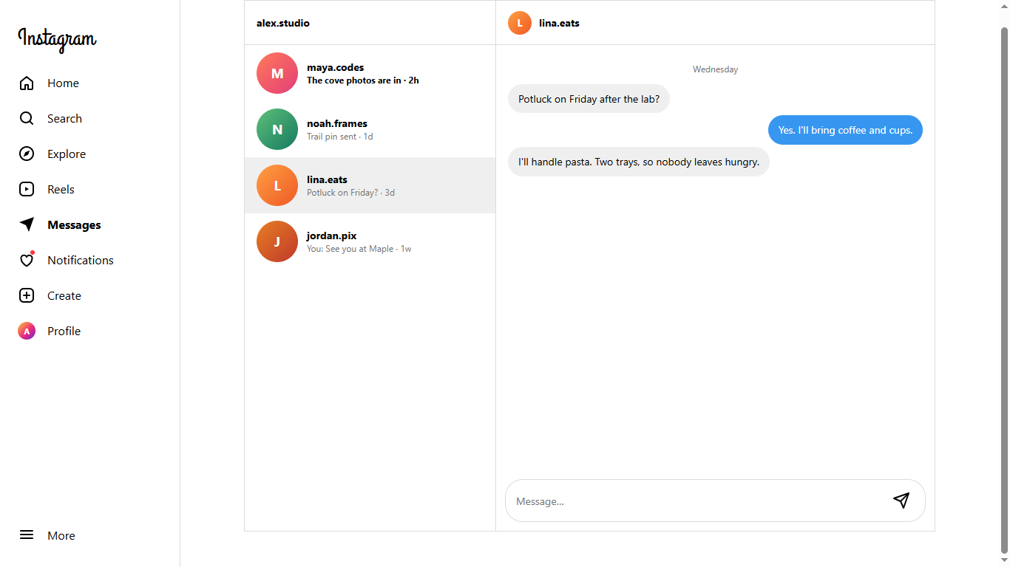
Messages screen
The messaging workspace shows the conversation list, selected conversation, message history, and message composer.
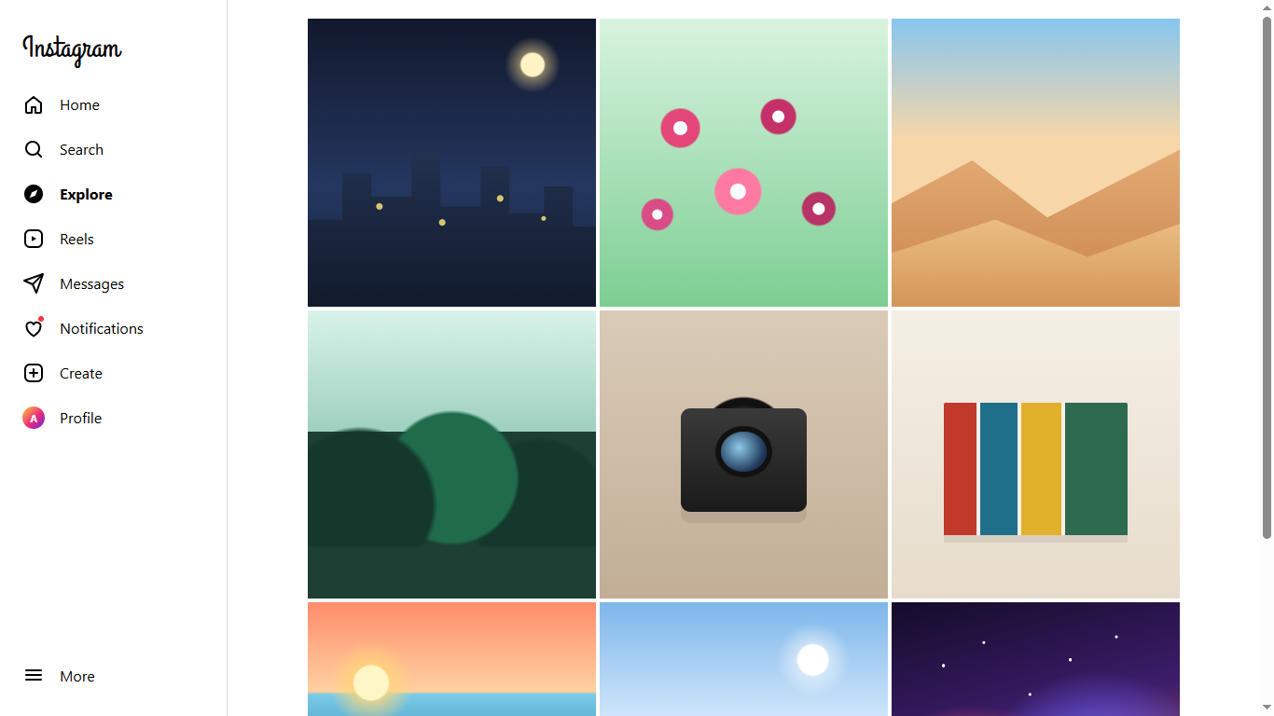
Explore screen
The Explore view presents a responsive image grid for discovering posts.
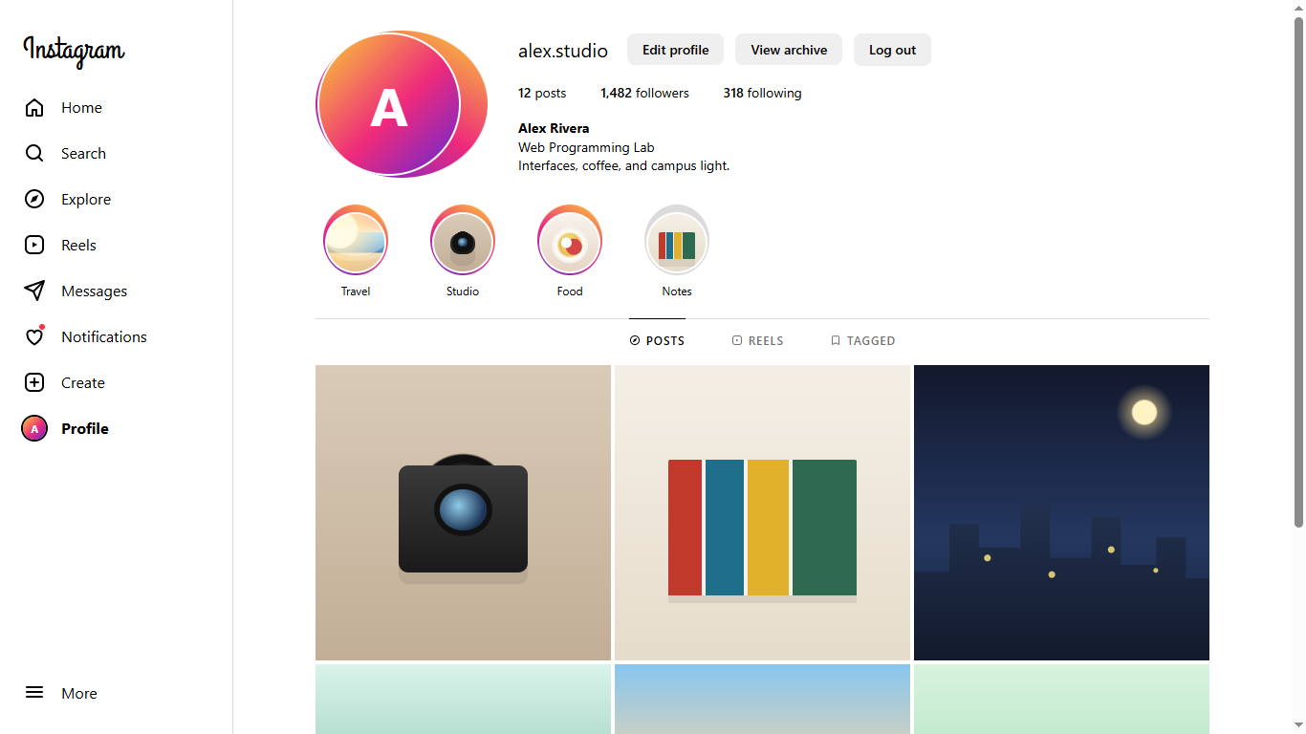
Profile screen
The profile view presents account details, counts, story highlights, tabs, and the post grid.

8. Maintenance and extension notes
- Keep route handlers session-aware and validate ownership before modifying posts, profiles, or notifications.
- Preserve the cached database connection pattern in lib/mongoose.ts to avoid creating excess connections during development reloads.
- When adding a new feature, update the relevant Mongoose model, route handler, client state, and this documentation together.
- Use the existing Tailwind theme tokens and dark-mode class rather than hard-coding new colors in component markup.
- Add automated tests for authentication boundaries, upload validation, ownership checks, pagination, and follow/notification side effects as the project grows.

Conclusion
This project provides a practical full-stack foundation for an Instagram-style application. Its separation between client components, authenticated route handlers, Mongoose models, and external media storage makes it suitable for classroom demonstration, feature expansion, and further production hardening.

