**ECG**

**Introduction**

The electrical functionality of various organs in the human body is expressed by bioelectrical signals. Amongst all other bioelectrical signals ECG is an important one. The properties and performance of the human heart is reflected by it. ECG conveys important hidden information in the structure of the human heart [1]. Extraction of this information is done before its useful interpretation and analyses. These extractions of ECG signal information are helpful in identifying and explaining different pathological conditions. Then the ECG is visually analyses on screen or paper to extract the features. To make analysis the time duration of signals plays a very important role, which is why manual analysis of ECG signals is a time consuming process. Manual analysis is accompanied by errors. Hence, to extract significant information ECG signal processing has become a crucial tool, thereby minimizing the subjectivisms of manual analysis.

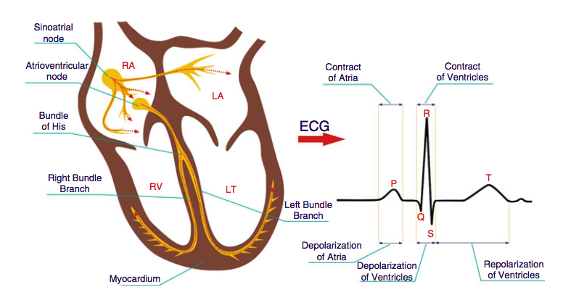

Fig. 1( Heart nodes and signal)

**Electrocardiography**

Registration of electrical activity against time is known as electrocardiography. During the depolarization and repolarization of the myocardial fibers there is change in the electrical potential difference which is recorded by electrodes places at the limbs and chest. The electrical potentials are generated by the contractile cardiac muscle cells. The waveform generated from ECG is either shown on a screen or is printed in the form of a graph on a paper. ECG is easily cost effective, easily available and readily implemented. It is a non-invasive procedure. ECG can used to scrutinize the abnormal functions of heart which includes blood flow disturbances, arrhythmias and defects in heart morphology. Performance of pacemakers can also be accessed with the help of ECG.

Conduction system of the heart

The Cardiac muscle is made up of two types of cells: cardiomyocytes, which generate electrical potential at the time of contraction and the cells which generate and conduct the action potentials [2]. These cells depolarize simultaneously.

There are five specialized tissues in the conductive system of the heart

1. Sinoatrial node
2. Atrioventricular node
3. Bundle of His
4. Right and Left bundle branch
5. Purkinje fibres

At SA node an impulse arises and traverse through atria which in turn depolarizes the atria. From there the impulse goes to AV node with some delay which in turn will allow atria to contract and pump blood into the ventricles. The impulse then spreads through bundle of His, right and left bundles and Purkinje fibres depolarizing the ventricles.

**ECG Leads**

ECG has twelve leads out of which sic are limb leads and the other six are chest leads as can be shown in figure 1.

Figure 2: Different Leads in ECG.

The leads are the electrodes which are used to pick up the cells electrical activity which in turn is converted to waves with the help of ECG machine [2].

**Interpretation**

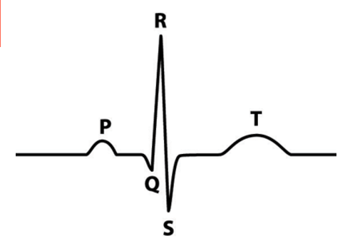

Figure 3: ECG Waveform [3].

PR Interval: Atrioventricular conduction time.

QRS Complex: Ventricular Depolarization.

QT Interval: Ventricular activity (depolarization and repolarization).

ST Interval: Early part of ventricular repolarization.

**ECG Signal**

ECG signal processing and analysis include a number of step among which the most important is

-: Amplification of signal and its A/C converter

-: Noise Elimination

-: Feature selection

All these features are really important because these steps shows the quality of overall process in a effective way.On the other hand signal amplification and A/C converter are perform in Hardware and Noise elimination perform by the computational power.

Processing of ECG signals:-

ECG signal is a important diagnostic information in cardiology. So, if you want to use this information, the signals has to be properly recorded and processed so you can perform an analysis. ECG signals are quasi-periodic of relatively low amplitude .When you are recorded ECG signals there are high probability they are affected by the noise. If order to perform the analysis you need to suppress noise to get better result.

The First step of overall processing is an analog to digital conversion, in order to eliminate the noise the further methods has to be feature selection, wave classification and analysis.

The overall ECG signal Processing include the following steps

Signal amplification

Analog to digital conversion

Noise suppression (filtering)

Data Compression

Features selection

Signal Classification

Interpretation

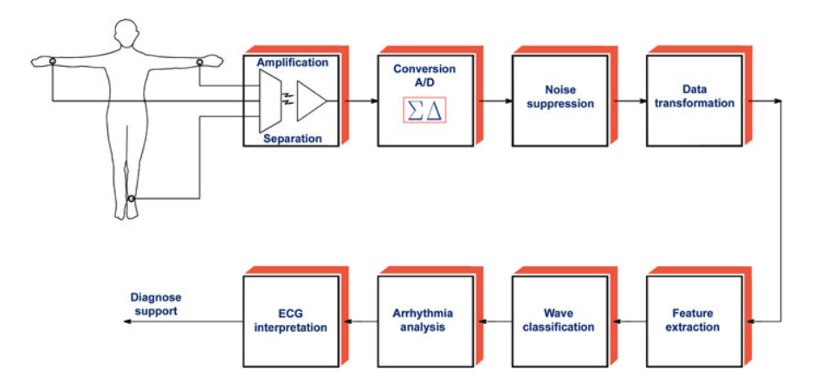

Fig.4 ECG signal processing

Amplification of ECG signals:-

You can recorder the ECG signals from various part of the body. But for the ECG we will recorded signals from the skin of chest and limbs. ECG signals are different from the microvolt to millivolt range. Because of this small range the signals need to be amplified in order to get better result for analysis. We perform galvanic separation for safety requirements in signal amplification of signal processing in first steps. In this process, signal is amplified several times to get a better result.

Analog to Digital Conversion :- In the process of analog to digital conversion, analog signal is converted into the digital signal which can be further stored in computer to further processing. In ECG we get analog signals from the our body part and than we convert those signal in discrete digital signals to perform the computer process on them.

Noise Suppression:- ECG signal always affected by the noise. Out of the all noise muscle noise and frequency noise are the most one that are difficult to handle. So, we used computer software to remove this noise to get out ECG signals

Data Compression:- In this ECG signals concern a transformation of data to some other format in order to enhance effectiveness of processing . We can reduce an amount of information to be proceed.

Features Extraction:- The main step of ECG signal is analysis of signal formation of a features space that is a collection of data that fully capture of the signal. We try to get the high discriminatory power which is important to get the ECG signal. However they are could be define in frequency domain. It is also possible to extract features at different domain.

ECG signal classification:-The classification of ECG signal are the discrimination of P-QRS-T signal complex as belong to the existing class. But the discrimination is mostly based n the shape of the QRS complex. The shape of QRS complex expressed in the term of shape, width and slope of R wave.

-Ventricular complex VC

-Supraventricular complex SVC

-Premature ventricular complex PVC

-Premature supraventricular complex PSVC

Basically, P-QRS-T complex in ECG signal from a basic analysis of the heart rhythm distribution.

Reference:-

[1] T. K. Abishek, S. Hariharan, and M. V Ramesh, “Signal Processing Algorithm for Wireless ECG Monitoring Systems.”

[2] S. M, *Learn ECG in a Day: A Systematic Approach*. 2013.

[3] “EKG Waveform | Lessons | Drills.” [Online]. Available: https://ekg.academy/ekg-waveform-lesson. [Accessed: 04-Oct-2017].

[4] Afonoso,VX,Thompkins,W.J, Nguyen: ECG beat detection using the filter breaks.

IEEE Trans. Bionmed ENG 46(2),192-202(1999)

[5] Ahmend, N., Milne, P.I: Electrocardiographic data compression via orthogonal transform

IEEE Trans. Biomed Eng. BME-22,484-487(1975)