A PROJECT REPORT ON

“Fake Social Media Detection Using Machine Learning Techniques ”

Submitted for fulfillment of award of the degree

BACHELOR OF TECHNOLOGY
(Computer Science & Engineering)
BY

Dhanashree Ravindra More (MITU23BTCSD020)
Dhanshree Ganesh Gavali (MITU23BTCSD021)
Payal Rohidas Pawshe (MITU23BTCSD044)
Sahil Sanjay Gaikwad (MITU22BTCS0685)

Under the guidance of
Prof . Dr.Rohit Pachlor


Department of Computer Science and Engineering

MIT School of Computing

MIT Art, Design and Technology University, Pune

MAEER’s Rajbaug Campus, Loni-Kalbhor, Pune 412201
November, 2023



MIT SCHOOL OF COMPUTING
DEPARTMENT OF COMPUTER SCIENCE & ENGINEERING
MAEER’s Rajbaug Campus, Loni-Kalbhor, Pune - 412201

CERTIFICATE

This is to certify that the project report entitled

“Fake Social Media Detection Using Machine Learning Techniques ”

Submitted by

Dhanashree Ravindra More (MITU23BTCSD020)
Dhanshree Ganesh Gavali (MITU23BTCSD021)
Payal Rohidas Pawshe (MITU23BTCSD044)
Sahil Sanjay Gaikwad (MITU22BTCS0685)

is a bonafide work carried out by students under the supervision of Prof . Dr.Rohit Pachlor and it is submitted towards the fulfillment of the requirement of MIT-ADT University, Pune for the award of the degree of Bachelor of Technology (Computer Science & Engineering )

(Prof. Dr.________________) (Prof. Dr_______________)
Guide Co-Guide

Prof.
Project Coordinator Professor & Head of the Department

Prof. Dr. Kishore Ravande
Principal

Seal/Stamp of the College
Place : Date

DECLARATION

We, the team members
Name | Enrollment No
Dhanashree Ravindra More | (MITU23BTCSD020)
Dhanshree Ganesh Gavali | (MITU23BTCSD021)
Payal Rohidas Pawshe | (MITU23BTCSD044)
Sahil Sanjay Gaikwad | (MITU23BTCS0685)

Hereby declare that the project work incorporated in the present project entitled “Collaborative Framework for Information Diffusion in Online Social Network” is original work. This work (in part or in full) has not been submitted to any University for the award or a Degree or a Diploma. We have properly acknowledged the material collected from secondary sources wherever required. We solely own the responsibility for the originality of the entire content.

Date:

Name & Signature of the Team Members

Name & Signature of the Guide

Seal/Stamp of the College
Place : Date :



DEPARTMENT OF COMPUTER SCIENCE & ENGINEERING
MIT SCHOOL OF ENGINEERING,
RAJBAUG, LONI KALBHOR,
PUNE – 412201

EXAMINER’S APPROVAL CERTIFICATE

The project report entitled “Fake Social Media Detection Using Machine Learning Techniques” submitted by Dhanashree Ravindra More, Dhanshree Ganesh Gavali , Payal Rohidas Pawshe , Sahil Sanjay Gaikwad in partial fulfilment for the award of the degree of “Bachelor of Technology ( Computer Science & Engineering) ” during the academic year 2019-20, of MIT-ADT University, MIT School of Engineering, Pune, is hereby approved.

Examiners:

1.

2.

ACKNOWLEDGEMENT

I express my profound thanks to my Guide _____________ for her expert guidance, encouragement and inspiration during this project work.
I would like to thank Dr. Reena Pagare, Project Coordinator, Department Computer Science & Engineering for extending all support during the execution of the project work.

I sincerely thank to Prof. Dr. Rajneeshkaur Sachdeo, Head, Department of Computer Science & Engineering, MIT School of Engineering, MIT-ADT Univer- sity, Pune, for providing necessary facilities in completing the project.

I am grateful to Prof. Dr. Kishore Ravande, Principal, MIT School of Engi- neering, MIT-ADT University, Pune, for providing the facilities to carry out my project work.

I am thankful to Prajakta Kashalkar, DevOps Lead, IBM PureApplication, IBM India, Pune, Pallavi Singh, Senior Software Engineer, IBM India, Pune, as well as Sanjay Singh, Cloud Engineer, IBM Cloud Orchestrator, IBM India, Pune for guiding me to carry out my project work.

I also thank all the faculty members in the Department for their support and advice.

Name, Enrollment No.

Abstract
The proliferation of fake accounts on social media platforms, particularly Instagram, has raised concerns regarding misinformation, fraud, and compromised user trust. This study explores the efficacy of machine learning techniques for detecting fake accounts by leveraging two prominent datasets—InstaFake and IJECE. Using preprocessing techniques like SMOTE for class balancing and models such as Random Forest, Decision Trees, and Neural Networks, we aim to identify attributes that distinguish real from fake accounts. The Random Forest model emerged as the best performer with an F1-score of 0.95, demonstrating its robustness in identifying fraudulent accounts. This paper discusses the methodologies, results, and opportunities for enhancing social media platform integrity through advanced detection mechanisms.

CONTENTS
 | Certificate |  | I
 | Declaration |  | II
 | Acknowledgment |  | III
 | Abstract |  | IV
 | List of Figures |  | VII
 | List of Tables  List of Notations |  | VIII  IX
 | Contents
I | INTRODUCTION
 | 1.1 | Introduction to the System | 1
 | 1.2 | Problem Definition | 4
 | 1.3 | Aim | 7
 | 1.5 | Objectives | 12
 | 1.6 | Goal | 12
 | 1.7 | Need of System | 14
II | HARDWARE AND SOFTWARE REQUIREMENT
 | 2.1 | Introduction | 16
 | 2.2  2.3  2.4 | System environment  Software requirement  Hardware requirement
III | SYSTEM ANALYSIS
 | 3.1 | Purpose
 | 3.5 | Project Scope | 37
 | 3.6 | Existing System | 39
 | 3.7 | Proposed System
 | 3.8 | System Description
IV |  | IMPLEMENTATION ISSUES
V |  | SYSTEM DESIGN | 40
VI | PROPOSED METHOD
 | 6.1 | Formulation | 51
 | 6.2 | Overview | 52
 | 6.3 | Framework Design  ……….. | 53
 | 6.4 | Result and Analysis ( Screenshots , Graphs)
 | .6.4.1 | Metrics | 63
 | 6.4.2 | Dataset | 64
 | 6.4.3 | Analysis | 65
 | 6.5 | Summary | 75
VII | 7.1  7.2 | SOFTWARE TESTING  Types of testing used  Test cases and results  PROJECT PLAN  Project Schedule  Project Cost Estimate | 77
VII | CONCLUSION AND FUTURE WORK |  | 80
 | BIBLIOGRAPHY |  | 83
 | Annexure A : Publications Details (first page of paper publication)  Annexure B: Laboratory assignments on Project Cost estimation, Mathematical modelling, testing.  Annexure C : Plagiarism Report |  | 93

List of Figures

Figure 1.1 | Use case diagram between ADMIN and SYSTEM | 14
Figure 2.1 | Use Case Diagram Between USER and SYSTEM | 17
Figure 2.2 | Use Case Diagram Between User and System | 17
Figure 2.3 | Sequence Diagram For Administrator | 21
Figure 3.1 | Sequence diagram for user | 22
Figure 4.1 | Data flow diagram | 43
Figure 5.1 | Er diagram
Figure 6.1 | Activity diagram

CHAPTER 1
INTRODUCTION

  - INTRODUCTION TO SYSYTEM

Social media platforms like Instagram have revolutionized global communication, fostering creativity and collaboration. However, their growth has also seen a surge in fake accounts used for spamming, phishing, and creating fake engagement. These malicious accounts exploit platform features for personal or financial gain, often deceiving users and businesses alike.Traditional detection methods, including manual moderation and rule-based algorithms, struggle to keep up with the sophisticated tactics employed by fraudsters. This has led to the adoption of machine learning (ML) techniques capable of analyzing large datasets and identifying subtle patterns indicative of fake behavior. This paper presents a comprehensive approach to fake account detection, employing two datasets—InstaFake and IJECE. By comparing various ML algorithms and evaluating their performance on metrics like precision, recall, and F1-score, we aim to identify the most effective model for this task.

  - PROBLEM DEFINATION
"Fake accounts on social media are comman, hard to spot manually, and always changing, which harms user and platform reliability."

  - AIM
To identify the most effective machine learning model for detecting fake Instagram accounts by analyzing and comparing algorithms using the InstaFake and IJECE datasets.

  - OBJECTIVE

The objective is to analyze the InstaFake and IJECE datasets to uncover patterns indicative of fake accounts, implement and compare various machine learning algorithms, and evaluate their performance using metrics like precision, recall, and F1-score. The ultimate goal is to identify the most effective detection model and propose strategies to reduce the prevalence of fake accounts on social media platforms.

  - GOAL

To develop a robust and efficient machine learning-based solution for detecting and mitigating fake accounts on social media platforms, enhancing user trust and platform integrity.

1.6 NEED OF THE SYSTEM

The rapid growth of social media platforms like Instagram has led to a surge in fake accounts used for spamming, phishing, and creating fake engagement, posing significant threats to users and businesses. Traditional detection methods, such as manual moderation and rule-based algorithms, struggle to keep pace with the sophisticated tactics employed by fraudsters. Therefore, there is a need for an advanced, data-driven system that leverages machine learning to effectively identify and mitigate fake accounts, ensuring platform security, enhancing user trust, and reducing fraudulent activities.

CHAPTER 2
HARDWARE AND SOFTWARE REQUIREMENTS

2.1 Contents:
- Software requirement
- Hardware requirements

2.2 Software Requirements:

- Technology: Python Django
- IDE : Vs code
- Client Side Technologies: HTML, CSS, JavaScript
- Server Side Technologies: Python
- Data Base Server: Sqlite
Operating System: Microsoft Windows/Linux

2.3 Hardware Requirements:
- Processor: Pentium-III (or) Higher
- Ram: 64MB (or) Higher
- Hard disk: 80GB (or) Higher

CHAPTER 3
SOFTWARE ANALYSIS
Contents:

Purpose
- Project Scope
- Existing System
- Proposed System
- System Overview

3.2 Project Scope:

This project aims to address the growing challenge of detecting fake accounts on social media platforms like Instagram by leveraging machine learning techniques. Using the InstaFake and IJECE datasets, the project will analyze user behavior and account attributes to identify patterns indicative of fake activity. Various machine learning algorithms will be implemented and evaluated on key performance metrics such as precision, recall, and F1-score to determine the most effective model. The scope includes comparing algorithm performance, optimizing detection accuracy, and providing insights for integrating the chosen model into social media systems to mitigate the impact of fake accounts and enhance platform security.

3.3 Proposed System:

The proposed system is a machine learning-based solution to detect fake accounts on social media platforms like Instagram. It will analyze datasets (InstaFake and IJECE) using various ML algorithms, evaluating them based on precision, recall, and F1-score. The goal is to identify the most effective model for automating fake account detection, offering higher accuracy and scalability compared to traditional methods, and improving platform security.

3.4 System Overview:

The system architecture for the Event Management System (EMS) is designed to ensure scalability, reliability, and flexibility to meet the dynamic needs of event organizers and attendees. The architecture comprises various components that work together seamlessly to facilitate event planning, execution, and evaluation. Below is an overview of the key components and their interaction.

CHAPTER 4
SYSTEM DESIGN
Contents:

- Use case diagram
- Class Diagram
- Sequence Diagram
- Data flow diagram
Use Case Diagram:
- Use case diagram consists of use cases and actors and shows the interaction between them. The key points are:
- The main purpose is to show the interaction between the use cases and the actor.
- To represent the system requirement from user’s perspective.
- The use cases are the functions that are to be performed in the module.
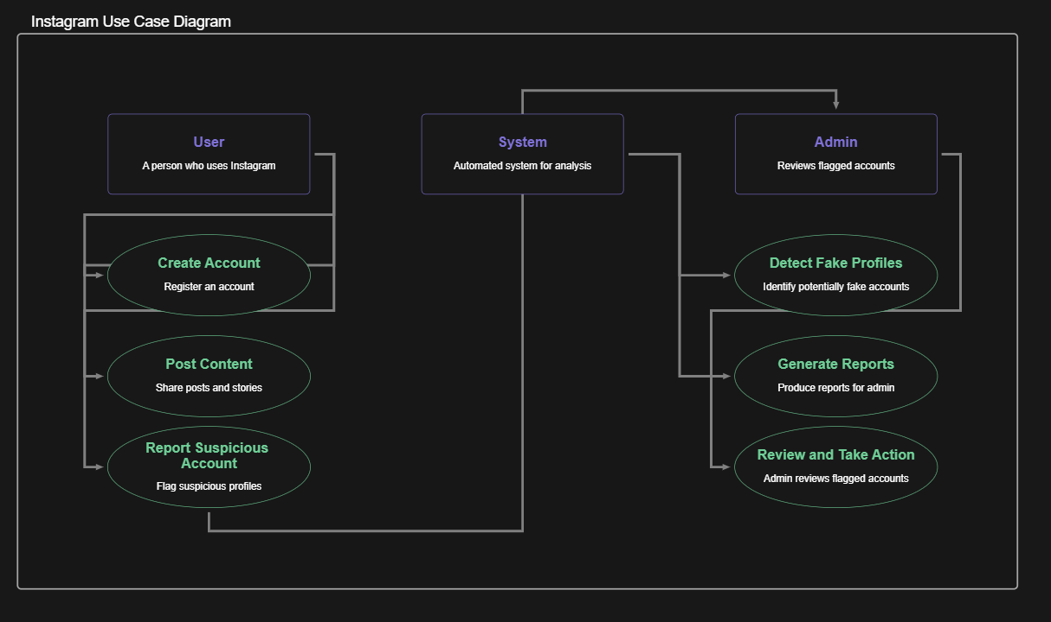

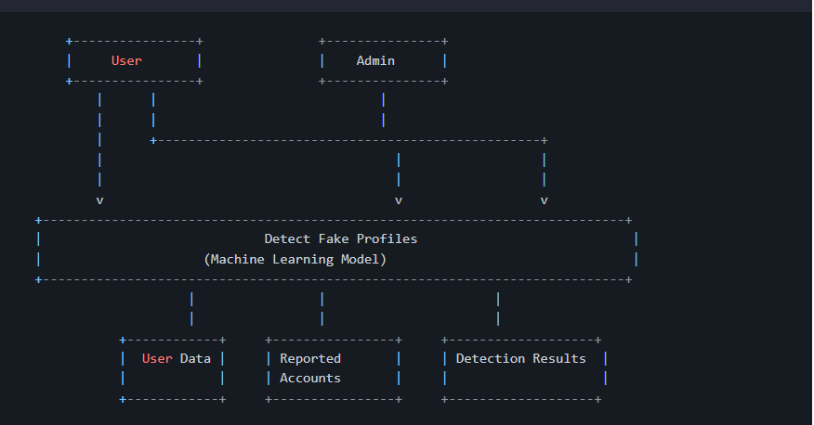
Flow Diagram

Level 0

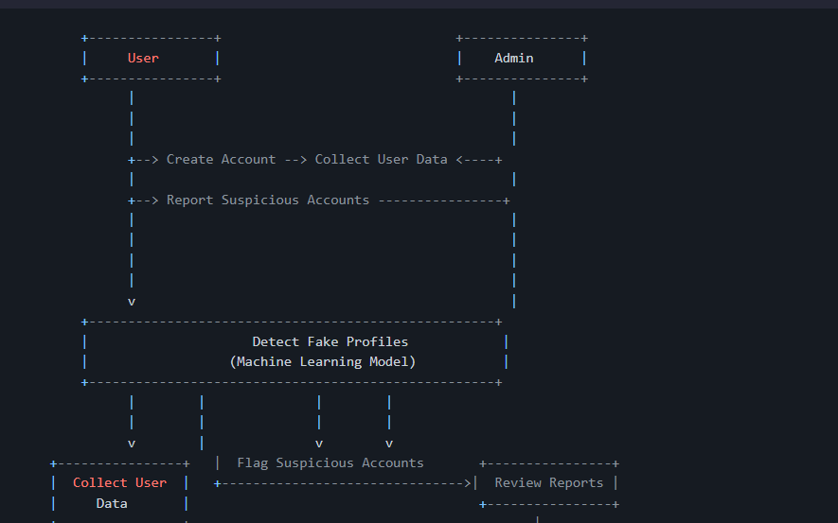
Level 1

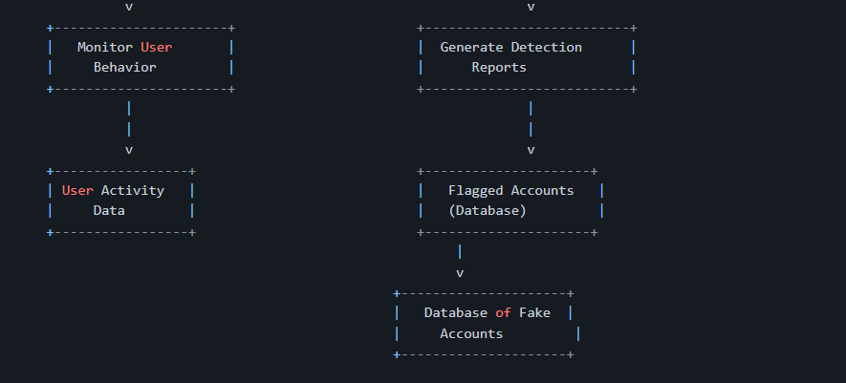

CHAPTER 5
SYSTEM DESIGN
Output screens

CHAPTER 6
ADVANTAGESE AND LIMITATIONS

Advantages of “ Event Bazaar ”
• Increased Accuracy: Machine learning algorithms can detect fake accounts with greater precision, reducing false positives and negatives compared to traditional methods.
• Scalability: The system can handle large volumes of data, making it suitable for platforms with millions of users.
• Automation: Automates the detection process, reducing the need for manual moderation and speeding up response times.
• Adaptability: Machine learning models can be updated and trained on new data, enabling them to adapt to evolving fraudulent tactics.
• Enhanced Security: Helps protect users and businesses from spam, phishing, and fake engagement, improving overall platform integrity.
• Cost-Effective: Reduces the need for manual intervention, lowering operational costs for platform owners.

CHAPTER 7
FUTURE SCOPE
FUTURE SCOPE
• Integration with Social Media Platforms: The system can be further developed to seamlessly integrate with social media platforms like Instagram, automating fake account detection in real-time.
• Continuous Learning: Future iterations can incorporate online learning techniques, allowing the model to continuously adapt and improve as new fraud patterns emerge.
• Cross-Platform Detection: The system can be expanded to detect fake accounts across multiple social media platforms, providing a more comprehensive solution to online fraud.
• Enhanced Features: Incorporating advanced features like natural language processing (NLP) for detecting fake content, or image recognition for identifying fake profile pictures, could further improve detection capabilities.
• Collaboration with Other Security Tools: The system could be integrated with other security tools, such as fraud detection systems or analytics platforms, to provide a more holistic approach to protecting users.
• Real-Time Detection and Prevention: Future work could focus on real-time detection, allowing platforms to instantly flag and take action against fake accounts as soon as they are identified.
• User Privacy Protection: Ensuring the system respects user privacy while detecting fake accounts, possibly through privacy-preserving ML techniques, could be a key area for development.

CONCLUSION

This study demonstrates the potential of machine learning techniques in detecting fake accounts on Instagram. Among the models tested, Random Forest achieved the best performance, balancing precision and recall while maintaining high accuracy.
While effective, the reliance on existing datasets highlights limitations like potential biases and class imbalance. Future work could focus on creating more comprehensive datasets and exploring hybrid models that combine the strengths of Random Forest and Neural Networks. Additionally, real-time detection systems incorporating contextual user behavior could further enhance detection accuracy.

REFERENCE

- Breiman, L. (2001). "Random Forests." Machine Learning, 45(1), 5-32.

- Chawla, N. V., Bowyer, K. W., Hall, L. O., & Kegelmeyer, W. P. (2002). "SMOTE: Synthetic Minority Over- sampling Technique." Journal of Artificial Intelligence Research, 16, 321-357.

- Chen, T., & Guestrin, C. (2016). "XGBoost: A Scalable Tree Boosting System." Proceedings of the 22nd ACM SIGKDD International Conference on Knowledge Discovery and Data Mining.

- Phua, C., Lee, V., Smith, K., & Gayler, R. (2010). "A Comprehensive Survey of Data Mining-based Fraud Detection Research." arXiv preprint arXiv:1009.6119.
- Bhattacharyya, S., Jha, S., Tharakunnel, K., & Westland, J. C. (2011). "Data Mining for Credit Card Fraud: A Comparative Study." Decision Support Systems, 50(3), 602-613.

- Instagram Fake Account Detection Project Team (2023). Internal Report.

