Cycle report

Group 17
Project manager:
Harry IDNO.0517733317

Group members:
Amy IDNO.0517728158
Annie IDNO.0517723071
Betty IDNO.0517723415
David IDNO.0517727152

2009.1.2.

Catalogue
Introduction the project...........................................................1--3
Red Flags 3
Previous cycle results 4
Customer feed back 5
Cycle plan 5
Top10risks 6
Top10 system requirements 7
The webs chart 8
The Gantt chart 9

Introduction
The main function of management program of hotel as followed:

1. The function of the standard room module needs to achieve
The establishment of room standards, standard information inputting, standard’s name, room size, the number of beds, housing prices, whether or not there is air conditioning, TV, telephone, and a separate toilet.

Standard rooms’ information input, modifies, and query

2. Room’s basic information module to achieve functions.
Room’s basic information print out, include room’s number, room kinds, room’s size, room’s price, remarks information,
Room’s basic information inquiry, insert, this include room’s number, room kinds, room’s size, room’s price, remarks information,
Room’s basic information deleted.

3. Reservation module to achieve functions:
The remaining room’s information inquiry
Reservation information pointing out, include room’s number, room’s kinds, room’s size, room’s price, customer’s name, customer identity
1
card’s number, check in date, discount and remarks information.
Reservation information inquiring and inserting, include room’s number, room’s kinds, room’s size, room’s price, customer’s name, customer identity card’s number, check in date, discount and remarks information.
Reservation information deleted.
4. Check out information module to achieve function:
Check out information pointing out: include room’s number, room’s kinds, and room’s size, room’s price, and customer’s name, customer identity card’s number, checking in date, discount and remarks information.
Check out information inquiring and inserting, include room’s number, room’s kinds, room’s size, room’s price, customer’s name, customer identity card’s number, and check in date, discount and remarks information.
5. User’s information management module:
Inserting, inquiring and deleted the user’s information.
6. Assistance module
It includes the basic information of this system.
7. System setting module
Lock system.
2
Re-login system.
Exit system.
To analysis the above the functions, in accordance with the requirement of the program design, we can make a module chat:
Shuixing hotel management system
Reservation
Module
User’s information management module
The function of the standard room module
Check out information module
Room’s basic information module
Database design
Database has five tables which include: guest room Standard table, guest room basic information table, Reservation information table, check-out’s information table, user’s information table.
These tables can store the whole data about the hotel. And different kind of data can store in different tables.
Red Flags：
1. Some members of group think the web part too difficult, which can not achieved, so the last plan exchanged from WEB and WINDOWS two parts into WINDOWS one part.
3
2. Customer requirements lead to increased consideration of additional issues
3. The requests and standard change continually.
4. Although do the project for some time, our plan is not rational.
5. Although do the project for some time, we also are lack of IT management experience.
6. Some team-mates cannot attend the meetings. These personal problems affect the conference; we cannot get the best achievement of the conference.
7. In program part, we do some parts of code, but we do not satisfy for it.
8. Some function will not be part of our budget plan.
9. Resource and time would be unexpected.
10. Checking progress part, for the personal reasons, some members’ absences.
Previous cycle results：
- Complete the WINDOWS part design in the main, There are various features display
- Divide the work for members for our project. Each one has their own functional point, a total of 5.
4
- Design is not perfect, mainly achieves the plan.
- Communicating with our clients availably, they require us to mend much more and encourage us to do better.
- Achieve the schema of the project and cycle actualized schedule, event log and PRI scope matrix.
- Prepare for the audit.
Customer Feedback：
1. Satisfactions of the project plan for our clients.
2. The cycle next of our project for client.
3. The scope of the project is valid.
4. More communicate with client.
5. The project schedule should achieve on time.
6. Show the production for client in the end of the term.
7. The change should be reduced.
8. The report of the plan cycle sends to client.
Cycle Plan:
- Achieve the website function.
5
- Discuss and improve some of function
- Adjust the cycle actualized schedule, event log and PRI scope matrix
- Send partial program to the clients and get customer feedback.
- Project report achievement state.
Top 10 Risks:
- Change the original plan and make a new program to make the work more efficient.
- Guard against the occurrence of the problem, and will help to take action in time.
- Misunderstanding of the contract requirements and responsibilities.
- Group communications; understand the schedule for each other and connection on cooperation.
- The proportion between history log and the remainder of the work, also the time coordination
- Achieve the possible link between normal system
- Achieve on steps the reports; keep the balance of the state.
6
- Control for the change, in terms of resources and time to allow changes in circumstances.
9. Communication with customers, do clients satisfy.
Top 10 System Requirements:
1. Resource request
2. Hardware request: map of hotel, size, equipment and rooms.
3. Room kinds and listing
4. Customer information query
5. Material management
6. Webs management
7. Registration information records.
8. The cost of the room query.
9. Business volume query.
10. Bargain’s requirement and responsibility.

7
The cycle plan

The last cycle
New cycle

Achieve the website
Annie
All members
Communicate with client and review the work
Change the plan and make work more efficient
Divide the work for members

David

All members

Develop the project program
Discuss and improve some of function

All members
Project report achievement state
Design is not perfect, mainly achieves the plan

All members
All members

Connect the website and management system

Communicate with client
Comprehend the client requirement
Get more customers’ feedback

David and Annie
Harry
Annie Amy and David
Betty
Log and PRI scope matrix
Addition of the function
Adjust the cycle actualized schedule

Regulate the periods of plan
Betty and Amy
All members

8
The Gantt chart
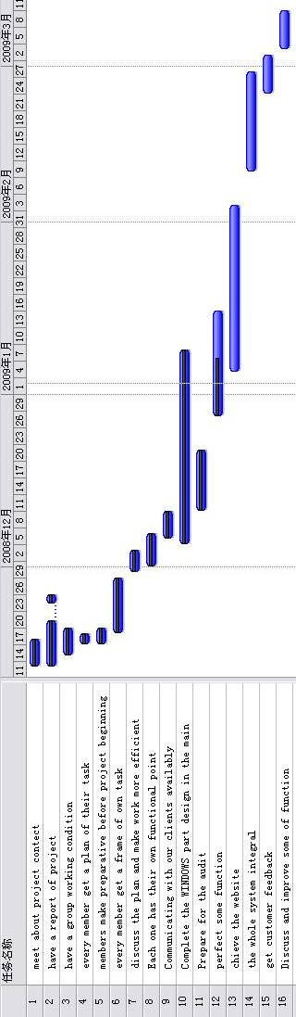

9

