Cycle report

Group 17
Project manager:
Annie IDNO.0517723071
Group members:
David IDNO.0517727152
Harry IDNO.0517733317
Amy IDNO.0517728158
Betty IDNO.0517723415

2008.11.20.
Catalogue
Red Flags 1
Previous cycle results 1
Customer feedback 2
Cycle plan 2
Top10 risks 3
Top10 system requirements 4
The webs chart 5
The Gantt chart 6

Red Flags：
1. In the first project, we have some functions which can not to implement. Some of the functions cannot accord with the truth.
2．Members are divided in their opinions on the aim of the project. Each one has their own opinions for the project.
3. Clients are undefined. There are not specific clients in the project, so members occurs arguments drastically.
4. The requests and standard change continually.
5. Lack of particular plan for our doing.
6. Lack of IT management experience.
7. Some teammates cannot attend the meetings. These personal problems affect the conference; we cannot get the best achievement of the conference.
8. In programming part, we cannot finish the task, according to the schedule lagging.
9. Some function will not be part of our budget plan.
10. Resource and time would be unexpected.
Previous cycle results：
1. Make sure the environment of the project development.
2. Divide the work for members for our project.
3. Perfect the practical functional points.
4. Cannot develop the project program, only things on paper.
1
Customer Feedback：
1. Satisfactions of the project plan for our clients.
2. The schedule of our project for client.
3. The scope of the project is valid.
4. Client like this project before we plan or not.
5. More communicate with client.
6. Show the production for client after a term.
7. Before the change of the function must inquire.
8．The necessary of project must tell client.
9. The report of the plan cycle must send to client.
10. The introduction of operation report sent to client.

Cycle Plan:
1. Compose the project general explanation report, functional request order first.
2. Build the schema of the project.
3. Add functional things, communicate with our clients.
4. Adjust the cycle actualized schedule, event log and PRI scope matrix
5. Send partial program to the clients and get customer feedback.
6. Project report achievement state.

2
Top 10 Risks:
1. Project manage is very important. The longer our project recovers the balance. PM should control the unbalance situation and make the project correct the plan quickly.
2. Communication with customers, do what clients satisfy.
3. Less proficiency of our group members.
4. Guard against the occurrence of the problem, and will help to take action in time.
5. Misunderstanding of the contract requirements and responsibilities.
6. The proportion between history log and the remainder of the work, also the time coordination
7. Control for the change, in terms of resources and time to allow changes in circumstances.
8. Group communications; understand the schedule for each other and connection on cooperation.
9. Group cost schedule control.
10. Achieve on steps the reports; keep the balance of the state.

3
Top 10 System Requirements:
1. Resource request
2. Hardware request: map of hotel, size, equipment and rooms.
3. Room sort and listing
4. Human resources
5. Material management
6. Webs management
7. Registration information records.
8. The cost of the room query.
9. Business volume query.
10. Misconceive the bargain’s requirement and responsibility.

4
The Webs chart:
The cycle plan

The last cycle
New cycle

Annie
All members
Communicate with client for the function
Make sure the environment of project
Divide the work for members
Build the schema

All members
All members

Project report achievement state
All members

Ensure
practical
functional points
Develop the project program
Send partial program to the clients

Annie and Amy
All members
Functional request order
Communicate with client
Get more customers’ feedback
Comprehend the client requirement
David and Annie
All members

Annie Amy and David
Log and PRI scope matrix
Betty

Addition of the function
Adjust the cycle actualized schedule
Regulate the periods of plan
Betty and Amy

All members

5
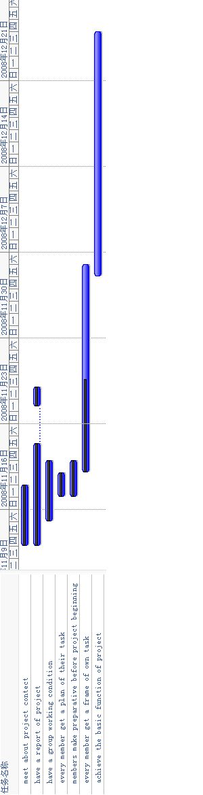
The Gantt chart

6

