Task 2: Agile Planning and DevOps Workflow
Selenium-Tested Proof-of-Delivery Portal
Field | Details
Student Name | Sahil Suresh Ghogare
Roll No. | 23102A0061
Class | BE CMPN A
Task | 2 of 15: Agile Planning and DevOps Workflow

Deliverable: Backlog, task board, sprint plan, Definition of Done and DevOps workflow diagram.

1. Introduction
This document plans the delivery of the Proof-of-Delivery Portal using Agile practices. The MVP frozen in Task 1 is converted into user stories with acceptance criteria, collected in a prioritised product backlog, and scheduled across five sprints that cover all 15 project tasks. A Kanban board tracks progress, a Definition of Done sets the quality bar, and a DevOps lifecycle diagram shows how code travels from development to operations.
Roles: Admin / Dispatcher, Delivery Agent and Reviewer. Story points use a simple 1 to 5 scale (1 = very small, 5 = largest story in the MVP).

2. User Stories and Acceptance Criteria
ID | User Story | Acceptance Criteria
US-01 | As a user, I want to log in with my credentials so that I only see the actions allowed for my role. | Given valid credentials, when I log in, then I reach my role's home page.  Given invalid credentials, then an error is shown and access is denied.  Given I am an Agent, then Admin-only pages are not accessible.
US-02 | As an Admin, I want to create a delivery record so that every parcel is tracked from the start. | Given the create form, when I enter tracking number, customer, address and item, then the record is saved with status Created.  Given a missing mandatory field, then the form shows a validation message and does not save.  Given a duplicate tracking number, then the record is rejected.
US-03 | As an Admin, I want to assign a delivery to an agent so that responsibility is clear. | Given a Created delivery, when I select an agent, then status becomes Assigned.  Given an assigned delivery, then the agent name is visible on the detail page.
US-04 | As an Agent, I want to see my assigned deliveries so that I know what to deliver. | Given I am logged in as an Agent, then only deliveries assigned to me are listed.  Given the list, then each row shows tracking number, customer, address and status.
US-05 | As an Agent, I want to mark a delivery as delivered with recipient details so that proof is recorded. | Given an Out for Delivery parcel, when I enter recipient name and a note or OTP, then status becomes Delivered.  Given the proof is saved, then the delivery time is stored automatically.  Given no recipient name, then the delivery cannot be marked Delivered.
US-06 | As a Reviewer, I want to verify or reject submitted proof so that records are trustworthy. | Given a Delivered record, when I click Verify, then status becomes Verified.  Given a Delivered record, when I click Reject with a reason, then status becomes Rejected.  Given a record in any other status, then Verify and Reject are not offered.
US-07 | As a user, I want to search deliveries by tracking number, customer or status so that I can find records quickly. | Given a search term, then matching records are listed.  Given no match, then a 'No records found' message is shown.  Given a status filter, then only that status is listed.
US-08 | As an Admin, I want to update delivery details so that mistakes can be corrected. | Given a record not yet Delivered, when I edit and save, then the changes are stored.  Given a Verified record, then editing is disabled.
US-09 | As an Admin, I want a dashboard with counts by status so that I see progress at a glance. | Given existing records, then the dashboard shows counts for each status.  Given a status change, then the counts update on the next page load.
US-10 | As the system owner, I want the status workflow enforced so that steps cannot be skipped. | Given status Created, then Delivered cannot be set directly.  Given any invalid transition, then it is blocked with a message.

Technical (DevOps) stories
ID | Technical Story
TS-01 | As a developer, I want a Git repository with a branching policy so that work is organised and traceable.
TS-02 | As a developer, I want Jenkins to build the project on every commit so that integration problems appear early.
TS-03 | As a developer, I want a Jenkinsfile that checks out, builds, packages and deploys so that releases are repeatable.
TS-04 | As a tester, I want Selenium tests for 3 to 5 key user journeys so that regressions are caught automatically.
TS-05 | As an operator, I want the application in a Docker image so that it runs the same on any machine.
TS-06 | As an operator, I want Jenkins to publish a versioned image and deploy a fresh container after tests pass.
TS-07 | As an operator, I want an Ansible or Puppet script that configures the server so that setup is automatic.
TS-08 | As an operator, I want a health check, idempotent re-runs and a rollback option so that the deployment is reliable.

3. Product Backlog
Priority uses MoSCoW (Must, Should, Could). Sprint numbers refer to the plan in section 5.
ID | Backlog Item | Priority | Points | Sprint
US-01 | Login and role-based access | Must | 3 | 2
US-02 | Create delivery record | Must | 3 | 2
US-03 | Assign delivery to agent | Must | 2 | 2
US-04 | Agent's assigned list | Must | 2 | 2
US-05 | Mark delivered with proof | Must | 5 | 2
US-06 | Verify / reject proof | Must | 3 | 2
US-07 | Search and filter deliveries | Must | 3 | 2
US-08 | Update delivery details | Should | 2 | 2
US-09 | Summary dashboard | Must | 3 | 2
US-10 | Status workflow validation | Should | 3 | 2
TS-01 | Git repository and branch policy | Must | 2 | 2
TS-02 | Jenkins CI build job | Must | 3 | 3
TS-03 | Jenkinsfile and Tomcat deployment | Must | 5 | 3
TS-04 | Selenium test suite and reports | Must | 5 | 3
TS-05 | Dockerfile and container lifecycle | Must | 3 | 4
TS-06 | Jenkins-Docker continuous deployment | Must | 5 | 4
TS-07 | Ansible / Puppet configuration | Must | 5 | 5
TS-08 | Provisioning, health check, rollback | Must | 5 | 5
Out of scope (kept in the icebox): photo or signature upload, GPS tracking, notifications, customer tracking page, mobile app and reports.

4. Task Board (Kanban)
The 15 project tasks are tracked on a Kanban board with five columns. Work in progress is limited to 2 tasks at a time so that effort stays focused. The board below shows the starting position; it is recreated on GitHub Projects (or Trello) and updated as work moves right.
Backlog | To Do | In Progress | Review | Done
T7 Jenkins CI job  T8 Jenkinsfile and deploy  T9 Selenium tests  T10 Continuous testing  T11 Docker lifecycle  T12 Jenkins-Docker CD  T13 Configuration script  T14 Provisioning and rollback  T15 Final release and viva | T3 Architecture and setup  T4 GitHub repository  T5 Feature branch workflow  T6 MVP completion | T2 Agile planning |  | T1 Problem definition

Column rules: a card moves to In Progress only when its sprint starts; it moves to Review when its deliverable evidence (document, screenshot, log or commit) is collected; it moves to Done only when it meets the Definition of Done in section 6.

5. Sprint Plan
The work is organised into five sprints. Sprint length should be set to fit the college submission calendar (for example, one week each); the order and goals stay the same.
Sprint | Tasks | Sprint Goal | Key Outputs
Sprint 1 | T1 Problem definition  T2 Agile planning  T3 Architecture and setup | Plan the project and have an empty application building locally. | Scope document, backlog, board, SRS summary, diagrams, local setup
Sprint 2 | T4 GitHub repository  T5 Feature branch workflow  T6 MVP completion | Working MVP under proper Git collaboration. | Repository, pull request, merge conflict resolved, tagged release
Sprint 3 | T7 Jenkins CI job  T8 Jenkinsfile and deploy  T9 Selenium tests  T10 Continuous testing | Automated build, deploy and quality gate. | Jenkins job, Jenkinsfile, Tomcat URL, Selenium reports, failed and fixed run
Sprint 4 | T11 Docker lifecycle  T12 Jenkins-Docker CD | Containerised, automatically deployed application. | Dockerfile, versioned image, commit-to-container pipeline
Sprint 5 | T13 Configuration script  T14 Provisioning and rollback  T15 Final release and viva | Reliable provisioning and final documented release. | Playbook or manifest, idempotency and rollback evidence, report, demo

Sprint ceremonies (kept light for an individual project): a short planning note at the start of each sprint, a daily self check against the board, and a review and retrospective at the end where the backlog is updated.

6. Definition of Done
A backlog item or task is Done only when all applicable points below are true.
- Code or configuration is committed to GitHub on a feature branch with a meaningful commit message and merged through a pull request.
- The acceptance criteria of the story are met and demonstrated.
- The project builds without errors using the build tool.
- Relevant automated tests (Selenium or unit) pass.
- No known critical defects remain open for the item.
- The Jenkins pipeline run for the change is green.
- Evidence is captured: screenshot, log or report, as required by the task deliverable.
- The backlog and Kanban board are updated, and documentation or README changes are made.
- For deployment items: the application is reachable at its URL and passes the health check.

7. DevOps Lifecycle Diagram
The diagram shows the continuous loop from planning to operations. Each stage maps to a tool used in this project, and monitoring feedback returns to planning.
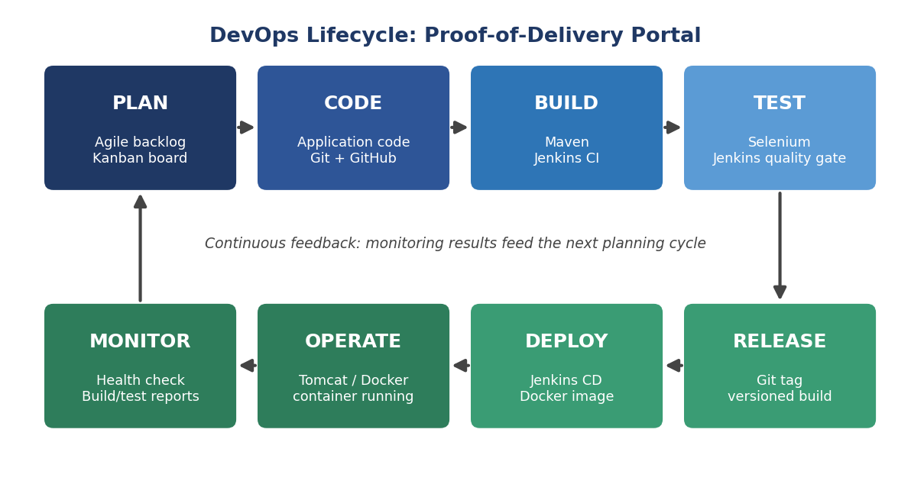
Pipeline flow for this project
Developer commit to GitHub > Jenkins pulls the code > Maven build and package > Selenium tests act as a quality gate (failure stops the pipeline) > Docker image built and versioned > container deployed > Ansible or Puppet keeps the target server configured > health check and logs feed back into the next sprint.
Stage | Tool or Activity | Output
Plan | Backlog, Kanban board, sprint plan | User stories, board
Code | Git and GitHub, feature branches, pull requests | Reviewed, merged code
Build | Maven and Jenkins CI | Packaged artefact
Test | Selenium WebDriver in Jenkins | Test reports, quality gate
Release | Git tags, versioned image | Tagged release
Deploy | Jenkinsfile, Docker, Tomcat | Running application
Operate | Ansible or Puppet, containers | Configured server
Monitor | Health check, Jenkins and container logs | Feedback for next sprint

