Task 3: Requirements, Architecture and Technology Setup
Selenium-Tested Proof-of-Delivery Portal
Field | Details
Student Name | Sahil Suresh Ghogare
Roll No. | 23102A0061
Class | BE CMPN A
Task | 3 of 15: Requirements, Architecture and Technology Setup

Deliverable: SRS summary, use-case diagram, architecture diagram, data model/API list and working local setup.

1. SRS Summary

1.1 Purpose and scope
The Proof-of-Delivery Portal lets a small delivery operation record parcels, assign them to agents, capture proof when a parcel is delivered, and have the proof reviewed. The scope is the frozen MVP from Task 1: create, view, update and search records; a role-based status workflow; and a summary dashboard.

1.2 Users and roles
Role | Description
Admin / Dispatcher | Creates and edits deliveries, assigns them to agents, views all records and the dashboard.
Delivery Agent | Sees only deliveries assigned to them, marks them out for delivery and submits proof of delivery.
Reviewer | Reviews delivered records and verifies or rejects the proof; can view all records and the dashboard.

1.3 Functional requirements
ID | Requirement
FR-01 | The system shall authenticate users with a username and password and apply role-based access.
FR-02 | An Admin shall create a delivery with tracking number, customer name, address and item; the initial status is Created.
FR-03 | The system shall reject a delivery with a missing mandatory field or a duplicate tracking number.
FR-04 | An Admin shall update delivery details until the delivery is Verified.
FR-05 | An Admin shall assign a Created delivery to an agent, changing the status to Assigned.
FR-06 | An Agent shall view only the deliveries assigned to them.
FR-07 | An Agent shall mark an Assigned delivery as Out for Delivery.
FR-08 | An Agent shall mark an Out for Delivery record as Delivered by entering the recipient name and a note or OTP; the delivery time is stored automatically.
FR-09 | A Reviewer shall verify a Delivered record, or reject it with a reason.
FR-10 | All roles that may view records shall be able to search by tracking number, customer name and filter by status.
FR-11 | The system shall enforce the status flow Created > Assigned > Out for Delivery > Delivered > Verified / Rejected and block any other transition.
FR-12 | The dashboard shall show the number of deliveries in each status.

1.4 Role permissions
Action | Admin | Agent | Reviewer
Log in | Yes | Yes | Yes
Create / update delivery | Yes | No | No
Assign to agent | Yes | No | No
View all deliveries and search | Yes | No (own only) | Yes
Mark out for delivery / delivered | No | Yes (own only) | No
Verify / reject proof | No | No | Yes
View dashboard | Yes | No | Yes

1.5 Non-functional requirements
ID | Requirement
NFR-01 | Usability: a delivery record can be created in under 1 minute.
NFR-02 | Performance: search returns results in under 2 seconds on test data.
NFR-03 | Security: passwords are stored hashed; pages and actions are protected by role.
NFR-04 | Portability: the application runs on any machine with Java 17, and later in a Docker container.
NFR-05 | Testability: key pages use stable element IDs so Selenium tests are reliable.
NFR-06 | Maintainability: layered code (controller, service, repository) built with Maven.
NFR-07 | Operability: a health endpoint reports whether the application is up.

1.6 Assumptions and constraints
- Dummy data only; no real customer information is stored.
- Single-node deployment; no clustering or high availability.
- Server-rendered pages; no separate mobile or single-page front end.
- Constraints from Task 1 apply: individual work, free tools only, tools required by the task sheet.

2. Use-Case Diagram
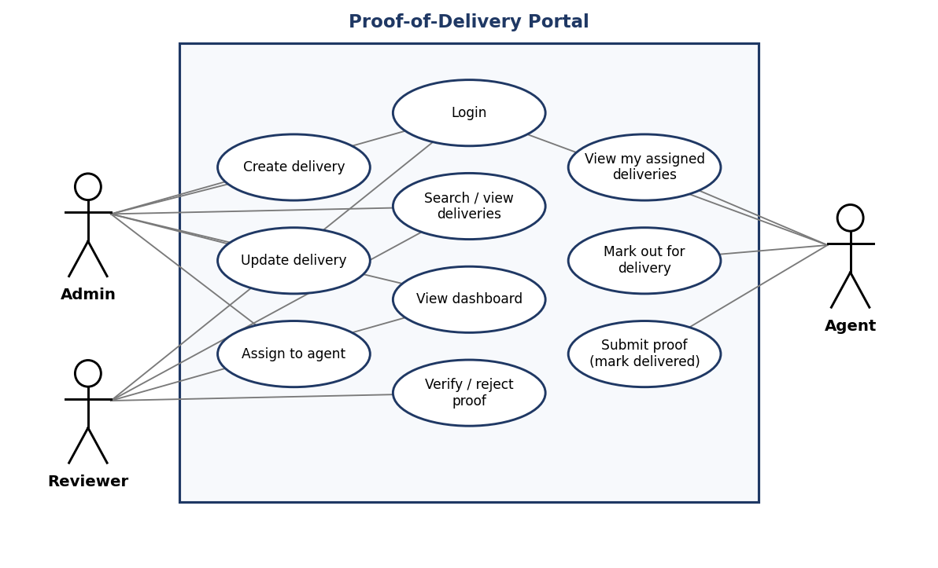
Figure 1: Use cases for the Admin, Reviewer and Delivery Agent roles. All roles must log in first.

3. Architecture
The application is a layered, server-rendered web application. The browser talks to Spring MVC controllers, which call a service layer that holds the business rules and status workflow. Repositories handle persistence, and Spring Security sits across the layers to protect access. The packaged WAR runs on Tomcat and is later containerised.
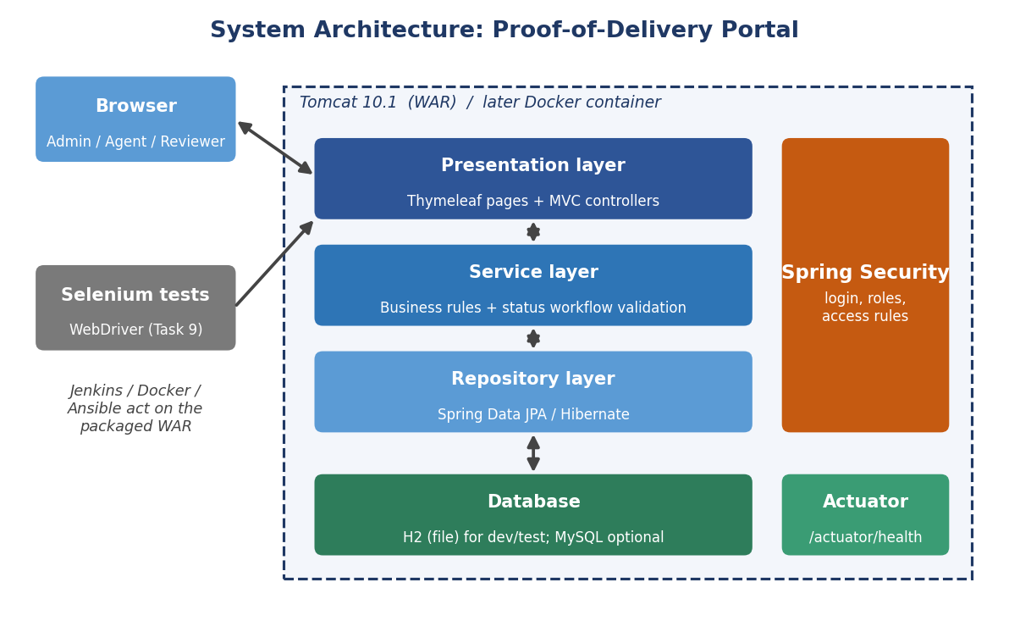
Figure 2: System architecture and deployment boundary.

3.1 Technology selection
Area | Choice | Reason
Language | Java 17 | Long-term support version, required by Spring Boot 3, widely used with Jenkins and Tomcat.
Framework | Spring Boot 3.3 | Quick setup, built-in web, security, JPA and health endpoint.
Views | Thymeleaf | Server-rendered pages with stable element IDs, which suit Selenium tests.
Persistence | Spring Data JPA + Hibernate | Less boilerplate for create, update and search.
Database | H2 (file mode); MySQL optional | H2 needs no installation, so setup is quick. The same code can move to MySQL later.
Security | Spring Security (added in Tasks 5 and 6) | Provides login and role checks for the status workflow.
Build tool | Maven 3.9 | Required by the task sheet; the standard choice for Jenkins and Selenium runs.
Testing | JUnit 5, Selenium WebDriver | Selenium is added in Task 9 and runs through Maven.
Deployment target | Tomcat 10.1 (WAR), later Docker | A Java WAR fits Tomcat; Nginx suits static sites, so it is not used.
Version control / CI | Git, GitHub, Jenkins | Set up in Tasks 4, 7 and 8.
Configuration management | Ansible or Puppet | Final choice is made in Task 13.

4. Data Model
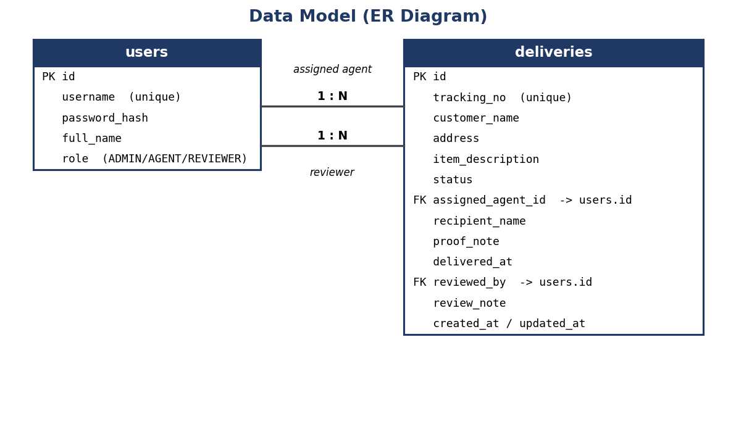
Figure 3: Data model with two tables.
Status values: CREATED, ASSIGNED, OUT_FOR_DELIVERY, DELIVERED, VERIFIED, REJECTED. Role values: ADMIN, AGENT, REVIEWER. The delivery table links to the users table twice: once for the assigned agent and once for the reviewer.

5. Endpoint (API) List
The portal uses server-rendered pages, so endpoints return pages or redirects rather than JSON.
Method | Path | Role | Purpose
GET | /login | All | Login page
POST | /login, /logout | All | Authenticate and end session (Spring Security)
GET | /deliveries?q=&status= | Admin, Reviewer, Agent (own) | List and search deliveries
GET | /deliveries/new | Admin | Create form
POST | /deliveries | Admin | Save new delivery
GET | /deliveries/{id} | All (permitted) | Delivery detail with role-based action buttons
GET | /deliveries/{id}/edit | Admin | Edit form
POST | /deliveries/{id} | Admin | Save changes
POST | /deliveries/{id}/assign | Admin | Assign to an agent
POST | /deliveries/{id}/out-for-delivery | Agent | Set status Out for Delivery
POST | /deliveries/{id}/deliver | Agent | Submit proof, set status Delivered
POST | /deliveries/{id}/verify | Reviewer | Set status Verified
POST | /deliveries/{id}/reject | Reviewer | Set status Rejected with reason
GET | /dashboard | Admin, Reviewer | Counts by status
GET | /actuator/health | Public | Health check used by Jenkins and Task 14

6. Local Development Setup

6.1 Prerequisites
- JDK 17 or newer (check with java -version)
- Apache Maven 3.9 or newer (check with mvn -version)
- Git
- An IDE such as IntelliJ IDEA, Eclipse or VS Code
- Apache Tomcat 10.1 (optional now; needed in Task 8)

6.2 Starter project
A starter project is supplied with this document (pod-portal-skeleton.zip). It contains a Maven pom.xml (WAR packaging), the Spring Boot main class, a home page, a health endpoint, an H2 database configuration, a basic test, .gitignore and README. Folder structure:
pod-portal/
pom.xml
README.md, .gitignore
src/main/java/edu/podportal/ (application and controller classes)
src/main/resources/ (application.properties, templates/index.html)
src/test/java/edu/podportal/ (tests)
docs/ (task documents)

6.3 Build and run
mvn clean package
java -jar target/pod-portal.war

Alternatively run from source with mvn spring-boot:run. Then verify:
- Open http://localhost:8080/ and confirm the page title Proof-of-Delivery Portal.
- Open http://localhost:8080/actuator/health and confirm the response shows status UP.
- Confirm mvn clean package ends with BUILD SUCCESS and the unit tests pass.

6.4 Tomcat check (optional)
Copy target/pod-portal.war into Tomcat's webapps folder, start Tomcat and open http://localhost:8080/pod-portal/. This confirms the WAR deploys on the target server before Jenkins automates it in Task 8.

6.5 Evidence to attach
- Screenshot of java -version and mvn -version
- Screenshot of mvn clean package ending in BUILD SUCCESS
- Screenshot of the home page in the browser
- Screenshot of the /actuator/health response
- Screenshot of the project open in the IDE showing the folder structure
[Insert the screenshots here after running the setup on your machine.]

