 |  | Hope Foundation’s  Finolex Academy of Management and Technology, Ratnagiri
 |  | Information Technology Department
Subject name: IP Lab |  |  |  |  |  |  |  |  | Subject Code: ITL501
Class |  | TE IT |  | Semester – V (CBCGS) |  |  |  | Academic year: 2023-24
Name of Student |  |  |  |  |  |  | QUIZ Score :
Roll No |  |  |  |  | Assignment/Experiment No. |  |  |  |  |  |  | 01

Title: Use and demonstration of HTML5 tags to design web forms and CSS3 and its types.

1.Lab objectives applicable

LOB1.To orient students to HTML for making webpages.

2. Lab outcomes applicable:

LO2 -Identify and apply the appropriate HTML tags to develop a webpage.

3. Learning Objectives:
- To understand html5 tags and use of css
- To know the types of css

4. Practical applications of the assignment/experiment: To design web pages for web application

5. Prerequisites:
- Understanding of internet and web applications
- Internet Access
- Knowledge TCP/IP protocol suite

6. Hardware Requirements:
- Internet Access with Browser
- PC with required hardware

7. Software Requirements:

Browser like Chrome, Internet Explorer Edge

8. Quiz Questions (if any): (Online Exam will be taken separately batchwise, attach the certificate/ Marks obtained)
- What are html5 tags?
- What are the types of css?
- How the css helps us build web pages faster?

9. Experiment/Assignment Evaluation:
Sr. No. | Parameters |  |  |  |  |  |  |  |  |  | Marks obtained |  |  | Out of
1 | Technical Understanding (Assessment may be done based on Q & A or any other relevant method.) Teacher should mention the other method used - |  |  |  |  |  |  |  |  |  |  |  |  | 6
2 | Neatness/presentation |  |  |  |  |  |  |  |  |  |  |  |  | 2
3 | Punctuality |  |  |  |  |  |  |  |  |  |  |  |  | 2
Date of performance (DOP) |  |  |  |  |  | Total marks obtained |  |  |  |  |  |  | 10
Date of checking (DOC) |  |  |  |  |  | Signature of teacher

10.Theory-.

Tag Description

<a> Defines a hyperlink.

<abbr> Defines an abbreviated form of a longer word or phrase.

<acronym> Obsolete Defines an acronym. Use <abbr> instead.

<address> Specifies the author's contact information.

<applet> Obsolete Embeds a Java applet (mini Java applications) on the page. Use <object> instead.

<area> Defines a specific area within an image map.

<article> Defines an article.

<aside> Defines some content loosely related to the page content.

<audio> Embeds a sound, or an audio stream in an HTML document.

<b> Displays text in a bold style.

<base> Defines the base URL for all relative URLs in a document.

<basefont> Obsolete Specifies the base font for a page. Use CSS instead.

<bdi> Represents text that is isolated from its surrounding for the purposes of bidirectional text formatting.

<bdo> Overrides the current text direction.

<big> Obsolete Displays text in a large size. Use CSS instead.

<blockquote> Represents a section that is quoted from another source.

<body> Defines the document's body.

<br> Produces a single line break.

<button> Creates a clickable button.

<canvas> Defines a region in the document, which can be used to draw graphics on the fly via scripting (usually JavaScript).

<caption> Defines the caption or title of the table.

<center> Obsolete Align contents in the center. Use CSS instead.

<cite> Indicates a citation or reference to another source.

<code> Specifies text as computer code.

<col> Defines attribute values for one or more columns in a table.

<colgroup> Specifies attributes for multiple columns in a table.

<data> Links a piece of content with a machine-readable translation.

<datalist> Represents a set of pre-defined options for an <input> element.

<dd> Specifies a description, or value for the term (<dt>) in a description list (<dl>).

<del> Represents text that has been deleted from the document.

<details> Represents a widget from which the user can obtain additional information or controls on-demand.

<dfn> Specifies a definition.

<dialog> Defines a dialog box or subwindow.

<dir> Obsolete Defines a directory list. Use <ul> instead.

<div> Specifies a division or a section in a document.

<dl> Defines a description list.

<dt> Defines a term (an item) in a description list.

<em> Defines emphasized text.

<embed> Embeds external application, typically multimedia content like audio or video into an HTML document.

<fieldset> Specifies a set of related form fields.

<figcaption> Defines a caption or legend for a figure.

<figure> Represents a figure illustrated as part of the document.

<font> Obsolete Defines font, color, and size for text. Use CSS instead.

<footer> Represents the footer of a document or a section.

<form> Defines an HTML form for user input.

<frame> Obsolete Defines a single frame within a frameset.

<frameset> Obsolete Defines a collection of frames or other frameset.

<head> Defines the head portion of the document that contains information about the document such as title.

<header> Represents the header of a document or a section.

<hgroup> Defines a group of headings.

<h1> to <h6> Defines HTML headings.

<hr> Produce a horizontal line.

<html> Defines the root of an HTML document.

<i> Displays text in an italic style.

<iframe> Displays a URL in an inline frame.

11. Installation Steps / Performance Steps –
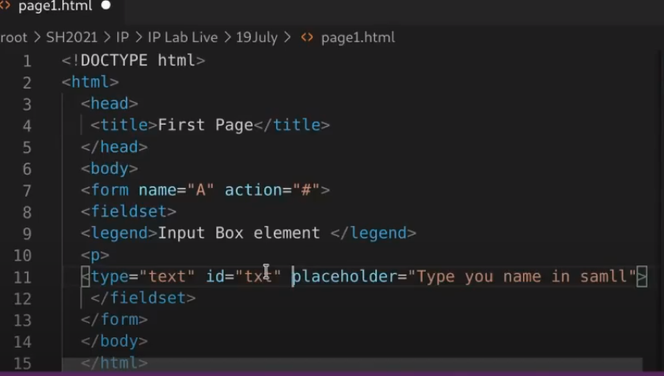
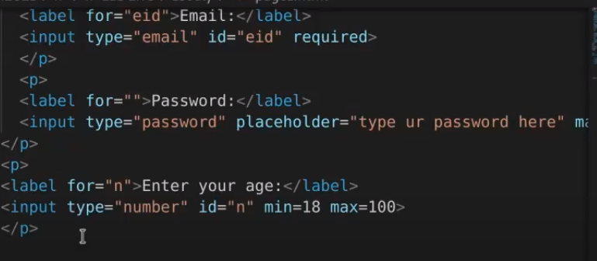

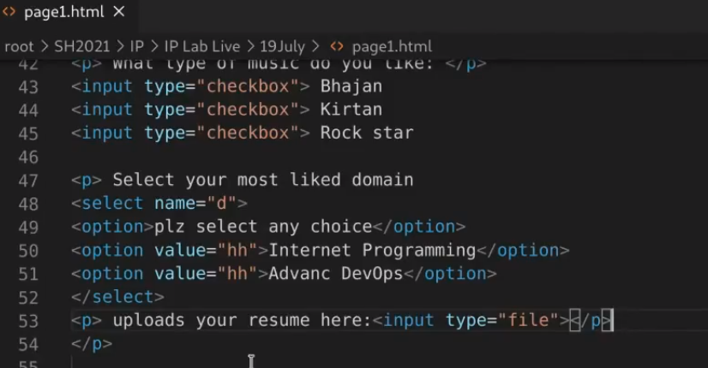
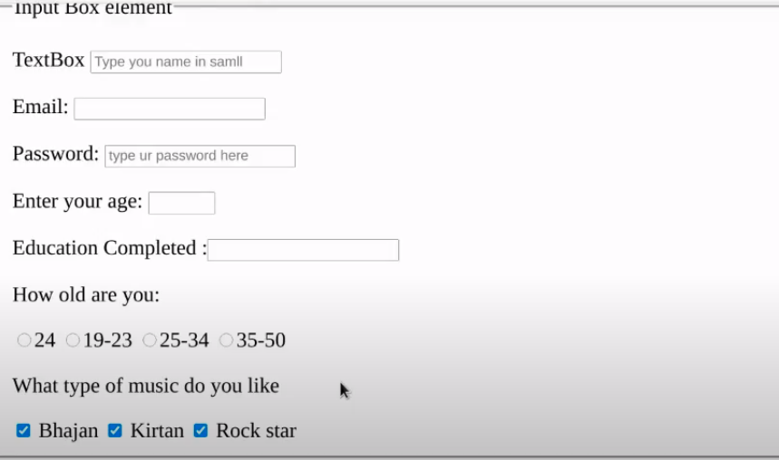

CSS3:
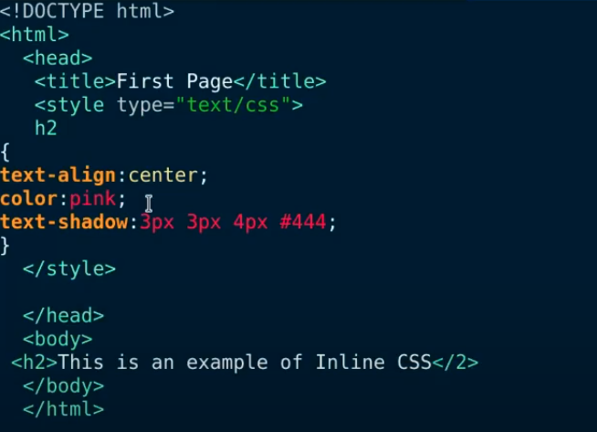

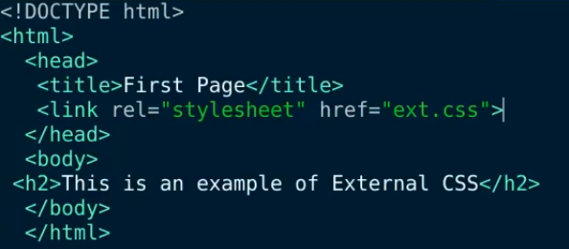

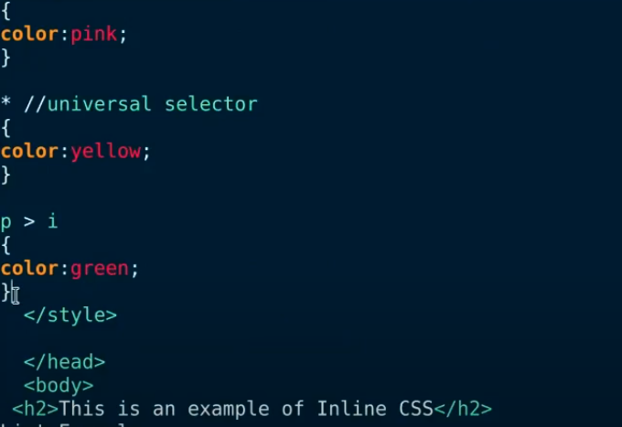

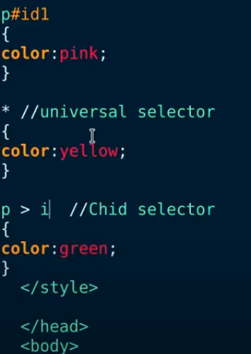

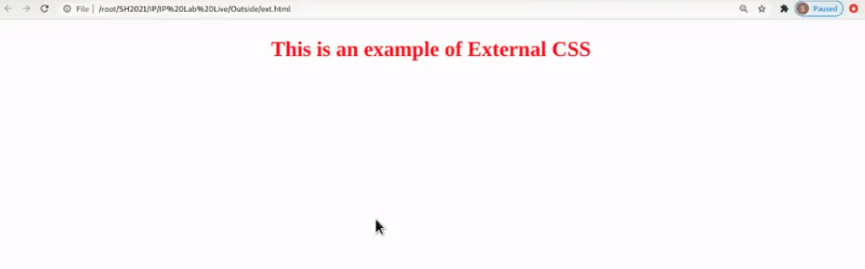

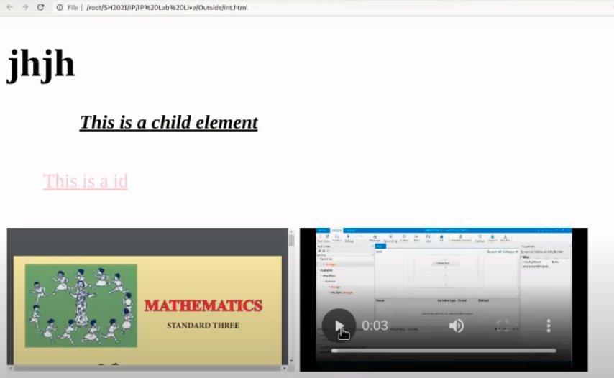

12. Learning Outcomes Achieved
- Students understood the css3 types and html5 tags
- Students understood the web elements

13. Conclusion:
- Applications of the studied technique in industry
  - To design the web pages for web applications
  - To develop a GUI for web applications
- Engineering Relevance
  - To host a static web site using web elements and css
  - To work on complex and large projects
- Skills Developed

1. HTML5 and css3 types

References :

https://www.tutorialrepublic.com/html-reference/html5-tags.php

