 |  | Hope Foundation’s  Finolex Academy of Management and Technology, Ratnagiri
 |  | Information Technology Department
Subject name: IP Lab |  |  |  |  |  |  |  |  | Subject Code: ITL501
Class |  | TE IT |  | Semester – V (CBCGS) |  |  |  | Academic year: 2023-24
Name of Student |  |  |  |  |  |  | QUIZ Score :
Roll No |  |  |  |  | Assignment/Experiment No. |  |  |  |  |  |  | 02

Title: Use and demonstrations of Javascript basic constructs and arrow function

1.Lab objectives applicable

LOB1.To expose students to JavaScript to make web pages interactive

2. Lab outcomes applicable:

LO2 -Use JavaScript to develop interactive web pages

3. Learning Objectives:
- To understand the arrow function
- To know the use of javascript

4. Practical applications of the assignment/experiment: To design web pages for web application

5. Prerequisites:
- Understanding of internet and web applications
- Internet Access
- Knowledge TCP/IP protocol suite

6. Hardware Requirements:
- Internet Access with Browser
- PC with required hardware

7. Software Requirements:

Browser like Chrome, Internet Explorer Edge

8. Quiz Questions (if any): (Online Exam will be taken separately batchwise, attach the certificate/ Marks obtained)
- What is dynamic web page?
- What is role of javascript in designing web pages?
- What is arrow function and its syntax?

9. Experiment/Assignment Evaluation:
Sr. No. | Parameters |  |  |  |  |  |  |  |  |  | Marks obtained |  |  | Out of
1 | Technical Understanding (Assessment may be done based on Q & A or any other relevant method.) Teacher should mention the other method used - |  |  |  |  |  |  |  |  |  |  |  |  | 6
2 | Neatness/presentation |  |  |  |  |  |  |  |  |  |  |  |  | 2
3 | Punctuality |  |  |  |  |  |  |  |  |  |  |  |  | 2
Date of performance (DOP) |  |  |  |  |  | Total marks obtained |  |  |  |  |  |  | 10
Date of checking (DOC) |  |  |  |  |  | Signature of teacher

10.Theory-.

JavaScript is a dynamic computer programming language. It is lightweight and most commonly used as a part of web pages, whose implementations allow client-side script to interact with the user and make dynamic pages. It is an interpreted programming language with object-oriented capabilities.

JavaScript was first known as LiveScript, but Netscape changed its name to JavaScript, possibly because of the excitement being generated by Java. JavaScript made its first appearance in Netscape 2.0 in 1995 with the name LiveScript. The general-purpose core of the language has been embedded in Netscape, Internet Explorer, and other web browsers.

The ECMA-262 Specification defined a standard version of the core JavaScript language.

JavaScript is a lightweight, interpreted programming language.

Designed for creating network-centric applications.

Complementary to and integrated with Java.

Complementary to and integrated with HTML.

Open and cross-platform

Arrow function is one of the features introduced in the ES6 version of JavaScript. It allows you to create functions in a cleaner way compared to regular functions. For example,

This function

// function expression
let x = function(x, y) {
return x * y;
}
can be written as
// using arrow functions
let x = (x, y) => x * y;

11. Installation Steps / Performance Steps –
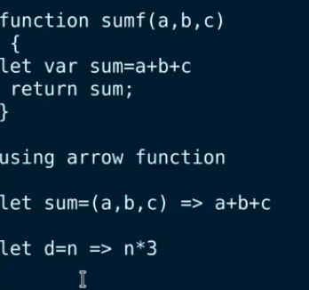

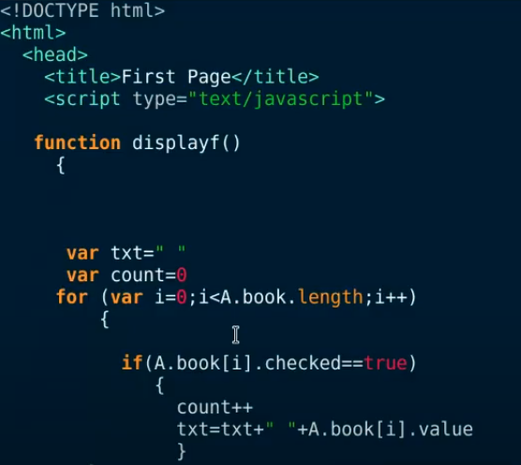

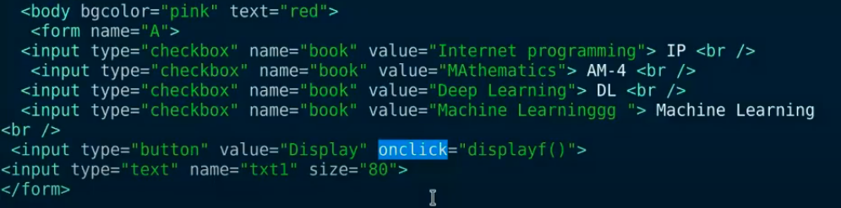
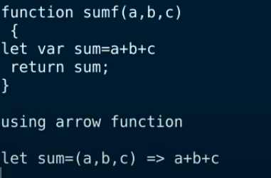

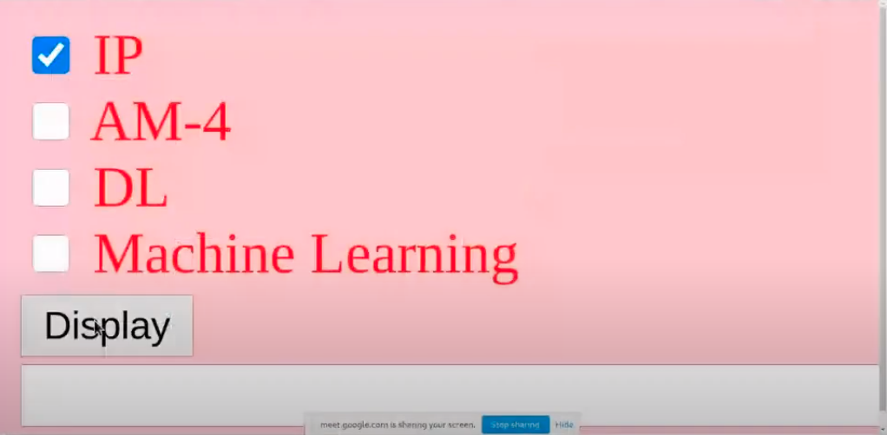

12. Learning Outcomes Achieved
- Students understood javascript and functions
- Students understood the arrow function

13. Conclusion:
- Applications of the studied technique in industry
  - To design the web pages for web applications
  - To develop a dynamic web page
- Engineering Relevance
  - To host a static web site using web elements and css
  - To host a dynamic web page
- Skills Developed

1. Javascript and arrow function

References :

https://www.programiz.com/javascript/arrow-function

