

**Tribhuvan University**

**Faculty of Humanities and Social Sciences**

**A PROJECT REPORT**

**ON**

**E-COMMERCE WEBSITE: ACCESSIOMART**

**Submitted to**

**Department of Computer Application**

**Everest College**

***In partial fulfillment of the requirements for the Bachelor’s in Computer Application***

Submitted by

Aayush Parajuli

Sahil Kumar Gupta

TU Registration No: 6-2-355-1-2021, 6-2-355-1-2021

June 2024

Under the supervision of

Mr. Kamal Pathak



**Tribhuvan University**

**Faculty of Humanities and Social Sciences**

**Everest College**

**SUPERVISOR’S RECOMMENDATION**

I hereby recommend that this project prepared under my supervision by Aayush Parajuli & Sahil Kumar Gupta entitled **“E-COMMERCE WEBSITE: ACCESSIOMART”** in partial fulfilment of the requirements for the degree of Bachelor of Computer Application is recommended for the final evaluation.

**SIGNATURE**

Mr. Kamal Pathak

**SUPERVISOR**

Lecturer

Department of Computer Application

Everest College, Thapathali, Kathamndu



**Tribhuvan University**

**Faculty of Humanities and Social Sciences**

**Everest College**

**LETTER OF APPROVAL**

This is to certify that this project prepared by Aayush Parajuli & Sahil Kumar Gupta entitled **“E-COMMERCE WEBSITE: ACCESSIOMART”** in partial fulfillment of the requirements for the degree of Bachelor of Computer Application has been evaluated. In our opinion, it is satisfactory in scope and quality as a project for the required degree.

|  |  |
| --- | --- |
| **SIGNATURE OF Supervisor**  Mr. Kamal Pathak  Lecturer  Department of Computer Application  Everest College, Thapathali, Kathmandu | **SIGNATURE of HOD/Coordinator**  Mr. Kamal Pathak  Lecturer  Department of Computer Application  Everest College, Thapathali, Kathamndu |
| **SIGNATURE of Supervisor**  **Internal Examiner**  Mr. Kamal Pathak | **SIGNATURE of Supervisor**  **External Examiner** |

# **ACKNOWLEDGEMENT**

It is a great pleasure to have the opportunity to extend our heartfelt gratitude to everyone who helped us throughout this project. We are profoundly grateful to our supervisor, **Mr. Kamal Pathak,** for his expert guidance, continuous encouragement and ever willingness to spare time from his otherwise busy schedule for the project’s progress reviews. His continuous inspiration has made us complete this project and achieve its target.

We would also like to express our deepest appreciation to **Mr. Kamal Pathak,** Coordinator, Everest College, for his constant motivation, support and for providing us with a suitable working environment.

We sincerely acknowledge direct and indirect help, suggestions and feedback offered by our colleagues before, during and after the development and implementation of this project.

Finally, our special thanks go to all staff members of the BCA department at Everest College who kindly extend their hands in making this project work a success.

# **ABSTARCT**

AccessioMart is a comprehensive e-commerce platform designed to streamline online shopping experiences through a robust and user-friendly interface. This project integrates multiple web technologies, including HTML, CSS, JavaScript, PHP, MySQL, JOSN and AJAX, to deliver a seamless and dynamic online marketplace.

HTML (Hypertext Markup Language) forms the backbone of the website, structuring the content and layout of AccessioMart. CSS (Cascading Style Sheets) is employed to enhance the visual presentation, ensuring an aesthetically pleasing and responsive design across various devices. JavaScript is utilized for client-side scripting, adding interactivity and enhancing user engagement through dynamic content updates and form validations. PHP (Hypertext Preprocessor) serves as the server-side scripting language, handling the backend processes such as user authentication, product management, and order processing. MySQL is the chosen relational database management system, efficiently storing and retrieving data related to products, users, orders, and other critical information.

The project leverages JSON (JavaScript Object Notation) for data interchange, ensuring efficient and lightweight communication between the client and server. AJAX (Asynchronous JavaScript and XML) is integrated to facilitate asynchronous data fetching, allowing for real-time updates and a smooth user experience without the need for full page reloads. AccessioMart features a comprehensive product catalog, add products to their cart, and complete purchases with a few simple clicks. Admins have access to a dedicated dashboard to manage inventory, track orders, and analyze sales data.

In summary, AccessioMart is a powerful e-commerce solution that combines modern web technologies to provide a seamless and efficient shopping experience for users and a reliable management system for administrators.

***Keywords: E-commerce, HTML, CSS, JavaScript, PHP, MySQL, JSON, AJAX, Online shopping, Web-development, AccessioMart.***

**Table of Contents**

ACKNOWLEDGEMENT iv

ABSTARCT v

LIST OF ABBREVATIONS vii

LIST OF FIGURES viii

LIST OF TABLES ix

CHAPTER 1: INTRODUCTION 1

1.1 Introduction 1

1.2 Problem Statement 2

1.3 Objectives 2

1.4 Scope and Limitations 3

1.4.1 Scope 3

1.4.2 Limitations 3

1.5 Report Organization 4

Chapter 2: BACKGROUND STUDY AND LITERAURE REVIEW 5

2.1 Background Study 5

2.2 Literature Review 5

2.3 Existing System 6

2.4 Proposed System 7

CHAPTER 3: SYSTEM ANALYSIS AND DESIGN 9

3.1 System Analysis 9

3.1.1. Requirement Analysis 11

3.1.2. Feasibility Analysis 12

3.1.3. Analysis 13

3.2 System Design 17

3.1.1. Database design 17

3.1.1. Interface design 17

Chapter 4: Implementation and Testing 20

4.1 Implementation 20

4.1.1. Tools Used 20

4.2 Testing 21

4.2.1 Test Cases for Unit Testing 21

Chapter 4: Conclusion and Future Recommendations 25

4.1 Conclusion 25

4.1 Future Recommendations 25

Chapter 4: References 26

Chapter 4: Appendices 27

4.1 Screenshots 27

# **LIST OF ABBREVATIONS**

|  |  |
| --- | --- |
| **HTML** | Hypertext Markup Language |
| **CSS** | Cascading Style Sheet |
| **JS** | JavaScript |
| **PHP** | Hypertext Pre-processor |
| **UI** | User Interface |
| **SQL** | Structured Query Language |
| **ER** | Entity Relationship |
| **DFD** | Data Flow Diagram |
| **AJAX** | Asynchronous JavaScript and XML |
| **JSON** | JavaScript Object Notation |

# **LIST OF FIGURES**

Figure 1: Prototype Model 10

Figure 2: Use Case Diagram 11

Figure 3: Gantt Chart 13

Figure 4: Flowchart for Admin 13

Figure 5: Flowchart for User 14

Figure 6: ER Diagram 15

Figure 7: DFD Level 0 for User & Admin 16

Figure 8: DFD Level 1 for Admin & User 16

Figure 9: Database Schema Design 17

Figure 10: Interface Design for Login 18

Figure 11: Interface Design for Signup 18

Figure 12: Interface Design for Homepage 19

# **LIST OF TABLES**

Table 1: User Application Testing 21

Table 2: Admin Application Testing 22

Table 3: System Testing 24

# **CHAPTER 1: INTRODUCTION**

## **1.1 Introduction**

AccessioMart is a cutting-edge e-commerce platform designed to meet the increasing demands of online shopping in today's digital age. It aims to provide a smooth and efficient shopping experience for users while giving administrators robust tools to manage their operations. This introduction highlights the advantages and disadvantages of AccessioMart, showcasing its strengths and areas where it could improve.

One of the biggest advantages of AccessioMart is its user-friendly interface. The platform is built with HTML and CSS, making it easy for customers to navigate the site. Its responsive design ensures a consistent and smooth experience across all devices, including desktops, tablets, and smartphones. This focus on user experience helps keep customers on the site longer, reduces bounce rates, and ultimately boosts sales and satisfaction.

AccessioMart also benefits from the integration of JavaScript and AJAX, which enhances interactivity. This means users get real-time updates, dynamic content loading, and seamless navigation without page reloads. These features not only improve the shopping experience but also keep users engaged, encouraging them to explore more products.

On the backend, AccessioMart uses PHP for server-side scripting, which efficiently handles tasks like user authentication and order processing. This creates a reliable foundation for the platform. Coupled with MySQL for database management, AccessioMart can store and retrieve large amounts of data efficiently. Security is a top priority, with secure payment gateway integration ensuring safe transactions. The platform is also customizable and scalable, allowing businesses to tailor it to their needs and handle growth effectively.

Despite these benefits, AccessioMart does have some drawbacks. Setting it up can be complex and time-consuming, especially for those without technical expertise. Maintaining and updating the platform can also be challenging due to the integration of various technologies like HTML, CSS, JavaScript, PHP, MySQL, and AJAX. Performance issues may occur under high traffic conditions, requiring continuous optimization. Additionally, the platform relies heavily on a stable internet connection for both user experience and backend operations. Any disruption in internet service can impact functionality and reliability, leading to potential loss of sales and decreased user satisfaction.

In conclusion, AccessioMart is a powerful and versatile e-commerce solution that leverages modern web technologies to offer a comprehensive online shopping experience. While it provides numerous benefits such as user-friendly interfaces, dynamic features, efficient backend management, and secure transactions, it also faces challenges in setup complexity, maintenance, performance, security, and internet dependency. By addressing these challenges, AccessioMart aims to be a reliable and effective platform for both consumers and businesses in the digital marketplace.

## **1.2 Problem Statement**

Setting up AccessioMart can be quite challenging due to the integration of various technologies like HTML, CSS, JavaScript, PHP, MySQL, JSON, and AJAX. This requires careful coordination and configuration, making the initial setup complex and time-consuming, especially for users with limited technical skills. Maintenance and updates also pose challenges. Keeping the platform stable and compatible across all these technologies demands ongoing monitoring and troubleshooting, which can be resource intensive. Regular updates are essential to keep the platform secure and functional, adding to the maintenance workload.

Performance and security are critical areas for AccessioMart. The platform may experience performance issues during high traffic periods, requiring continuous optimization of both the front-end and back-end components. Security is another concern; despite secure transaction protocols, the platform remains vulnerable to cyber threats. Regular security audits and updates are necessary to protect against potential breaches. Additionally, AccessioMart relies heavily on stable internet connectivity for both user experience and backend operations. Disruptions in internet service can negatively impact the platform's functionality and reliability, leading to potential sales losses and decreased user satisfaction. Ensuring robust security measures and reliable internet infrastructure is crucial for maintaining user trust and safeguarding sensitive information.

## **1.3 Objectives**

1. Simplify the integration process of multiple web technologies to make the initial setup more user-friendly.
2. Develop efficient maintenance and update methods to ensure compatibility and stability across all platform components.
3. Implement continuous performance monitoring and optimization strategies for both front-end and back-end components.
4. Conduct regular security audits and updates to protect against cyber threats and ensure data safety.
5. Provide comprehensive technical support and resources to assist users with limited technical expertise.
6. Ensure robust and secure integration with payment gateways for safe and reliable transactions.

## **1.4 Scope and Limitations**

### **1.4.1 Scope**

1. Offer a wide range of products across various categories, providing users with diverse shopping options.
2. Design a responsive and intuitive interface accessible on multiple devices, ensuring a seamless user experience.
3. Use AJAX to provide real-time updates, reducing the need for page reloads and enhancing interactivity.
4. Integrate secure payment gateways to ensure safe and reliable financial transactions for users.
5. Provide administrators with a comprehensive dashboard for managing products, users, and orders.
6. Design the platform to be scalable, accommodating increasing user loads and expanding product inventories.

### **1.4.2 Limitations**

1. Initial setup and maintenance require significant technical knowledge, which can be a barrier for non-technical users.
2. The platform's functionality heavily depends on stable internet connectivity, which can affect reliability in areas with poor internet service.
3. Potential performance issues may arise under extremely high traffic conditions, requiring continuous optimization.
4. Despite robust security measures, the platform remains vulnerable to cyber threats, necessitating regular updates and monitoring.
5. Ongoing maintenance and updates can be resource-intensive, requiring dedicated time and technical skills.
6. Initial setup and ongoing maintenance can be costly, potentially limiting access for smaller businesses or startups.

## **1.5 Report Organization**

This report is organized into 5 chapters:

**Chapter 1: "Introduction"**

- This chapter introduces the problem statement, objectives, and limitations of the project.

**Chapter 2: "Requirement and Feasibility Analysis"**

- This chapter describes the functional and non-functional requirements, economic feasibility, technical feasibility, operational feasibility, and scheduling feasibility.

**Chapter 3: "System Design"**

- This chapter introduces the system and interface design of the project.

**Chapter 4: "Implementation and Testing"**

- This chapter clearly illustrates the methods and tools used to implement the project.

**Chapter 5: "Conclusion and Future Works"**

- This final chapter concludes the project and discusses future plans.

# **Chapter 2: BACKGROUND STUDY AND LITERAURE REVIEW**

## **2.1 Background Study**

The rapid growth of e-commerce has revolutionized the way consumers shop and businesses operate. Over the past two decades, the rise of the internet and digital technologies has facilitated the development of online marketplaces, allowing consumers to purchase goods and services from the comfort of their homes. This shift has been driven by several factors, including increased internet penetration, advancements in mobile technology, and the convenience offered by online shopping. E-commerce platforms have evolved from simple online storefronts to sophisticated systems that provide personalized shopping experiences, efficient order management, and secure payment processing.

The success of e-commerce giants like Amazon and Alibaba has set benchmarks for the industry, encouraging new entrants to innovate and improve. These platforms have demonstrated the importance of user-friendly interfaces, reliable delivery services, and robust customer support. Moreover, the integration of artificial intelligence and machine learning has enabled more accurate product recommendations and efficient inventory management. As the industry continues to grow, there is a need for platforms that can offer a seamless shopping experience, cater to diverse consumer needs, and ensure secure transactions. This background study sets the stage for understanding the current state of e-commerce and the necessity for innovative solutions like AccessioMart.

## **2.2 Literature Review**

The literature on e-commerce platforms encompasses a wide range of topics, including user interface design, security measures, and performance optimization. Research indicates that a user-friendly interface is crucial for retaining customers and reducing bounce rates. Studies have shown that responsive design, intuitive navigation, and real-time updates significantly enhance the user experience. For instance, a study by Smith (2020) highlights the impact of AJAX technology in providing dynamic content loading and seamless navigation, which keeps users engaged and encourages them to explore more products.

Security is another critical aspect extensively covered in the literature. According to Jones (2019), secure payment gateways and encryption protocols are essential for building trust with customers and ensuring safe transactions. The research emphasizes the need for regular security audits and updates to protect against cyber threats. Furthermore, performance optimization is vital for handling high traffic volumes and maintaining fast loading times. Studies by Brown et al. (2018) suggest that continuous monitoring and optimization of both front-end and back-end components are necessary to provide a smooth and efficient shopping experience. This literature review provides insights into the key factors that influence the success of e-commerce platforms and underscores the importance of addressing these factors in the design and development of AccessioMart.

## **2.3 Existing System**

**Daraz:** Daraz is one of the leading e-commerce platforms in South Asia, offering a wide range of products across various categories, including electronics, fashion, and home appliances. It is known for its user-friendly interface, multiple payment options, and efficient delivery services. Daraz uses a combination of HTML, CSS, JavaScript, and PHP to create an engaging shopping experience. The platform integrates real-time updates and personalized recommendations powered by AI algorithms, which enhances user engagement and satisfaction. However, Daraz faces challenges such as maintaining performance during peak traffic times and ensuring the security of user data amidst growing cyber threats. Despite its strengths, Daraz has certain limitations. The platform's dependency on stable internet connectivity can be a drawback in regions with unreliable internet service. Additionally, while Daraz offers a vast product catalog, the quality and authenticity of products can vary, leading to customer dissatisfaction. The platform's return and refund policies, though comprehensive, can be cumbersome for users to navigate. These issues highlight the need for continuous improvement and innovation to meet the evolving demands of the e-commerce market.

**SastoDeal:** SastoDeal is a prominent e-commerce platform in Nepal, catering to a wide range of consumer needs with products spanning electronics, fashion, groceries, and more. Known for its competitive pricing and frequent discounts, SastoDeal attracts a significant number of budget-conscious shoppers. The platform's interface is designed to be simple and accessible, ensuring that users can easily find and purchase products. SastoDeal employs a combination of HTML, CSS, and PHP, with AJAX for real-time updates, to provide a seamless shopping experience. However, SastoDeal also encounters several challenges. The platform often struggles with performance issues during high traffic periods, which can lead to slow loading times and a less satisfactory user experience. Security remains a concern, as with any online marketplace, requiring constant vigilance and updates to protect user data. Furthermore, the logistics of timely delivery, especially in remote areas, can be problematic. These limitations underscore the importance of robust infrastructure and continuous optimization to enhance the overall reliability and user experience of the platform.

**HamroBazar:** HamroBazar is a popular online classifieds platform in Nepal, offering a space for individuals and businesses to buy and sell a wide range of products and services. Unlike traditional e-commerce platforms, HamroBazar operates more as a marketplace for peer-to-peer transactions. It is well-known for its extensive product listings, ranging from real estate and vehicles to electronics and household items. The platform's simple and straightforward interface makes it easy for users to post ads and browse through listings. HamroBazar leverages basic web technologies like HTML, CSS, and JavaScript to maintain its operations. Despite its popularity, HamroBazar has its share of limitations. The lack of integrated secure payment gateways means that transactions are often conducted offline, which can pose risks for both buyers and sellers. Additionally, the platform's user interface, while functional, lacks the sophistication and interactivity seen in more modern e-commerce sites. Performance can also be an issue, especially with many listings to manage. Addressing these challenges is crucial for HamroBazar to remain competitive and ensure a safe, efficient marketplace for its users.

## **2.4 Proposed System**

The proposed system, AccessioMart, aims to address the limitations identified in existing e-commerce platforms by integrating advanced technologies and user-centric design principles. AccessioMart will offer a comprehensive product catalog, ensuring a wide range of products across various categories to meet diverse consumer needs. The platform will feature a user-friendly interface designed with HTML, CSS, and JavaScript, providing a seamless experience across desktops, tablets, and smartphones. By leveraging AJAX, AccessioMart will deliver real-time updates, reducing the need for page reloads and enhancing interactivity.

AccessioMart's backend will be powered by PHP and MySQL, ensuring efficient order management and secure transactions. The platform will integrate robust payment gateways to ensure safe financial transactions, building trust with users. Additionally, AccessioMart will feature an admin dashboard for efficient management of products, users, and orders, making it easier for administrators to oversee operations. The platform's scalable design will accommodate increasing user loads and expanding product inventories, ensuring consistent performance as the business grows.

To further enhance the user experience, AccessioMart will incorporate customer support features such as live chat and FAQs, helping users resolve queries quickly. The platform will also include tools for sales analytics and reporting, enabling administrators to make informed business decisions. Customizability will be a key feature, allowing businesses to tailor the platform to their specific needs and branding. By addressing the challenges faced by existing systems and incorporating advanced features, AccessioMart aims to provide a reliable and efficient e-commerce solution that meets the evolving demands of the digital marketplace.

# **CHAPTER 3: SYSTEM ANALYSIS AND DESIGN**

## **3.1 System Analysis**

System Analysis is an online shopping system that involves the examination and evaluation of various components and processes within the system. It aims to identify requirements, analyze user needs, and propose an effective solution. Here are the key aspects to consider during system analysis.

**Prototype Model**

For the development of this project, we are using a prototype model. This methodology enables us to actively involve stakeholders, refine requirements, and swiftly adapt to evolving needs, ensuring a dynamic and user-centric final product. The prototype model, a flexible and iterative approach, proves instrumental in the development of our innovative E-commerce platform. Here are some reasons why the prototype may be preferred in certain situations and why it might be considered better than other models in certain contexts:

**Why to use and better than other models:**

* **User Engagement:** Involves user early, gathering feedback for better alignment.
* **Requirement Clarity:** Tangible prototypes clarify ambiguous requirements.
* **Reduced Miscommunication:** Visual representation minimizes misunderstandings
* **Early Issue Detection:** To facilitate early identification and resolution of design flaws.
* **Flexibility:** Adaptable to changes, ideal for dynamic project environments.
* **User Satisfaction:**  Active user involvement leads to higher satisfaction.

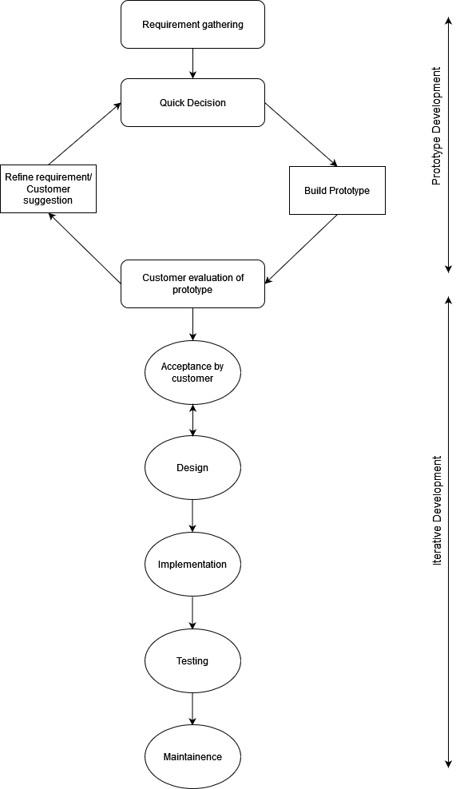

**Figure 1: Prototype Model**

### **3.1.1. Requirement Analysis**

**a) Functional Requirements**

This is how the system shall look like and do when successfully complete. The system shall meet the following functional requirements:

1. **Admin**
2. **Add product:** Add different categories of products.
3. **View/Edit/Delete:** Can view/ update/ delete the product from database.
4. **View/Update Order:** Can view all the orders received from the customer and change the order details accordingly.
5. **User**
6. **Registration:** User can register his details.
7. **Login:** User can login to his account.
8. **Homepage:** User can visit his homepage.
9. **Product details:** User Can view products details by selecting a product and view its details such as price, brand, color, etc.

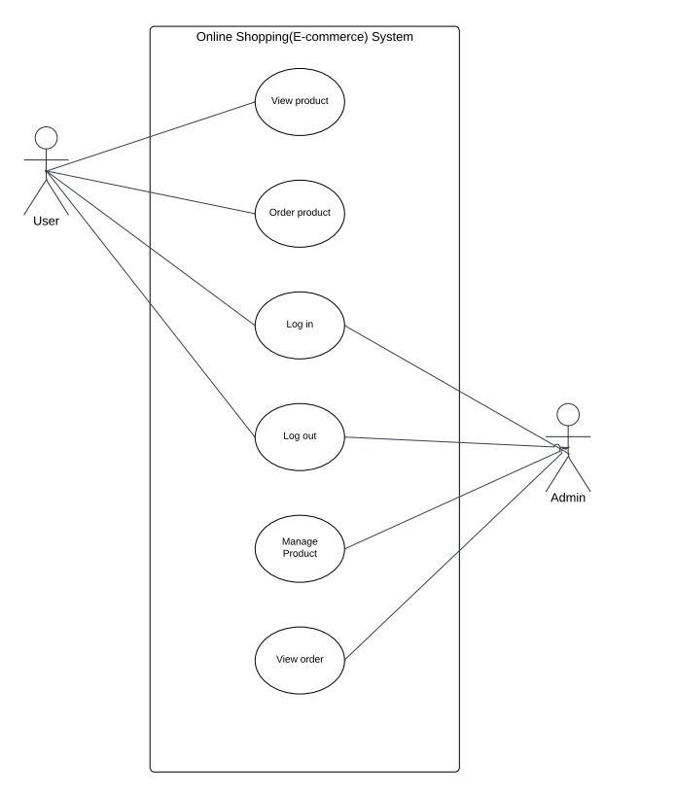

**Figure 2: Use Case Diagram**

**b) Non-functional Requirements**

A non-functional requirement is a requirement that specifies criteria that can be used to judge the operation of a system, rather than specific behaviors.

Some of the non-functional requirements include:

1. **Maintainability:** easy to maintain
2. **Performance/ response time:** fast response
3. **Usability by target user community:** easy to use
4. **Expandability:** needs to be future proof or upgradable
5. **Safety:** should be safe to use

### **3.1.2. Feasibility Analysis**

The study of the effect on the organization after the development system is feasibility analysis. The system may have positive as well as negative impact on the organization. The feasibility study can be carried out in four ways such as technical, economical, operational and schedule.

1. **Technical Feasibility**

While developing this project, the tools which were used are VS.VS server has free access to user, they were selected to use. As we have studied this software in basic, they were easy to use.

1. **Operational Feasibility**

Does not require manual work and this project saves the precious time of the customers with quick search of products with different price range.

1. **Economic Feasibility**

No cost is used in programming languages like PHP, VS. Took about 3 months to develop this project and took few costs while printing.

1. **Schedule Feasibility**

This project was completed within the scheduled period.

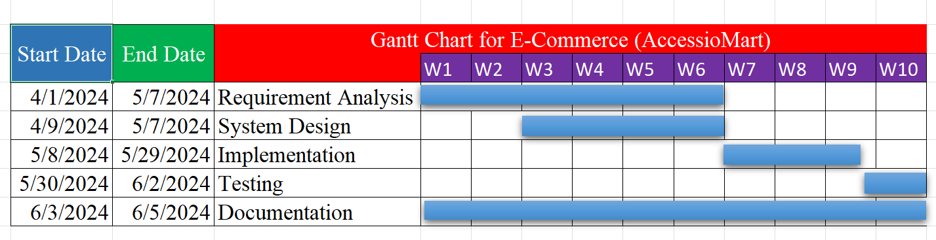

**Figure 3: Gantt Chart**

### **3.1.3. Analysis**

* **Flowchart**

**Figure 4: Flowchart for Admin**

**Figure 5: Flowchart for User**

* **ER Diagram**

An ER diagram or Entity Relationship diagram is a visual representation of the entities and relationships found within an ecommerce website. It helps to identify the relationships between different types of data, such as customers and products, so that developers can create a logical structure for how information should be stored on the website.

**Figure 6: ER Diagram**

* **DFD**

The context level data flow diagram describes the whole system. The 0 level data flow diagram describes all users modules who operate the system. The below DFD of the system shows the two users that can operate the system. They are Customer and Admin.

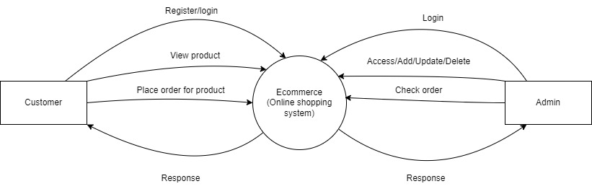

**Figure 7: DFD Level 0 for User & Admin**

**DFD level 1 for Admin**

The DFD for Admin describes the functionality of Admin, Admin is the owner of the system. Admin can add menu, add gallery for a menu and then add items accordingly. Then the admin cam manages the order.

**DFD level 1 for Customer**

Customers include all people who operate or visit our website. The customer can register in our system and login. After that they can search for the menu, select menu to place an order from our website.

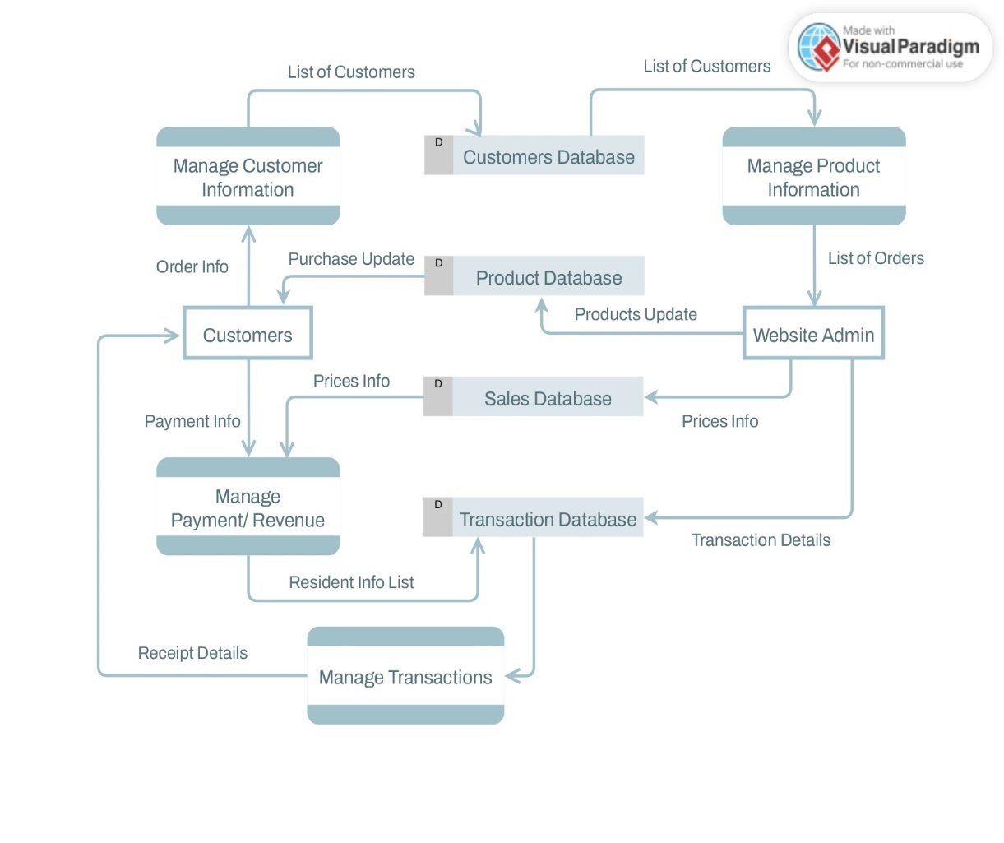

**Figure 8: DFD Level 1 for Admin & User**

## **3.2 System Design**

### **3.1.1. Database design**

Database schema design is the process of defining the structure of a database. It involves identifying the different entities in the database, their attributes, and the relationships between them.

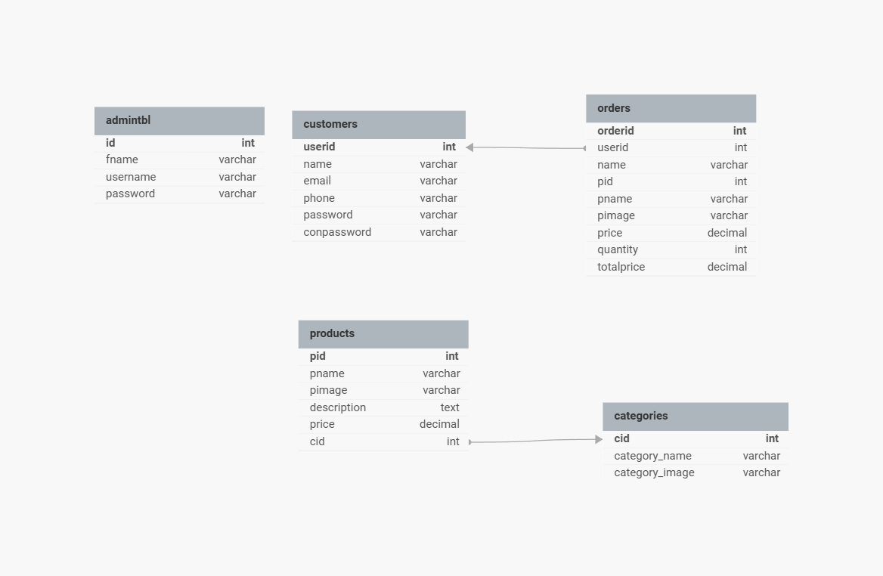

**Figure 9: Database Schema Design**

### **3.1.1. Interface design**

User interface design is one of the most important parts of the system as it determines how easy it is for a new user using the system to understand the different components listed and navigate through them to achieve the intended goal of using the system. The interface of our system will be presented according to the following representations.

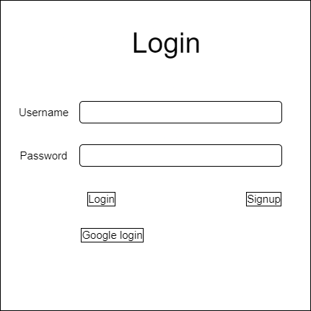

**Figure 10: Interface Design for Login**

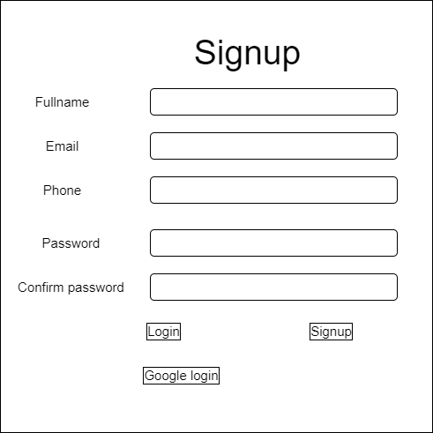

**Figure 11: Interface Design for Signup**

**Figure 12: Interface Design for Homepage**

# **Chapter 4: Implementation and Testing**

## **4.1 Implementation**

The system has been implemented using the following technologies: MySQL is for creating database, HTML and CSS for designing and styling the interfaces, JSON for creating communication between client and server, AJAX for making smooth experiences without reloading the pages. Visual Studio Code has been used as the code editor for the system.

### **4.1.1. Tools Used**

For the E-commerce website, the following technologies have been used:

**Frontend:** HTML, CSS, JavaScript, JSON, AJAX, PHP

**Backend:** PHP, JOSN, AJAX

**Database:** MySQL

**Code Editor:** Visual Studio Code

**4.1.2 Implementation Details of Modules**

Implementation details of CRUD (Create, Read, Update, Delete) operations typically involve developing modules for each functionality. Below are the key steps and considerations for implementing CRUD operations.

1. **Login Page**

This is the code for the login page for our project. By using the given codes we’ve created a simple login form using HTML, CSS and PHP. To login the user should register first and can proceed login ahead.

1. **Add Menu Product**

This is the code for adding products. By using the given codes we’ve created addproduct page where admin can add products as his/her choice.

1. **Edit Product**

This is another page for our website. By using the given code admin can edit product which may no longer be available simply by using HTML, CSS and PHP.

1. **Delete Product**

The given code is to delete products which can only be done by admin.as only admin can access this page.

## **4.2 Testing**

Testing in E-commerce website is an essential aspect of ensuring a seamless and satisfying user experience. Testing is the process of evaluating a software product or system to ensure that it meets its requirements and is fit for use. It involves executing the software with the intent of finding errors, gaps, or other defects.

### **4.2.1 Test Cases for Unit Testing**

Unit testing is a software testing method that focuses on verifying the correctness of individual units or components of a system. A unit refers to the smallest testable part of an application, typically a single function, method, or class. The goal of unit testing is to isolate and test these units in isolation to ensure they work as intended and produce the expected output for a given set of inputs.

**4.2.1.1 User Application Testing**

**Table 1: User Application Testing**

|  |  |  |  |  |  |  |
| --- | --- | --- | --- | --- | --- | --- |
| **S.N.** | **Test Case**  **ID** | **Test Description** | **Steps Executed** | **Expected Results** | **Actual Results** | **Pass/Fail** |
| i) | TC-01 | User registration | 1. Click on the registration button. 2. Enter valid user details and required   information | Registration form is displayed. User is successfully registered | The user can register for a new account. | pass |
| ii) | TC-02 | User login | 1. Click on the login button 2. Enter the valid login   credentials | Login form is displayed.  User is logged in  successfully. | The user can  login to  the system | pass |
| iii) | TC-03 | Product browsing and selection | 1. Navigate the Product page. 2. Browse   through the  Product options. | Product is displayed with a list of available products.  Product details are displayed | The user can add product to  their cart. | pass |
| iv) | TC-04 | Order Product | Proceed to Order | The user should be able to place an  order | The user can place an  order. | pass |

**4.2.1.2 Admin Application Testing**

**Table 2: Admin Application Testing**

|  |  |  |  |  |  |  |
| --- | --- | --- | --- | --- | --- | --- |
| **S.N.** | **Test**  **Case ID** | **Test Description** | **Steps Executed** | **Expected Results** | **Actual Results** | **Pass/Fail** |
| i) | TC-01 | Admin login | 1.Click on the admin  login button | Admin login form is displayed | The admin is able to  login to the  system. | pass |
|  |  |  | 2.Enter the valid login  credentials | Admin is logged in  successfully |  |  |
| ii) | TC-02 | Product  management | 1.Navigate to the Product  management section | Product  management page is displayed | The admin can add, edit, and delete products from the  system. | pass |
|  |  |  | 2.Add a new  product to the product page. | New product is  added to the  page |  |  |
|  |  |  | 3.Update the details of an existing  product | Product details are successfully  updated |  |  |
|  |  |  | 4.Remove a product from the menu | Product is removed from page |  |  |

**4.2.1.3 System Testing**

**Table 3: System Testing**

|  |  |  |  |  |  |  |
| --- | --- | --- | --- | --- | --- | --- |
| **S.N.** | **Test Case ID** | **Test**  **Description** | **Steps Executed** | **Expected Results** | **Actual Results** | **Pass/Fail** |
| i) | TC-01 | User login and registration | User signup with username, email, and password, it gets saved to database, the user now signs in with the same  credential. | User can fill form  to signup, fill sign in form and sign in to dashboard. | User is successfully Login. | Pass |
| ii) | TC-02 | User Order Product | Click on Product and order product according to user  requirements. | User can order product. | User is successfully ordered product. | Pass |

# **Chapter 4: Conclusion and Future Recommendations**

## **4.1 Conclusion**

The online shopping system has significantly transformed the way people order and receive products. Overall, it has proven to be a convenient and efficient solution for both customers and business. In conclusion, the online shopping system has revolutionized the shopping industry, providing convenience, customization and efficiency for both customers and businesses. Its adoption has significantly enhanced the overall shopping experience, making it easy for everyone involved.

## **4.1 Future Recommendations**

In the future, the online shopping system should aim to provide a seamless and convenient experience for customers. Here are some recommendations to enhance the system:

1. User-friendly interface
2. Mobile optimization
3. Personalization and customization
4. Quick and easy ordering process
5. Real time order tracking

Remember, as technology evolves, continuously monitor customer feedback, analyzer user behaviors, and adopt the online shopping system to meet changing demands and expectations.

# **Chapter 4: References**

[1] OpenAI, "ChatGPT," Available: https://www.openai.com/chatgpt. [Accessed: 26-Jun-2024].

[2] Draw.io, "Diagram Design Tool," Available: https://www.draw.io. [Accessed: 26-Jun-2024].

[3] Instagantt, "Gantt Chart Tool," Available: https://www.instagantt.com. [Accessed: 26-Jun-2024].

[4] YouTube, "Video Sharing Platform," Available: https://www.youtube.com. [Accessed: 26-Jun-2024].

[5] Daraz, "E-commerce Platform," Available: https://www.daraz.com. [Accessed: 26-Jun-2024].

[6] W3Schools, "Web Development Tutorials," Available: https://www.w3schools.com. [Accessed: 26-Jun-2024].

[7] GitHub, "Design and Template Repository," Available: https://www.github.com. [Accessed: 26-Jun-2024].

# **Chapter 4: Appendices**

## **4.1 Screenshots**

1. **Homepage**

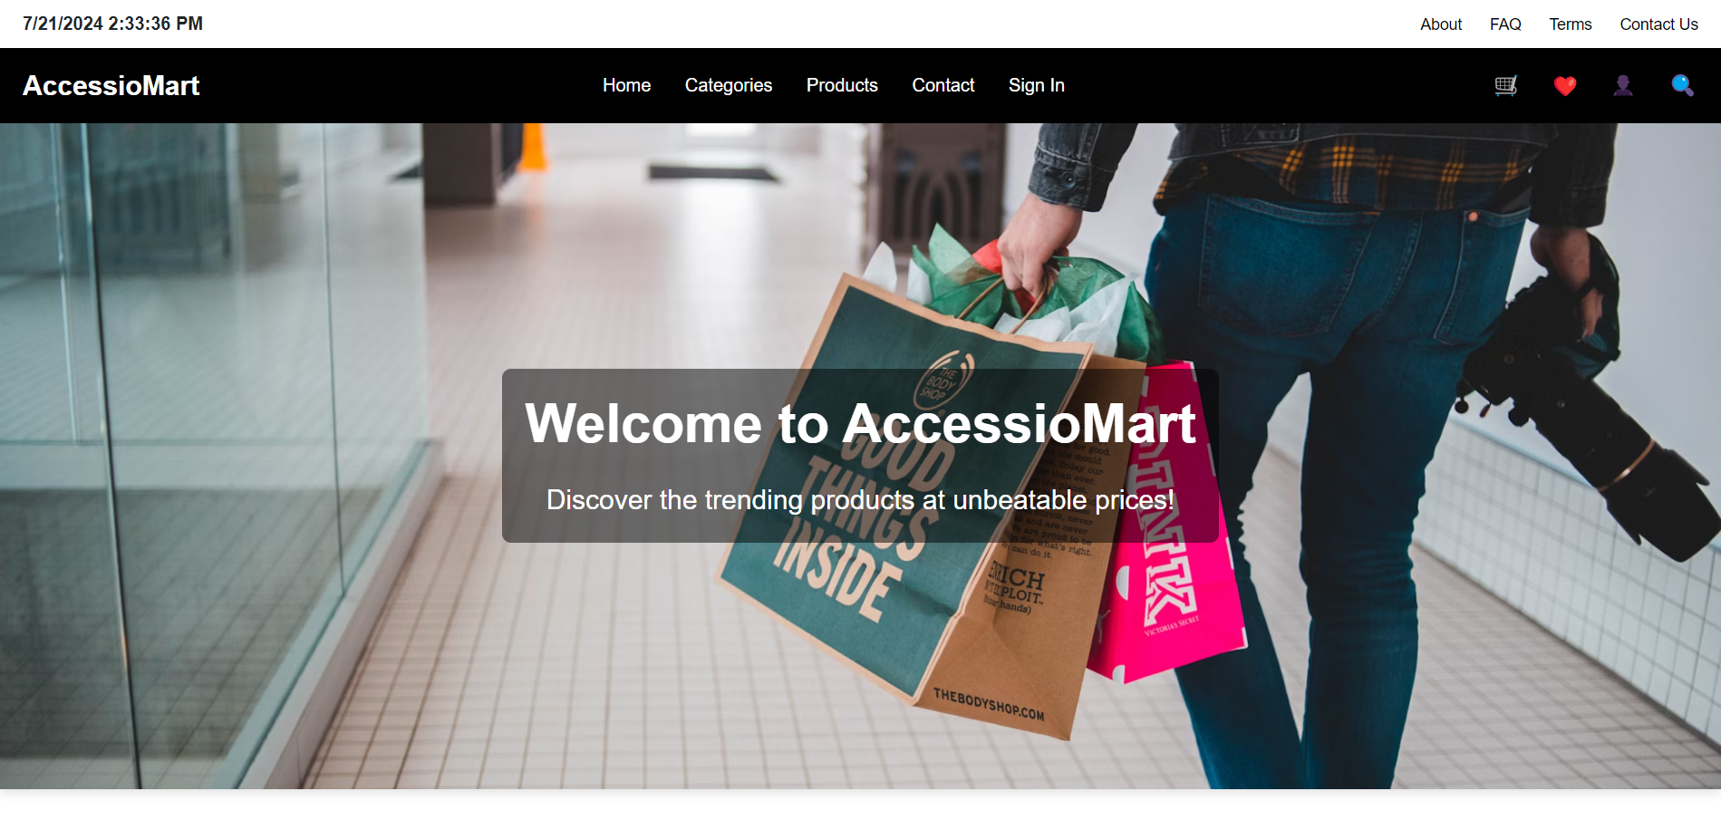

1. **About Us page**

1. **FAQ’s page**

1. **Product’s page**

1. **Contact Us page**

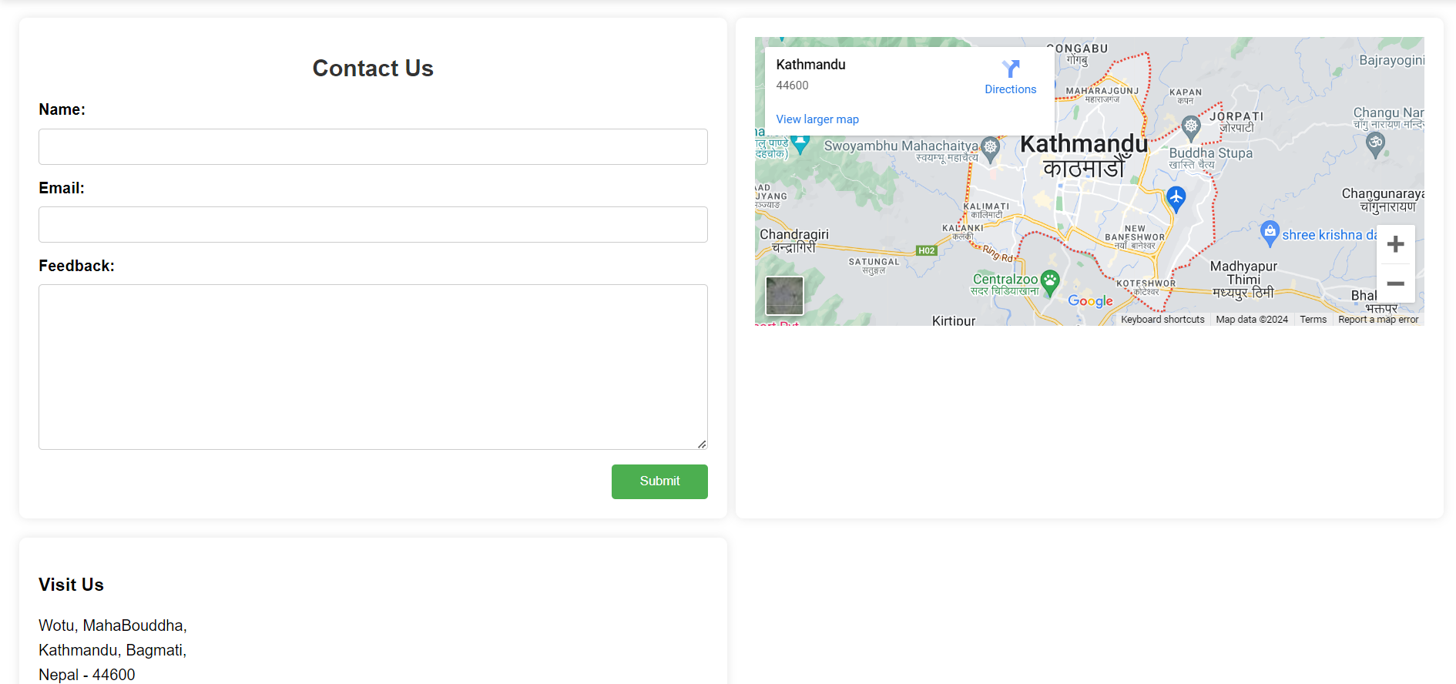

1. **Admin Login**

1. **Admin Dashboard**

1. **Orders page**
2. **Add categories page**

