Name: Sahil Hedau

Sec: A (A3)

Roll No.: 56

Date: 13/5/2023

**OOPs Practical 1**

**Aim:**

1. Create a class Stack and implement the functionalities of the Stack Class
2. Write a program to demonstrate method overloading. Create a class 3DShape and overload a method named volume() to calculate volume of different geometric shapes like sphere, cube, cuboid and cylinder. Create a main() to implement all the methods.

**Code & Output:**

**Code A:**

**stack.java**

public class stack {

    int top;

    int MAXSIZE = 20;

    int a[] = new int[MAXSIZE];

    stack(){

        top = -1;

    }

    int pop(){

        if(isEmpty()==0){

            System.out.println("Popped Element: "+ a[top]);

            int data = a[top];

            top--;

            return data;

        }

        System.out.println("STACK UNDERFLOW");

        return -1;

    }

    void push(int num){

        if(isFull()==0){

            top++;

            a[top] = num;

        }

    }

    int isEmpty(){

        if(top == -1){

            System.out.println("Stack Empty!");

            return 1;

        }

        return 0;

    }

    int isFull(){

        if(top == MAXSIZE-1){

            System.out.println("Stack Full!");

            return 1;

        }

        return 0;

    }

    int peek(){

        if(isEmpty()==0){

            System.out.println("Peek --> "+ a[top]);

            return a[top];

        }

        System.out.println("STACK UNDERFLOW");

        return -1;

    }

}

**main.java**

public class main {

    public static void main(String[] args) {

        stack S = new stack();

        S.push(49);

        S.peek();

        S.push(56);

        S.push(10);

        S.peek();

        S.pop();

        S.peek();

        S.pop();

        S.pop();

        S.pop();

    }

}

**Output A:**

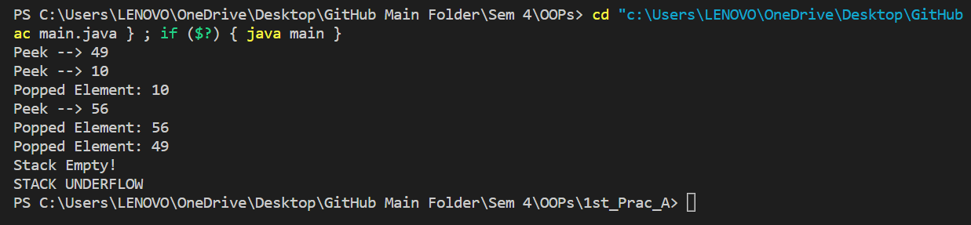

**Code B:**

**three_d_shape.java**

public class three_d_shape {

    double volume(double radius){

        return 4*Math.PI*radius*radius*radius/3;

    }

    double volume(int l, int b, int h){

        return l*b*h;

    }

    double volume(int r, int h){

        return Math.PI*r*r*h;

    }

    double volume(int side){

        return side*side*side;

    }

}

**main.java**

public class main {

    public static void main(String[] args) {

        three_d_shape v = new three_d_shape();

        double sphere_v = v.volume(5.0);

        System.out.println("Volume of Sphere : "+sphere_v);

        double cube_c= v.volume(2);

        System.out.println("Volume of Cube : "+cube_c);

        double cuboid_v = v.volume(2,3,4);

        System.out.println("Volume of Cuboid : "+cuboid_v);

        double cylinder_v = v.volume(2,3);

        System.out.println("Volume of Cylinder : "+cylinder_v);

    }

}

**Output B:**

