Name: Sahil Hedau

Sec: A (A3)

Roll No.: 56

Date: 24/5/2023

**OOPs Practical 4**

**Aim:**   
Write a program to implement multiple inheritance.  
Consider a class BankAccount with data members as account number, aadhar number, owner name, ROI and balance with member functions openAccount(), deposit(amount),closeAccount() and updateInterest()(this method deposits 4% interest to the account). Create an interface Debitable which has method withdraw().  
Derive a class FixedDepositAccount from BankAccount having data member lockInPeriod. Override methods updateInterest() to update Simple Interest, and method closeAccount() to charge 5 % for closure of FD Account before lockInPeriod.  
Derive a class SavingAccount from class BankAccount and interface Debitable.  
The account numbers should be serial numbers of  5 digit and automatically assigned on object creation, such that all FDAccounts start with 55 and all Saving account start with 11.  
[ROI for Saving Account is 4% and for FD – 1-2yrs-6% ; 2-5yrs-6.5% ; >5yrs- 7%]

**Code:**

**main.java**

public class main{

    public static void main(String[] args) {

        // Saving Account 1

        SavingAccount s1 = new SavingAccount(123456, "Sahil", 500);

        s1.withdraw(100);

        s1.deposit(2000);

        s1.updateInterest();

        s1.withdraw(500);

        s1.closeAccount();

        // Fixed Deposite

        FixedDepositeAccount f1 = new FixedDepositeAccount(987654, "Samrat", 5, 100000);

        f1.updateInterest();

        f1.closeAccount(3);

        // Saving Account 2

        SavingAccount s2 = new SavingAccount(123456, "Sahil", 5000);

        s2.withdraw(500);

        s2.closeAccount();

    }

}

**BankAccount.java**

public class BankAccount {

    int accountNumber;

    int aadharNumber;

    String name;

    double roi = 0;

    double balance;

    BankAccount(int aadharNumber, String name, double amount){

        openAccount(aadharNumber, name, amount);

        accountNumber = 99999;

    }

    private void openAccount(int aadharNumber, String name , double amount){

        this.aadharNumber = aadharNumber;

        this.name = name;

        this.balance = amount;

    }

    void deposit(int amount){

        balance += amount;

        System.out.println("\n"+amount + "Rs. Deposited!\n");

    }

    void updateInterest(){

        double interest = 0.04*balance;

        balance += interest;

    }

    void closeAccount(){

        System.out.println("\nAccount Number: "+accountNumber);

        System.out.println("Aadhar Number: "+aadharNumber);

        System.out.println("Name: "+name);

        System.out.println("Balance: "+balance);

        System.out.println("Account is Closed!");

    }

}

**SavingAccount.java**

public class SavingAccount extends BankAccount implements Debitable{

    static int base = 11001;

    SavingAccount(int aadharNumber, String name, int amount){

        super(aadharNumber, name, amount);

        accountNumber = base++;

    }

    public int withdraw(int amount){

        balance -= amount;

        System.out.println("Account Number: "+accountNumber);

        System.out.println("Name: "+name);

        System.out.println("Current Balance: "+balance);

        System.out.println("Rs. "+amount+" Withdrawed!");

        return amount;

    }

}

**FixedDepositeAccount.java**

public class FixedDepositeAccount extends BankAccount{

    double lockInPeriod;

    static int base = 55001;

    FixedDepositeAccount(int aadharNumber, String name, int lockInPeriod, int amount){

        super(aadharNumber, name, amount);

        this.lockInPeriod = lockInPeriod;

        accountNumber = base++;

        if(lockInPeriod >=1 && lockInPeriod <= 2)

            roi = 6;

        else if (lockInPeriod >=2 && lockInPeriod <= 5)

            roi = 6.5;

        else

            roi = 7;

    }

    void updateInterest(){

        double interest = roi*balance/100;

        balance += interest;

    }

    void closeAccount(double endTime){

        double charge = 0;

        if(endTime<lockInPeriod){

            charge = 0.05*balance;

        }

        balance -= charge;

        System.out.println("\nAccount Number: "+accountNumber);

        System.out.println("Aadhar Number: "+aadharNumber);

        System.out.println("Name: "+name);

        System.out.println("Balance: "+balance);

        System.out.println("Account is Closed! With "+ charge +" Charges.\n");

    }

}

**Debitable.java**

public interface Debitable {

    int withdraw(int amount);

}

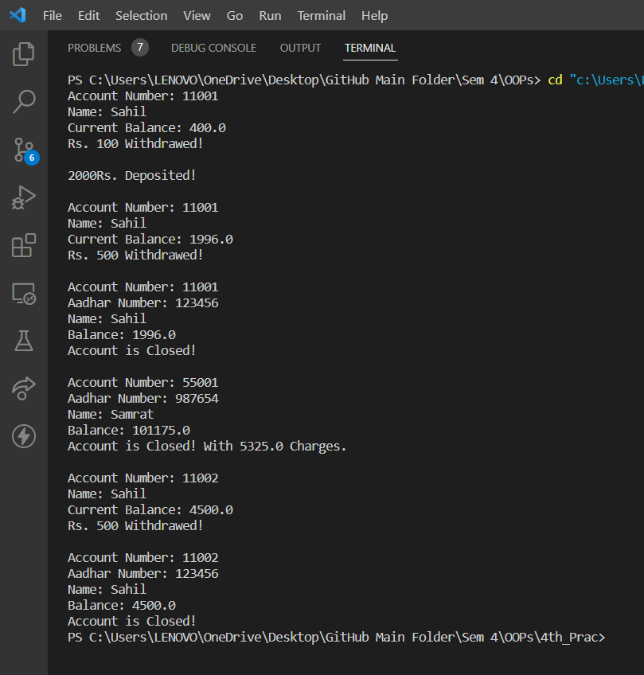**Terminal Output:**