

**TRIBHUVAN UNIVERSITY**

**INSTITUTE OF SCIENCE AND TECHNOLOGY**

**A Project Proposal**

**On**

**"Job Portal System"**

**Submitted to**

**Department of Statistics and Computer Science**

**Patan Multiple Campus**

*In partial fulfillement of the requriments for Bachelor Degree in Computer science and Information Technology*

**Submitted by:**

**Sahil Shrestha** (23072/076)

**Prasant Dhamala** (23048/076)

**Sandeep Gautam** (23075/076)

**Table of content**

**1. Introduction** 1

**2. Problem statements** 1

**3. Objectives** 2

**4. Methodology** 2

**4.1 Requirement Identification** 2

**4.1.1 Study of existing system** 2

**4.1.2 Literature Review** 3

**4.2 Requirements Analysis** 3

**4.3 Feasibility Study** 5

**4.3.1 Technical Feasibility** 5

**4.3.2 Operational Feasibility** 5

**4.3.3 Economic Feasibility** 5

**4.4 Detailed Module Description with all Functionalities** 6

**4.4.1 Registration** 6

**4.4.2 Job Post** 6

**4.4.3 Search** 6

**4.4.5 Manage Account** 6

**5. High Level Design of System** 7

**5.1 Methodology of the proposed system** 7

**5.2 System Flowchart** 8

**5.3 Use Case Diagram** 10

**5.4 Class Diagram** 11

**5.4 Description of algorithms** 12

**6. Testing** 14

**6.1 Black Box Testing** 14

**6.2 White box testing** 15

**7. Gantt chart** 16

**8. Expected outcome** 16

**9. References** 17

**Table of Figures**

**Figure 1: Waterfall Model** 7

**Figure 2: Flowchart for Job Seekers** 8

**Figure 3: Flowchart for employer** 9

**Figure 4: Use Case Diagram for System** 10

**Figure 5: Black Box Testing** 12

**Figure 6: White Box Testing** 13

**Figure 7: Gantt Chart for Online Job Portal System** 14

# **1. Introduction**

A digital platform that links job seekers and employers and streamlines the hiring and job search process is known as an online job portal system. Its enormous benefits and extensive use in the contemporary work market have led to its rising popularity. Job Portal will allow job provider to establish one to one relationship with candidates. This Portal will primarily focus on the posting and management of job vacancies. [1]

Online employment boards are available around-the-clock from any location with an internet connection. The application process is more flexible because job seekers can look for positions and submit applications whenever is most convenient. These platforms have a vast reach, allowing employers to connect with a large pool of potential candidates from different geographic locations. Job seekers can explore opportunities beyond their local area. Online job boards can be less expensive for employers than conventional hiring practices. There is less need for in-person interviews and administrative work because they may post job postings, analyze resumes, and connect with applicants online. In order to be updated about opportunities that are relevant to them, job seekers can sign up to receive notifications when new positions that fit their criteria are posted.

# **2. Problem statements**

The existing job portal system doesn't have a strong matching algorithm, which leads to ineffective matching between employers and job seekers, a high rate of mismatches, and lost time for both sides. Users lack confidence in some job portal system because of their worries about the security and privacy of their personal information. This might make users less likely to provide accurate and comprehensive information on their profiles. The job portal system's user interface and user experience are obsolete, making it difficult for users to browse, search for positions, and submit applications. Potential users are discouraged from completing their profiles or submitting job applications form due to the complexity, long registration and application procedures. Due to the lack of proper description about the listed job that can cause misunderstanding and demotivation on people.

# **3.** **Objectives**

The main objective of job portal system is

* Create a user-friendly central platform for job seekers and employers to connect
* Provide clear information about job vacancies from different geographic areas
* Modernize the traditional job search process by enabling online job applications
* Bridge the gap between job seekers and employers by facilitating direct communication and interaction

# **4.** **Methodology**

## **4.1 Requirement Identification**

Defining the precise features, functionalities, and capabilities that the platform must have to satisfy the needs of job seekers, employers, and other stakeholders constitutes requirement identification for an online job portal.

Requirement identification is the collecting the relevant requirements that will be used to develop a system. There are different methods to gather requirement which includes studying of existing system, interviews, questionnaires etc.

### **4.1.1** **Study of existing system**

The existing job portal systems follows the traditional way publishing the vacancies, where users are often unable to get proper information about the job vacancy. We need to examine the data security measures and privacy policies of existing job portals that helps to identify any reported data breaches or security vulnerabilities that is solved to make perfect job portal system. The existing system is also lack of detail information about any job and that also have complex UI so the job seeker might get confused with the job and working procedure. By recognizing the methods used by platforms now in use to implement job matching algorithms and link job searchers with appropriate job listings. Analyze how well these algorithms perform in finding precise matches. In the conventional method, filling out paper applications or printing off physical resumes and mailing them might be time-consuming and laborious.

### **4.1.2** **Literature Review**

Now a days, job portal system plays important role where companies can simply publish their vacancies and job seeker can choose the job on the basis of their qualification and skills through online. With the growth of the internet, the job portal system has been booming with every generation attracted towards the varieties of job it provides, easier for applying to the job vacancy and security of the personal information. Traditional job-hunting techniques include going to job fairs, visiting companies in person, or relying on newspaper ads. These techniques may only be effective in specific locations. Nowadays, job seekers can access a worldwide job market from their devices via employment portals that are available around-the-clock from any location with an internet connection. With just a few clicks, job searchers may quickly apply to various openings on online job portals, frequently by uploading their digital resumes and supporting documentation. Due to the lack of the real time updates on traditional job portal system becomes less efficient whereas modern job portal systems are fully updated with real time data and information. The popular job portal systems include: merojob, linkedin, social media ads and so on. They are responsible to provide the varieties of job to the peoples worldwide so many peoples get benefitted.

### **4.2** **Requirements Analysis**

Requirements will be collected through interviews, Google searches, website visits and friendly suggestions.

#### **4.2.1 Functional Requirement**

* Allow job seekers and employers to create accounts and build user profiles
* Match users to relevant jobs based on preferences, credentials and abilities
* Enable submission of job applications and supporting documents
* Provide recommendations based on user history and secure user data privacy

#### **4.2.2 Non-functional Requirement**

**Availability**

The system will be available for all the users from any geographical location.

**Reliability**

The system will be reliable as it uses encryption to protect user data.

**User Interaction**

Users will get an attractive and easy interface to interact with the system.

**Performance**

The system will have higher performance than the existing one.

**Security**

This system will implement safe data storage and encryption for sensitive user data, including contact details, resumes, and communication logs.

**Data Backup and Recovery**

The system will create routine data backup practices and test data recovery techniques to avoid data loss in the event of unforeseen circumstances.

## **4.3** **Feasibility Study**

### **4.3.1** **Technical Feasibility**

When doing a technical feasibility study, it is important to identify the hardware and software the system will require in order to successfully meet user requirements. The ability to achieve results in a certain amount of time. Our project is an online program that is depending on a client-server application. Every page is rendered from this application's database as output. Therefore, it is essential that the page be delivered promptly from server to client. [2]

The system can be built using web development technologies such as HTML, CSS, ASP.NET, JavaScript, JQuery framework. We are using Microsoft SQL server as a database server for our project. Thus, it is technically feasible.

### **4.3.2** **Operational Feasibility**

Operation feasibility is used to check whether the project is operationally feasible or not. It determines if the proposed system can be successfully installed, run, and maintained inside the company or commercial setting. Our product differs from other systems in large part due to its web-support functionality. Therefore, the operational feasibility test uses a different metric than previous one. Since the proposed system can be accessed using a web browser which is available in both desktop computers as well as mobile devices, thus, it is operationally feasible.

### **4.3.3** **Economic Feasibility**

Economic feasibility is the measure to determine the cost and benefit of the proposed system. A project is economical feasible which is under the estimated cost for its development. These benefits and costs may be tangible or intangible. Job Portal is the cost-effective project in which there is less possibility of intangible cost so there is no difficulty to determine the cost of the project. This system is economically viable because it will be constructed with the help of free online tools and techniques.

## **4.4** **Detailed Module Description with all Functionalities**

### **4.4.1 Registration**

Job seekers must fill out all the required information during registration, including their name, address, phone number, and information about their education, including their school, post-secondary education, graduation, and course certifications. Additionally, the job applicant must include information about his experience, job criteria, and resume uploading photo. While for registration, the job recruiter must include his contact information and organization details, submit the company profile and logo.

### **4.4.2 Job Post**

An employer can advertise a job by including all relevant employment information, such as the job's qualifications, requirements, classification, compensation, and type. Whenever they choose, they can also delete the jobs. When a job is properly advertised, it will be accessible to all the seeking employment; looking for employment. Additionally, it will appear on the front page as recently uploaded job.

### **4.4.3 Search**

Employees are able to search for jobs based on their interests. Additionally, they can submit an application for the position or add it to their wish list so that they can easily locate the organization in the future when they find a position with that employer. Employers use technology like keywords to find applicants who meet their standards. Furthermore, you can send messages to the employee for any additional questions or information both also applicant’s resumes are seen by employers.

### **4.4.5 Manage Account**

Employers are able to control their job ads and the actual job account. And providing all the employment information, including the type of positions, designation information, requirements for the work, compensation information, and qualification information. Additionally, they have complete control over job deletion. Employees can manage their wish lists, apply for jobs, and get complete employer details. Any time that employees can remove their accounts. Additionally, they might apply for various employment in accordance with to their benefit.

# **5. High Level Design of System**

## **5.1** **Methodology of the proposed system**

Using the waterfall software development lifecycle paradigm, the suggested system will be created. In this paradigm, the coding process begins once the requirements have been acquired from multiple sources, analyzed, and a design has been created. Finally, a number of test cases are used to evaluate the developed system. The finished system is ready for implementation if all test cases are completed and passed.

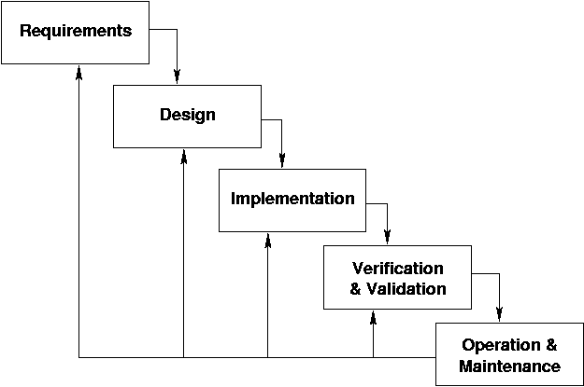

**Figure 1: Waterfall Model**

## **5.2** **System Flowchart**

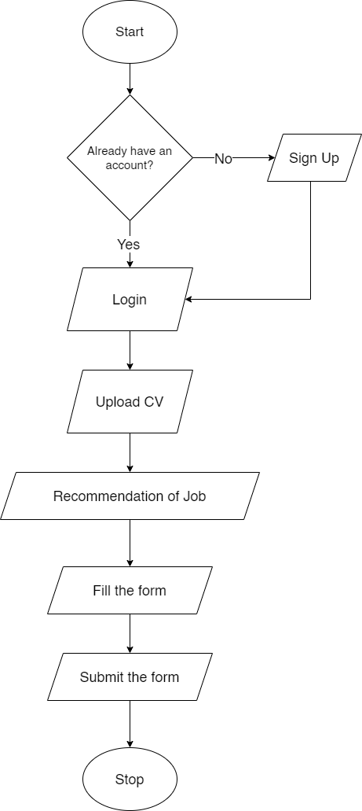

**Figure 2: Flowchart for Job Seekers**

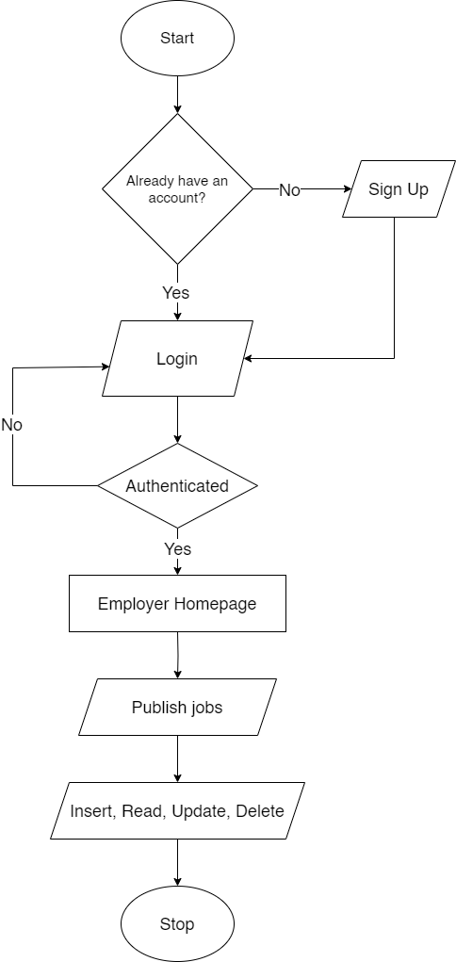

**Figure 3: Flowchart for employer**

## **5.3 Use Case Diagram**

**Job Portal System**

Admin

Employee

Employer

**Figure 4: Use Case Diagram for System**

## **5.4 Class Diagram**

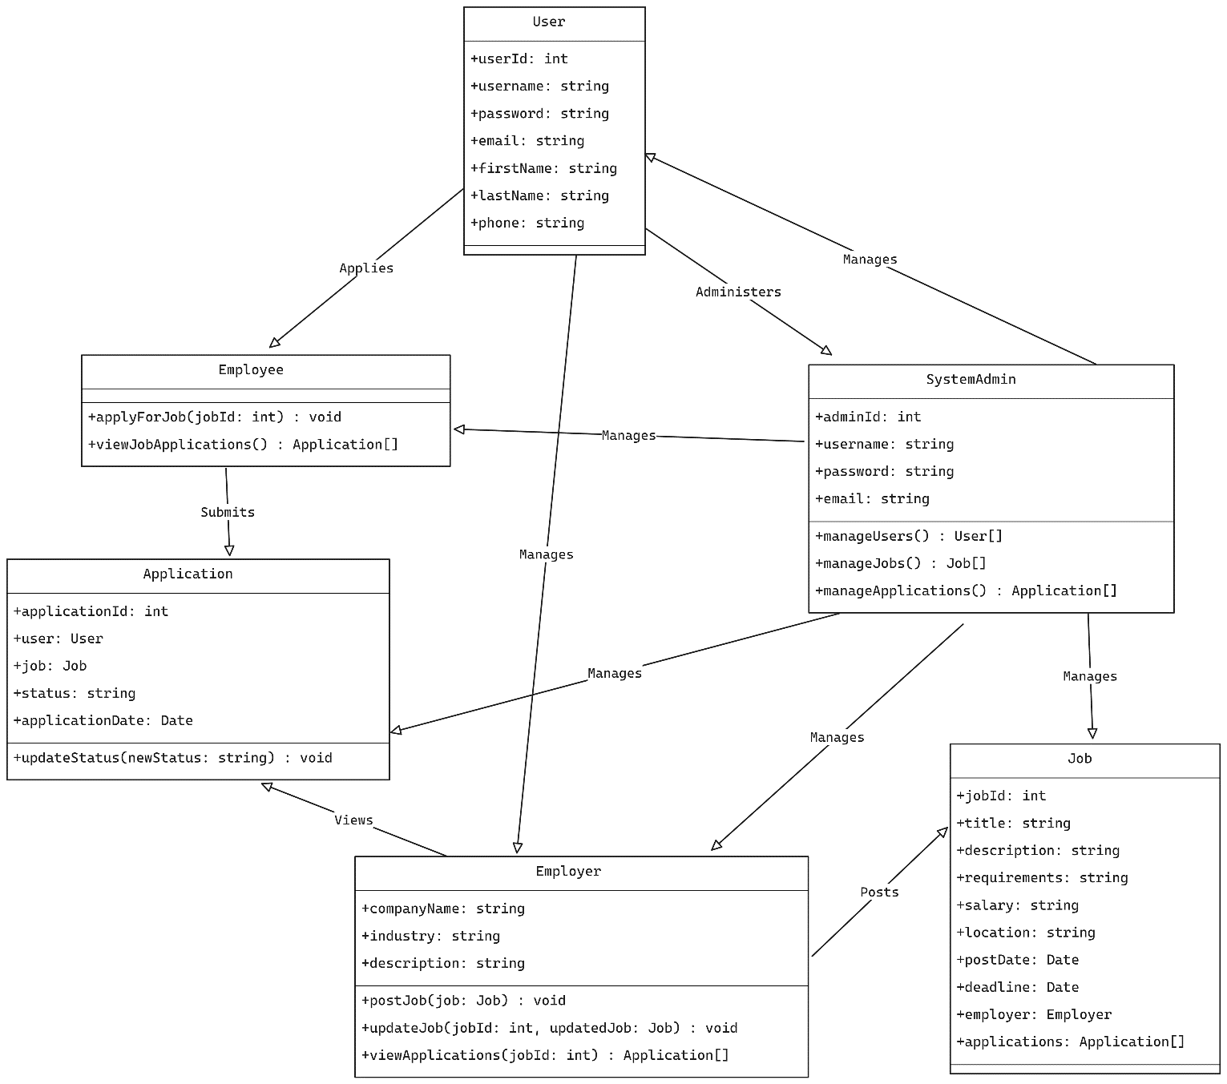

**Figure 5: Class Diagram for System**

## **5.4** **Description of algorithms**

This job portal system will be using these algorithms in various aspects of job seeking and shortlisting processes. They are as follows:

**Naïve Bayes Classifier**

Naive Bayes is a simple technique for constructing classifiers: models that assign class labels to problem instances, represented as vectors of feature values, where the class labels are drawn from some finite set. [3] In this system, we classify the job seekers into various categories based on their credentials and skill level and make the screening process for the employer easy.

This method uses Bayes Probability to make a prediction which is given as:

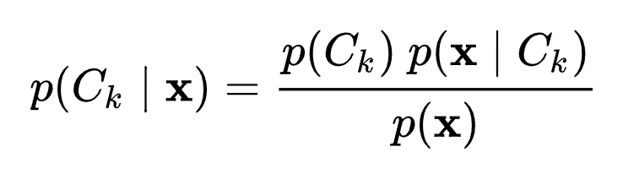

**Content based filtering**

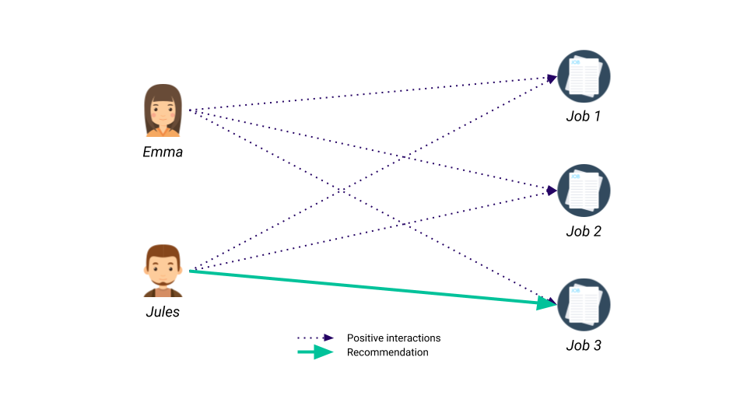Content-based filtering is an algorithm that recommends jobs to users based on the similarity between the job description and the user's profile and preferences. The system analyzes the text content of job postings and the interests/skills listed in the user's profile to find the closest matches. For example, if a user has Python programming in their skills section, the system will recommend jobs with Python mentioned in the description. The algorithm creates a user profile to represent their interests and preferences. As the user applies to more jobs or saves/likes job postings, the profile is updated to better capture their preferences. Content-based filtering allows customized, personalized job recommendations specific to each user's unique interests and background. [4]

# **6. Testing**

There will be two phases of testing which are mentioned below:

## **6.1 Black Box Testing**

Black box testing, a type of testing carried out by the tester, without having access to the internal workings of a system, is a type of testing that can be used to assess the functionality, security, performance, and other features of an application. Automated black box security testing is shown by examining dynamic code. Black Software testers build test cases and use the software in a way that a user would to verify that it is working as intended performs as expected.

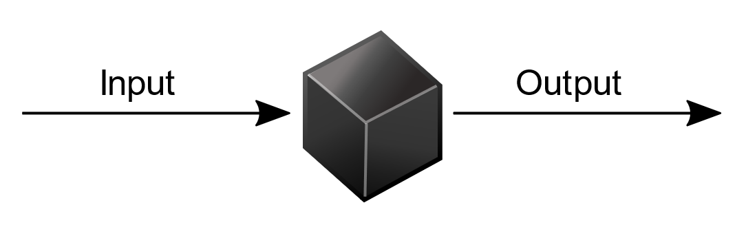

**Figure 6: Black Box Testing**

## **6.2 White box testing**

White-box testing (also known as clear box testing, glass box testing, transparent box testing, and structural testing) verifies the internal structures or workings of a program, as opposed to the functionality exposed to the end-user. It is carried out by the software developers. In white-box testing, an internal perspective of the system (the source code), as well as programming skills, are used to design test cases. The developers choose inputs to exercise paths through the code and determine the appropriate outputs. This is analogous to testing nodes in a circuit, e.g.in circuit testing (ICT). While white-box testing can be applied at the [unit](https://en.wikipedia.org/wiki/Unit_testing), [integration](https://en.wikipedia.org/wiki/Integration_testing), and [system](https://en.wikipedia.org/wiki/System_testing) levels of the software testing process, it is usually done at the unit level.  It can test paths within a unit, paths between units during integration, and between subsystems during a system–level test. [5]

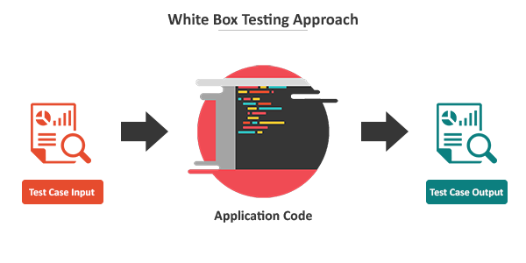

**Figure 7: White Box Testing**

# **7. Gantt chart**

|  |  |  |  |  |  |  |  |  |  |  |
| --- | --- | --- | --- | --- | --- | --- | --- | --- | --- | --- |
| Process | No. of Weeks | | | | | | | | | |
| 1 | 2 | 3 | 4 | 5 | 6 | 7 | 8 | 9 | 10 |
| Requirement Gathering |  |  |  |  |  |  |  |  |  |  |
| Planning |  |  |  |  |  |  |  |  |  |  |
| Designing |  |  |  |  |  |  |  |  |  |  |
| Coding |  |  |  |  |  |  |  |  |  |  |
| Testing and debugging |  |  |  |  |  |  |  |  |  |  |
| Implementation |  |  |  |  |  |  |  |  |  |  |

**Figure 8: Gantt Chart for Online Job Portal System**

# **8.** **Expected outcome**

The expected outcomes of implementing content-based filtering in the job portal include providing users with personalized job recommendations matched to their skills, interests and preferences. This will lead to increased engagement on the platform, higher applicant conversion rates, reduced effort for job seekers to find relevant openings, and more effective reach of suitable candidates for employers. Overall, the project aims to develop an efficient job portal that connects job seekers and employers through intelligent recommendation algorithms, improving the hiring and job search process for both parties. The customized recommendations are expected to enhance the user experience and optimize the recruitment process.

# **9. References**

|  |  |
| --- | --- |
| [1] | J. D. a. T. Naz, "“Integration of Job portals by Meta-search"," Portugal, 2007. |
| [2] | M. G. a. C. S. Bsiri, "Structuring job search via local grammars," *Advances in Natural Language Processing and Applications,* p. 201, 2008. |
| [3] | "Wikipedia," [Online]. Available: https://en.wikipedia.org/wiki/Naive_Bayes_classifier. |
| [4] | "TowardsDataScience," [Online]. Available: https://towardsdatascience.com/introduction-to-recommender-systems-1-971bd274f421. |
| [5] | J. O. Paul Ammann, Introduction to Software Testing, The old school : Cambridge University Press, 2016. |
| [6] | M. G. a. C. R. S. Bsiri, "Structuring job search via local grammars," *Advances in Natural Language Processing and Applications,* p. 201, 2008. |
| [7] | "Wikipedia," [Online]. Available: https://en.wikipedia.org/wiki/Naive_Bayes_classifier. |