PROMPT OPTIMIZER
An Intelligent System for Improving AI Prompts
AI Mini Project Report
Name: Sahil Joshi
PRN: 1022512047
TY ECE A3

Problem Statement and Objectives

Problem Statement
Artificial Intelligence tools are widely used for learning, programming, research, and content creation. However, users may provide short, incomplete, or unclear instructions. If a prompt does not specify the task, audience, expected format, or constraints, the response may be less useful than expected. This project aims to help users improve their prompts before using them with an AI system.

Objectives
- Analyze the structure of user-provided prompts.
- Identify missing prompt components: role, context, task, output format, and constraints.
- Calculate and display a prompt quality score.
- Generate a clearer and more structured version of the original prompt.
- Provide a simple web interface for prompt optimization.
- Use a sample dataset to test the system and perform basic data analysis.

Dataset and Source
The project uses a CSV file named prompt_dataset.csv. It contains a small, self-created collection of example prompts grouped into categories such as Artificial Intelligence, Programming, Education, Career, DBMS, Email Writing, Data Analysis, and Presentation.
Source: Self-created working dataset based on common example prompts. The dataset is used for testing and basic analysis; it is not used to train a machine learning model.
The dataset can be expanded in future work by collecting a larger and more diverse set of prompts and documenting their sources.

Basic Data Analysis
The Pandas library is used to read the CSV dataset and analyze the prompts. The analysis script applies the rule-based optimizer to each prompt and records values such as the original quality score, word count, number of missing components, and category.
The basic analysis includes:
- Total number of prompts in the dataset.
- Average original prompt quality score.
- Average word count before and after optimization.
- Average number of missing components.
- Average score by prompt category.
The analysis results are saved in analysis_results.csv. Actual numerical results should be taken from the output produced by running data_analysis.py; no results are assumed in this report.

AI Tool Used and Purpose
ChatGPT was used as an AI-assisted development tool during project planning and implementation. It supported understanding prompt-engineering concepts, exploring the workflow, assisting with Python code, troubleshooting errors, and preparing documentation.
The current application itself uses a rule-based approach. It checks predefined keywords and patterns to identify five prompt components and then adds suitable guidance where components are missing. The current version does not claim to train or use a machine learning model.
An LLM or AI API may be integrated in a future version to improve semantic understanding and context-aware optimization.

Work Completed
- Designed a web-based interface using HTML, CSS, and JavaScript.
- Created a Python backend using the Flask framework.
- Implemented rule-based checks for role/persona, context/audience, clear task, output format, and constraints.
- Implemented prompt quality scoring and missing-component detection.
- Implemented generation of an improved prompt based on detected missing components.
- Created a sample CSV dataset for testing and basic analysis.
- Developed a Pandas analysis script to produce analysis_results.csv.
- Prepared the project structure and run instructions for local testing.

Initial Results
The prototype is designed to accept a prompt through the website, analyze it, and display a quality score, quality level, detected components, missing components, and an optimized version. The analysis script also produces a CSV file containing per-prompt analysis.

Example
Original prompt: Explain machine learning.
Illustrative optimized prompt: Act as an AI teacher. Explain machine learning to college students using simple examples. Use clear headings and bullet points. Keep the explanation concise and practical.
This example illustrates the intended behavior of the optimizer. For final submission, add screenshots of the running website and insert the actual score and output produced by the current implementation.

Output Screenshot:

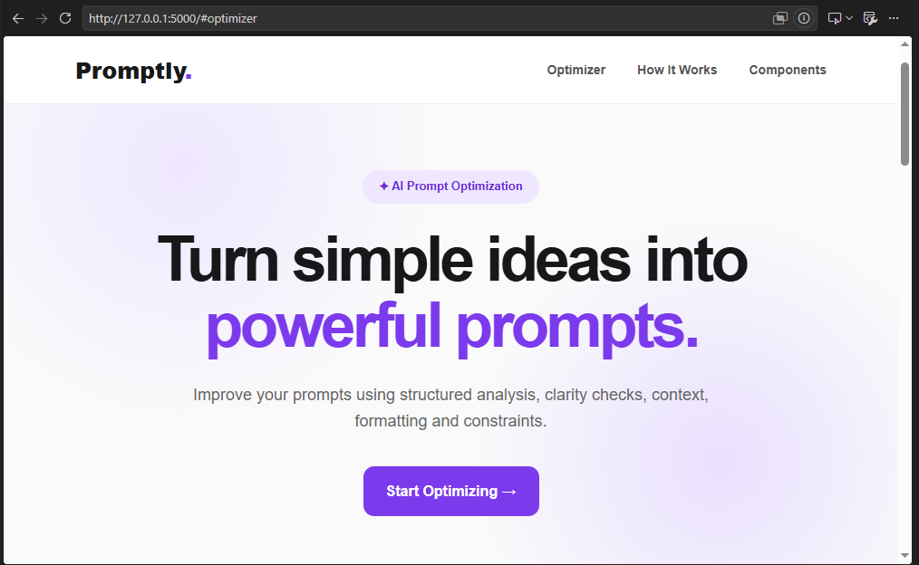

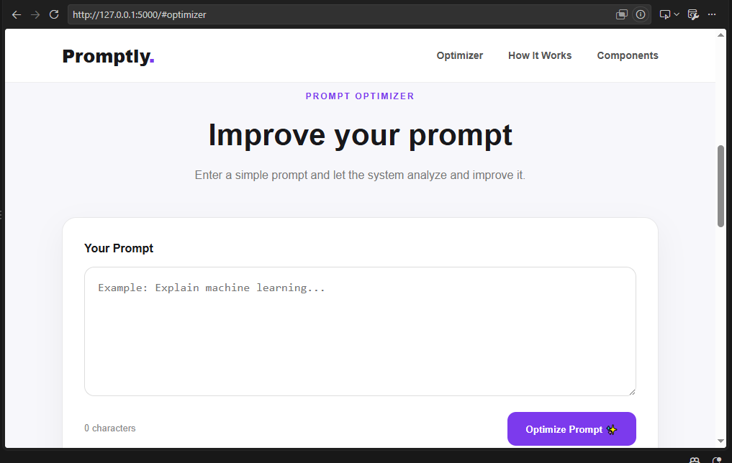

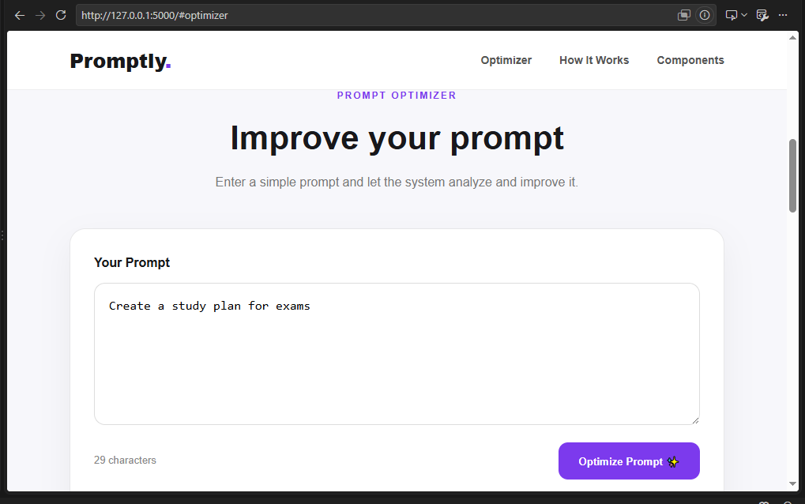

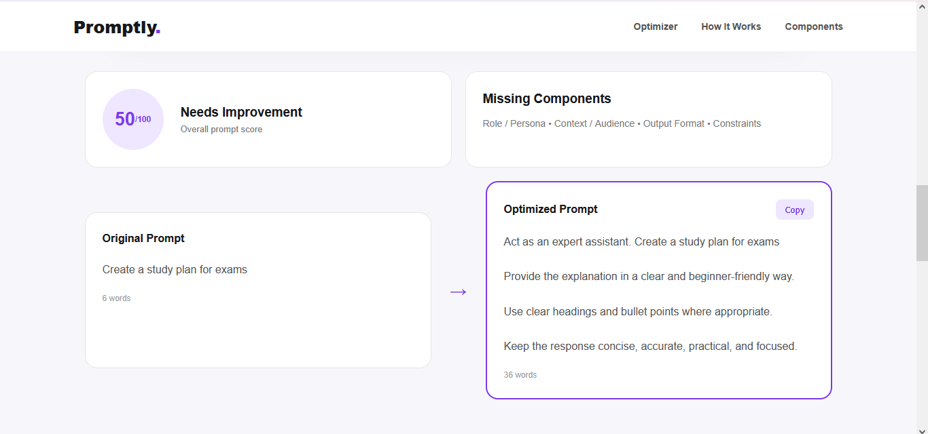

Future Scope:

The current Prompt Optimizer is a basic rule-based prototype. It can be further improved to make it more intelligent and useful in real-world applications.

- LLM Integration: Integrate an LLM or AI API to understand the meaning and context of prompts more accurately.
- Semantic Analysis: Move beyond keyword matching and understand the actual intention of the user.
- Multiple Optimization Modes: Add Academic, Coding, Research, Creative and Professional modes.
- Prompt History: Allow users to save and manage their previous prompts and optimized versions.
- User Feedback: Allow users to rate the optimized prompt so the system can improve over time.
- AI Model Comparison: Allow users to compare responses generated by different AI models using the same optimized prompt.
- Browser Extension: Develop a browser extension that can optimize prompts directly on AI platforms.
- Online Deployment: Deploy the application online so that it can be accessed from anywhere.
- Larger Dataset: Use a larger and more diverse real-world dataset for better testing and evaluation.

- Conclusion:
The Prompt Optimizer project provides a simple and practical solution for improving the quality of AI prompts. The system analyzes a user's prompt, checks important components such as role, context, task, output format and constraints, identifies missing information, calculates a quality score and generates an improved prompt.
The current prototype demonstrates how prompt engineering concepts can be converted into a user-friendly web application using Python, Flask, HTML, CSS, JavaScript and Pandas.

