Data Structure & Algorithms
Below are the recommended different topics to learn complete DSA
- Fundamentals : Maths, Complexity Analysis
- Data Structures : Array, Hashing, Strings, Matrix, Linked List, Stack, Queue, Deque, Tree, Heap, Graph
- Algorithms : Searching, Sorting, Two Pointer, Window Sliding, Prefix Sum, Recursion, Greedy Algorithms, Dynamic Programming
- Advanced Topics : Trie, Segment Tree, Red-Black Tree & Binary Indexed Tree
- Other Algorithms : Bitwise Algorithms, Backtracking, Divide and Conquer, Branch and Bound, Geometric & Randomized

FUNDAMENTALS:
1)Complexity Analysis:
- Complexity Analysis : Order of Growth, Asymptotic Analysis, Big-O, Theta, Big – Ω, Time Complexity, Space Complexity
Example 1 : 4n² + 3n + 100
- After ignoring lower order terms, we get 4n²
- After ignoring constants, we get n²
- Hence order of growth is n²
Example 2 : 100 n Log n + 3n + 100 Log n + 2
- After ignoring lower order terms, we get 100 n Log n
- After ignoring constants, we get n Log n
- Hence order of growth is n Log n

Asymptotic Analysis
Given two algorithms for a task, how do we find out which one is better?
A naive approach is to implement both algorithms and compare their running times on different inputs, but this method has many drawbacks for analyzing algorithms.
- Asymptotic analysis focuses on this growth, allowing us to compare algorithms independent of machine speed for large inputs.
Big O Notation
Big O notation is used to describe the time or space complexity of algorithms. Big-O is a way to express an upper bound of an algorithm’s time or space complexity.
- Describes the asymptotic behavior (order of growth of time or space in terms of input size) of a function, not its exact value.
- It provides an upper limit on the time taken by an algorithm in terms of the size of the input. We mainly consider the worst case scenario of the algorithm to find its time complexity in terms of Big O
Big-O notation is a way to measure the time and space complexity of an algorithm. It describes the upper bound of the complexity in the worst-case scenario. Let’s look into the different types of time complexities:
1. Linear Time Complexity: Big O(n) Complexity
Linear time complexity means that the running time of an algorithm grows linearly with the size of the input.
For example, consider an algorithm that traverses through an array to find a specific element
2. Logarithmic Time Complexity: Big O(log n) Complexity
Logarithmic time complexity means that the running time of an algorithm is proportional to the logarithm of the input size.
For example, a binary search algorithm has a logarithmic time complexity

3. Quadratic Time Complexity: Big O(n²) Complexity
Quadratic time complexity means that the running time of an algorithm is proportional to the square of the input size.
For example, a simple bubble sort algorithm has a quadratic time complexity

4. Cubic Time Complexity: Big O(n³) Complexity
Cubic time complexity means that the running time of an algorithm is proportional to the cube of the input size.
For example, a naive matrix multiplication algorithm has a cubic time complexity
5. Polynomial Time Complexity: Big O(n^{k}) Complexity
Polynomial time complexity refers to the time complexity of an algorithm that can be expressed as a polynomial function of the input size n. In Big O notation, an algorithm is said to have polynomial time complexity if its time complexity is O(nk), where k is a constant and represents the degree of the polynomial.
Algorithms with polynomial time complexity are generally considered efficient, as the running time grows at a reasonable rate as the input size increases. Common examples of algorithms with polynomial time complexity include linear time complexity O(n), quadratic time complexity O(n2), and cubic time complexity O(n3).

6. Exponential Time Complexity: Big O(2^{n}) Complexity
Exponential time complexity means that the running time of an algorithm doubles with each addition to the input data set.
For example, the problem of generating all subsets of a set is of exponential time complexity

7. Factorial Time Complexity: Big O(n!) Complexity
Factorial time complexity means that the running time of an algorithm grows factorially with the size of the input. This is often seen in algorithms that generate all permutations of a set of data.

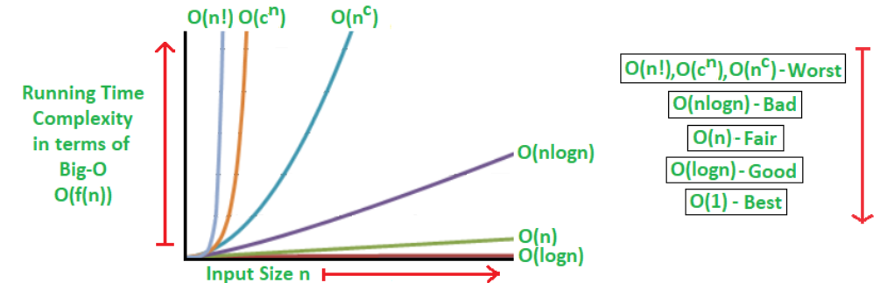

Mathematical Examples of Runtime Analysis
Below table illustrates the runtime analysis of different orders of algorithms as the input size (n) increases.
n | log(n) | n | n * log(n) | n^2 | 2^n | n!
10 | 1 | 10 | 10 | 100 | 1024 | 3628800
20 | 2.996 | 20 | 59.9 | 400 | 1048576 | 2.432902e+1818

Algorithmic Examples of Runtime Analysis
Below table categorizes algorithms based on their runtime complexity and provides examples for each type.
Type | Notation | Example Algorithms
Logarithmic | O(log n) | Binary Search
Linear | O(n) | Linear Search
Superlinear | O(n log n) | Heap Sort, Merge Sort
Polynomial | O(n^c) | Strassen’s Matrix Multiplication, Bubble Sort, Selection Sort, Insertion Sort, Bucket Sort
Exponential | O(c^n) | Tower of Hanoi
Factorial | O(n!) | Determinant Expansion by Minors, Brute force Search algorithm for Traveling Salesman Problem

Theta Notation for Analysis
- Compared to Big O or Big Omega , It gives more information in cases where we have exact bound available and should be preferred. For example, for Merge Sort, we can say that time is Θ(n Log n) and for Binary Search, we can say worst case time is Θ(Log n).
Time Complexity with Simple Examples
Imagine a classroom of 100 students in which you gave your pen to one person. You have to find that pen without knowing to whom you gave it.
Here are some ways to find the pen and what the O order is.
- O(n2): You go and ask the first person in the class if he has the pen. Also, you ask this person about the other 99 people in the classroom if they have that pen and so on. This is what we call O(n²).
- O(n): Going and asking each student individually is O(N).
- O(log n): Now I divide the class into two groups, then ask: "Is it on the left side, or the right side of the classroom?" Then I take that group and divide it into two and ask again, and so on. Repeat the process till you are left with one student who has your pen. This is what you mean by O(log n).
Is the Time Complexity Same as Time of Execution?
The Time Complexity is not equal to the actual time required to execute a particular code, but the number of times a statement executes.
Space Complexity:
The term Space Complexity is misused for Auxiliary Space at many places. Following are the correct definitions of Auxiliary Space and Space Complexity.
Auxiliary Space is the extra space or temporary space used by an algorithm.
The space Complexity of an algorithm is the total space taken by the algorithm with respect to the input size. Space complexity includes both Auxiliary space and space used by input.
For example, if we want to compare standard sorting algorithms on the basis of space, then Auxiliary Space would be a better criterion than Space Complexity. Merge Sort uses O(n) auxiliary space, Insertion sort, and Heap Sort use O(1) auxiliary space. The space complexity of all these sorting algorithms is O(n) though.

2)Data Structures:
----------------------------------------------Array Data Structure-----------------------------
Arrays are used to build other data structures like Stack Queue, Deque, Graph, Hash Table, etc. An array is not useful in places where we have operations like insert in the middle, delete from middle and search in a unsorted data.
An array is a collection of items of the same variable type that are stored at contiguous memory locations. It is one of the most popular and simple data structures used in programming.
Basic terminologies of Array
- Array Element: Elements are items stored in an array.
- Array Index: Elements are accessed by their indexes. Indexes in most of the programming languages start from 0.
Memory representation of Array
In an array, all the elements or their references are stored in contiguous memory locations. This allows for efficient access and manipulation of elements.

Declaration of Array
Arrays can be declared in various ways in different languages. For better illustration, below are some language-specific array declarations:
// This array will store integer type element
int arr[];

// This array will store char type element
char arr[];

// This array will store float type element
float arr[];

Initialization of Array
Arrays can be initialized in different ways in different languages. Below are some language-specific array initialization:

int arr[] = { 1, 2, 3, 4, 5 };
char arr[] = { 'a', 'b', 'c', 'd', 'e' };
float arr[] = { 1.4f, 2.0f, 24f, 5.0f, 0.0f };

Why do we Need Arrays?
Assume there is a class of five students and if we have to keep records of their marks in examination then, we can do this by declaring five variables individual and keeping track of records but what if the number of students becomes very large, it would be challenging to manipulate and maintain the data. So we use an array of students.

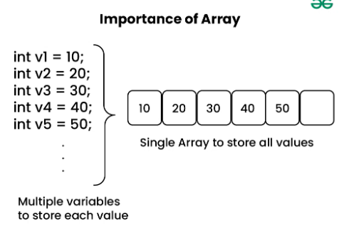
Types of Arrays
Arrays can be classified in two ways:
- On the basis of Size
- On the basis of Dimensions

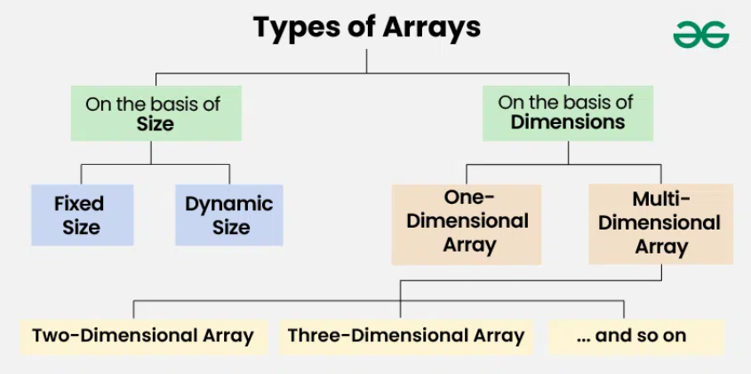

Types of Arrays on the basis of Size
1. Fixed Sized Arrays
- We cannot alter or update the size of this array. Here only a fixed size (i,e. the size that is mentioned in square brackets []) of memory will be allocated for storage.
- In case, we don't know the size of the array then if we declare a larger size and store a lesser number of elements, it will result in a wastage of memory. And if we declare a lesser size than the number of elements then we won't get enough memory to store all the elements.

// Fixed sized array examples
int[] arr1 = new int [5];

// Another way (Array creation and initialization both)
int[] arr2 = {1, 2, 3, 4, 5};

2. Dynamic Sized Arrays
The size of the array changes as per user requirements during execution of code so the coders do not have to worry about sizes. They can add and removed the elements as per the need. The memory is mostly dynamically allocated and de-allocated in these arrays.
// Dynamic Integer Array
ArrayList<Integer> arr = new ArrayList<>();

Types of Arrays on the basis of Dimensions
1. One-dimensional Array(1-D Array): You can imagine a 1d array as a row, where elements are stored one after another.
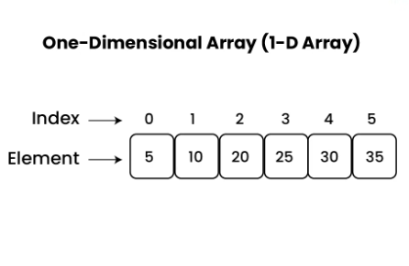
2. Multi-dimensional Array: A multi-dimensional array is an array with more than one dimension. We can use multidimensional array to store complex data in the form of tables, etc. We can have 2-D arrays, 3-D arrays, 4-D arrays and so on.
- Two-Dimensional Array(2-D Array or Matrix): 2-D Multidimensional arrays can be considered as an array of arrays or as a matrix consisting of rows and columns.
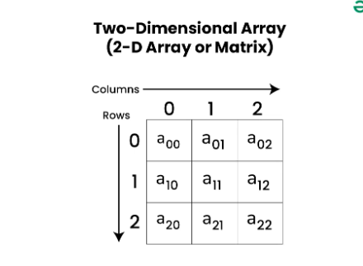

3)Three-Dimensional Array(3-D Array): A 3-D Multidimensional array contains three dimensions, so it can be considered an array of two-dimensional arrays.
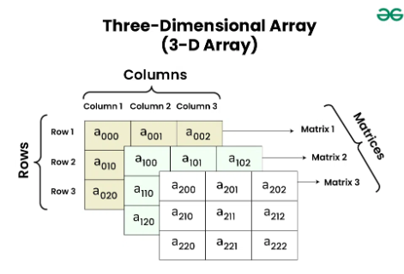

-------------------------------------------Hashing DATASTRUCTURE-------------------------------

Hashing refers to the process of generating a small sized output (that can be used as index in a table) from an input of typically large and variable size. Hashing uses mathematical formulas known as hash functions to do the transformation. This technique determines an index or location for the storage of an item in a data structure called Hash Table.
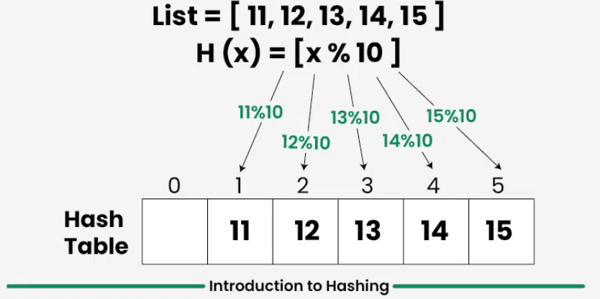

Hash Table Data Structure Overview
- It is one of the most widely used data structure after arrays.
- It mainly supports search, insert and delete in O(1) time on average which is more efficient than other popular data structures like arrays, Linked List and Self Balancing BST.
- We use hashing for dictionaries, frequency counting, maintaining data for quick access by key, etc.
- Real World Applications include Database Indexing, Cryptography, Caches, Symbol Table and Dictionaries.

Components of Hashing
There are majorly three components of hashing:
- Key: A Key can be anything string or integer which is fed as input in the hash function the technique that determines an index or location for storage of an item in a data structure.
- Hash Function: Receives the input key and returns the index of an element in an array called a hash table. The index is known as the hash index .
- Hash Table: Hash table is typically an array of lists. It stores values corresponding to the keys. Hash stores the data in an associative manner in an array where each data value has its own unique index.
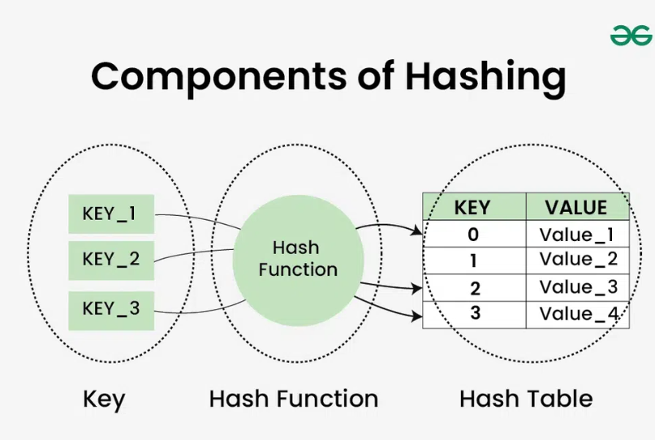

There are mainly two forms of hash typically implemented in programming languages.

Hash Set : Collection of unique keys.
HashSet in Java implements the Set interface of the Collections Framework. It is used to store the unique elements, and it doesn't maintain any specific order of elements.
- HashSet does not allow duplicate elements.
- Uses HashMap internally which is an implementation of hash table data structure.
- Also implements Serializable and Cloneable interfaces.
- HashSet is not thread-safe. To make it thread-safe, synchronization is needed externally.
- Does not support primitive types directly; requires wrapper classes (Integer, Character, etc.).
import java.util.*;

class GFG
{
public static void main(String[] args)
{
// Instantiate an object of HashSet
HashSet<Integer> hs = new HashSet<>();

// Adding elements
hs.add(1);
hs.add(2);
hs.add(1);

System.out.println("HashSet Size: " + hs.size());
System.out.println("Elements in HashSet: " + hs);
}
}

Output
HashSet Size: 2
Elements in HashSet: [1, 2]

Hierarchy Diagram of HashSet
It implements the Set interface, which is a sub-interface of the Collection interface.
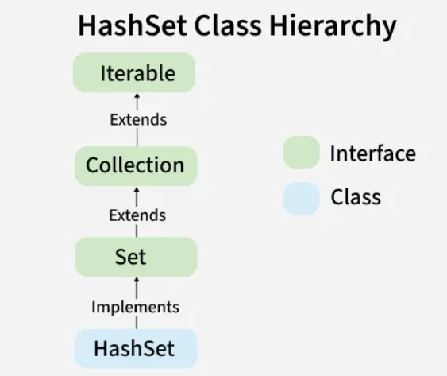

Constructors of HashSet class
To create a HashSet, we need to create an object of the HashSet class. The HashSet class consists of various constructors that allow the possible creation of the HashSet. The following are the constructors available in this class.
1. HashSet()
Creates a new empty HashSet with default capacity (16) and load factor (0.75).
HashSet<String> set = new HashSet<>();

Performing Various Operations on HashSet
1. Adding Elements in HashSet
To add an element to the HashSet, we can use the add() method. However, the insertion order is not retained in the HashSet. We need to keep a note that duplicate elements are not allowed and all duplicate elements are ignored.
import java.util.*;

class GFG
{
public static void main(String[] args)
{
// Creating an empty HashSet of string entities
HashSet<String> hs = new HashSet<String>();

// Adding elements using add() method
hs.add("Geek");
hs.add("For");
hs.add("Geeks");

System.out.println("HashSet : " + hs);
} }
Output
HashSet : [Geek, For, Geeks]

2. Removing Elements in HashSet
The values can be removed from the HashSet using the remove() method.
import java.util.*;

class GFG
{
public static void main(String[] args)
{

HashSet<String> hs = new HashSet<String>();

// Adding elements to above Set using add() method
hs.add("Geek");
hs.add("For");
hs.add("Geeks");
hs.add("A");
hs.add("B");
hs.add("Z");

System.out.println("HashSet : " + hs);

// Removing the element B
hs.remove("B");

// Printing the updated HashSet elements
System.out.println("HashSet after removing element : " + hs);

// Returns false if the element is not present
System.out.println("B exists in Set : " + hs.remove("B"));
}
}
Output:
HashSet : [A, B, Geek, For, Geeks, Z]
HashSet after removing element [A, Geek, For, Geeks, Z]
B exists in Set : false

3. Iterating through the HashSet
Iterate through the elements of HashSet using the iterator() method. Also, the most famous one is to use the enhanced for loop.

import java.util.HashSet;
import java.util.Iterator;

public class GFG
{
public static void main(String[] args)
{
// Create a HashSet of Strings
HashSet<String> hs = new HashSet<>();

// Add elements to the HashSet
hs.add("A");
hs.add("B");
hs.add("Geeks");
hs.add("For");
hs.add("Geeks");
hs.add("Z");

// Using iterator() method to iterate Over the HashSet
System.out.print("Using iterator : ");
Iterator<String> iterator = hs.iterator();

// Traversing HashSet
while (iterator.hasNext())
System.out.print(iterator.next() + ", ");

System.out.println();

// Using enhanced for loop to iterate Over the HashSet
System.out.print("Using enhanced for loop : ");
for (String element : hs)
System.out.print(element + " , ");
}
}

Output
Using iterator : A, B, Geeks, For, Z,
Using enhanced for loop : A , B , Geeks , For , Z ,

Hash Map : Collection of key value pairs with keys being unique
A HashMap is a part of Java’s Collection Framework and implements the Map interface. It stores elements in key-value pairs, where, Keys are unique. and Values can be duplicated.
- Internally uses Hashing, hence allows efficient key-based retrieval, insertion, and removal with an average of O(1) time.
- HashMap is not thread-safe, to make it synchronized, use Collections.synchronizedMap().
- Insertion order is not preserved in HashMap. To preserve the insertion order, LinkedHashMap is used and to maintain sorted order, TreeMap is used.
- HashMap allows one null key and multiple null values. If a null key is added multiple times, it overwrites the previous value.
import java.util.HashMap;
import java.util.Map;
public class GFG{
public static void main(String[] args){
// Create a HashMap
HashMap<String, Integer> hashMap = new HashMap<>();

// Add elements to the HashMap
hashMap.put("John", 25);
hashMap.put("Jane", 30);
hashMap.put("Jim", 35);

// Iterate through the HashMap
for (Map.Entry<String, Integer> entry : hashMap.entrySet()) {
System.out.println(entry.getKey() + " -> " + entry.getValue());
}
}
}
Output
John -> 25
Jane -> 30
Jim -> 35
Hierarchy of HashMap in Java
It extends AbstractMap and implements the Map Interface.

Performing Various Operations on HashMap
1. Adding Elements in HashMap in Java
To add an element to the map, we can use the put() method. However, the insertion order is not retained in the Hashmap.
import java.io.*;
import java.util.*;

class AddElementsToHashMap {
public static void main(String args[])
{
// No need to mention the Generic type twice
HashMap<Integer, String> hm1 = new HashMap<>();

// Initialization of a HashMap using Generics
HashMap<Integer, String> hm2 = new HashMap<Integer, String>();

// Add Elements using put method
hm1.put(1, "Geeks");
hm1.put(2, "For");
hm1.put(3, "Geeks");

hm2.put(1, "Geeks");
hm2.put(2, "For");
hm2.put(3, "Geeks");

System.out.println("Mappings of HashMap hm1 are : "
+ hm1);
System.out.println("Mapping of HashMap hm2 are : "
+ hm2);
}
}
Output
Mappings of HashMap hm1 are : {1=Geeks, 2=For, 3=Geeks}
Mapping of HashMap hm2 are : {1=Geeks, 2=For, 3=Geeks}

2. Changing Elements in HashMap in Java
We can change a value in a HashMap by using the put() method with the same key, which replaces the old value with the new one.

import java.io.*;
import java.util.*;
class ChangeElementsOfHashMap {
public static void main(String args[])
{

// Initialization of a HashMap
HashMap<Integer, String> hm
= new HashMap<Integer, String>();

// Change Value using put method
hm.put(1, "Geeks");
hm.put(2, "Geeks");
hm.put(3, "Geeks");

System.out.println("Initial Map " + hm);

hm.put(2, "For");

System.out.println("Updated Map " + hm);
}
}

3. Removing Element from Java HashMap
To remove an element from the Map, we can use the remove() method. It removes the mapping for the specified key if it is present and returns the value associated with that key, or null if the key is not found.
import java.io.*;
import java.util.*;
class RemoveElementsOfHashMap{
public static void main(String args[])
{
// Initialization of a HashMap
Map<Integer, String> hm
= new HashMap<Integer, String>();
​
// Add elements using put method
hm.put(1, "Geeks");
hm.put(2, "For");
hm.put(3, "Geeks");
hm.put(4, "For");
​
// Initial HashMap
System.out.println("Mappings of HashMap are : "
+ hm);
​
// remove element with a key
// using remove method
hm.remove(4);
​
// Final HashMap
System.out.println("Mappings after removal are : "
+ hm);
}
}
Output
Mappings of HashMap are : {1=Geeks, 2=For, 3=Geeks, 4=For}
Mappings after removal are : {1=Geeks, 2=For, 3=Geeks}

4. Traversal of Java HashMap
We can use an Iterator with Map.Entry<?, ?> to traverse a HashMap and print its entries using the next() method.
import java.util.HashMap;
import java.util.Map;
​
public class TraversalTheHashMap {
public static void main(String[] args)
{
// initialize a HashMap
HashMap<String, Integer> map = new HashMap<>();
​
// Add elements using put method
map.put("vishal", 10);
map.put("sachin", 30);
map.put("vaibhav", 20);
​
// Iterate the map using for-each loop
for (Map.Entry<String, Integer> e : map.entrySet())
System.out.println("Key: " + e.getKey()
+ " Value: " + e.getValue());
}
}
Output
Key: vaibhav Value: 20
Key: vishal Value: 10
Key: sachin Value: 30

Time and Space Complexity
- HashMap provides constant time complexity for basic operations.
- In the worst case, HashMap operations can take O(N) time due to hash collisions.
Operation | Time Complexity | Space Complexity
Adding elements in HashMap | O(1) | O(1) (extra)
Removing elements from HashMap | O(1) | O(1) (extra)
Extracting elements from HashMap | O(1) | O(1) (extra)

----------------------------------------------------String----------------------------------------------------
A string is a sequence of characters. The following facts make string an interesting data structure.
- Small set of elements. Unlike normal array, strings typically have smaller set of items. For example, lowercase English alphabet has only 26 characters. ASCII has only 256 characters.
- Strings are immutable in programming languages like Java, Python, JavaScript and C#.
- Many String Problems can optimized using the fact that the character set size is small. For example sorting can be done faster, counting frequencies of items is faster and many interesting interview questions are based on this.
- How Strings are represented in Memory?
- Java: Strings are immutable objects of the String class, meaning their values cannot be modified once assigned.
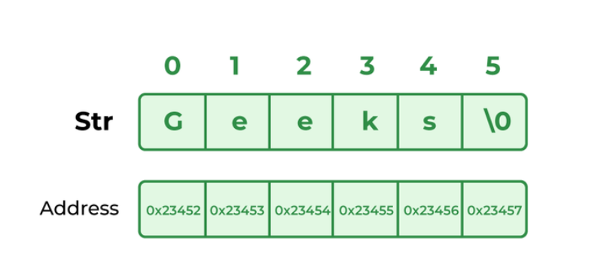
// Java code to illustrate String
import java.io.*;
import java.lang.*;

class Test {
public static void main(String[] args)
{
// Declare String without using new operator
String s = "GeeksforGeeks";

// Prints the String.
System.out.println("String s = " + s);

// Declare String using new operator
String s1 = new String("GeeksforGeeks");

// Prints the String.
System.out.println("String s1 = " + s1);
}
}
-----------------------------------------------------------------------------------------------------------

// Java Program to demonstrate why
// Java Strings are immutable
import java.io.*;

class GfG {

public static void main(String[] args) {
String s1 = "java";
s1.concat(" rules");

// s1 is not changed because strings are
// immutable
System.out.println("s1 refers to " + s1);
}
}

General Operations performed on String
Here we are providing you with some must-know concepts of string:
- Length of String : The length of a string refers to the total number of characters present in it, including letters, digits, spaces, and special characters. It is a fundamental property of strings in any programming language and is often used in various operations such as validation, manipulation, and comparison.
- Search a Character : Searching for a character in a string means finding the position where a specific character appears. If the character is present multiple times, you might need to find its first occurrence, last occurrence, or all occurrences.
- Check for Substring : Checking for a substring means determining whether a smaller sequence of characters exists within a larger string. A substring is a continuous part of a string, and checking for its presence is a common operation in text processing, search algorithms, and data validation.
- Insert a Character : Inserting a character into a string means adding a new character at a specific position while maintaining the original order of other characters. Since strings are immutable in many programming languages, inserting a character usually involves creating a new modified string with the desired character placed at the specified position.
- Delete a Character : Deleting a character from a string means removing a specific character at a given position while keeping the remaining characters intact. Since strings are immutable in many programming languages, this operation usually involves creating a new string without the specified character.
- Check for Same Strings : Checking if two strings are the same means comparing them character by character to determine if they are identical in terms of length, order, and content. If every character in one string matches exactly with the corresponding character in another string, they are considered the same.
- String Concatenation : String concatenation is the process of joining two or more strings together to form a single string. This is useful in text processing, formatting messages, constructing file paths, or dynamically creating content.
- Reverse a String : Reversing a string means arranging its characters in the opposite order while keeping their original positions intact in the reversed sequence. This operation is commonly used in text manipulation, data encryption, and algorithm challenges.
- Rotate a String Rotating a string means shifting its characters to the left or right by a specified number of positions while maintaining the order of the remaining characters. The characters that move past the boundary wrap around to the other side.
- Check for Palindrome : Checking for a palindrome means determining whether a string reads the same forward and backward. A palindrome remains unchanged when reversed, making it a useful concept in text processing, algorithms, and number theory.

How Strings are Stored in Java Memory
String literal
Whenever a String Object is created as a literal, the object will be created in the String constant pool. This allows JVM to optimize the initialization of String literal. The string constant pool is present in the heap.
Example 1: Using String literals to assigning char sequence value.
String str1 = "Hello";
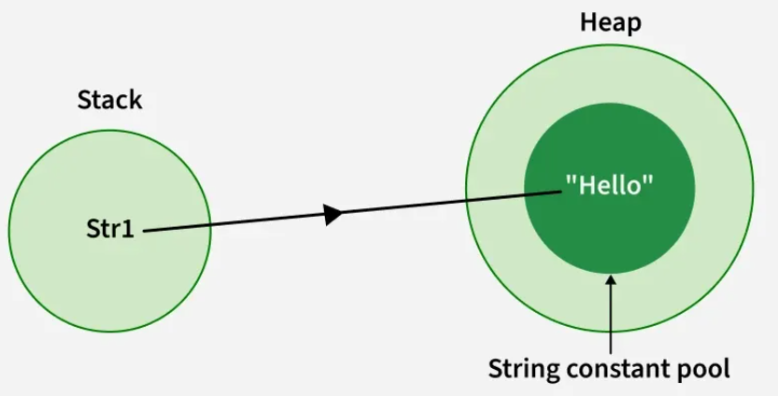
Example 2: When we initialize the same char sequence using string literals.
String str1 = "Hello";
String str2 = "Hello";
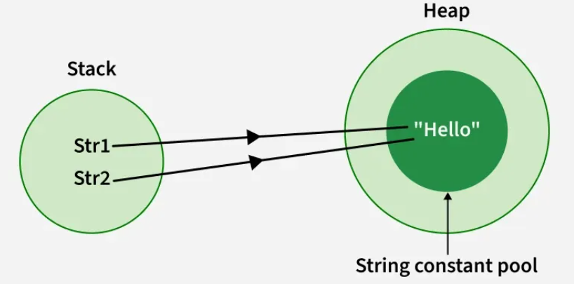
Using new Keyword
Strings can also be created using the new keyword, which allocates a new object in heap memory. However, the string literal inside it is still stored in the String Constant Pool (if not already present).
Example 1: Using new keyword to assign a char sequence to a String object.
String str1 = new String("John"); String str2 = new String("Deo");
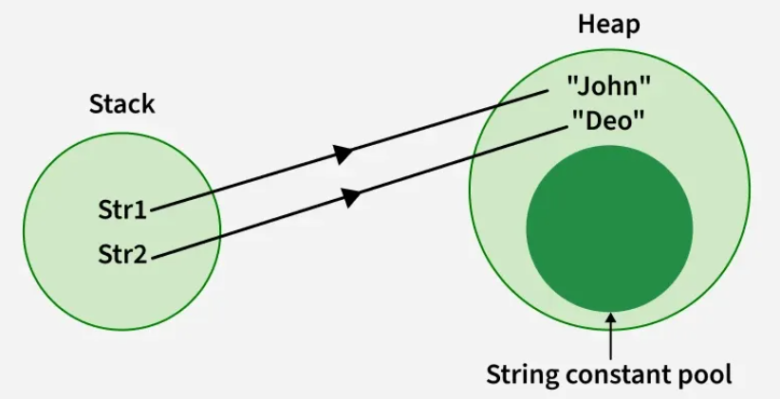

---------------------------------------------Matrix Data Structure--------------------------------------

