Fundamentals

- Complexity Analysis : Order of Growth, Asymptotic Analysis, Big-O, Theta, Big – Ω, Time Complexity, Space Complexity
Example 1 : 4n² + 3n + 100
- After ignoring lower order terms, we get 4n²
- After ignoring constants, we get n²
- Hence order of growth is n²
Example 2 : 100 n Log n + 3n + 100 Log n + 2
- After ignoring lower order terms, we get 100 n Log n
- After ignoring constants, we get n Log n
- Hence order of growth is n Log n

Asymptotic Analysis
Given two algorithms for a task, how do we find out which one is better?
A naive approach is to implement both algorithms and compare their running times on different inputs, but this method has many drawbacks for analyzing algorithms.
- Asymptotic analysis focuses on this growth, allowing us to compare algorithms independent of machine speed for large inputs.
Big O Notation
Big O notation is used to describe the time or space complexity of algorithms. Big-O is a way to express an upper bound of an algorithm’s time or space complexity.
- Describes the asymptotic behavior (order of growth of time or space in terms of input size) of a function, not its exact value.
- It provides an upper limit on the time taken by an algorithm in terms of the size of the input. We mainly consider the worst case scenario of the algorithm to find its time complexity in terms of Big O
Big-O notation is a way to measure the time and space complexity of an algorithm. It describes the upper bound of the complexity in the worst-case scenario. Let’s look into the different types of time complexities:
1. Linear Time Complexity: Big O(n) Complexity
Linear time complexity means that the running time of an algorithm grows linearly with the size of the input.
For example, consider an algorithm that traverses through an array to find a specific element
2. Logarithmic Time Complexity: Big O(log n) Complexity
Logarithmic time complexity means that the running time of an algorithm is proportional to the logarithm of the input size.
For example, a binary search algorithm has a logarithmic time complexity

3. Quadratic Time Complexity: Big O(n²) Complexity
Quadratic time complexity means that the running time of an algorithm is proportional to the square of the input size.
For example, a simple bubble sort algorithm has a quadratic time complexity

4. Cubic Time Complexity: Big O(n³) Complexity
Cubic time complexity means that the running time of an algorithm is proportional to the cube of the input size.
For example, a naive matrix multiplication algorithm has a cubic time complexity
5. Polynomial Time Complexity: Big O(n^{k}) Complexity
Polynomial time complexity refers to the time complexity of an algorithm that can be expressed as a polynomial function of the input size n. In Big O notation, an algorithm is said to have polynomial time complexity if its time complexity is O(nk), where k is a constant and represents the degree of the polynomial.
Algorithms with polynomial time complexity are generally considered efficient, as the running time grows at a reasonable rate as the input size increases. Common examples of algorithms with polynomial time complexity include linear time complexity O(n), quadratic time complexity O(n2), and cubic time complexity O(n3).

6. Exponential Time Complexity: Big O(2^{n}) Complexity
Exponential time complexity means that the running time of an algorithm doubles with each addition to the input data set.
For example, the problem of generating all subsets of a set is of exponential time complexity

7. Factorial Time Complexity: Big O(n!) Complexity
Factorial time complexity means that the running time of an algorithm grows factorially with the size of the input. This is often seen in algorithms that generate all permutations of a set of data.

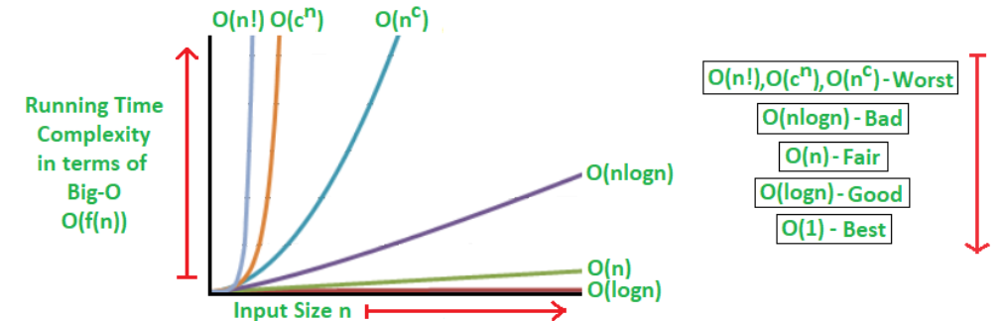

Mathematical Examples of Runtime Analysis
Below table illustrates the runtime analysis of different orders of algorithms as the input size (n) increases.
n | log(n) | n | n * log(n) | n^2 | 2^n | n!
10 | 1 | 10 | 10 | 100 | 1024 | 3628800
20 | 2.996 | 20 | 59.9 | 400 | 1048576 | 2.432902e+1818

Algorithmic Examples of Runtime Analysis
Below table categorizes algorithms based on their runtime complexity and provides examples for each type.
Type | Notation | Example Algorithms
Logarithmic | O(log n) | Binary Search
Linear | O(n) | Linear Search
Superlinear | O(n log n) | Heap Sort, Merge Sort
Polynomial | O(n^c) | Strassen’s Matrix Multiplication, Bubble Sort, Selection Sort, Insertion Sort, Bucket Sort
Exponential | O(c^n) | Tower of Hanoi
Factorial | O(n!) | Determinant Expansion by Minors, Brute force Search algorithm for Traveling Salesman Problem

Theta Notation for Analysis
- Compared to Big O or Big Omega , It gives more information in cases where we have exact bound available and should be preferred. For example, for Merge Sort, we can say that time is Θ(n Log n) and for Binary Search, we can say worst case time is Θ(Log n).
Time Complexity with Simple Examples
Imagine a classroom of 100 students in which you gave your pen to one person. You have to find that pen without knowing to whom you gave it.
Here are some ways to find the pen and what the O order is.
- O(n2): You go and ask the first person in the class if he has the pen. Also, you ask this person about the other 99 people in the classroom if they have that pen and so on. This is what we call O(n²).
- O(n): Going and asking each student individually is O(N).
- O(log n): Now I divide the class into two groups, then ask: "Is it on the left side, or the right side of the classroom?" Then I take that group and divide it into two and ask again, and so on. Repeat the process till you are left with one student who has your pen. This is what you mean by O(log n).
Is the Time Complexity Same as Time of Execution?
The Time Complexity is not equal to the actual time required to execute a particular code, but the number of times a statement executes.
Space Complexity:
The term Space Complexity is misused for Auxiliary Space at many places. Following are the correct definitions of Auxiliary Space and Space Complexity.
Auxiliary Space is the extra space or temporary space used by an algorithm.
The space Complexity of an algorithm is the total space taken by the algorithm with respect to the input size. Space complexity includes both Auxiliary space and space used by input.
For example, if we want to compare standard sorting algorithms on the basis of space, then Auxiliary Space would be a better criterion than Space Complexity. Merge Sort uses O(n) auxiliary space, Insertion sort, and Heap Sort use O(1) auxiliary space. The space complexity of all these sorting algorithms is O(n) though.

Maths, Pattern & Recursion
Introduction to Recursion
The process in which a function calls itself directly or indirectly is called recursion and the corresponding function is called a recursive function.
- A recursive algorithm takes one step toward solution and then recursively call itself to further move. The algorithm stops once we reach the solution.
- Since called function may further call itself, this process might continue forever. So it is essential to provide a base case to terminate this recursion process.
Example 1 : Sum of Natural Numbers (n=3)
Input : n = 3
Output : 6
Explanation : The sum of first 3 natural numbers is 1+2+3 = 6.
Input : n = 7
Output : 28
Explanation : The sum of first 7 natural numbers is 1+2+3+4+5+6+7 = 28.
- Base Case : At n == 1, it returns 1 for n = 3, the recursion reaches this after going through 3 → 2 → 1.
- Recursive Case : Each call adds n to sum(n-1) , so sum(3) = 3 + sum(2), sum(2) = 2 + sum(1).

Program:
public class Main {
public static int sum(int n) {
// base condition
if (n == 1)
return 1;
return n + sum(n - 1);
}
public static void main(String[] args) {
int n = 3;
System.out.println(sum(n));
} }
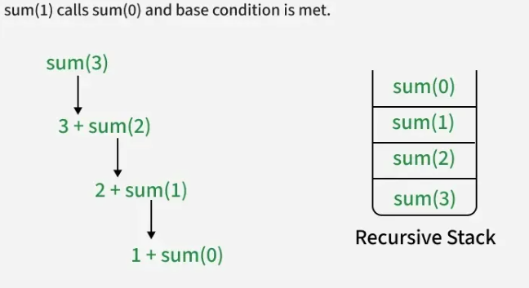
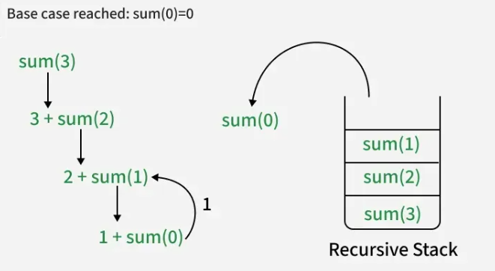
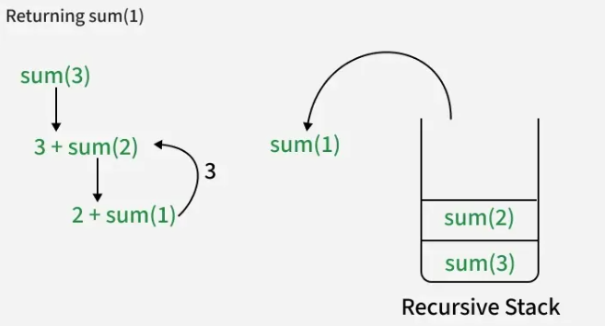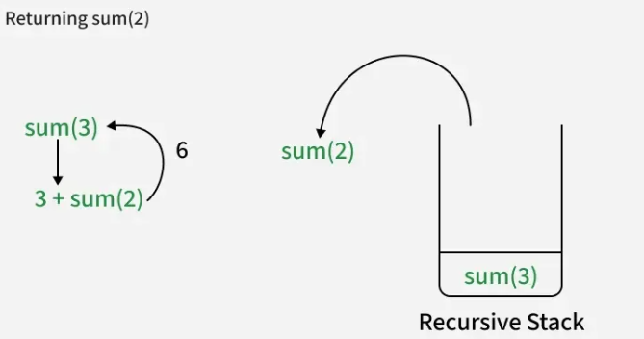
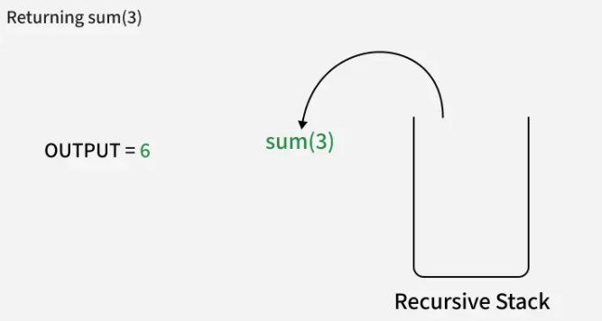
- Recursive solutions work as a a basis for Dynamic Programming and Divide and Conquer algorithms.

- Example 2 : Factorial of a Number

The factorial of a number n (where n >= 0) is the product of all positive integers from 1 to n. To compute the factorial recursively, we calculate the factorial of n by using the factorial of (n-1). The base case for the recursive function is when n = 0, in which case we return 1.
public class GfG {
public static int fact(int n) {
// BASE CONDITION
if (n == 0)
return 1;
return n * fact(n - 1);
}
public static void main(String[] args) {
System.out.println("Factorial of 5 : " + fact(5));
}
}

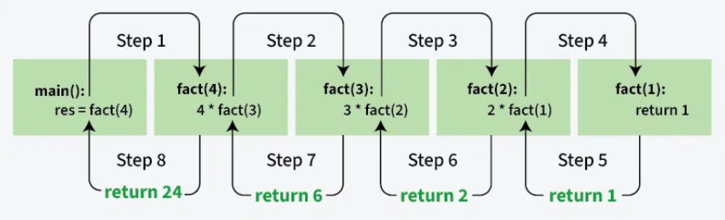
What is the difference between direct and indirect recursion?
A function is called direct recursive if it calls itself directly during its execution. In other words, the function makes a recursive call to itself within its own body.
An indirect recursive function is one that calls another function, and that other function, in turn, calls the original function either directly or through other functions. This creates a chain of recursive calls involving multiple functions, as opposed to direct recursion, where a function calls itself.
How memory is allocated to different function calls in recursion?
Recursion uses more memory to store data of every recursive call in an internal function call stack.
- Whenever we call a function, its record is added to the stack and remains there until the call is finished.
- The internal systems use a stack because function calling follows LIFO structure, the last called function finishes first.

- Recursive programs typically have more space requirements and also more time to maintain the recursion call stack.
- Recursion can make the code more difficult to understand and debug, since it requires thinking about multiple levels of function calls..

Example 3 : Fibonacci with Recursion
Write a program and recurrence relation to find the Fibonacci series of n where n >= 0.

// Java code to implement Fibonacci series
import java.util.*;
class GFG
{
// Function for fibonacci
static int fib(int n)
{
// Stop condition
if (n == 0)
return 0;
// Stop condition
if (n == 1 || n == 2)
return 1;
// Recursion function
else
return (fib(n - 1) + fib(n - 2));
}
// Driver Code
public static void main(String []args)
{
// Initialize variable n.
int n = 5;
System.out.print("Fibonacci series of 5 numbers is: ");
// for loop to print the fibonacci series.
for (int i = 0; i < n; i++)
{
System.out.print(fib(i)+" ");
}
} }
OUTPUT: Fibonacci series of 5 numbers is: 0 1 1 2 3
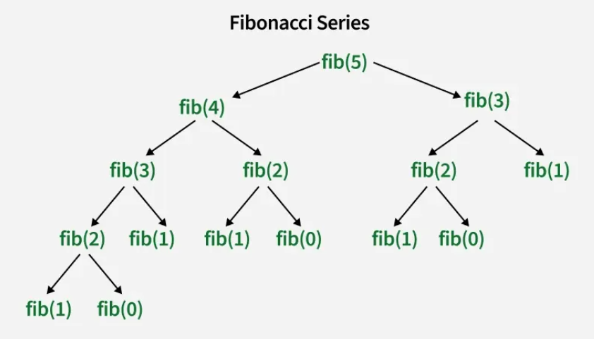
Common Applications of Recursion
- Tree and Graph Traversal: Used for systematically exploring nodes/vertices in data structures like trees and graphs.
- Sorting Algorithms: Algorithms like quicksort and merge sort divide data into subarrays, sort them recursively, and merge them.
- Divide-and-Conquer Algorithms: Algorithms like binary search break problems into smaller subproblems using recursion.
- Fractal Generation: Recursion helps generate fractal patterns, such as the Mandelbrot set, by repeatedly applying a recursive formula.
- Backtracking Algorithms: Used for problems requiring a sequence of decisions, where recursion explores all possible paths and backtracks when needed.
- Memoization: Involves caching results of recursive function calls to avoid recomputing expensive subproblems.

PROBLEMS OF EASY MATHS
Q. CHCEK EVEN OR ODD
Given a positive integer n, determine whether it is odd or even. Return true if the number is even and false if the number is odd.
Examples:
Input: n = 15
Output: false
Explanation: The number is not divisible by 2, Odd number.
Constraints:
1 ≤ n ≤ 10⁴
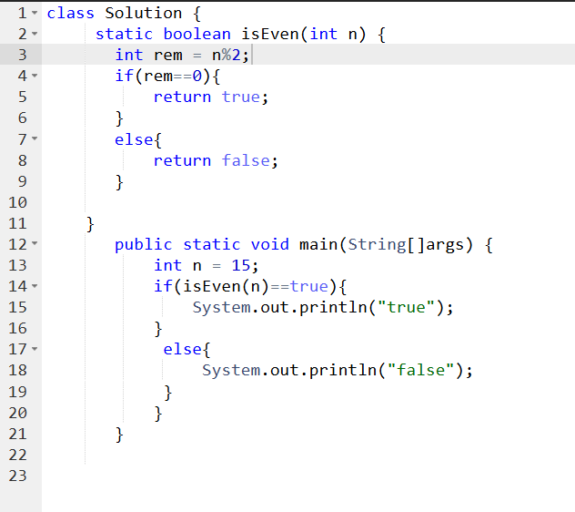

Q. Program for multiplication table
Create the multiplication table from 1 to 10 for a given number n and return the table as an array.
Examples:
Input: n = 9
Output: 9 18 27 36 45 54 63 72 81 90
Constraints:
1 <= N <= 10⁶

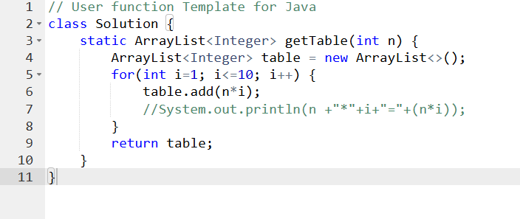

Q. Sum of Natural Numbers
Given an integer n. Your task is to calculate the sum of all natural numbers from 1 up to n (inclusive). If n is 0, the sum should be 0.
Examples:
Input: n = 3
Output: 6
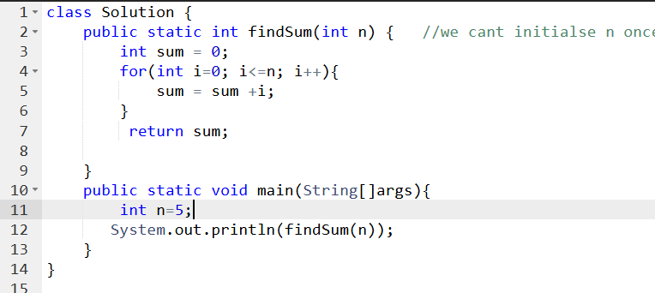

Q. Closest Number
Given two integers n and m (m != 0). The problem is to find the number closest to n and divisible by m. If there is more than one such number, then output the one having the maximum absolute value.
Examples :
Input: n = 13, m = 4
Output: 12
Explanation: 12 is the Closest Number to 13 which is divisible by 4.
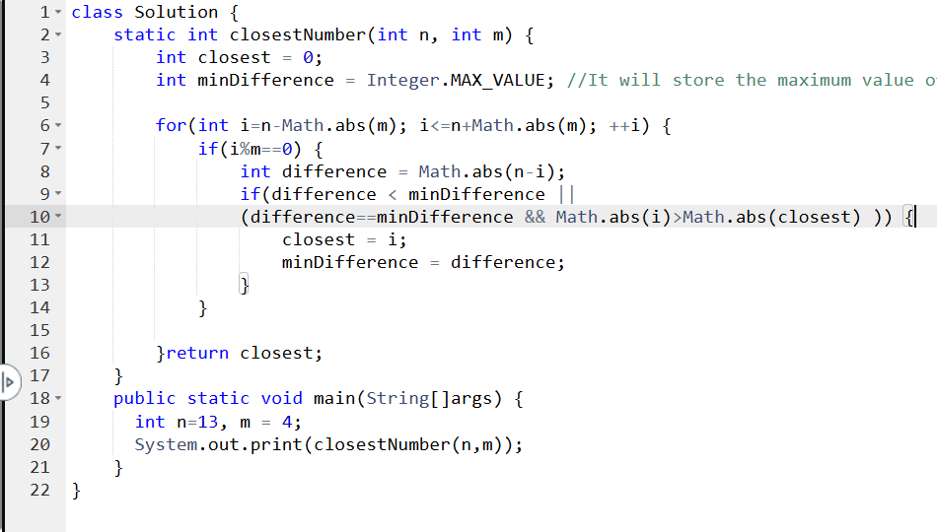

Q. Solid Rectangle
Given two integers n and m, print a solid rectangle pattern consisting of n rows and m columns.
Note: There is a space between two adjacent stars (*) in the pattern.
Examples
Input: n = 3, m = 5
Output:
* * * * *
* * * * *
* * * * *
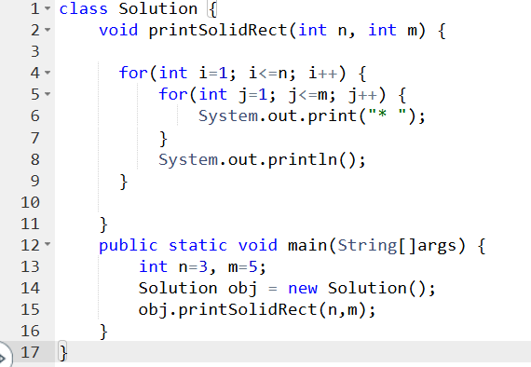
Q. Floyd's triangle
Given a number n. Print Floyd's triangle with n lines.
Note: There is a space between two adjacent numbers in the pattern.
Examples:
Input: n = 4
Output:
1
2 3
4 5 6
7 8 9 10

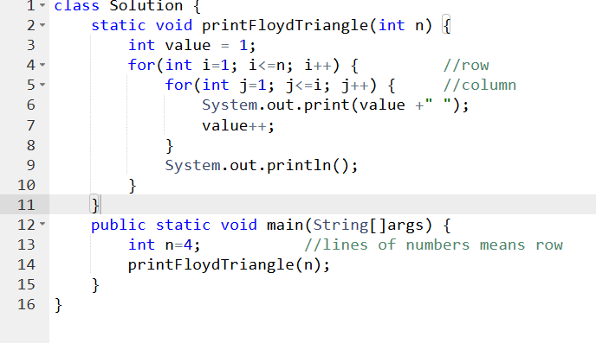
Q. Hollow rectangle or square
Given two integers n and m, print a hollow rectangle or square pattern consisting of n rows and m columns.
Examples
Input: n = 3, m = 5
Output:
*****
* *
*****
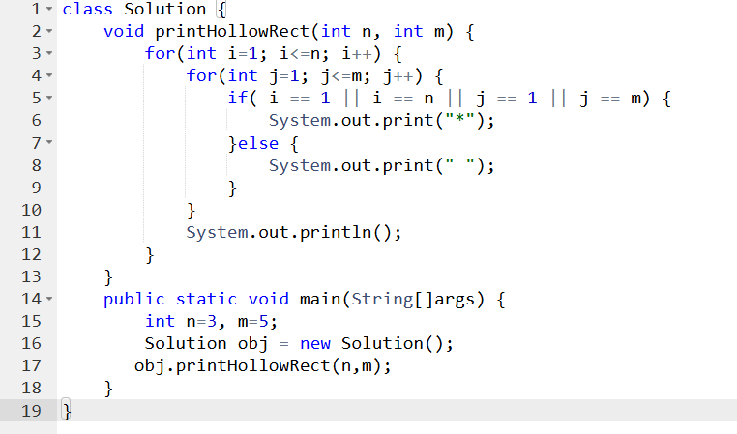

Q. 1 to n Without Loops
Given an positive integer n, print numbers from 1 to n without using loops.
Implement the function printTillN() to print the numbers from 1 to n as space-separated integers.
Examples
Input: n = 5
Output: 1 2 3 4 5
Explanation: We have to print numbers from 1 to 5.
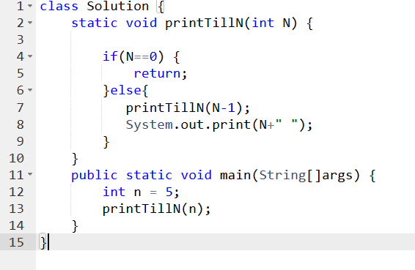

Q. Factorial
Given a positive integer, n. Find the factorial of n.
Examples :
Input: n = 5
Output: 120
Explanation: 1 x 2 x 3 x 4 x 5 = 120

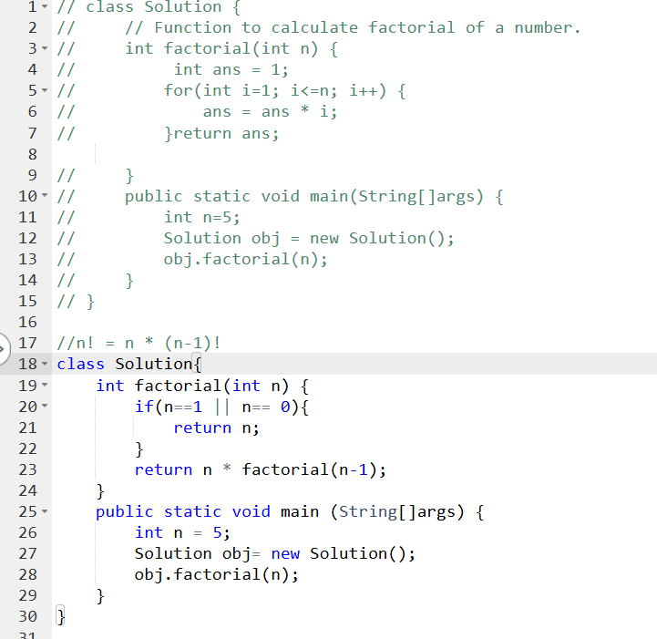

Q.GCD of two numbers
Given two positive integers a and b, find GCD of a and b.
Note: Don't use the inbuilt gcd function
Examples:
Input: a = 20, b = 28
Output: 4
Explanation: GCD of 20 and 28 is 4

