**EXPERIMENT: 03**

**Name**: Sahil Ashok Jagdale  
**PRN**: 23410005  
**Experiment No**:  
**Branch**: Electronics (EN-1)  
**Software Used**: Thonny

**AIM:**

Programs to study if-else statement, for loop, while loop, break, continue, and pass statements.

**SOFTWARE USED:**

Thonny

**THEORY:**

**1. If-Else Statement in Python**

The if-else statement is used for decision-making in Python. It allows conditional execution based on whether a given condition evaluates to True or False.

* The if block runs when the condition is True.
* The else block executes if the condition is False.
* The elif (else if) statement is used to check multiple conditions sequentially.

**2. For Loop in Python**

The for loop is used for iterating over sequences like lists, tuples, strings, or the range() function. It automatically assigns each item in the sequence to a variable and executes the loop body.

* It is commonly used when the number of iterations is known beforehand.
* The loop continues until all elements in the sequence are processed.

**3. While Loop in Python**

The while loop executes a block of code repeatedly as long as the given condition remains True.

* It is useful when the number of iterations is not known beforehand.
* Care must be taken to ensure the loop condition eventually becomes False, or else it will result in an infinite loop.

**4. Break Statement in Python**

The break statement is used to terminate a loop prematurely when a certain condition is met.

* When encountered inside a loop, it stops further execution and exits the loop immediately.
* It is often used in search operations or when a condition triggers an early exit.

**5. Continue Statement in Python**

The continue statement is used to skip the current iteration of a loop and move directly to the next iteration.

* It is useful when some part of the loop body should be skipped under certain conditions.
* Unlike break, it does not exit the loop but simply jumps to the next cycle.

**6. Pass Statement in Python**

The pass statement is a placeholder that does nothing when executed.

* It is used to define empty functions, loops, or conditionals where code will be added later.
* Helps avoid syntax errors in cases where an indented block is syntactically required but no action is needed at that moment.

Program:

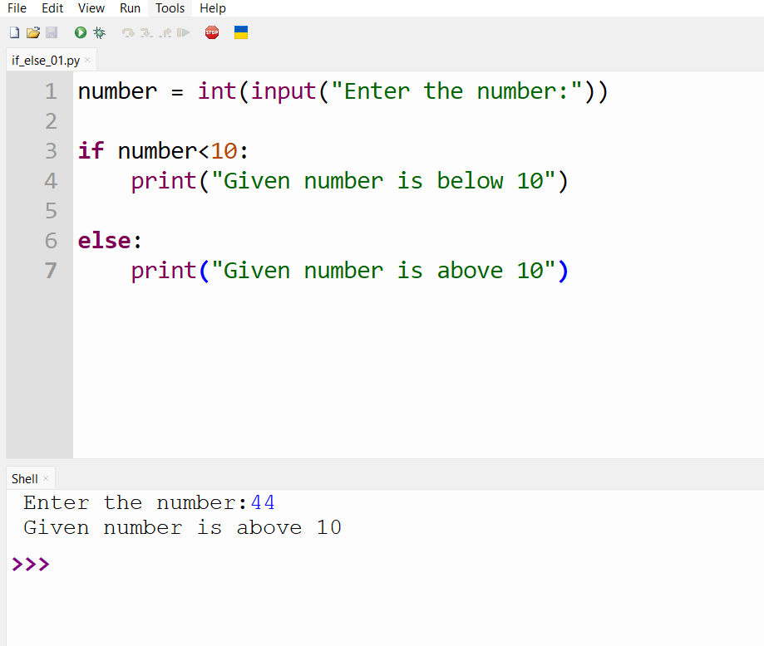

Program:

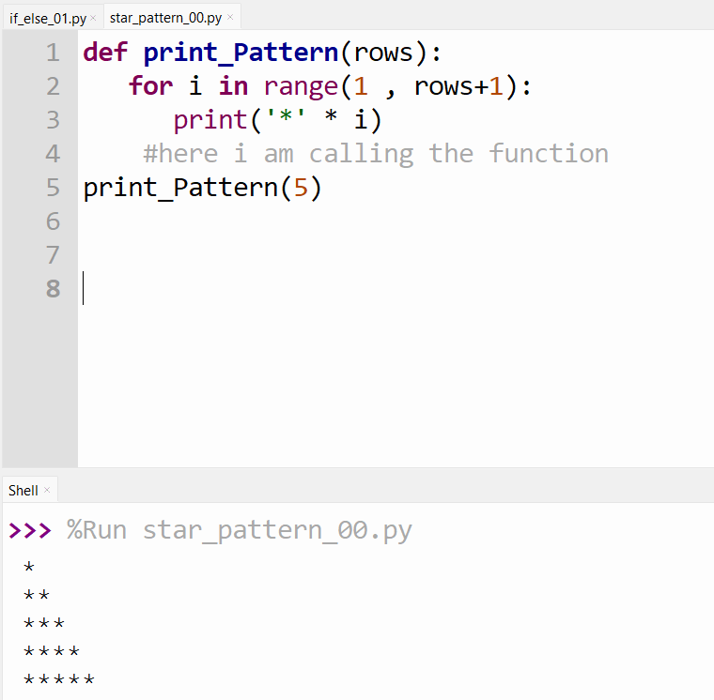

Program:

