**Experiment: 5**

**Name**: Sahil Ashok Jagdale  
**PRN**: 23410005  
**Experiment No**:  
**Branch**: Electronics (EN-1)  
**Software Used**: Thonny

**Aim**: Programs to study Tuples, Sets and Dictionary

**Tuple:**

* Tuples are used to store multiple items in a single variable.
* Tuple is one of 4 built-in data types in Python used to store collections of data, the other 3 are **List**, **Set**, and **Dictionary**, all with different qualities and usage.
* A tuple is a collection which is **ordered, unchangeable & allows duplicates**.
* Tuples are written with round brackets.
* When we say that tuples are ordered, it means that the items have a defined order, and that order will not change.

**Lists:**

* Lists are used to store multiple items in a single variable.
* Lists are one of 4 built-in data types in Python used to store collections of data, the other 3 are **Tuple**, **Set**, and **Dictionary**, all with different qualities and usage.
* Lists are created using square brackets.

**Dictionary:**

dictionary is an unordered collection of key-value pairs. Creation: Defined using curly braces {key: value} or dict(). Accessing Elements: Values are accessed using keys. Modifications: Keys must be unique and immutable, but values can be updated. Operations: Supports keys(), values(), items(), get(), update(), and pop().

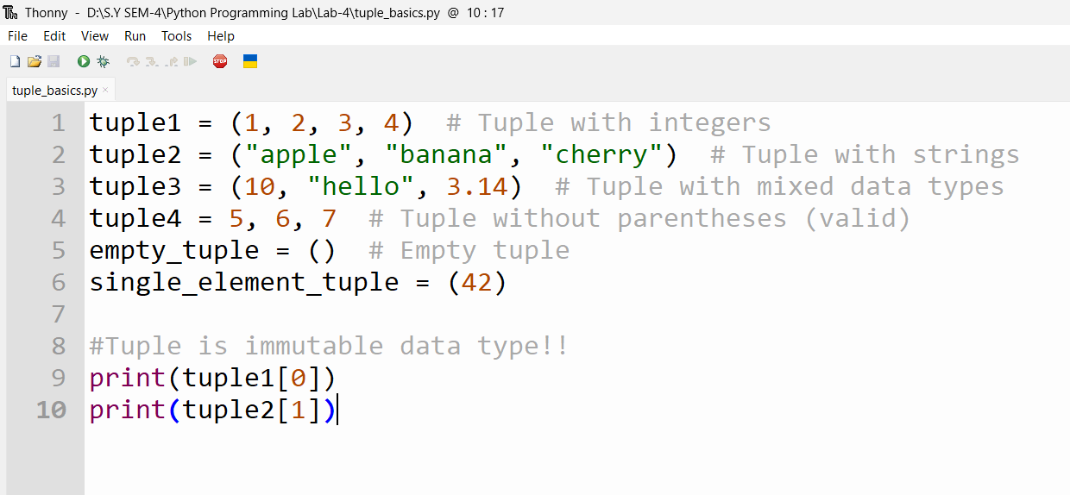

Output:

