**Experiment: 6**

**Name**: Sahil Ashok Jagdale  
**PRN**: 23410005  
**Experiment No**: 6  
**Branch**: Electronics (EN-1)  
**Software Used**: Thonny

**Aim**: Programs to study Python Functions, Python Function Arguments, Python Variable Scope and Python Global Keyword.

**THEORY:**

**1. Python Functions**

A function in Python is a block of code designed to perform a specific task. It allows you to organize code, make it reusable, and avoid repetition. Functions are defined using the def keyword followed by the function name and parentheses. The body of the function contains the code that is executed when the function is called.

* **Function Definition:** Functions can take inputs (called parameters) and produce outputs (called return values).
* **Return Statement:** The return keyword is used to send a result back from the function to the caller.

**2. Python Function Arguments**

Python functions can accept various types of arguments to pass data into the function. There are four primary types of arguments in Python:

* **Positional Arguments:** Arguments are passed in the order in which they appear in the function definition.
* **Keyword Arguments:** Arguments are passed by explicitly specifying the parameter name.
* **Default Arguments:** These are parameters that assume a default value if a value is not provided when the function is called.
* **Variable-length Arguments:** These are used when you do not know beforehand how many arguments will be passed. They can be:
  + *args (for non-keyword variable arguments)
  + **kwargs (for keyword variable arguments)

**3. Python Variable Scope**

Variable scope refers to the region of a program where a variable is accessible. In Python, variable scope can be categorized as:

* **Local Scope:** Variables declared inside a function are accessible only within that function.
* **Enclosing Scope:** Variables in the enclosing function, accessible from nested functions.
* **Global Scope:** Variables declared at the top level of a script or module are accessible throughout the entire script.
* **Built-in Scope:** This is the scope where Python’s built-in functions and exceptions reside, such as print(), len(), etc.

The scope determines which variable will be accessed in case of name conflicts (i.e., if a variable with the same name exists in multiple scopes).

Program:

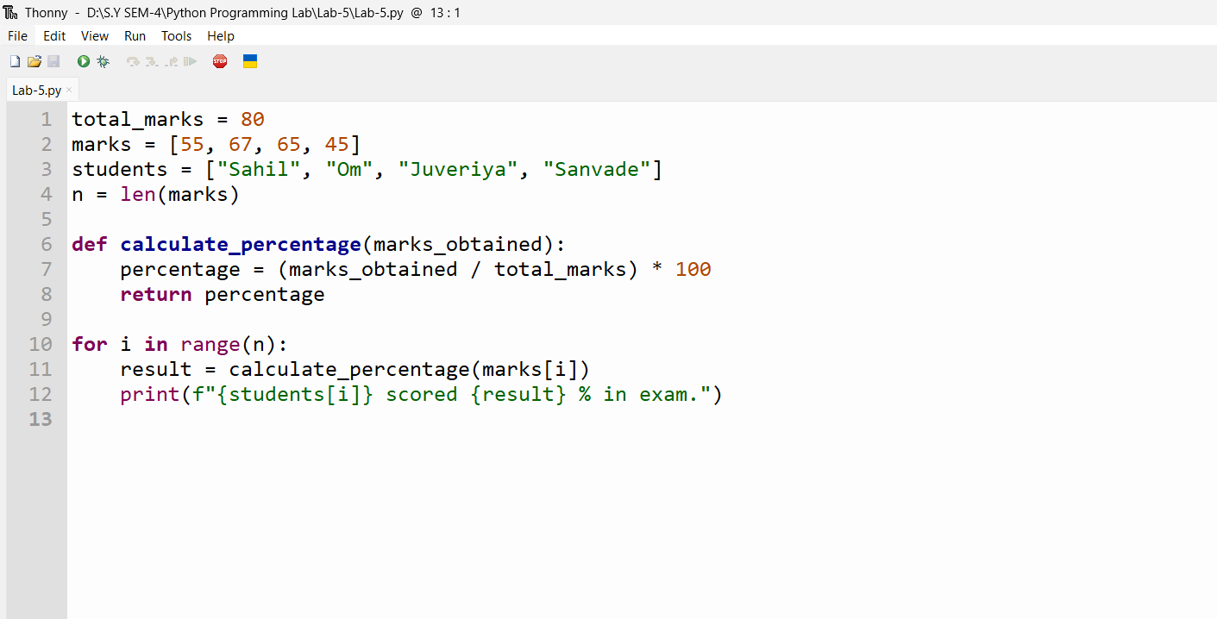

Output:

