CAr and Bike Booking system

This is based on Booking cars and bike . A Button **project ( to start the project)**

**Support:**

This program is build in python 2.7.14 in windows 10.

**Basics:**

**Tkinter,Gif,Sqlite3**

**Steps :**

* **There will be a splash window in which as soon as the mouse will be moved over the image then there will be window open in which project is there. As show in image 1**

1.

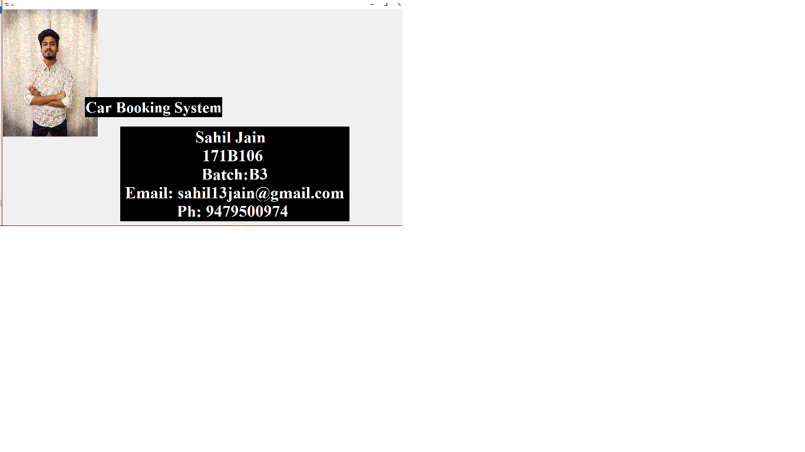

* Click on project
* Tkinter will appear named MENU with three image Buttons :

1. To select the Cars and bike

* ***select cars***:

1. Select Book button To book the Car or bike:
2. This menu of will automatically fill the model and show the amount
3. Fill the form.
4. Click on Book.
5. This will open a payment window which will have following option :

* Cash on delivery
* Cancel payment
* Payment from debit

1. This payment on delivery will open a thanks window in which we there will be thank you note for customer.
2. And payment from debit will open another window where there will be : card no. cvv and amount , then this will generate an otp this otp will be put in another window then if the otp is correct the then a message will appear which is: payment is successfull . if the otp is wrong then it will take the program to gernate otp.
3. To Find Any records :
4. Enter the name to find the person
5. Click Find
6. To See ALL Records Click on All Records