**Shared Folder:**

1. Create a folder on Windows/Linux OS and copy the path

Ex. C:\Users\jossa\OneDrive\Desktop\DSBDA Practicals

1. Click on VM settings and enter the path and Shared folder name

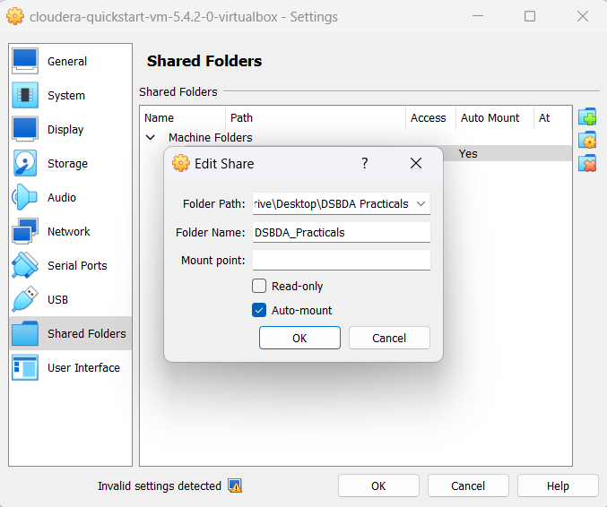

1. Create a folder in Cloudera

Ex. /home/cloudera/Desktop/DSBDA_shared

1. Now open Terminal and type

su root

Password: cloudera

1. mount -t vboxsf /home/cloudera/Desktop/DSBDA_shared

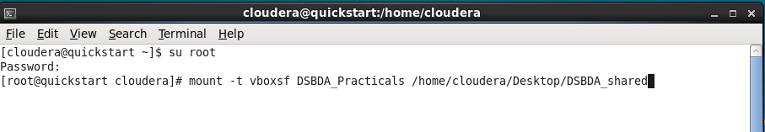

**MapReduce**

1. Create a new project with class ex. Movie
2. Add 3 External Archives

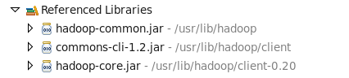

Path:

* File System/usr/lib/hadoop/hadoop-common.jar
* File System/usr/lib/hadoop/client/commons-cli-1.2.jar
* File System/usr/lib/Hadoop/client-0.20/hadoop-core.jar

1. Export the project in JAR file after everytime any changes are done

Ex. movie.jar

1. Load the csv file in Cloudera through Shared Folder (Remove the column names after copying it into Cloudera’s Home)
2. Put the csv file into HDFS

hadoop fs -put movie.csv movie.csv (or any different name)

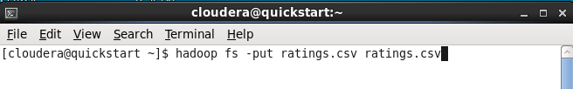

1. Now for executing MapReduce job:

hadoop jar movie.jar Movie movie.csv temp



1. Output:

hadoop fs -ls temp

hadoop fs -cat temp/part-r-00000

