**Exporting data from Hive tables to HBase tables**

1. Create a table in HBase and insert data into it:

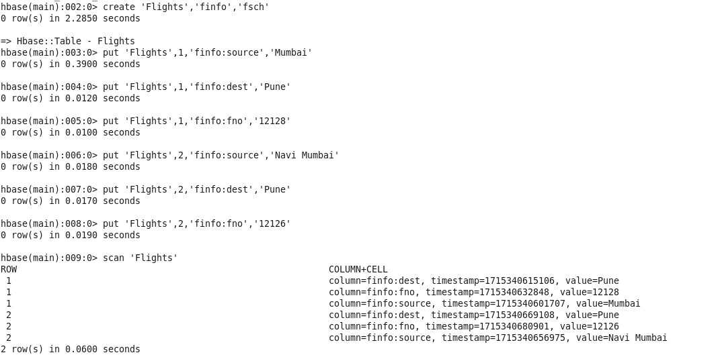

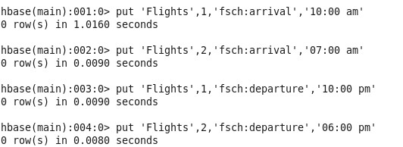

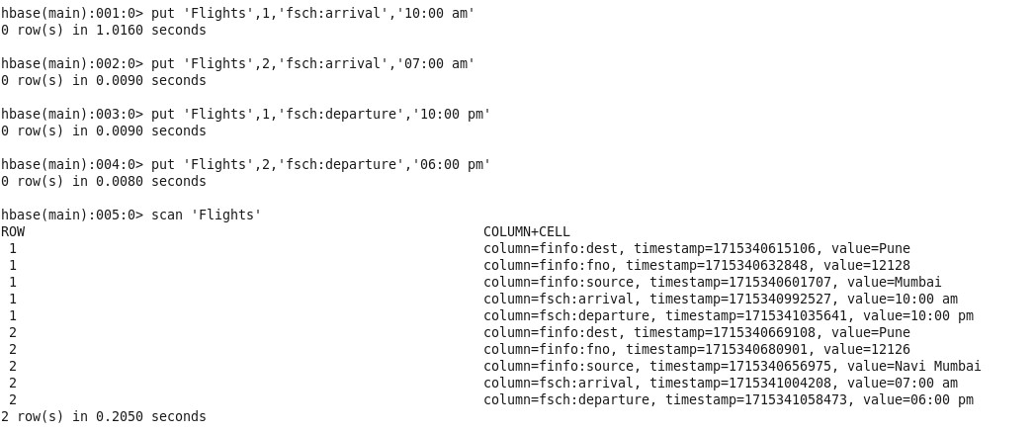

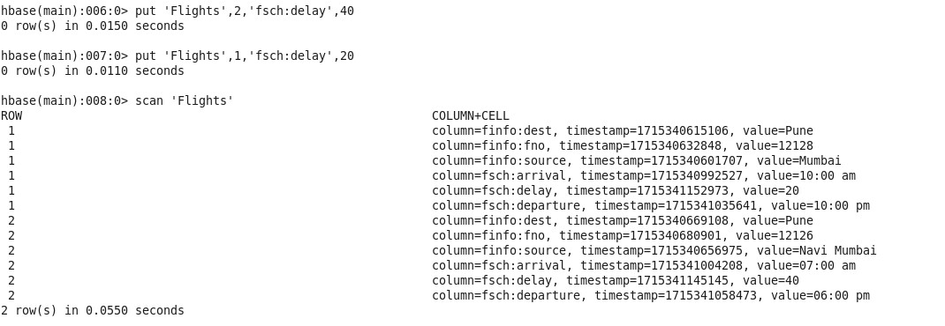

1. Create an external table in Hive to connect to HBase

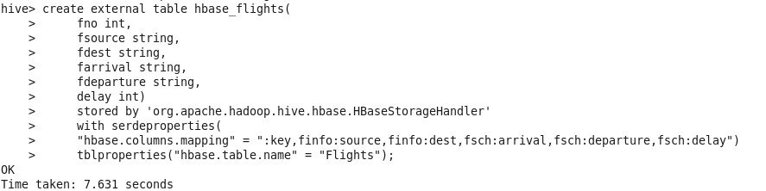

1. Display the data from Hive table

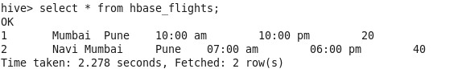

1. Total and Average Delay

