**Exporting data from Hive tables to HBase tables**

1. Create a table in HBase:



1. Create a table in Hive:

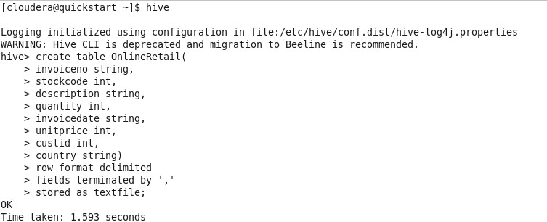

1. Load data in the Hive table

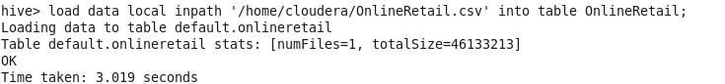

1. Create external table in Hive for connecting to the HBase table

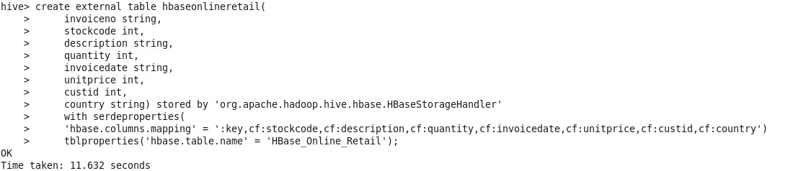

1. Load data from Hive table to external Hive-HBase table

Insert into hbaseonlineretail select * from OnlineRetail;

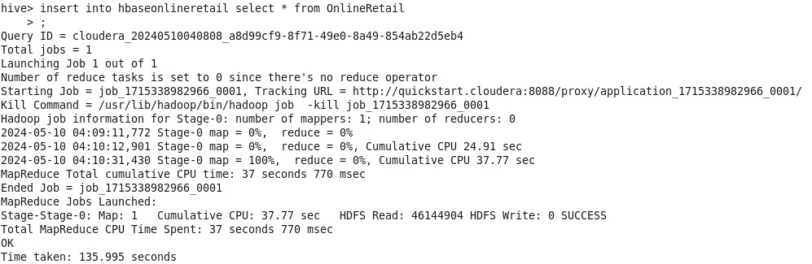

1. Scan from HBase table

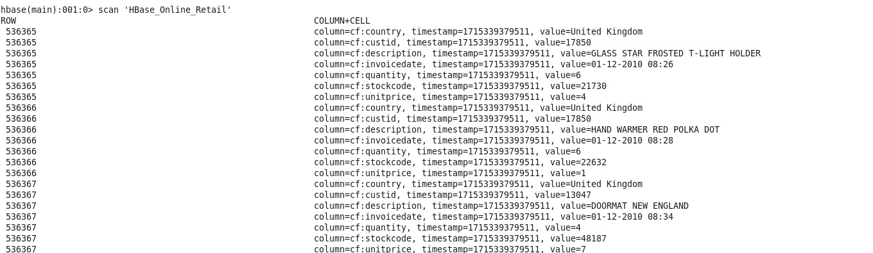

1. Queries:

* create index idx on table OnlineRetail(invoiceno) as “compact” with deferred rebuild;
* select sum(quantity*price) as total_sales, avg(quantity*price) as avg_sales from OnlineRetail;
* select invoiceno, sum(quantity*price) as total_cost from OnlineRetail group by invoiceno order by total_cost desc limit 1;
* select customerid, sum(quantity*price) as total_cost from OnlineRetail group by customerid order by total_cost desc limit 1;
* select country, sum(quantity*price) as max_sale from OnlineRetail group by country order by max_sale desc limit 1;
* select country, sum(quantity*price) as min_sale from OnlineRetail group by country order by min_sale asc limit 1;