

Faculty of Technology
Department of Computer Engineering
Dharmsinh Desai University

PROJECT REPORT
ON

ATTENDANCE SYSTEM USING REALTIME FACE RECOGNITION SYSTEM

BY
INAMDAR AAKARSH (CE058)
JARIWALA SAHIL Y. (CE059)

B. TECH CE SEMESTER- VI

SUBJECT:
SOFTWARE DEVELOPMENT PROJECT

GUIDED BY
DR. MALAY BHATT

INDEX

1. Software Requirement specification …..............................................................………… 03
1.1. Purpose …………………………………………………………………. 03
1.2. Scope …...………………………………………………………………. 04
1.3. Functional Requirements ………………………………………………. 05
2. Analysis And Design..............................................................................................................06
2.1. Non Functional Requirnment.......................................................................06
2.2. Hardware Rqruirnment.................................................................................06
2.3. Usecase Diagram...........................................................................................06
2.4. Class Diagram...............................................................................................06
2.5. Sqeuance Diagram.........................................................................................06
2.6. Acitvity Diagram............................................................................................06
2.7. Data Flow Diagram........................................................................................06

- SOFTWARE REQUIRMENT SPECIFICATION

1.1 PURPOSE

- Real time face recognition system is used for many purposes like securities, protecting law enforcement etc of which one is Attendance management system.

- It is very tiresome, time-consuming job to physically record attendance of thousands and thousands of people of any institutions and organizations. Also, due to involvement of humans, chances of typographical as well as mathematical errors has also increased. Thus, recording and maintaining huge and huge sets of data is very difficult. Also, it is very difficult to generate reports from them.

- In order to get rid of all the above problems, to maintain attendance and generate reports based on them for huge records of attendance is made very simple with the help of ‘Attendance Management System Using Realtime Face Recognition System’. This system registers new employees and also keep their attendance by keeping records of date and time of user logging in and out using real-time video of them. It also generates reports for attendance of them. Thus, removing all the human (typographical, mathematical) errors.
.

1.2 Scope

- In modern periods, one of the most important aspects which an organization requires is security. Day-by-day, more and more technologies are developing and older technologies are getting developed more and more, thus the risk for organization’s security is also increasing day-by-day. But the good thing is, technologies are also getting modern to provide security. Real time face recognition is also one of the technologies used for security purpose of the organization.

- Also, real time face recognition system is used for many purposes like, maintaining attendance, preventing retails crimes, protect law enforcement, find missing persons, validate identities at ATM, unlock phones etc.

- Attendance management system using real-time face recognition can be used in educational institutions, industrial level system etc to record check-in and checkout time of employees every day and also it can be used to generate reports for employees thus helping the institution to get the employee’s performance.

1.3 FUNCTIONAL REQUIREMENTS

R.1 MANAGE ATTENDANCE

R.1.1 CHECK-IN
DESCRIPTION: This functionality helps the user of the system to log in to the system
and thus, granting his/her attendance for the day.
INPUT: User’s selection and real-time video of user’s face.
OUTPUT: Confirmation message of granting attendance and redirecting to home
Page of the system.

R.1.2 CHECK-OUT
DESCRIPTION: This functionality helps the user to log out successfully from the
system thus recording the time of checkout.
INPUT: User’s selection and real-time video of user’s face.
OUTPUT: Confirmation message of logout recorded and user successfully logged out.

R.1.3 GENERATE REPORT
DESCRIPTION: This functionality is used to generate report for the system or for aspecific employee based on the previous attendance of the employees recorded into the system.
R.1.3.1 GENERATE SYSTEM REPORT
INPUT: User’s Selection.
OUTPUT: Report of all the employees of the system.

R.1.3.2 GENERATE EMPLOYEE REPORT
INPUT: User’s selection and employee ID.
OUTPUT: Employee specific report.

R.2 MANAGE EMPLOYEE DETAILS:
R.2.1 REGISTER EMPLOYEE:
DESCRIPTION: This functionality is used to add new employee in the system. Here, the employee needs to add his personal information at the time of registration. After that only admin can add real time face data of new employee in the system.

R.2.1.1 TAKE EMPLOYEE DETAILS:
INPUT: Employee’s personal details
OUTPUT: Confirmation message
R.2.2. COLLECT FACIAL DATA:
INPUT: Employee’s facial data via real time video
OUTPUT: Success message

R.2.2: LOGIN
DESCRIPTION: Using this functionality use can login to the system using different apparoches.User needs to login to the system before accessing any functionality of system.
INPUT: User selected apparoch and Login details
OUTPUT: Success message

R.2.3: TRAIN THE SYSTEM
DESCRIPTION: Admin use this functionality to train/update the system for new facedata which has collected at registration time of new employee.
INPUT: User Selection
OUTPUT: Success message

R.2.4: Display employee Details:
DESCRIPTION: User can see his details which he has provided at registration time.
INPUT: User selection
OUTPUT: Display User Details

2. ANALYSIS AND DESIGN:
2.1 NON FUNCTIONAL REQUARINMENT:
- Reusability
- Accuracy
- Reliability
- Supportabiltiy
2.2 HARDWARE REQUIRMENT :
- web cam

2.3 USE CASE DIAGRAM:
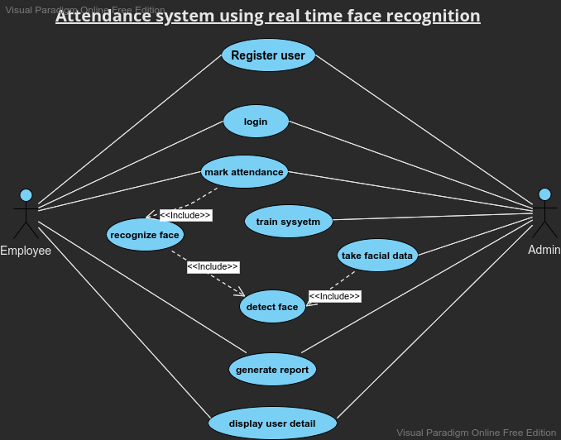

2.4 Classs Diagram :
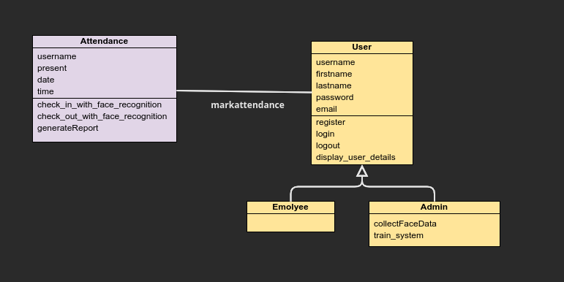
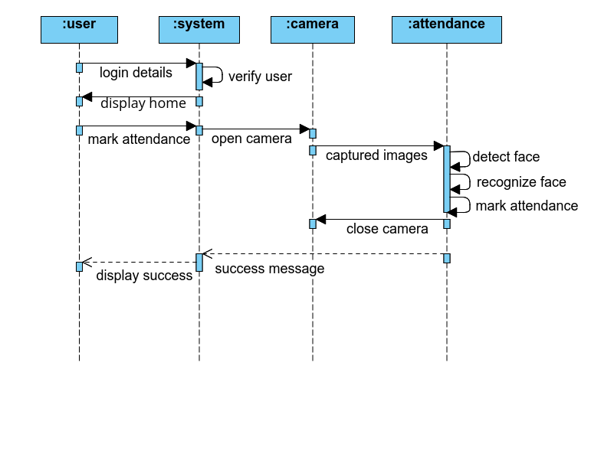
2.5 SEQUANCE DIAGRAM:

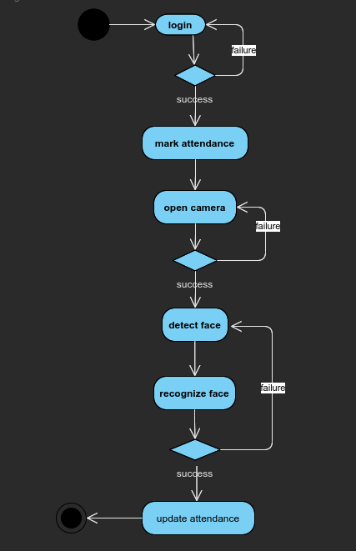
2.6. ACTIVITY DIAGRAM:

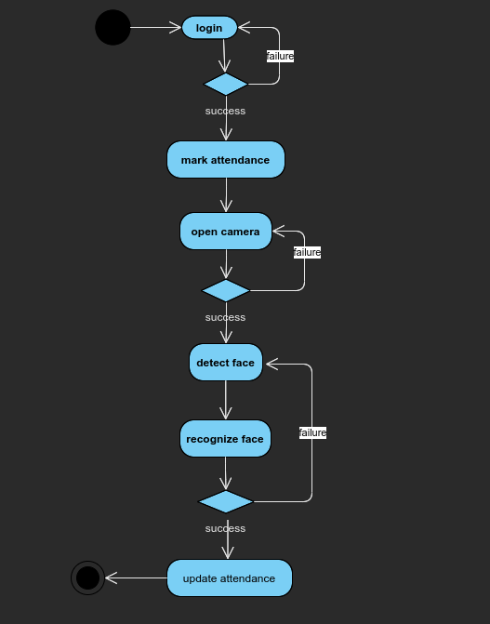
2.7 DATA FLOW DIAGRAM:
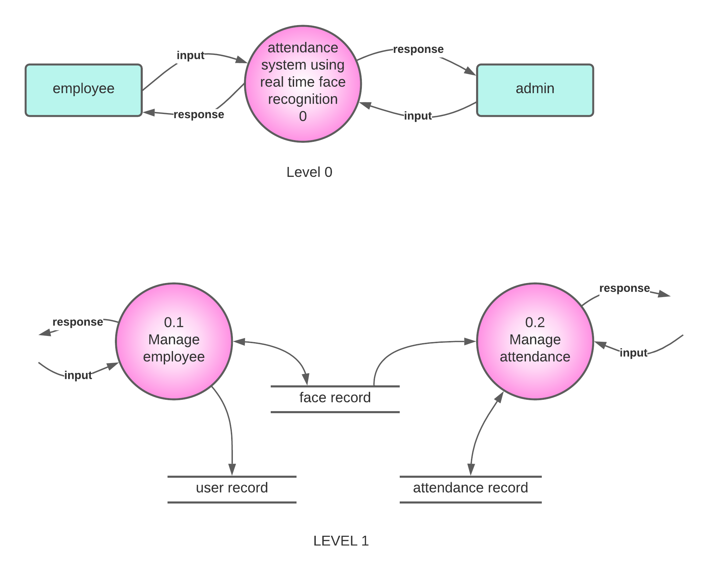
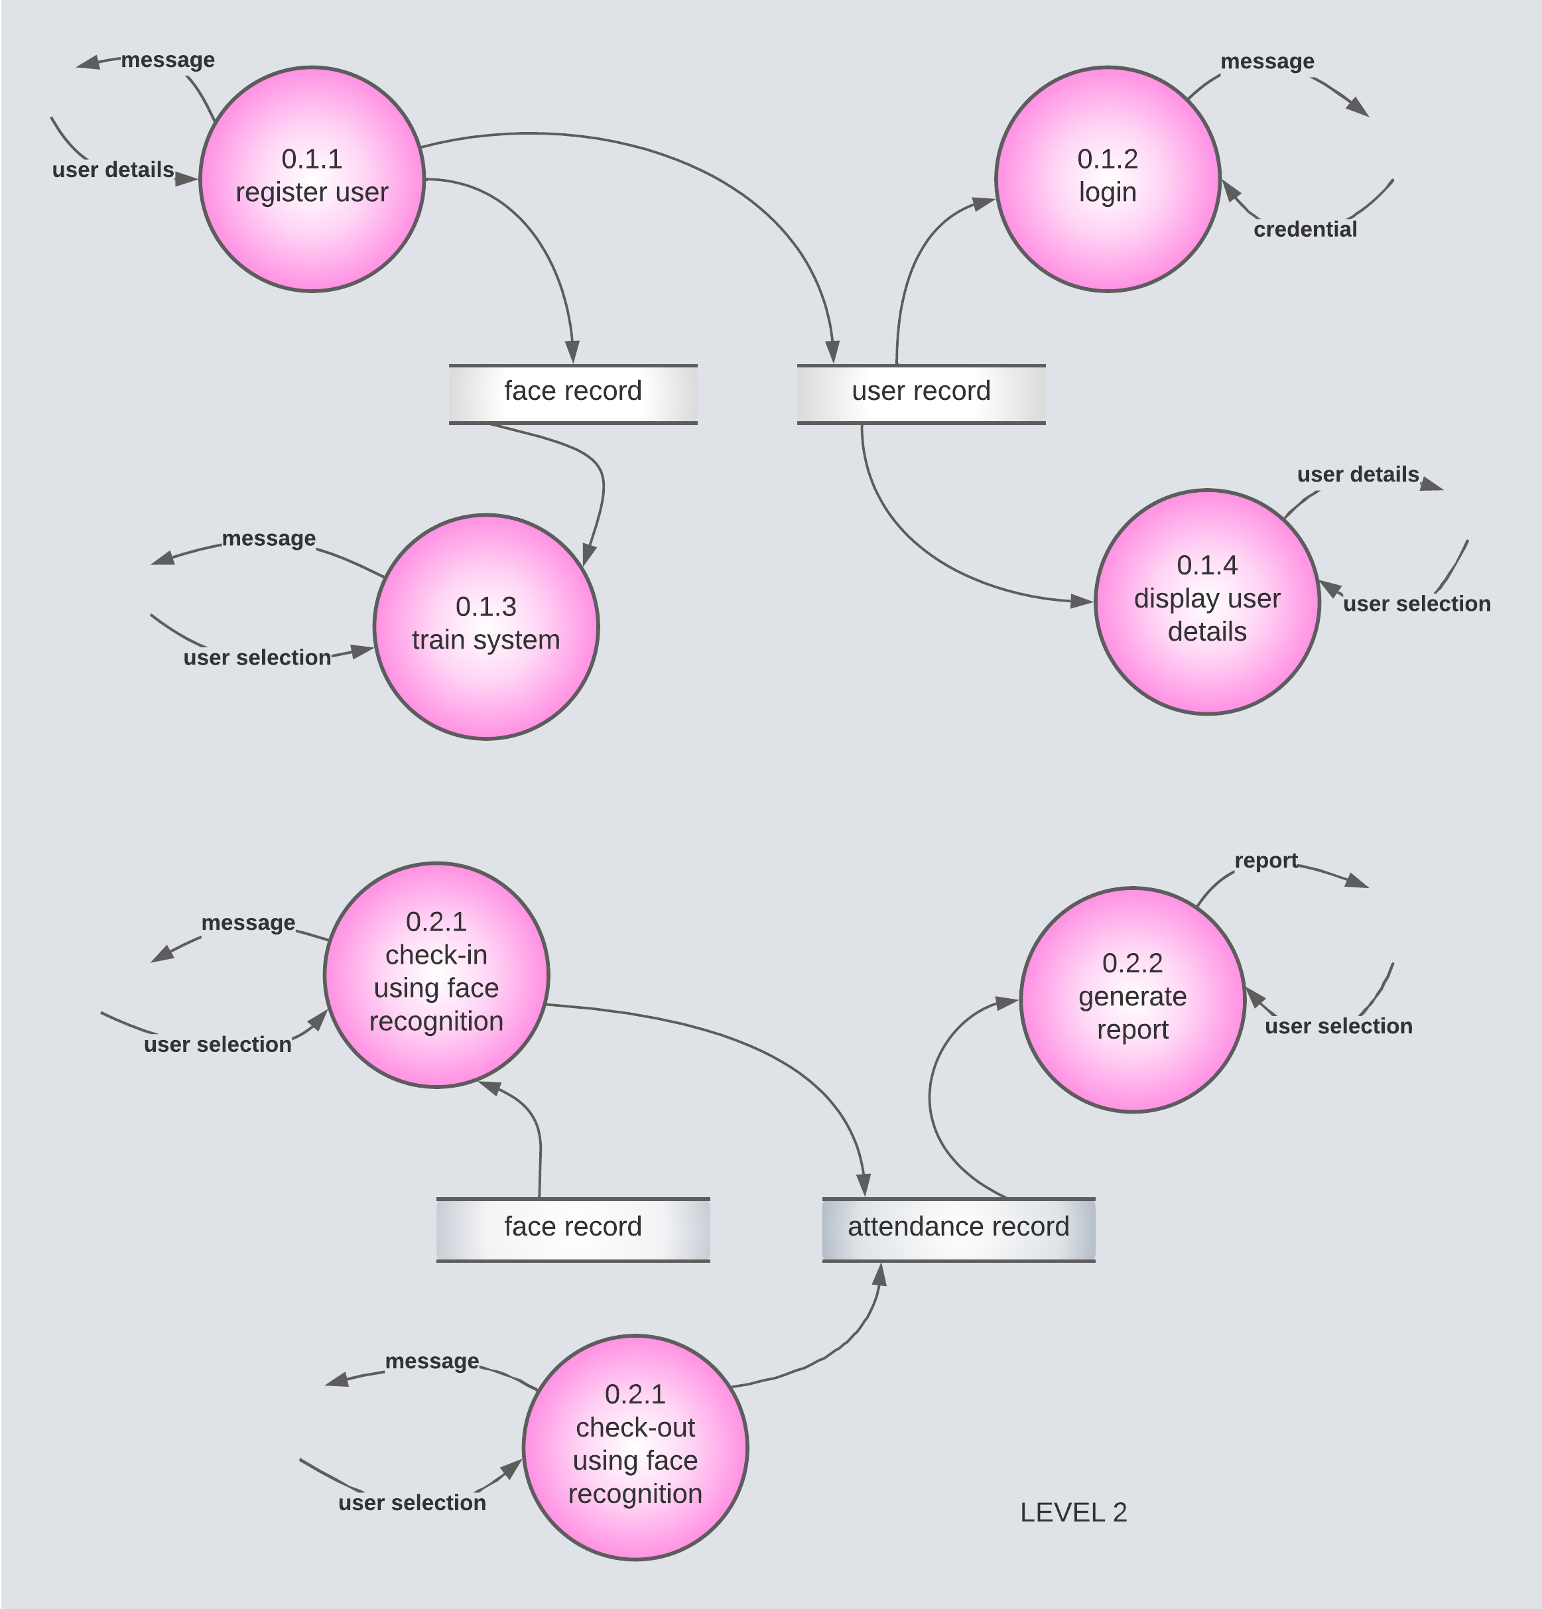
3. IMPLEMENTATION:
3.1 TECHNOLOGY DETAILS:

