

Faculty of Technology
Department of Computer Engineering
Dharmsinh Desai University

PROJECT REPORT
ON

ONLINE STUDENT PORTAL SYSTEM

BY
JARIWALA SAHIL Y. (CE057)
INAMDAR AAKARSH (CE056)

B. Tech CE Semester- V

Subject:
ADVANCE TECHNOLOGY

GUIDED BY
PROF. PRASHANT JADHAV

INDEX:
Abstract
Introduction
SRS
Class Diagram
DFDs
Implemention details
Testing
Screen shots of system
Conclusion
Limitation and fututre extension
Bibliography

1.Abstract………………………………………………….03
2.Introduction………………………………………...........04
3.Software Requirement Specification……………………06
4.Design…………………………………………………...14
4.2. Class Diagram………………………………...15
4.5 Data Flow Diagram……………………………20
5.Implementation Details………………………………….23
6.Work Flow/ Layout With Testing……………………….29
7.Conclusion………………………………………………32
8.Limitations And Future Extension………………………36
9.Bibliography…………………………………………….37

- ABSTRACT:

In modern days, everyone opts for less time-consuming jobs.
Time matters everywhere. That’s where the role of software comes into picture. A software reduces both time and efforts of the users for completion of their job.

Taking into consideration about software from university’s point of view, Online Student Portal System plays a very important role. It reduces the efforts for student to visit the notice boards regularly for viewing important notices like results, competitions, fees payment etc. Also, students get benefits by getting their study materials online. Thus, saving so much of time. Also, major advantage of this software is that student can be updated all the time that what’s going on in the university.

- INTRODUCTION:

This software is for students so they can easily know the details about universities, their personal details like assignments etc. Using this software, the students can view their personal details registered at their university, update them as well. Student can download student material uploaded by their faculties. Student can also upload their assignments online.

From the faculty’s point of view, they can easily share their study materials to student through this software, they can view the assignments of students, on this software. They can also send students some important notice if they wish.

TECHNOLOGY USED:

-Mongo DB
-React
-Express
-Node js

TOOL USED:

-VS CODE EDITOR
-ROBO 3T
-POSTMAN

- SOFTWARE REQUIREMENT SPECIFICATION:

1.MANAGE USERS:

R.1.1 SIGN IN/SIGN UP
DESCRIPTION: For using system user must have an account. If user is new then he/she has to register himself/herself using this functionality by providing necessary information. If user is already registered, he/she can directly login into the system.
.
R.1.1.1 REGISTER NEW USERS
Input: Name, address, email (if user has), mobile no, new
username and password.
Output: Confirmation of registration status and information
stored in system and also sent registration mail and user directed to login page.

R.1.1.2 LOGIN
Input: Username and password
Output: If user is verified successfully, he/she will be prompted to Home page.

BELOW FUNCTIONALITIES CAN BE USED
ONLY IF USER STATUS IS LOGGED IN.

R.1.2: DISPLAY USER DETAILS
DESCRIPTION: Using his functionaltiy user can see his/her details which are provided while registration.
INPUT: Option selection.
OUTPUT: Displayed user’s current details.

R.1.3: UPDATE USER DETAILS
DESCRIPTION: Using this functionality, user can update his/her details record stored at university.
INPUT: User input
OUTPUT: Updated details displayed.

R.1.4: DELETE USER ACCOUNT
DESCRIPTION: If user wishes to delete account, he/she could do so with help of this functionality.
INPUT: User selection
OUTPUT: Confirmation message and user account is deleted.

2.MANAGE SUBJECTS:

R.2.1 ADD SUBJECT
DESCRIPTION: If subject is assign to faculty then he/she can create a classroom for that subject in which he/she can post material and assignment.
INPUT: Subject name and its credit.
OUTPUT: New id and classcode for that subject is generated and classcode is displayed.

R.2.2 DISPLAY SUBJECT
DESCRIPTION: All types of user can see classrooms which are joined or created by user.
INPUT: select option
OUTPUT: Display subjects.

R.2.3 ADD SUBJECT MATERIAL/ASSIGNMENT
DESCRIPTION: Faculty can add material or assignment for specific subject using this functionality
INPUT: Material/Assignment details
OUTPUT: Confirmation message and send mail to students who have joined that subject

R.2.4 DISPALY SUBJECT MATERIAL/ASSIGNMENT
DESCRIPTION: Using this functionality student can see newly or old material/assignment for specific subject’s classroom which is added by faculty and student can also download the material/assignment.
INPUT: select option
OUTPUT: Display assignment/maaterial details

R.2.5 DELETE ASSIGNMENT/MATERIAL
DESCRIPTION: Using this functionality faculty can delete assignment/material from classroom
INPUT: Select option
OUTPUT: Confirmation message and assignment/material deleted

R.2.6 SUBMIT ASSIGNMENT
DESCRIPTION: Using this functionality student can upload their answer books for given assignment
INPUT: select option
OUTPUT: Conformation message and change status

R.2.7 SEE SUBMISSION
DESCRIPTION: Using this functionality faculty can see answer book of student which is uploaded by student for specific subject also faculty can see that how many students have uploaded and faculty can also download uploaded files.

INPUT: select option
OUTPUT: Display uploaded answer book and count of submission.

3.MANAGE NOTICES:

R.3.1: ADD NOTICE
DESCRIPTION: In order to send important notices to students, this functionality can be used.
INPUT: User selection and information related to notice.
OUTPUT: success message and email is sent.

R.3.2: UPDATE NOTICE
DESCRIPTION: Using this functionality, faculties can edit some wrongly written information or add some extra information to the notice posted earlier
INPUT: User selection and updated details.
OUTPUT: Confirmation message.

R.3.3: DELETE NOTICE
DESCRIPTION: Whenever user wants to delete the notice, he/she can do so using this functionality.
INPUT: User selection
OUTPUT: Confirmation message.

R.3.3: DISPLAY NOTICE
DESCRIPTION: Using this functionality all type of user can see notice created by faculty or admin
INPUT: Selection
OUTPUT: All notice will be display.

4.DESIGN

- ER DIAGRAM

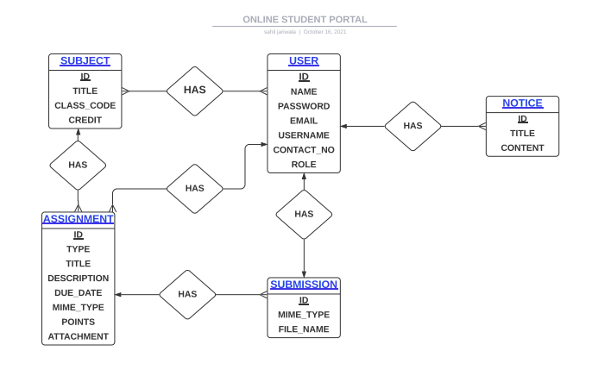
- DFD:

LEVEL 0:

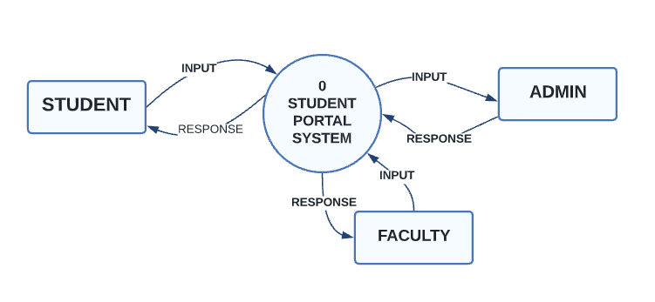

LEVEL 1:

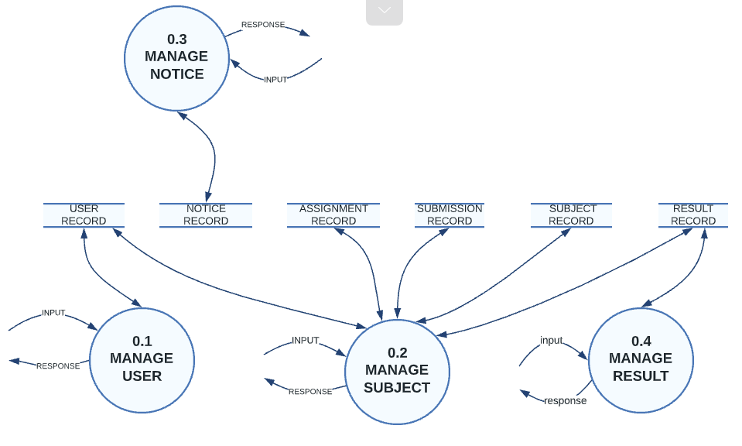

LEVEL 2:

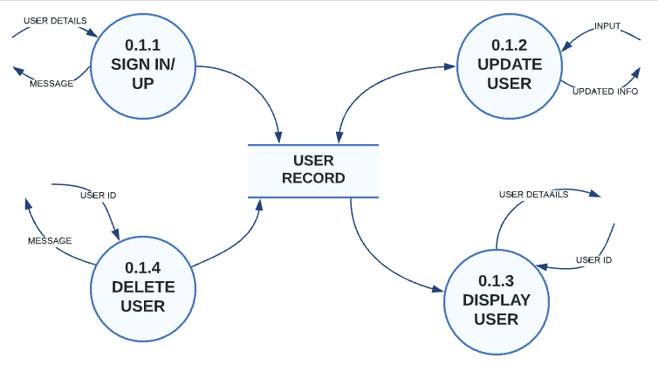
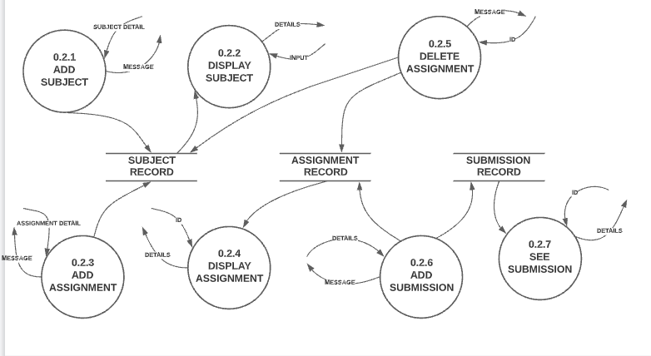

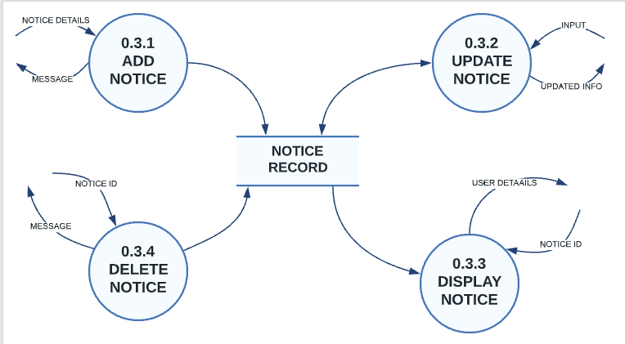

III. DATA DICTIONARY:

In our project we have used the NoSQL database so we cannot create a data
dictionary as well as entity relationship diagram but we are providing here some pictures
of our database. We have used the MONGO database. It doesn’t have a table, row
& column but it has a collection document & field as shown in below pictures.

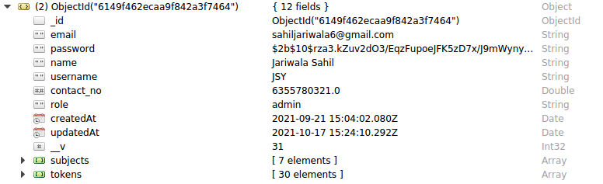

TESTING:

TEST CASES:

TEST_ID | SRS_ID | TEST CASE OBJECTIVE | INPUT | EXPECTED OUTPUT | ACTUAL OUTPUT | STATUS
TC_01 | R.1.1.1 | Registration | User data | Sucess message and email | Sucess message and email | Pass
TC_02 | R.1.1.2 | Login | Credential | Sucess message | Success message | Pass
TC_02.1 | R.1.1.2 | Login | Wrong Credential | Invalid login | Invalid login | Pass
TC_03 | R.1.2 | Display user | User selection | User data | User data | Pass
TC_04 | R.1.3 | Update user | User new data | Updated user data | Updated user data | Pass
TC_05 | R.1.4 | Delete user | User selection | Message | Message | Pass
TC_06 | R.2.1 | Add subject | Subject data | Success message | Success message | Pass
TC_07 | R.2.2 | Display subject | Selection | Subjects detail | Subjects detail | Pass
TC_08 | R.2.3 | Add assignment/ material | Details | Success message and email sent | Success message and email sent | Pass
TC_09 | R.2.4 | Display assignment/material | Selection | Display details | Display details | Pass
TC_10 | R.2.5 | Delete assignment/material | Selection | Success message | Success message | Pass
TC_11 | R.2.6 | Add submission | Submission dta | Success message | Success message | Pass
TC_12 | R.2.7 | See submission | Selection | Submission details | Submission details | Pass
TC_13 | R.3.1 | Add notice | Notice data | Success message end email sent | Success message and email sent | Pass
TC_14 | R.3.2 | Update notice | Notice new data | Updated notice | Updated notice | Pass
TC_15 | R.3.3 | Display notice | Selection | Display notices | Display notices | Pass
TC_16 | R.3.4 | Delete notice | Delete notice | Success message | Success message | Pass

Some Screenshot of testing using postman:

