# Practical 1

**Aim: Import the legacy data from different sources such as (Excel, SqlServer, Oracle etc.) and load in the target system.**

1. Launch Power BI Desktop.
2. From the Home ribbon, select ‘Get Data’. Select ‘OData feed’.

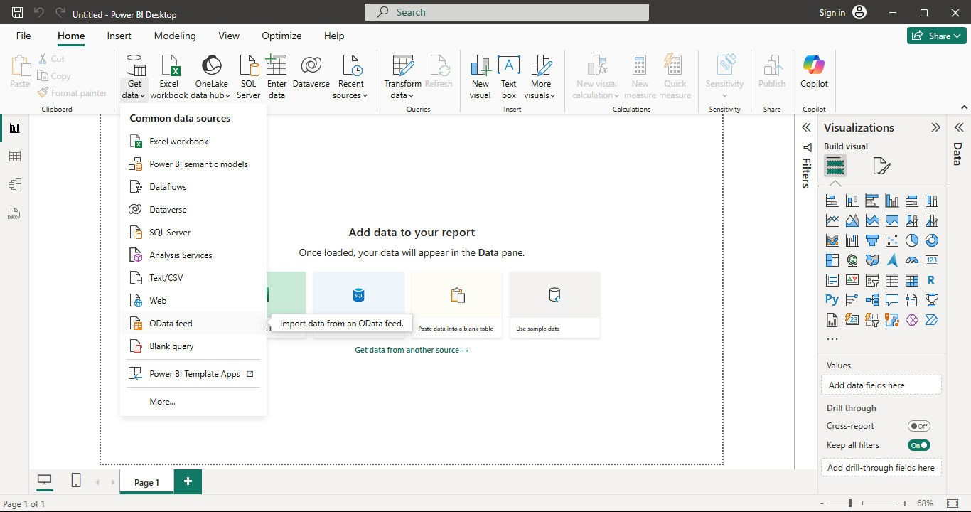

1. In the OData Feed Dialog box, paste the URL for the Northwind OData feed. Select OK.

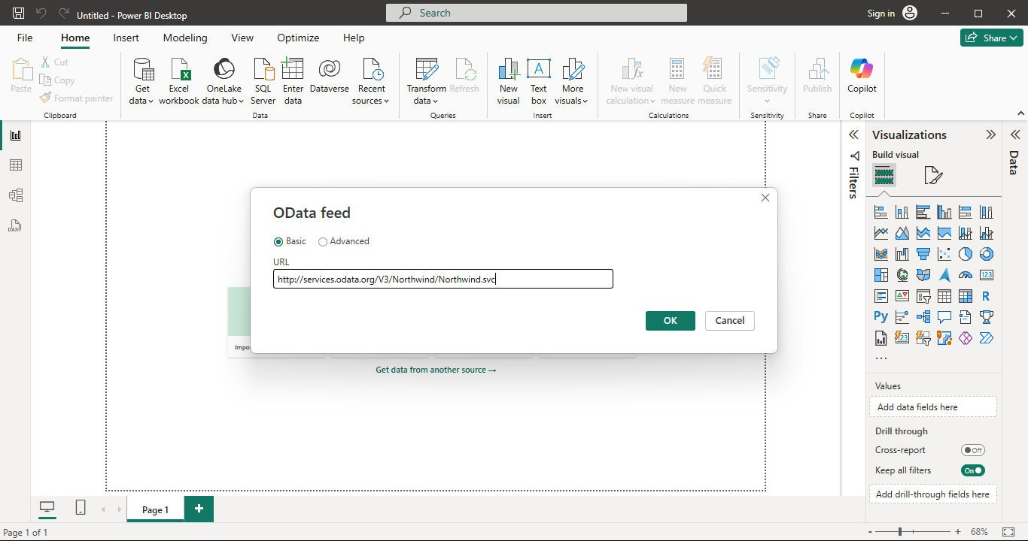

1. In the Navigator pane, select Order_Details, Orders and Products tables. Click ‘Transform Data’.

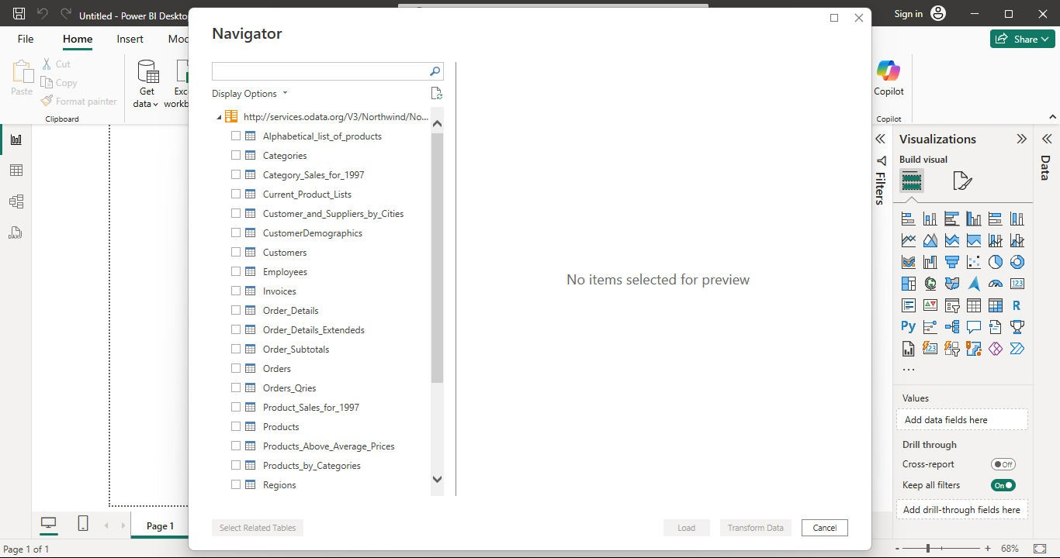

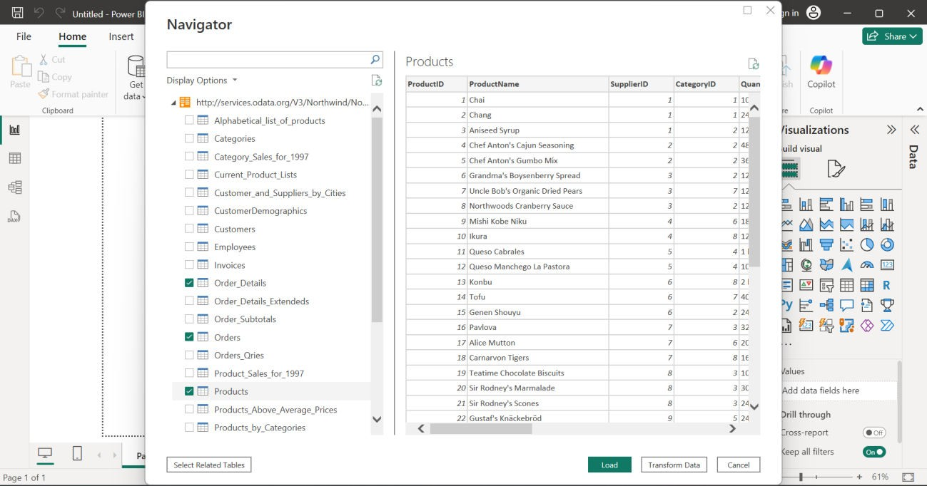

# Practical 2

**Aim: Perform the Extraction Transformation and Loading (ETL) process to construct the database in the Sqlserver / Power BI.**

**ETL PROCESS IN POWER BI**

1. Remove all columns except ProductID, ProductName, UnitsInStocks and QuantityPerUnit.

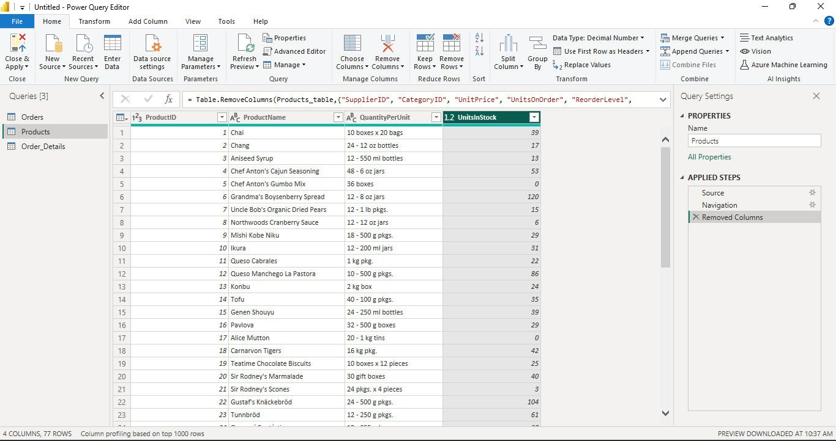

1. Change the data type of UnitsInStock column to Whole Number. Right click on UnitsInStock column, go to Change Type, click Whole Number.

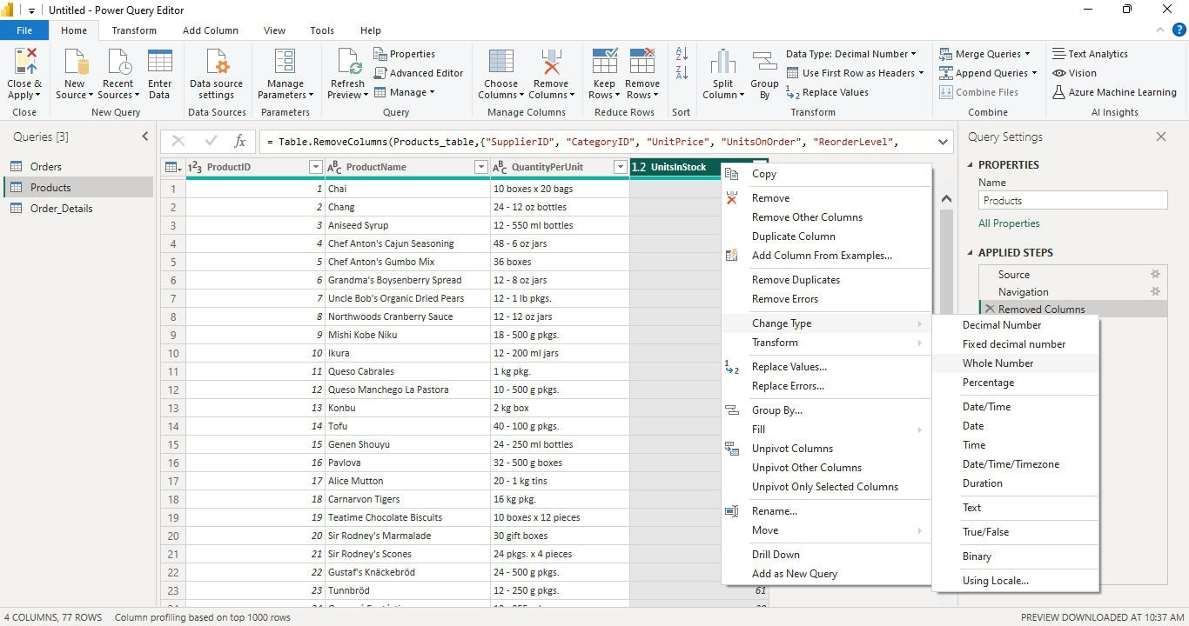

1. Expand the Order_Details table that is related to the Orders table, to combine the ProductID, UnitPrice and Quantity columns from Order_Details into the Orders table.

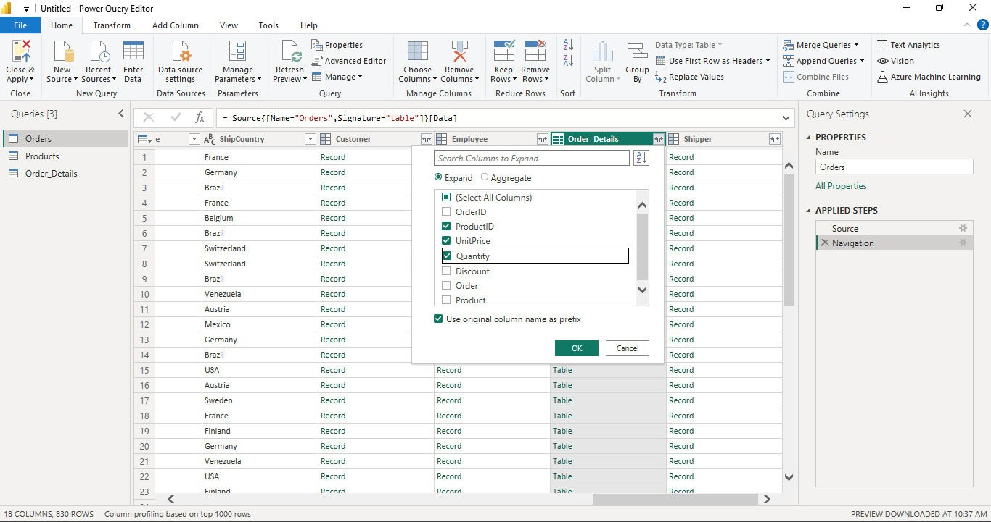

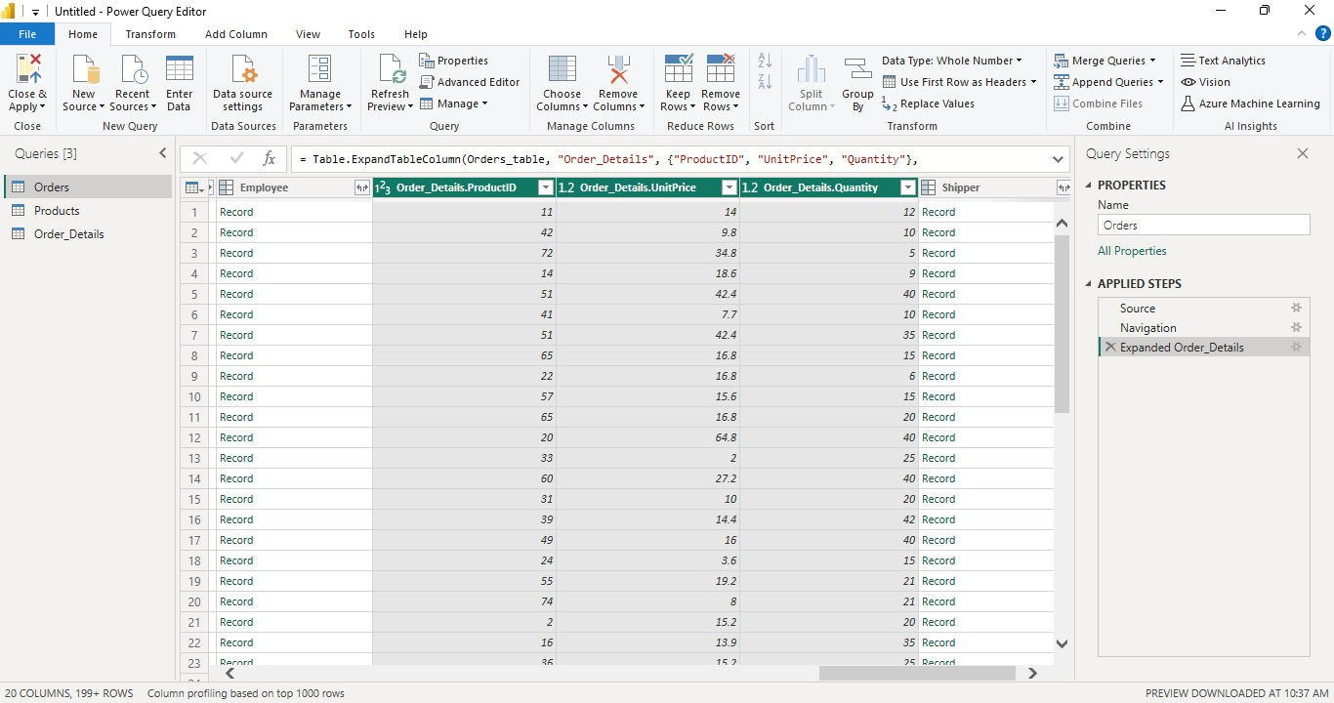

1. Go to Add Column ribbon, select Custom Column. Calculate the Line Total for each Order_Details row.

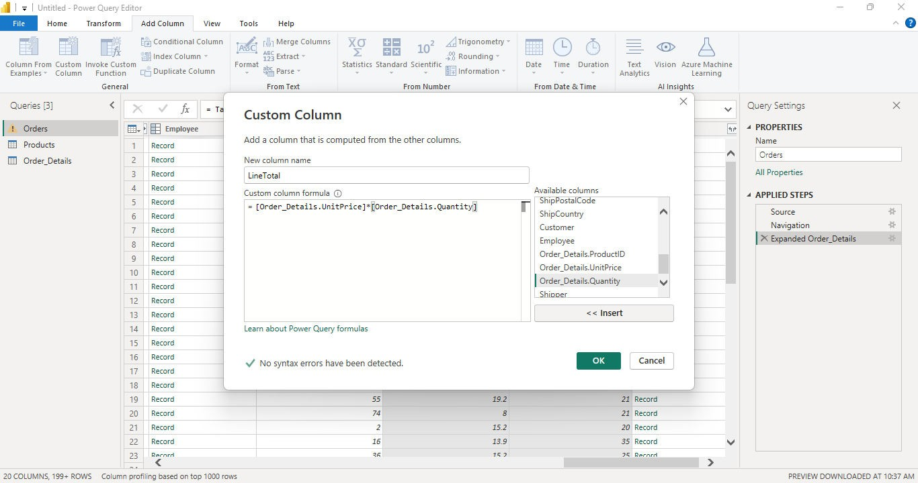

1. Drag the Line Total column to the left of ShipCountry. Rename Line Total as

Total. Remove the Order_Details. prefix from Order_Details.ProductID, Order_Details.UnitPrice, Order_Details.Quantity columns by double-clicking on each column header.

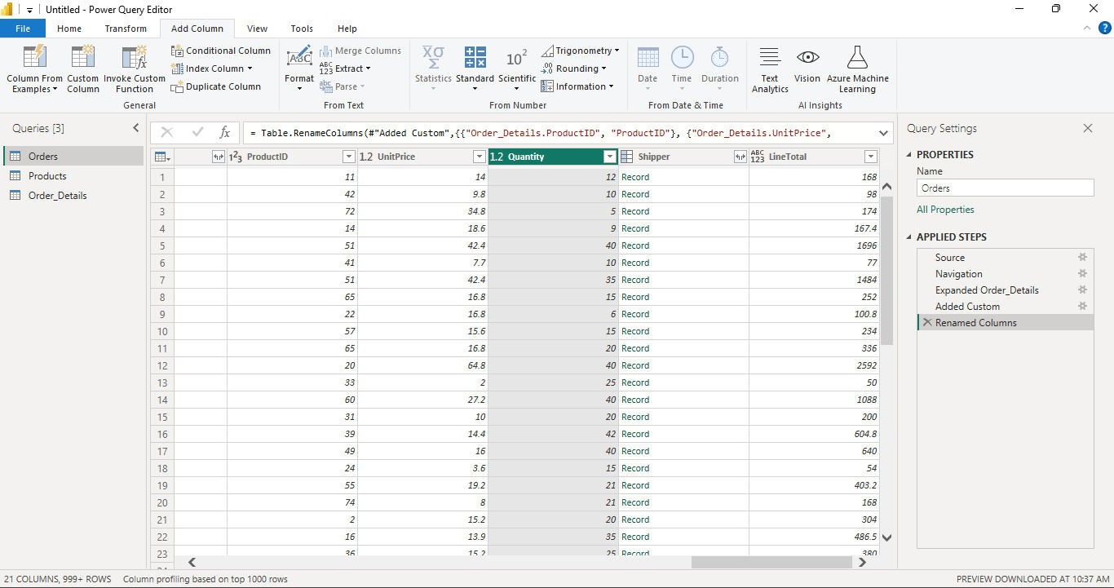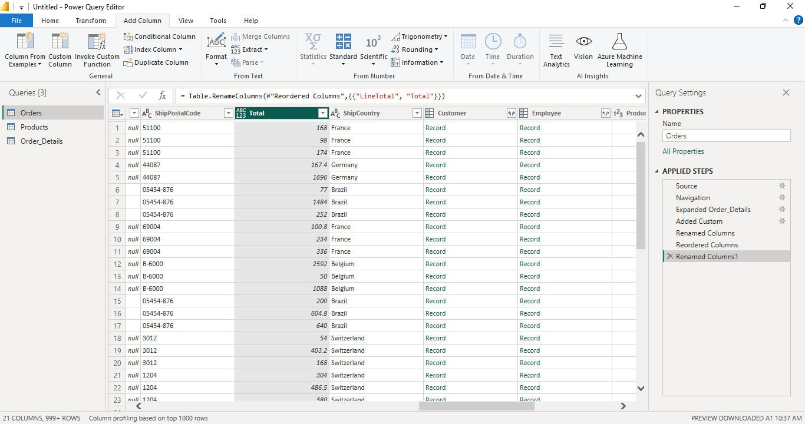

1. From the Home ribbon, select Close & Load.

1. Once the data is loaded, you can view the tables in Relationship View. Select the Manage Relationship button from Home ribbon. Click on the New button.

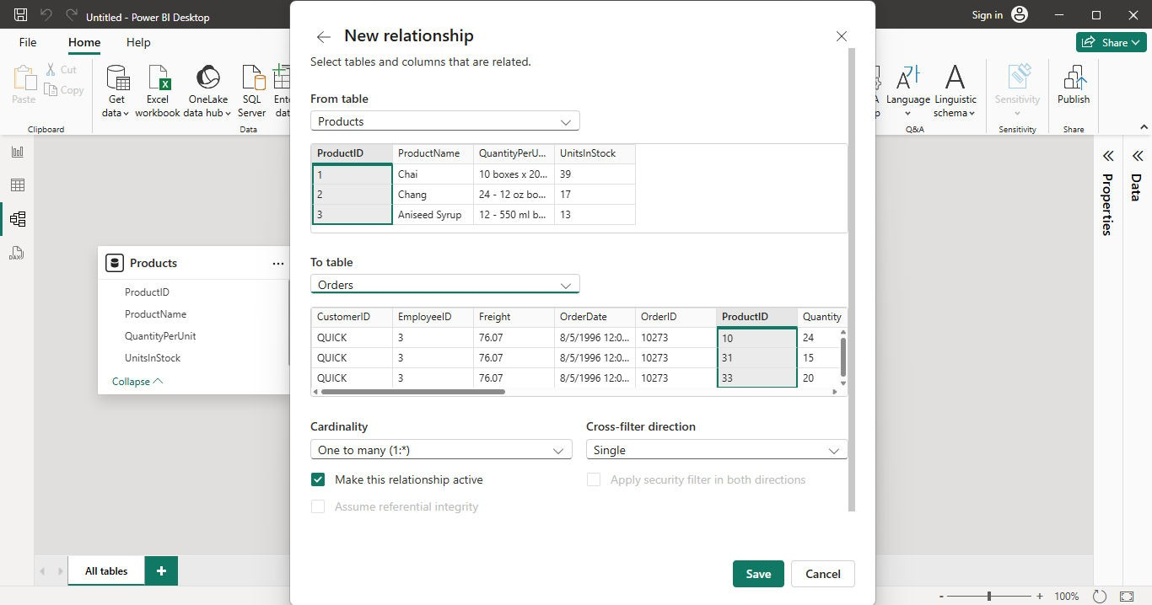

1. Select Products and Orders Table and click Save.

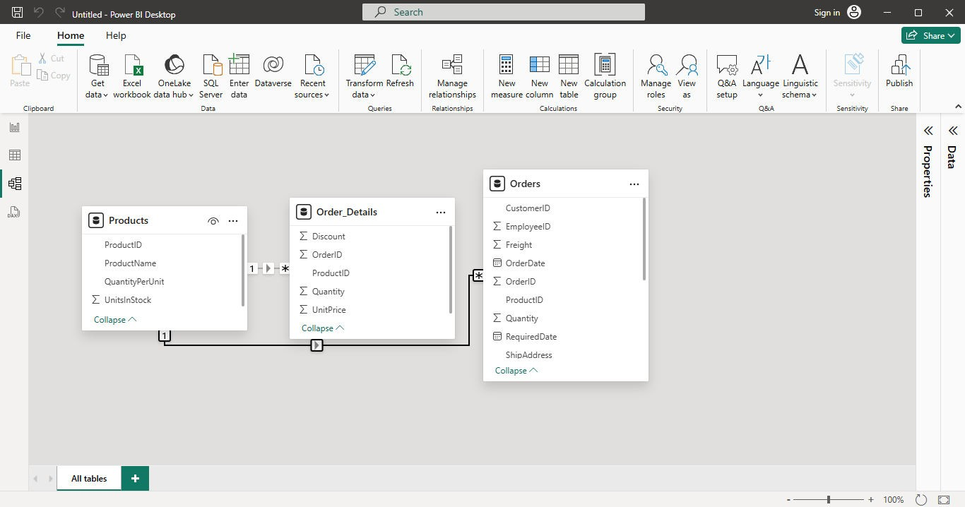

# Practical 3

**Aim: Data Visualization from ETL Process**

1. Create a Clustered Column Chart showing Units in Stock by Product and Total Sales by Year.

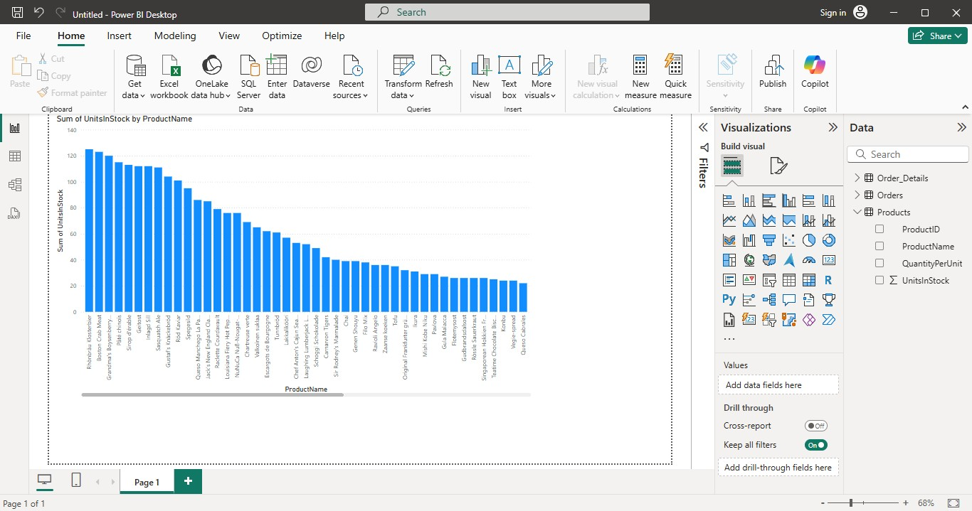

1. Insert a map visualization. Drag ShipCountry to the Location field and Total to Legend field.

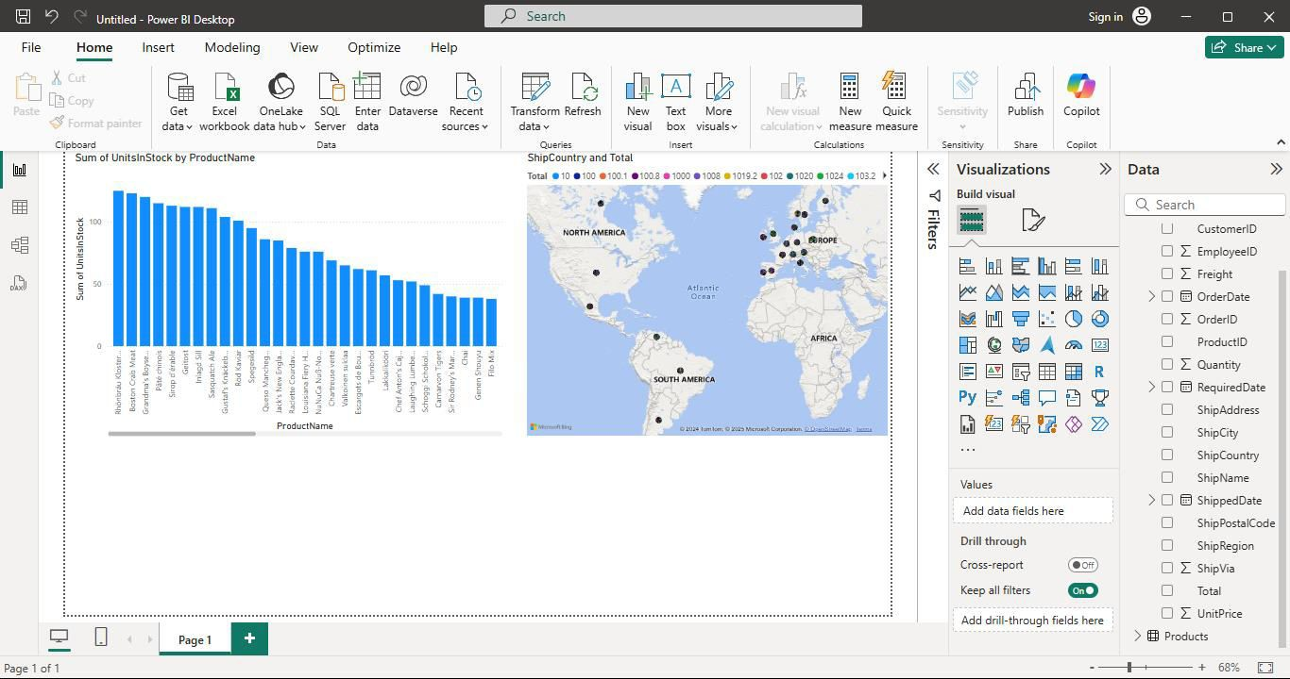

1. Add Q&A, search ‘total freight over time’.

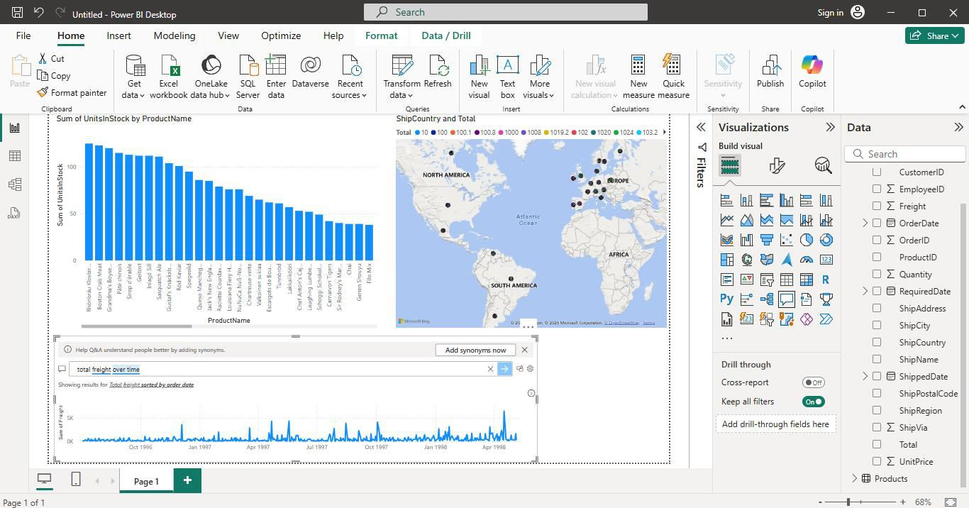

# Practical 5

**Aim: Apply the what – if Analysis for data visualization. Design and generate necessary reports based on the data warehouse data.**

1. Open MS Excel.

**Goal Seek:**

1. Type the following:

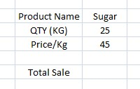

1. Go on the empty cell beside Total Sale and type the following formula to multiply QTY and Price:

=E4*E5

1. Select ‘Total Sale’ value, then in the Data tab click on What If Analysis and select Goal Seek.

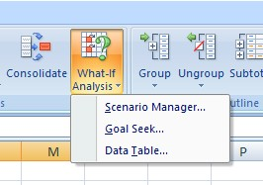

You will get the following window:

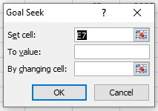

1. Type 1500 in ‘To value’ and select ‘QTY’ value in ‘By changing cell’. Click ‘OK’.

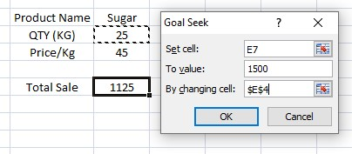

The quantity will be changed according to the total sale.

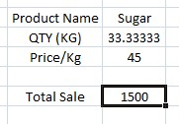

f) Similarly, you can perform the same with ‘Price/Kg’ value.

**Data Table:**

1. Type the following:

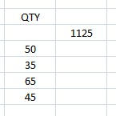

1. Select the cells as shown below.

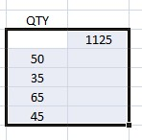

1. In the Data tab, click on What If Analysis and select Data Table.



1. After selecting Data Table you will get a window.

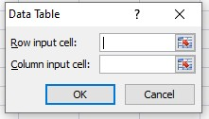

1. Select ‘25’ as ‘Column input cell’ to get the price for the corresponding quantity.

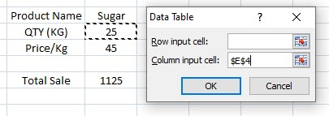

The corresponding values will appear.

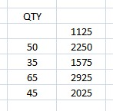

1. Type the following:

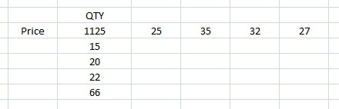

1. Select the cells as shown below:

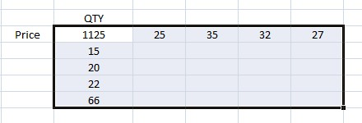

1. In the Data tab, click on What If Analysis and select Data Table.



1. Since quantity values are written in the column and price values in row, we select ‘25’ as ‘Column input cell’ and ‘45’ as ‘Row input cell’.

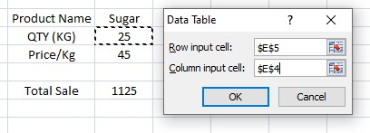

The corresponding values will appear.

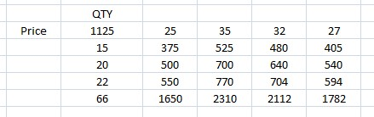

**Scenario Manager:**

1. In the Data tab, click on What If Analysis and select Scenario Manager.



1. The following window will appear. Click on ‘Add’ to add a scenario.

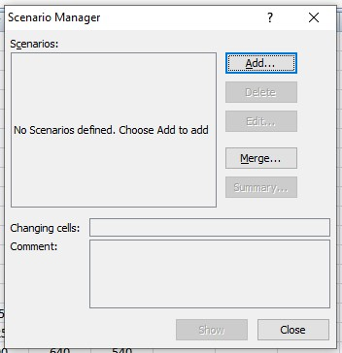

1. Type a scenario name and select the changing cells.

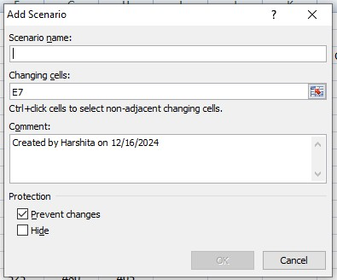

For instance, type ‘Sunday Sale’ as the scenario name and select E4, E5(‘25’,’45’) as changing cells. Then click ‘OK’.

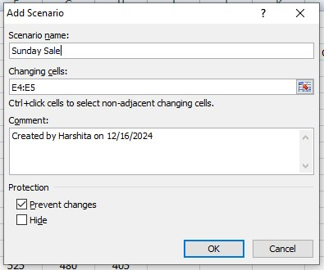

1. Type the values ‘25’ and ‘45’ respectfully and click ‘OK’.

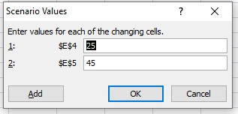

A scenario is created as shown below.

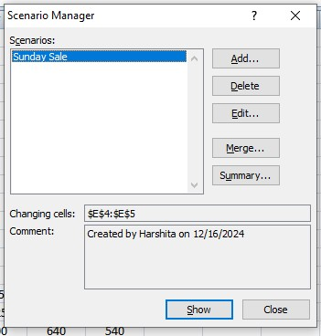

Now change the values ‘25’ and ‘45’ to some other value. To get the original value, go to ‘Scenario Manager’, select ‘Sunday Sale’ and click on ‘Show’.

# Practical 10

## Aim: Data Analysis using Time Series Analysis

**Code:**

rainfall <- c(799,1174.8,865.1,1334.6,635.4,918.5,685.5,998.6,784.2,985,882.8,1071) rainfall.timeseries <- ts(rainfall,start = c(2012,1),frequency = 12) print(rainfall.timeseries) png(file = "rainfall.png") plot(rainfall.timeseries) dev.off()

**Output:**

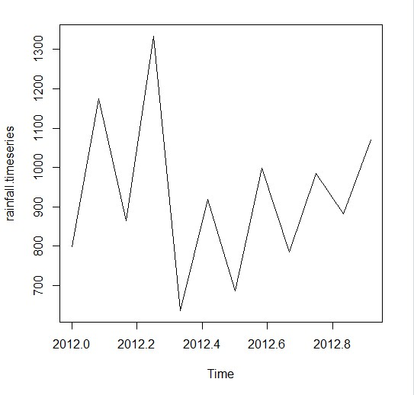

# Practical 9

## Aim: Prediction Using Linear Regression

**Code:**

x <- c(151,174,138,186,128,136,179,163,152,131) y <- c(63,81,56,91,47,57,76,72,62,48) relation <- lm(y~x) a <- data.frame(x = 170) result <- predict(relation,a) print(result)

**Output:**



# Practical 6

## Aim: Implementation of Classification algorithm in R Programming

**Code:**

x <- c(151,174,138,186,128,136,179,163,152,131) y <- c(63,81,56,91,47,57,76,72,62,48) relation <- lm(y~x) png(file = "linearregression.png") plot(y,x,col = "blue",main = "Height & Weight Regression",abline(lm(x~y)), cex = 1.3,pch = 16,xlab = "Weight in Kg",ylab = "Height in cm") dev.off()

**Output:**

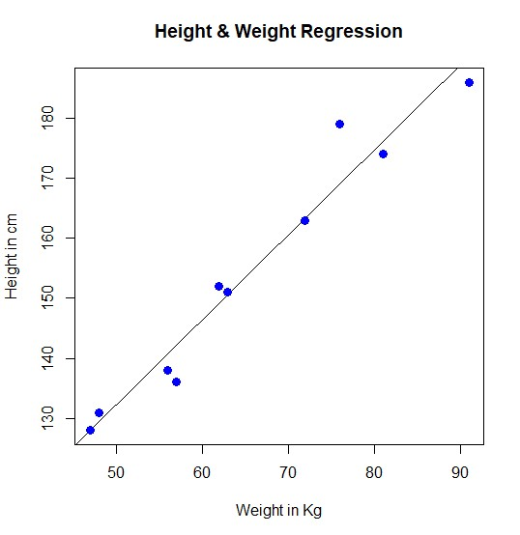

# Practical 8

## Aim: k-means clustering using R

**Code:**

newiris <- iris newiris$Species <- NULL

(kc <- kmeans(newiris,3))

**Output:**

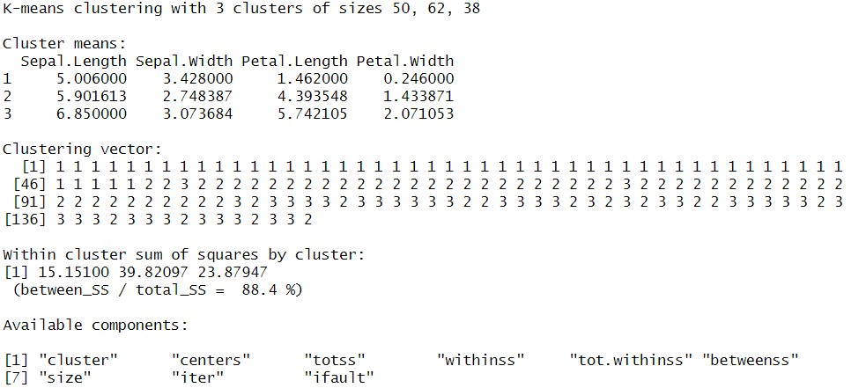

**Code:**

table (iris$Species,kc$cluster) **Output:**

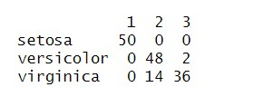

**Code:**

plot(newiris[c("Sepal.Length","Sepal.Width")],col=kc$cluster) points(kc$centers[,c("Sepal.Length", "Sepal.width")],col=1:3,pch=8,cex=2)

**Output:**

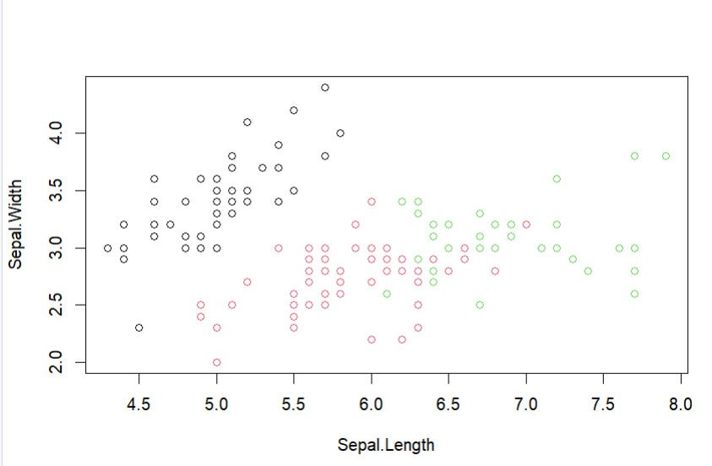

Name: Sahil Kamble

Roll No.: IT22093

Class: TYBSc IT Date: 16/12/2024

**Practical 7**

**Aim: Practical Implementation of Decision Tree using R Tool.**

**Code:**

library(party) print(head(readingSkills)) input.dat <- readingSkills[c(1:105),] png(file = "decision_tree.png") output.tree <- ctree(nativeSpeaker ~ age + shoeSize + score,data = input.dat) plot(output.tree) dev.off()

**Output :**

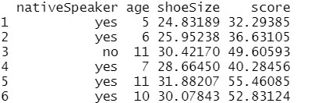

Name: Sahil Kamble

Roll No.: IT22093

Class: TYBSc IT Date: 16/12/2024

