EXPT#1

1. The data was read and stored in list and therein the M,F and I was changed to their corresponding values.
2. The dataset is standardized

Now for various values of frac and lambda, graphs were plotted and the observation is

So, as we can see the values of frac are given in the plots itself

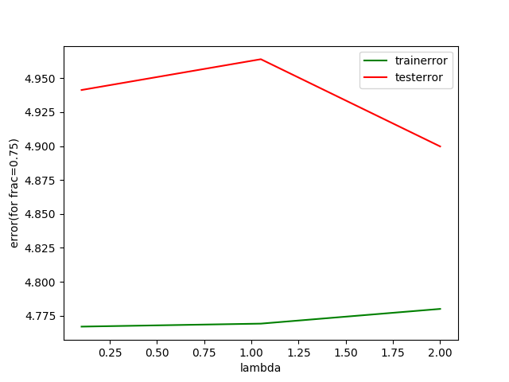

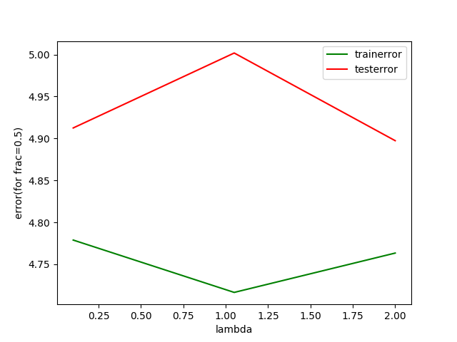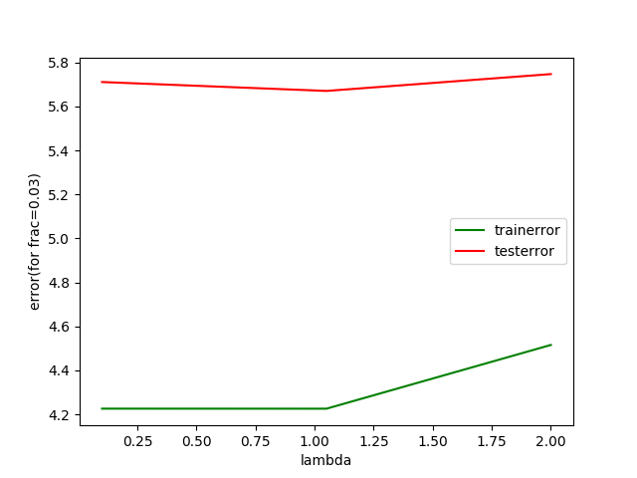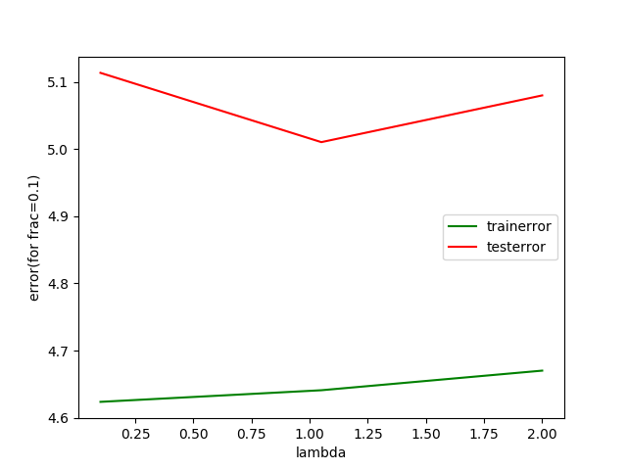

Now the plot for min avg test error and minavglambda vs frac are given below in different colors

The y-axis is min error/ min lambda and the x axis is the fraction.

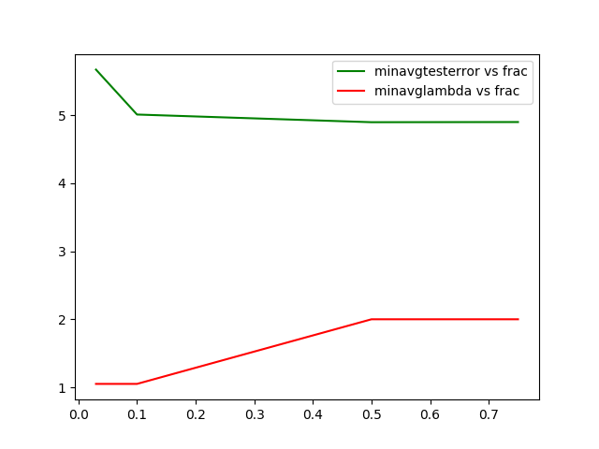

Finally,

The graph for actual value vs predicted value is given below for the training/test case

The y-axis is actual value and the x-axis is the y-axis.

Hence, the graph is close to a line of 45 degree thus confirming that this is indeed a Very efficient code.

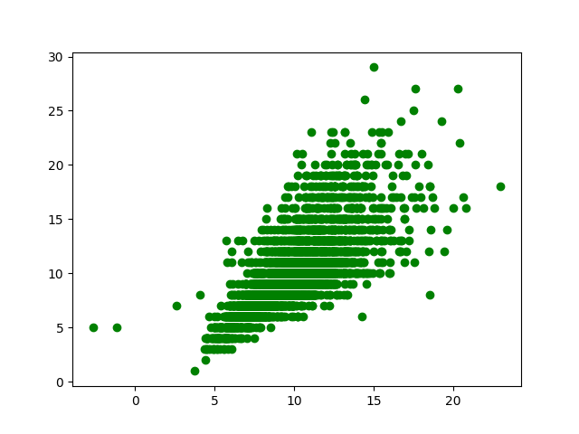

EXPT #2:

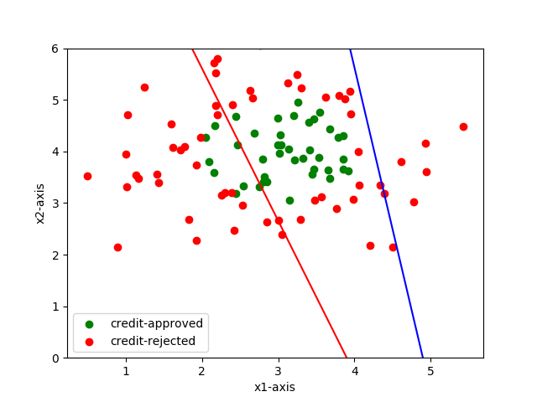

The above graph has red line learnt from the gradient descent approach and the blue line is learnt from newton raphson method. This is for 1000 iterations.

The newton raphson method is way fater than the gradient descent as is observed from the graph below which is for low number of iterations, the newton raphson has already achieved minima while the gradient descent is a long way from its actual value.

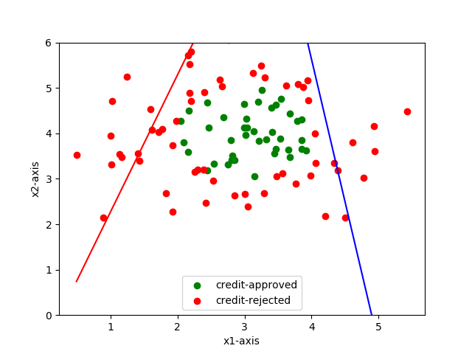

The data however is not linearly separable as is evident from the graph above, it can only be separated by higher degree polynomials.