LAB-3: Self driving car

1. Training the neural network ->

A 1024-512-64-1 neural network was created in python. The sigmoid function from the python library was used. The number of training iterations (epoch), batch size and the learning rate (alpha) can all be tuned. Some default values have been assigned to them which can be modified in the first few lines of the file ann.py.

The images are converted to grayscale to get a 32\*32 matrix and each of the pixel value is used as an attribute.

The initial weight and training example have all been set as per the instructions.

1. Observations and graphs ->

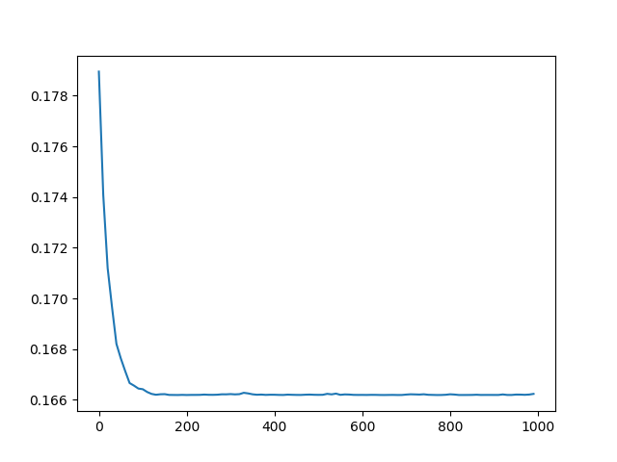

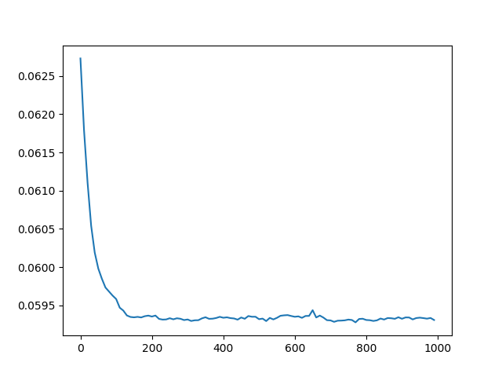

The above graphs are for batch size = 64 and alpha = 0.01

So, the observation is that after the first epoch, the error is already pretty low at 0.18. Now, as the epochs increase the error decrease first at a fast pace and then slower.

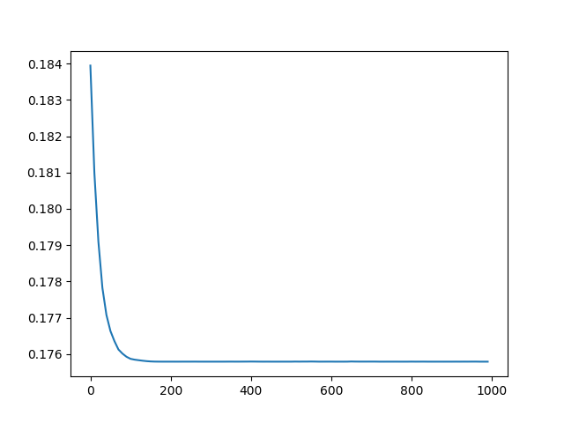

Training error vs epochs

This graph is for batch size=32 and 1000 epochs with learning rate = 0.01

The one with 64 batch size is founded in 2.i

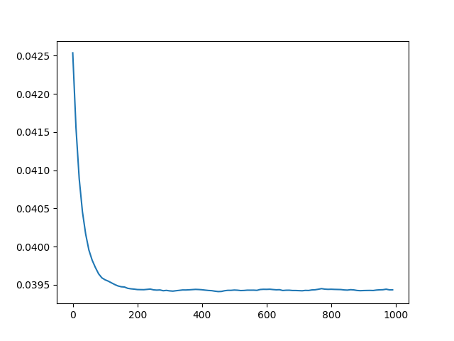

Testing error vs epochs

For, batch size = 32



Training error vs epochs

For, batch size = 128

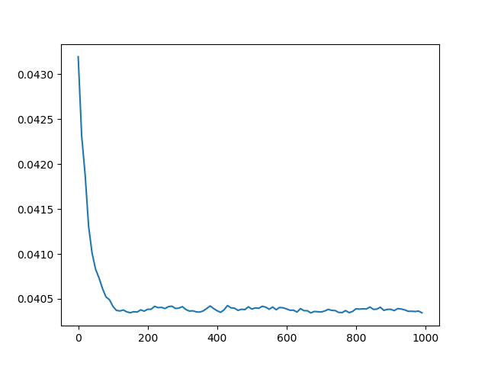

Testing error vs epochs

Batch size = 128

Observation -> we notice that, when the batch size is increased, the time taken for the program to terminate decreases. But on the other hand, the graph takes more iterations for converging to the minima.

Thus time per iteration decreases and number of iterations to converge increases on increasing the batch size.

1. On keeping the dropout rate = 0.5, overfitting is prevented so, the error on training set increases. This is a way of regularizing the neural networks.

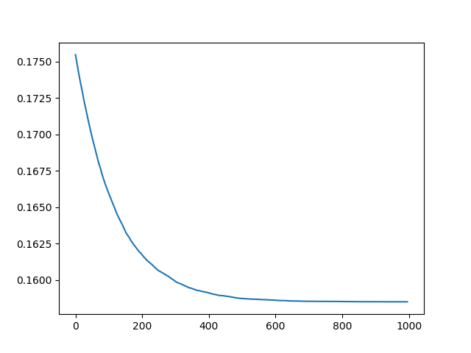

Training error vs epochs for training rate = 0.001

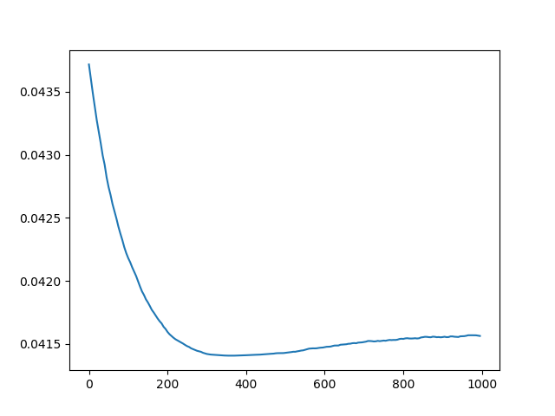

Testing error vs epochs for training rate alpha = 0.001

So, as we can see the time taken to converge has increased on decreasing the rate to 0.001

Now, for alpha = 0.05,

The graph showed behaviour of not converging and was bouncing due to high rate of alpha.

For, alpha = 0.005,

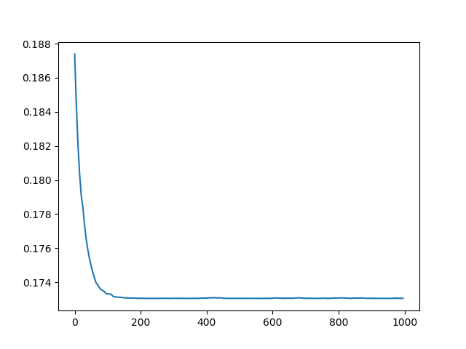

Training error vs epochs

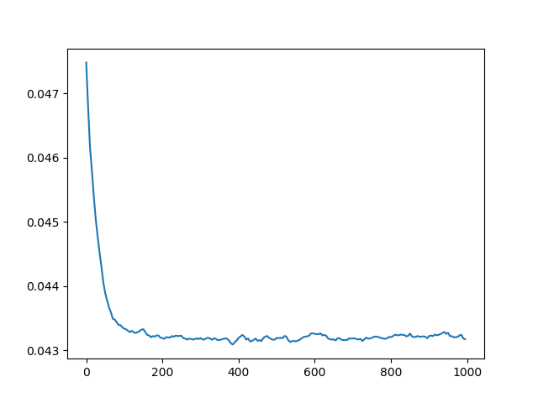

Testing error vs epochs

This is a moderate learning rate.

The best learning rate of the ones we tries was alpha = 0.01.