**SOFTWARE SYSTEM LABORATORY**

**CSP 203**

**DOCUMENT DESIGN**



**TnP Student Portal**

**Group No.: 3**

Submitted by:

SHREYANSHU SHEKHAR (2016csb1060)

SAMEER ARORA (2016csb1058)

SAHIL KUMAR (2016csb1057)

AKSHAT RATHORE (2016csb1030)

**Submitted On: 8 March 2018**

**Supervised by:**

**Dr. Mukesh Kumar**

**4th Semester, Session 2017-2018**

Table of Contents

1 Introduction 2

2 Functionalities 2

2.1 Streamlining Mails 3

2.2 Alumni Connect 4

2.3 Off-Campus Placement Opportunities & Internship Opportunities 5

2.4 Internship Tools 6

2.5 Preparation Zone 7

2.6 Home 8

3 Use Cases 9

3.1 Streamlining Mails 9

3.2 Alumni Connect 10

3.3 Off-Campus Placement Opportunities & Internship Opportunities 11

3.4 Internship Tools 12

3.4.1 CV Maker 12

3.4.2 Letter of Motivation 13

3.4.2 Cover Letter 13

3.5 Preparation Zone 14

3.6 Login and Signup 15

4 ER-Diagram 16

5 Tech Stack 16

7 Individual Roles 16

7.1 SHREYANSHU SHEKHAR (Module 1) 17

7.2 SAMEER ARORA (Module 2) 17

7.3 SAHIL KUMAR (Module 3) 17

7.4 AKSHAT RATHORE (Module 4) 17

# 1 Introduction

In our college we have a TnP (now CDCDRC) website. But on some level a lack of an internal portal is felt. In our project we aim to solve this problem by developing a TnP Portal which will be a website internal to the college students and facilitate functions like connecting to alumni, streamlined mails, internship and placement opportunities etc. It will also be extended to provide features like CV maker, preparation materials and tools for various companies etc.

# 2 Functionalities

We aim to incorporate the following features:

* Streamlining mails from the TnP Cell
* Connecting to Alumni
* Internship Opportunities
* Off-Campus Placement opportunities
* Internship Tools
* Preparation Zone
* Login and Signup

## 2.1 Streamlining Mails

We receive a lot of mails from the TnP cell, so at times it can get difﬁcult to keep track. Also, since these are generally forwarded mails, the readability of the mails is also reduced. So, in this section of the portal we will place all the important mails and notices under one aesthetic place. Also, we will try to facilitate desktop notiﬁcations and a Google calendar for the events lined up.

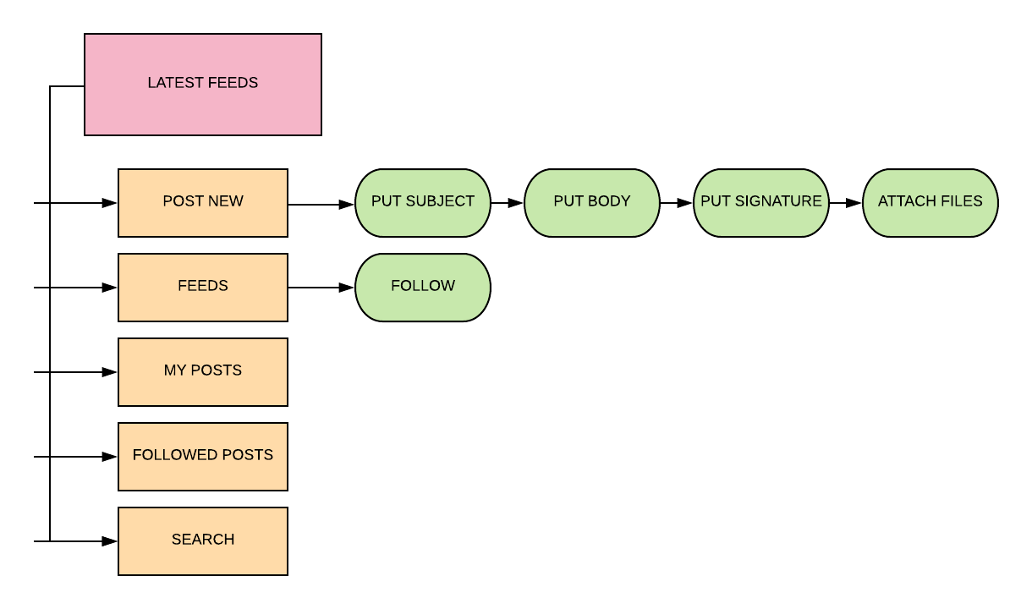

## 2.2 Alumni Connect

We have a Facebook page and group for interaction with our alumni. But using this section we could improve our interaction with our alumni manifold way. Basically, we will provide a Google form with ﬁelds like Name, Batch year, Current Job/designation etc. This will help us in creating a database of our alumni. Now, from the student’s perspective we will provide him the facilities to search an alumnus by name, or search all our alumni working in a particular company among many other features.

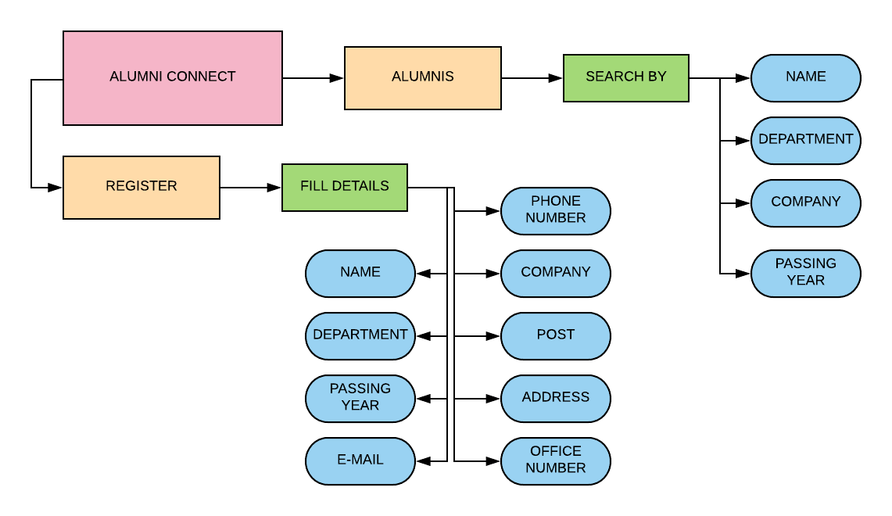

## 2.3 Off-Campus Placement Opportunities & Internship Opportunities

Currently, we came to know about internship opportunities and programs through a mail which has been travelling from batch to batch until it reached us. This has two main disadvantages. First that we came to know about it a bit late. Secondly, it is not really very well organized. So, to overcome this problem we will develop a page in the website which contains all the internship programs and their details. Also, this will keep the data centralized and organized and we will try to ensure to keep this updated from time to time. This section could also contain information on how to make your CV or cover letters. Basically, this will be the one stop solution to all queries about how to get an intern.

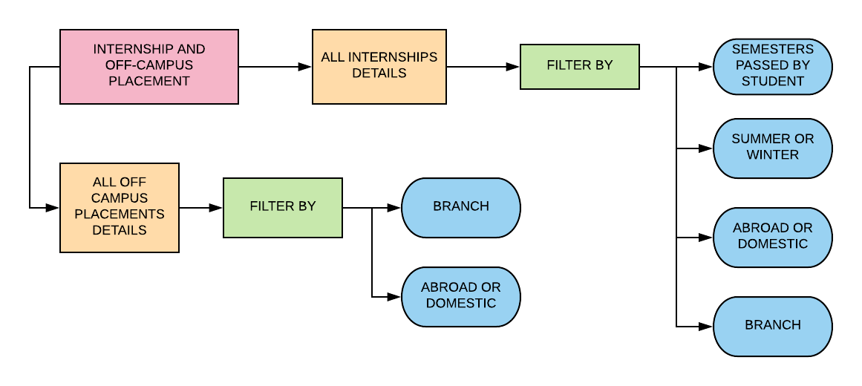

## 2.4 Internship Tools

As most of us may be aware, MS-Word is not the best tool when it comes to making CVs. Although L ATEX, is a very nice tool for making CVs, it does not come easy to all particularly the non-CSE students. Thus, we will try to incorporate a CV maker in the portal where a layman ca easily generates beautiful looking CVs without having to use any coding. (This idea has been borrowed somewhat from IIT Delhi’s TnP cell) Please note that developing the CV Maker is not the part of our project. We will just provide a link or suitable API. The reason being that the CV Maker can be an individual project in itself requiring a lot of time and effort and maybe even some skills which we are yet to learn.

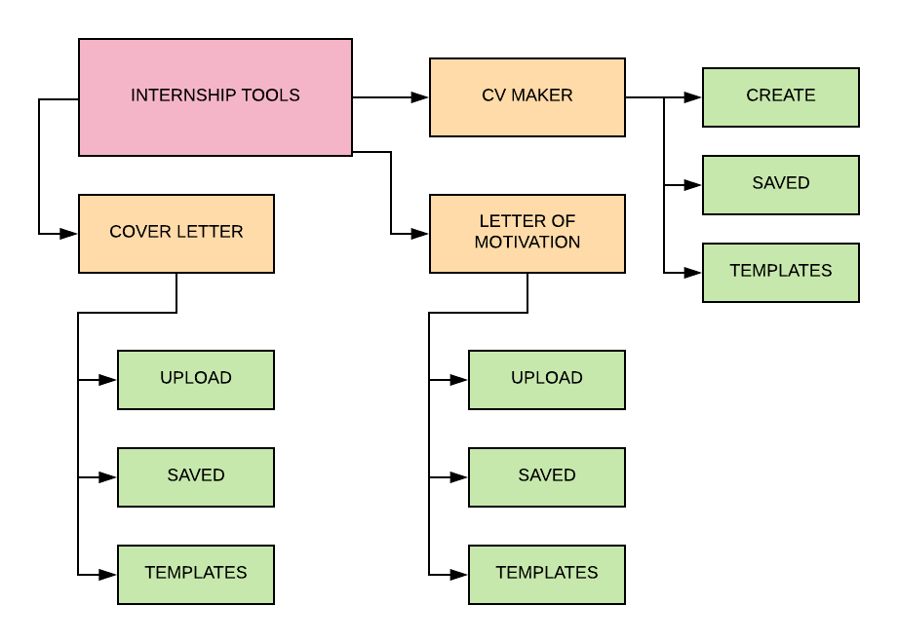

## 2.5 Preparation Zone

Similar to GeeksforGeeks, we can have an internal section on the portal where we can provide company speciﬁc questions for not only CSE but also other branches. Also, we could have testimonies, interview experiences and preparation strategies of our alumni working in prestigious companies and those who have cracked competitive exams like CAT, UPSC, etc.

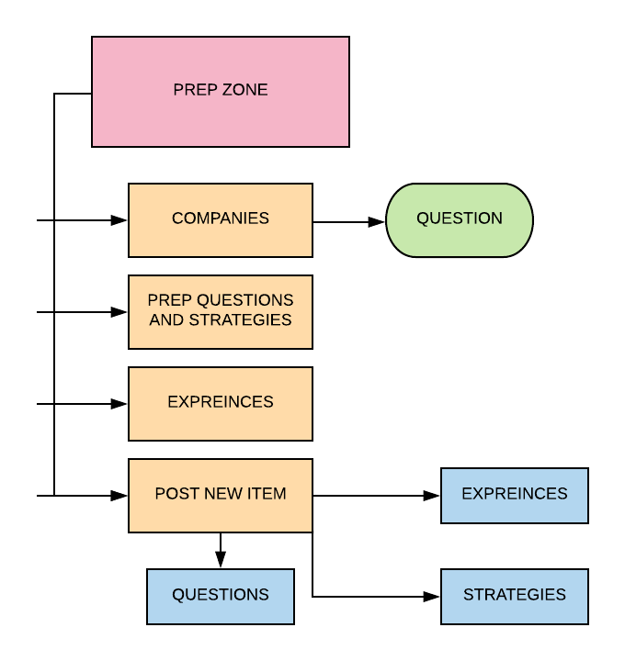

## 2.6 Home

Home page will have links to all these different pages:

* HOME
* LATEST FEEDS
* PREPRETION ZONE
* ALUMNI CONNECT
* INTERNSHIP AND PLACEMENT
* INTERNSHIP TOOLS
* LOGIN AND SIGNUP

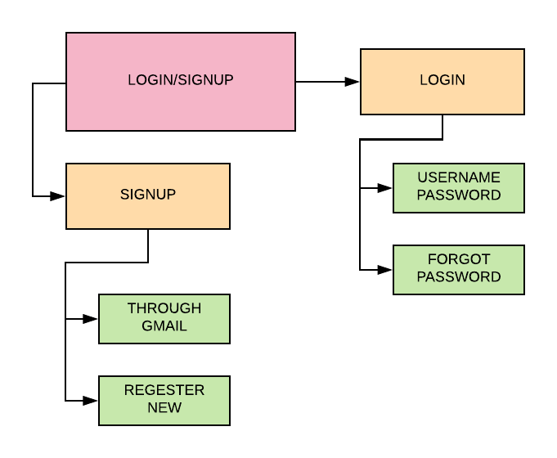

# 3 Use Cases

## 3.1 Streamlining Mails

1. One can post the details just like mail by giving the subject, body, signature and attachments if any.
2. One can check the feeds that will be in good format to increase the readability.
3. One can check the posts he had posted and edit them just like making new.
4. One can follow any post so that if he or she wants to see that post again or feel its importance by clicking on the option followed posts.
5. One can search for any specific mail by typing some keywords.
6. While posting or checking followed posts if that person is not logged in the or she will be directed to login or signup page.

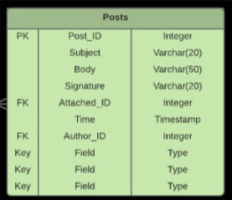

## 3.2 Alumni Connect

1. Currently we only have a Facebook group for alumni interaction. This is not an optimum solution as it is not possible to get specific results when it comes to some alumni. Also, the only way to get what you want here would be to make a post there and wait till someone replies.
2. This portal will solve this problem. It will provide a one stop solution for connecting with our alumni.
3. Here the student can simply go to the page and simply find the specific alumni.
4. He can search for the alumni by his name or he can find all alumni of a specific department and a specific batch or he can find all alumni working in a specific company. Basically, this provides a lot of power to the student and helps him to find the information he requires.
5. The student can find the following information about some alumni - Name, department, batch, email, company, phone number, designation and address.

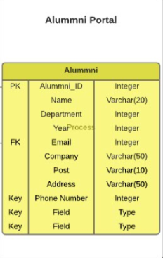

## 3.3 Off-Campus Placement Opportunities & Internship Opportunities

This page will contain details about all the major internship programs and off-campus placement opportunities. This will keep the data centralized and organized, which will be updated time to time. There will be two separate pages one for internships and the other for off-campus placement opportunities.

1. The page will contain all the important internships in one page.
2. The student will be able to filter the internships details.
3. The sorting/filtering will be on the basis of the semesters passed by student, summer or winter internship, branch of internship (like computer science, electrical, etc.), national or abroad internship.
4. Each column will have a brief summary of an internship and a hyperlink redirecting to the internship’s official webpage.

The off-campus placement page will also have similar features.

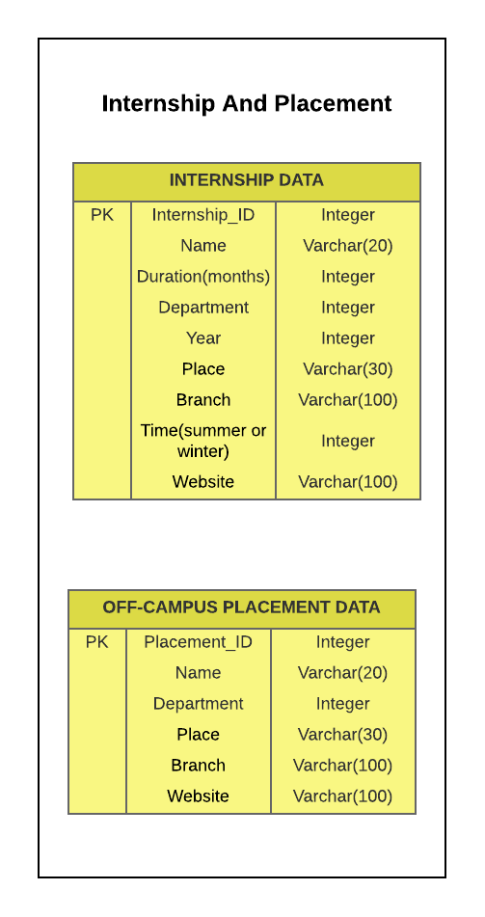

## 3.4 Internship Tools

This page will contain the general guidelines about each of the tool required for the internship. The page will give guidelines and importance of each of these.

* CV maker
* Letters of Motivation
* Cover Letters

### 3.4.1 CV Maker

CV maker in the portal where a layman can easily generate beautiful looking CVs It is built to provide the students an option to select from the previously used CV’s and choice to customize its own using the google docs or latex editor

1. The users should be able to login using their google emails and make their CV’s on this CV maker and upload and download the CV made by other users.
2. The Users will have three choices for making CV online using google docs API or the latex interface given as in the sharelatex.
3. There will also be a ranking of the templates according the number of users accessing that template.
4. The CV maker will allow users to export the output files as pdf files.
5. The CV maker will also provide the classification based on the fields like department, year, and research or industry.

### 3.4.2 Letter of Motivation

Letter of motivation will also be just like the CV where people can upload their letters and download them. The letter of motivation would be provided by just Google Docs API not Latex.

It has the features similar to the CV’s.

### 3.4.2 Cover Letter

Cover letters will be text files which students/alumni can upload their letters and download them. The cover letters would be provided by just Google Docs API not Latex.

It has the features similar to the CV’s.

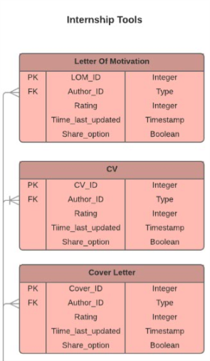

## 3.5 Preparation Zone

1. There will a list of companies in which clicking on any company will give you all the questions asked by that company in the interview.
2. There will be list of questions for preparation and few strategies posted by the experts like alumni or   experienced person.
3. One can also share their experiences of interview like a story.
4. One can post about their experiences, some strategies or any good questions.
5. While posting if that person is not logged in the or she will be directed to login or signup page.

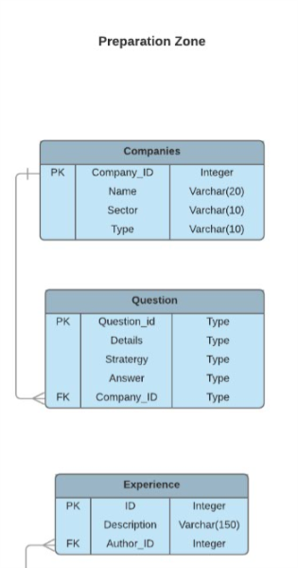

## 3.6 Login and Signup

There will be the signup/login option for the portal. Every student/faculty/alumni of IIT Ropar can register on the page.

1. The student/faculty can only use his official IIT Ropar Email id to register on the portal.
2. The student can login from anywhere in the portal as there will be a header in every page redirecting to login/signup page

The different roles will be assigned for each of the user:

* Student
* Alumni
* Faculty

All the official details about the internship and mails will have to be checked by the faculty before mailing to college

There will be distinction made during the signup and login such that students can be sorted year wise, department wise and maybe grade wise too.

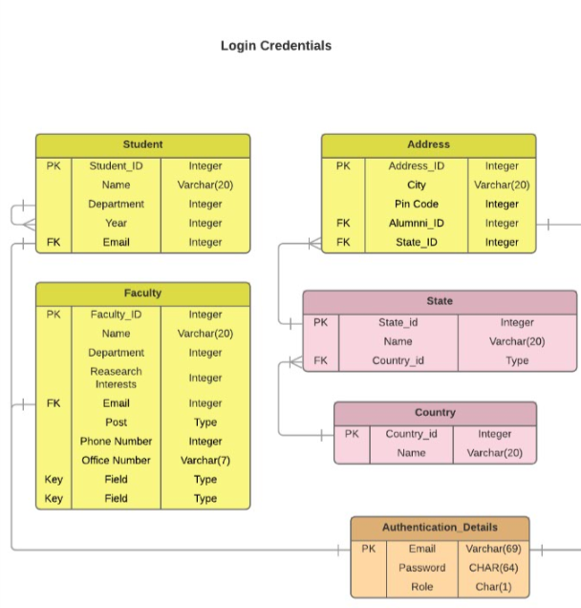

# 4 ER-Diagram

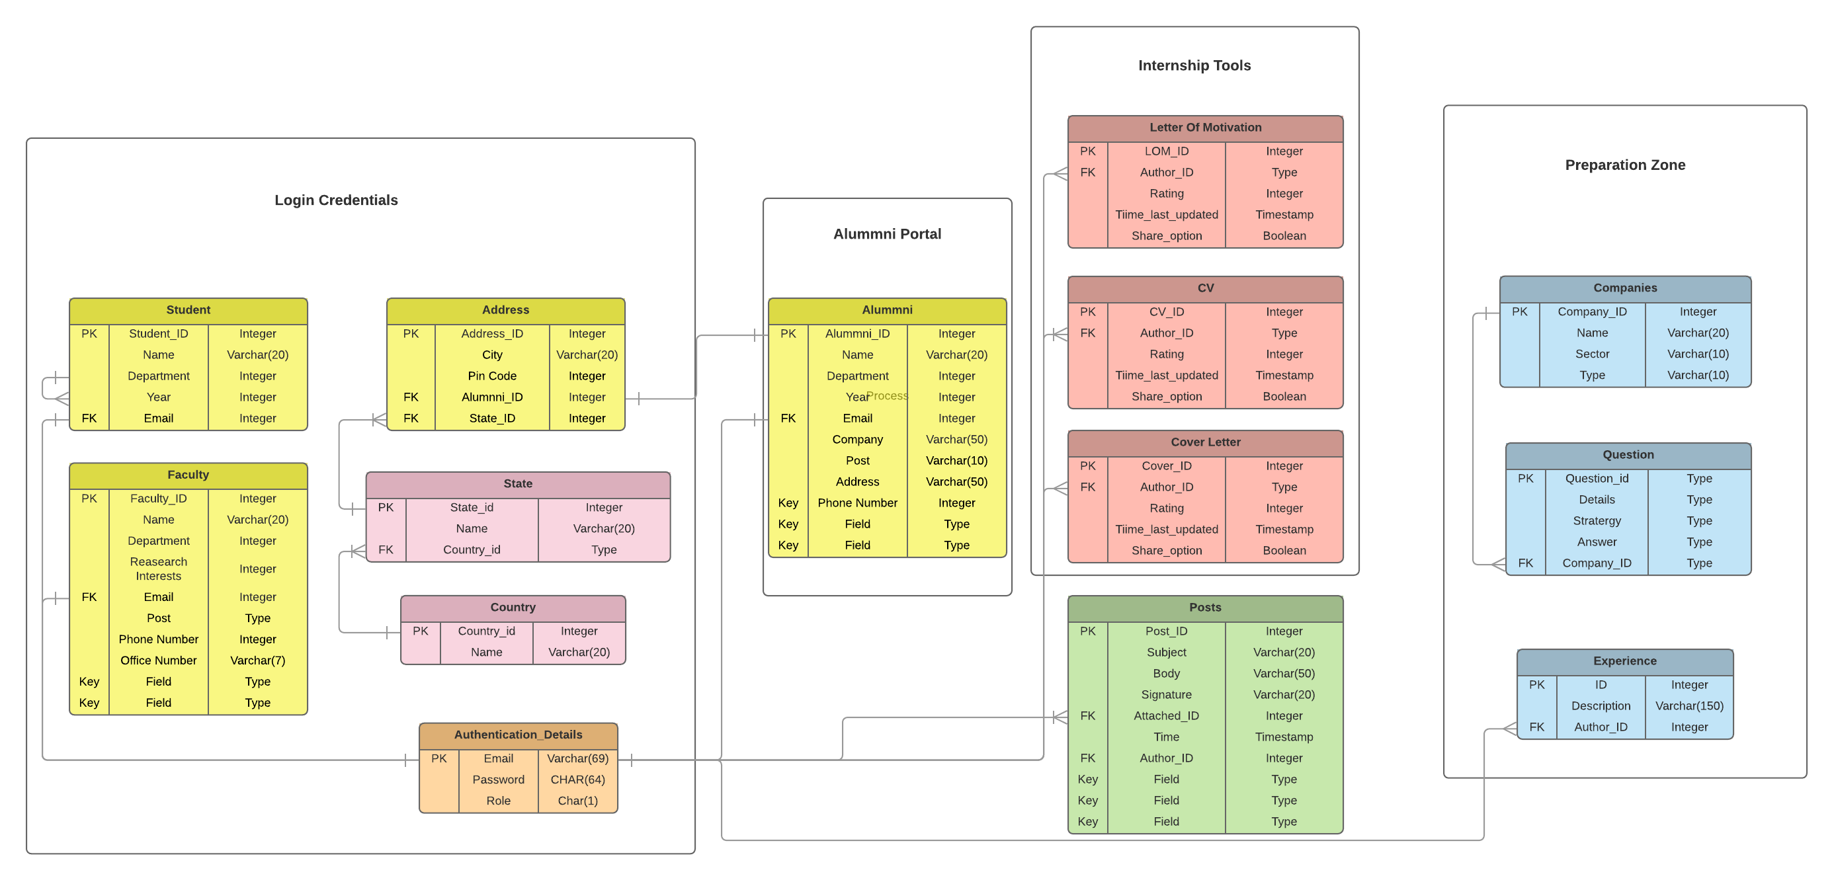

# 5 Tech Stack

We would be using following technologies for our project:

* PHP for back-end programming
* The database we would use will be MySQL with server Apache
* HTML, CSS and JavaScript for front end development of the website.

# 7 Individual Roles

We have divided our module not on the basis of different languages but on the basis of different section of this project. Each of our module handles some functionalities of this project. We tried to divide our project into 4 equal modules.

## 7.1 SHREYANSHU SHEKHAR (Module 1)

This module will contain:

* Streamlining mails
* Preparation zone
* Creating home page

## 7.2 SAMEER ARORA (Module 2)

This module will contain:

* Internship tools
* Login and signup

## 7.3 SAHIL KUMAR (Module 3)

This module will contain:

* Off-Campus Placement Opportunities
* Internship Opportunities

## 7.4 AKSHAT RATHORE (Module 4)

This module will contain:

* Connecting to Alumni
* Registering the Alumni’s