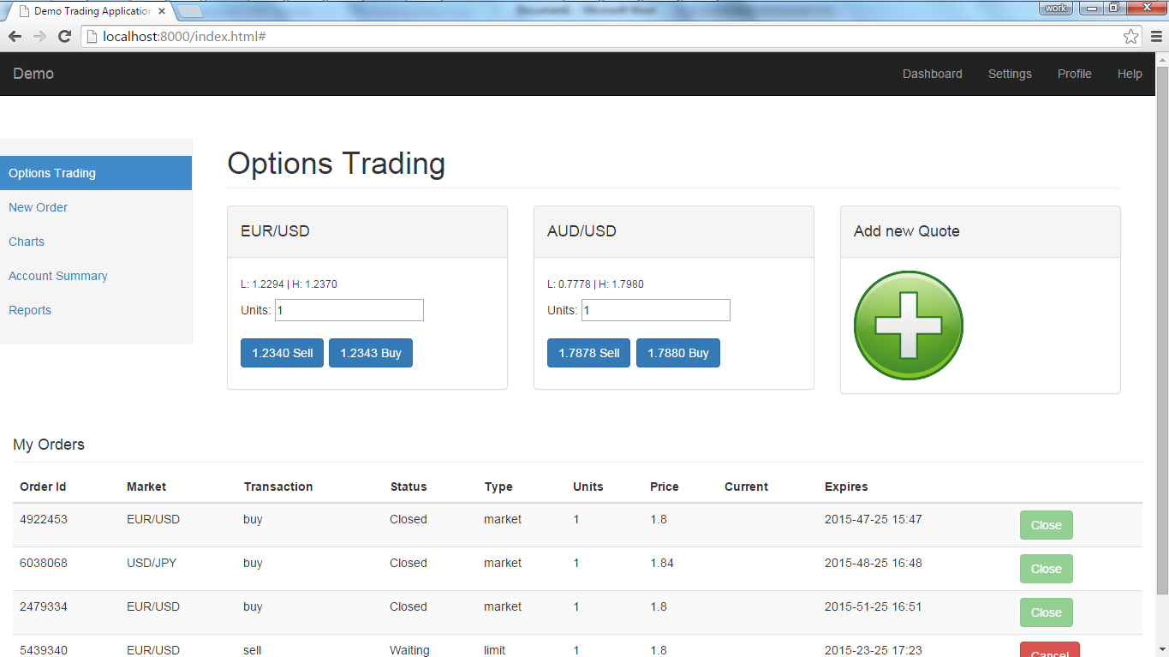

The Pricing screen
- User can add New Quotes using the Add New Quote placeholder.
- The user can add as many quotes as he wants.
- Clicking on the Buy/Sell buttons will display a modal dialog for the user to quickly make a trade
Further enhancements:
- An option could be added to switch between panels display or table display for the currency quotes.
- A toggle options could be added to the My Orders table. This could then be minimized/docked by the user.

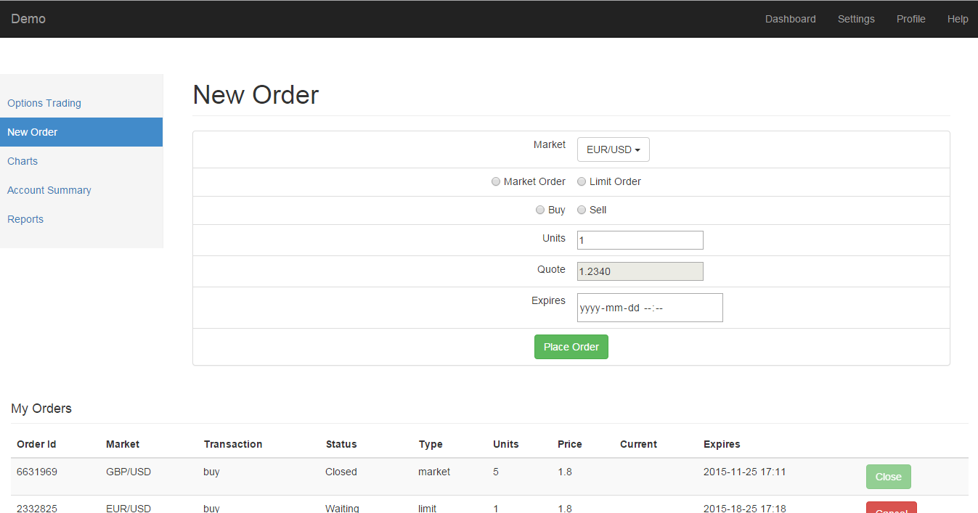

The New Order Screen
- This enables user to place a new order.
Enhancements
- An advanced option so that the user can set the Stop Loss, Take Profit and other values
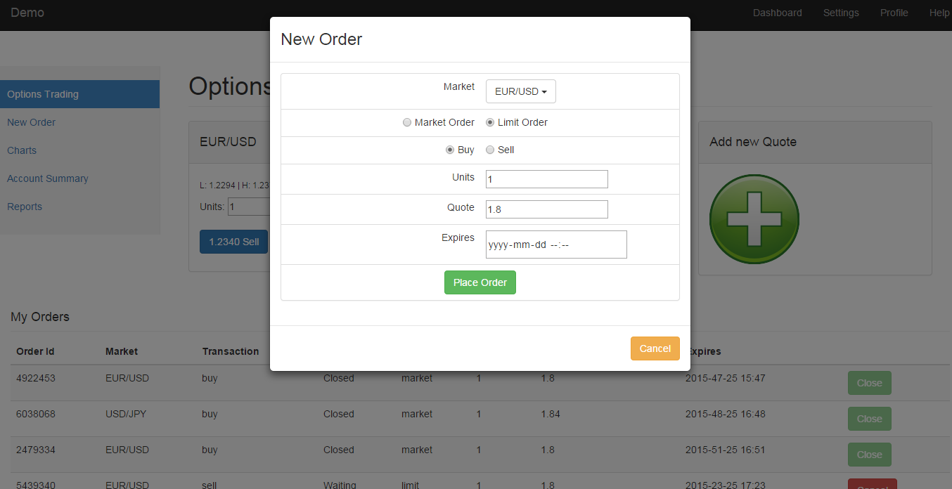
The New Order Popup
- Allows the user to quickly place an order without switching screens.
Enhancements
- An advanced option so that the user can set the Stop Loss, Take Profit and other values

